Comprehensive Plan Figures

# Population

### POP_bar_primarygeo_population_overtime:

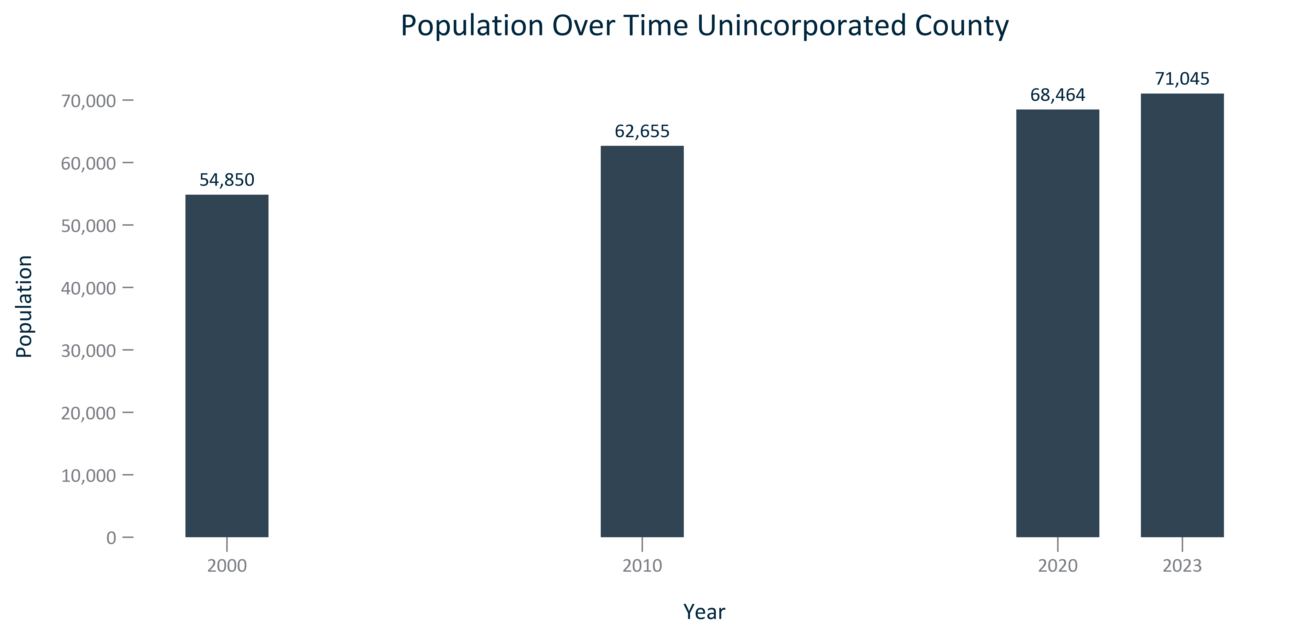

Citation: 2000, 2010, and 2020 Decennial Census, 2023 Population Estimates

### POP_line_primarygeo_historicalpopulation_overtime:

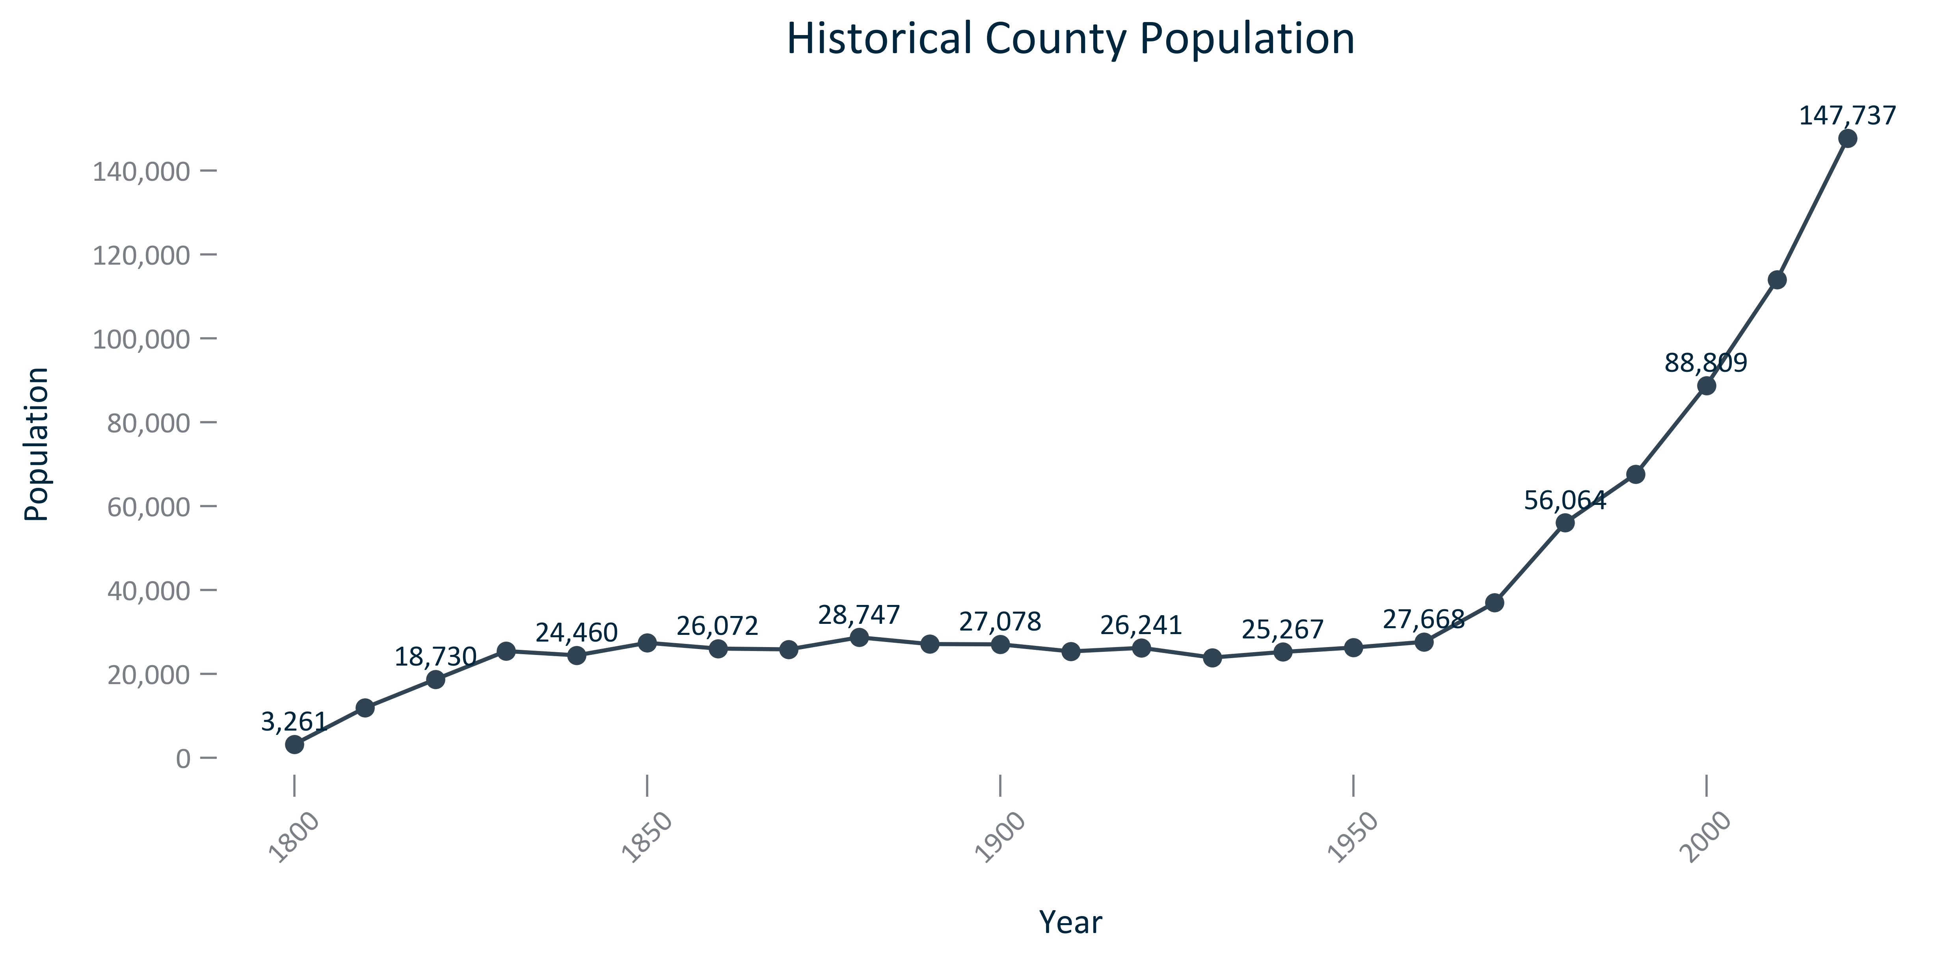

Citation: 1900-2020 Decennial Census

### POP_line_primarygeo_historicalpopulationchange_overtime:

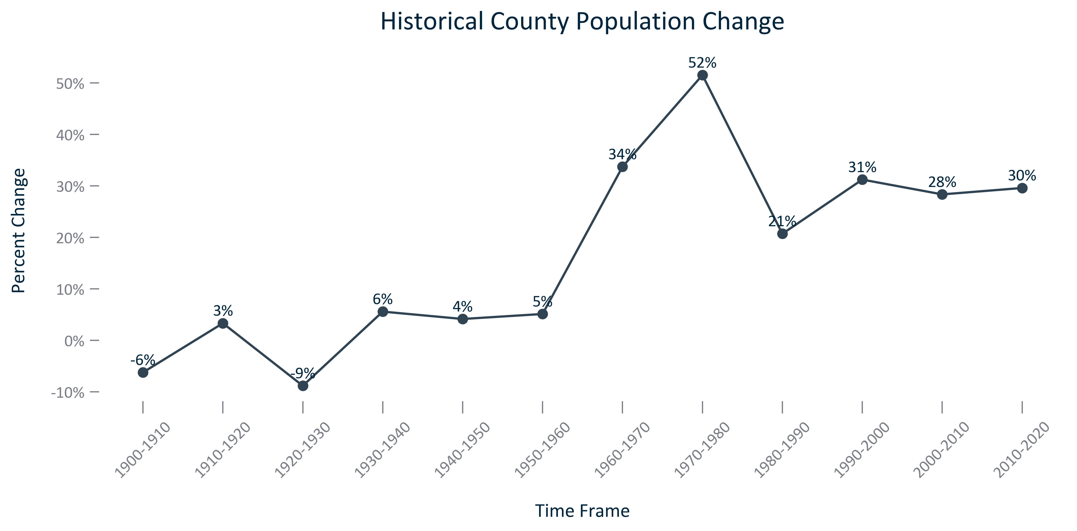

Citation: 1900-2020 Decennial Census

### POP_bar_primarygeo_projectedpopulation_overtime:

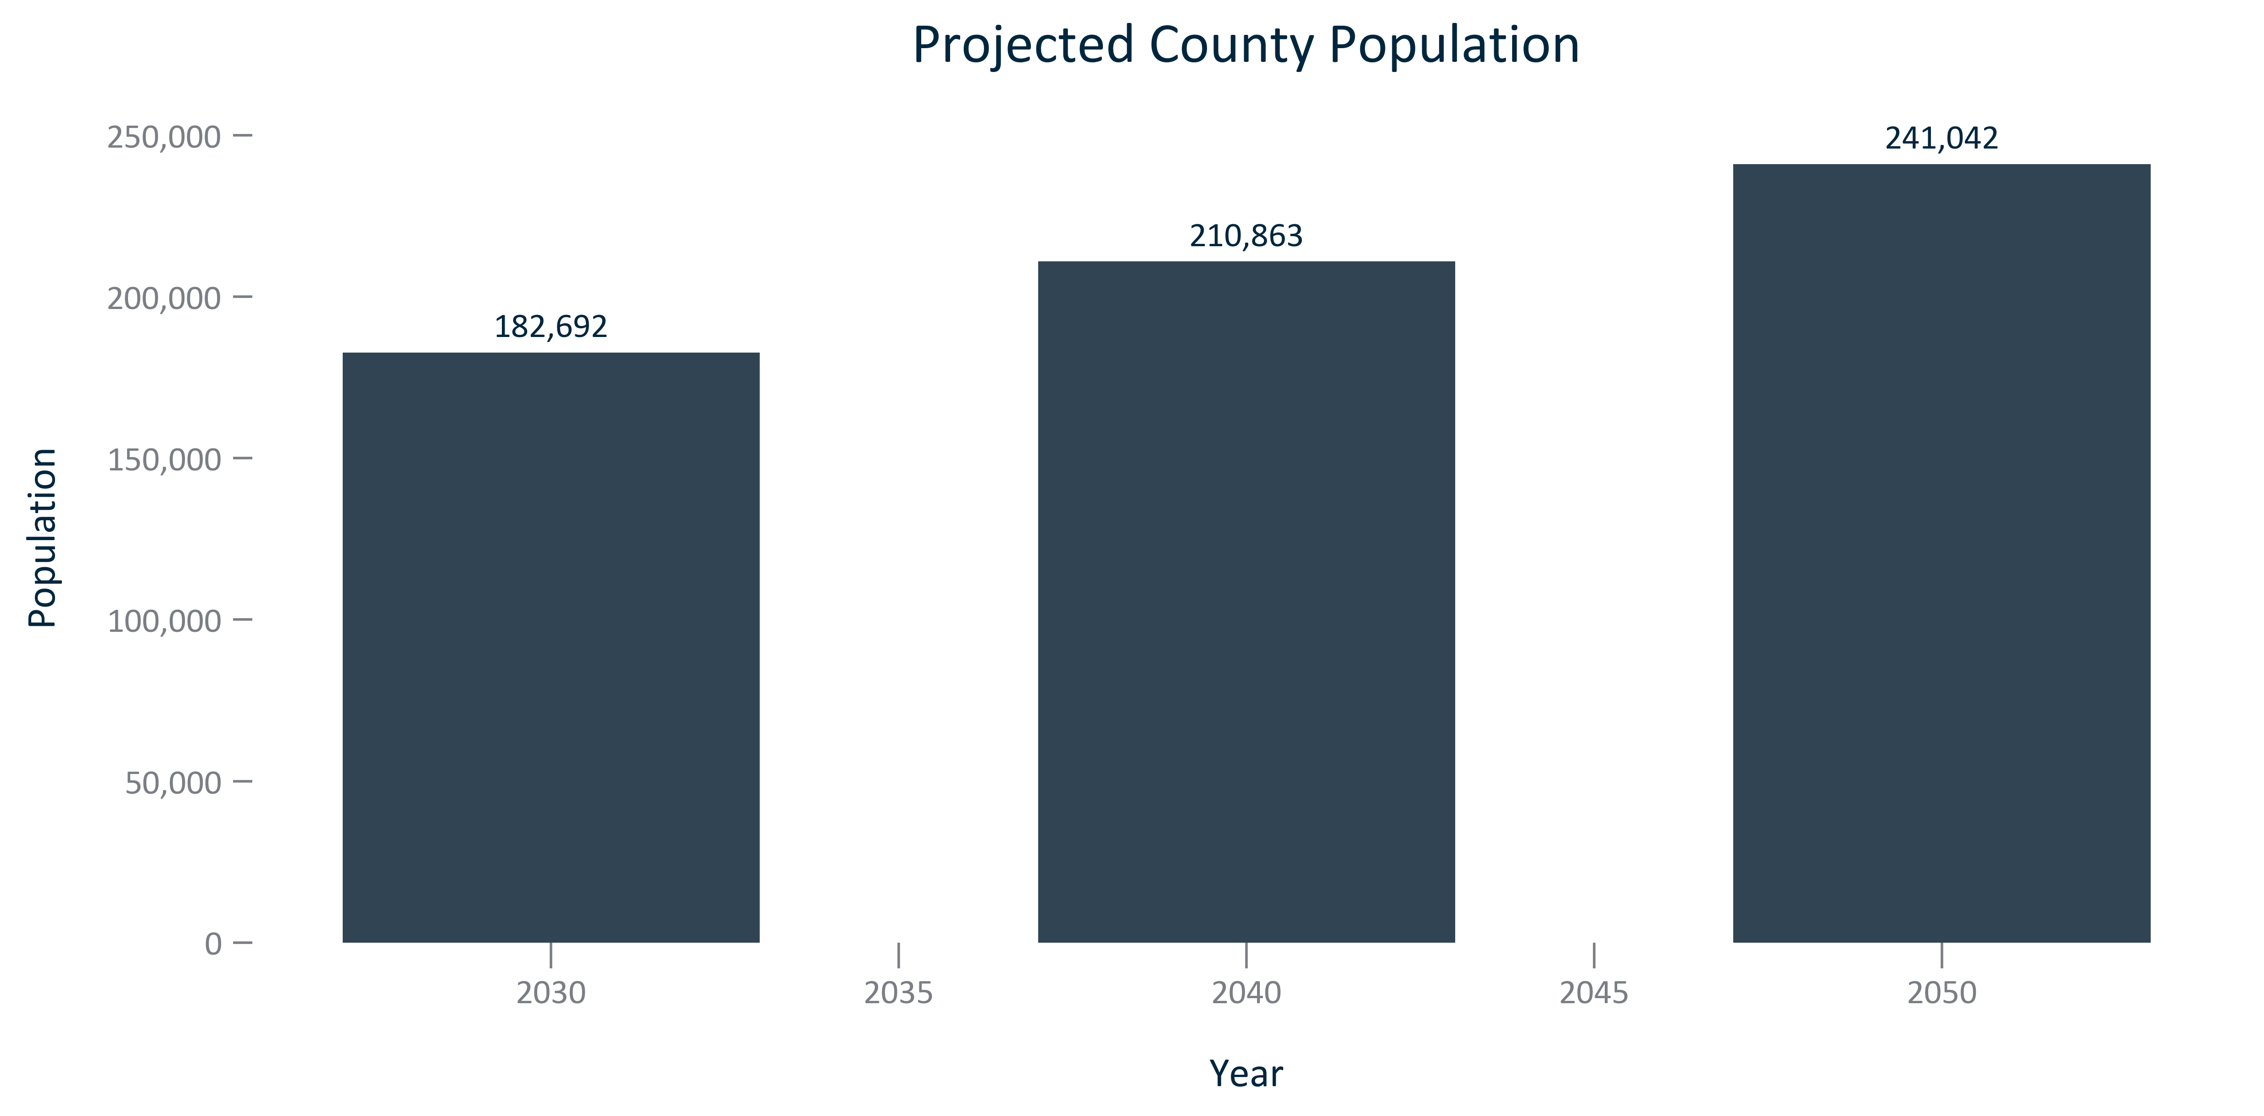

Citation: Woods and Poole Population Projections

### POP_bar_primarygeo_populationprojectionchange_overtime:

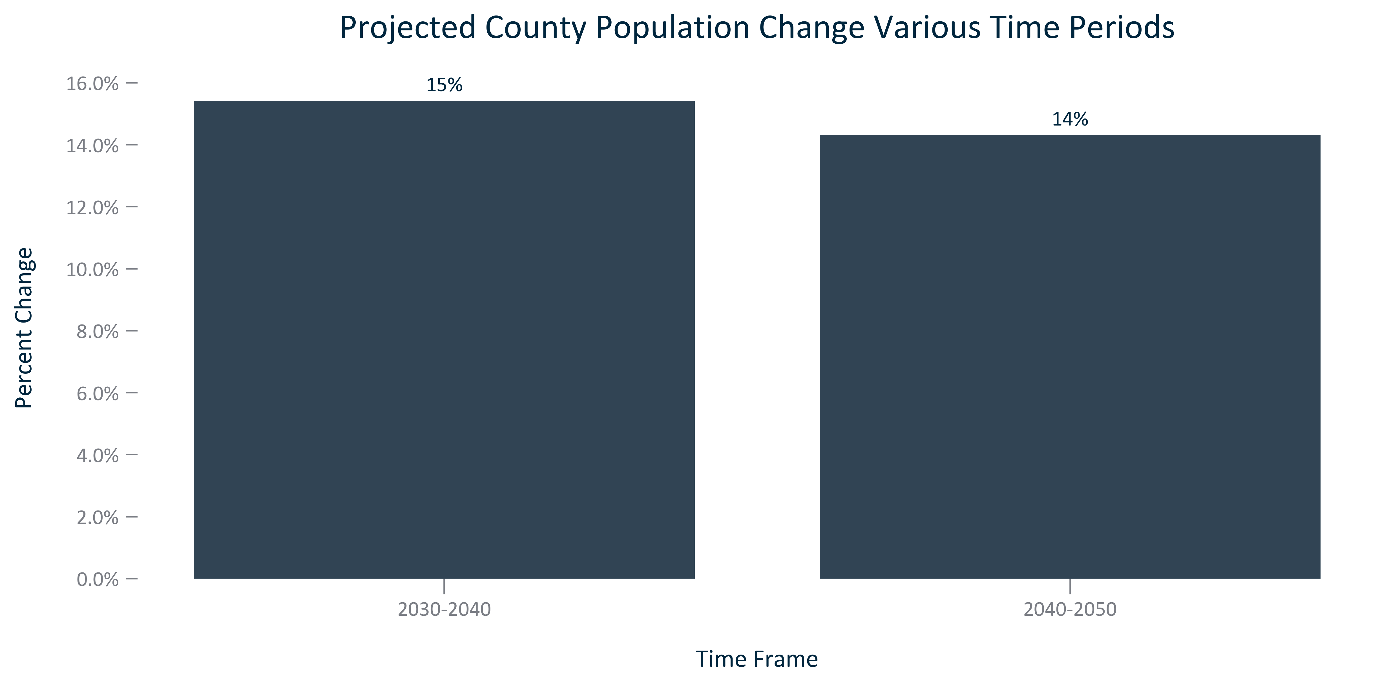

Citation: Woods and Poole Population Projections

### POP_line_geocomparative_population_overtime:

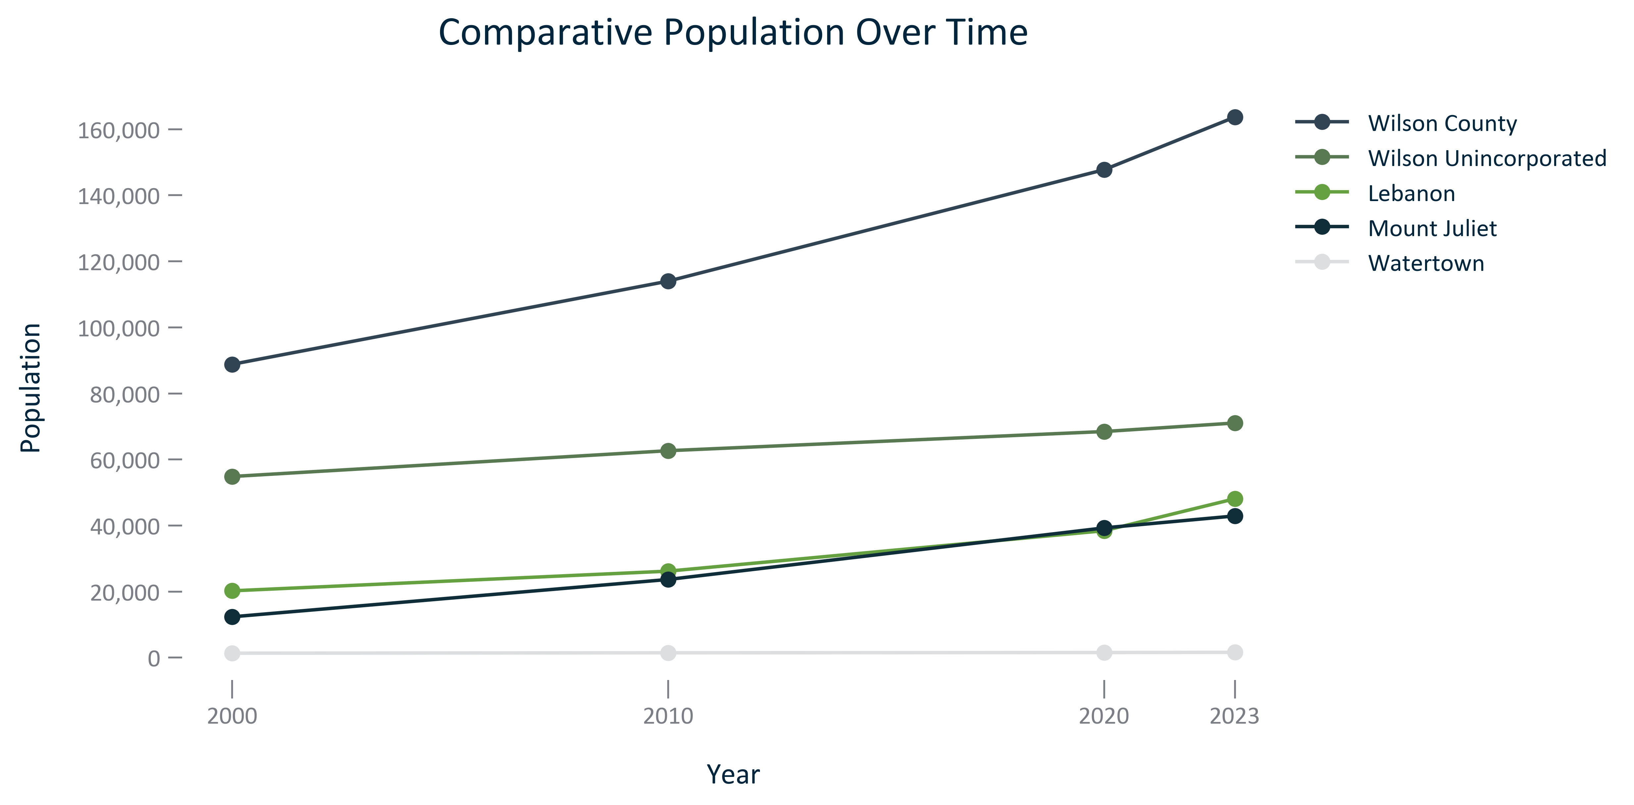

Citation: 2000, 2010, and 2020 Decennial Census, 2023 Population Estimates

### POP_bar_geocomparative_populationchange_overtime:

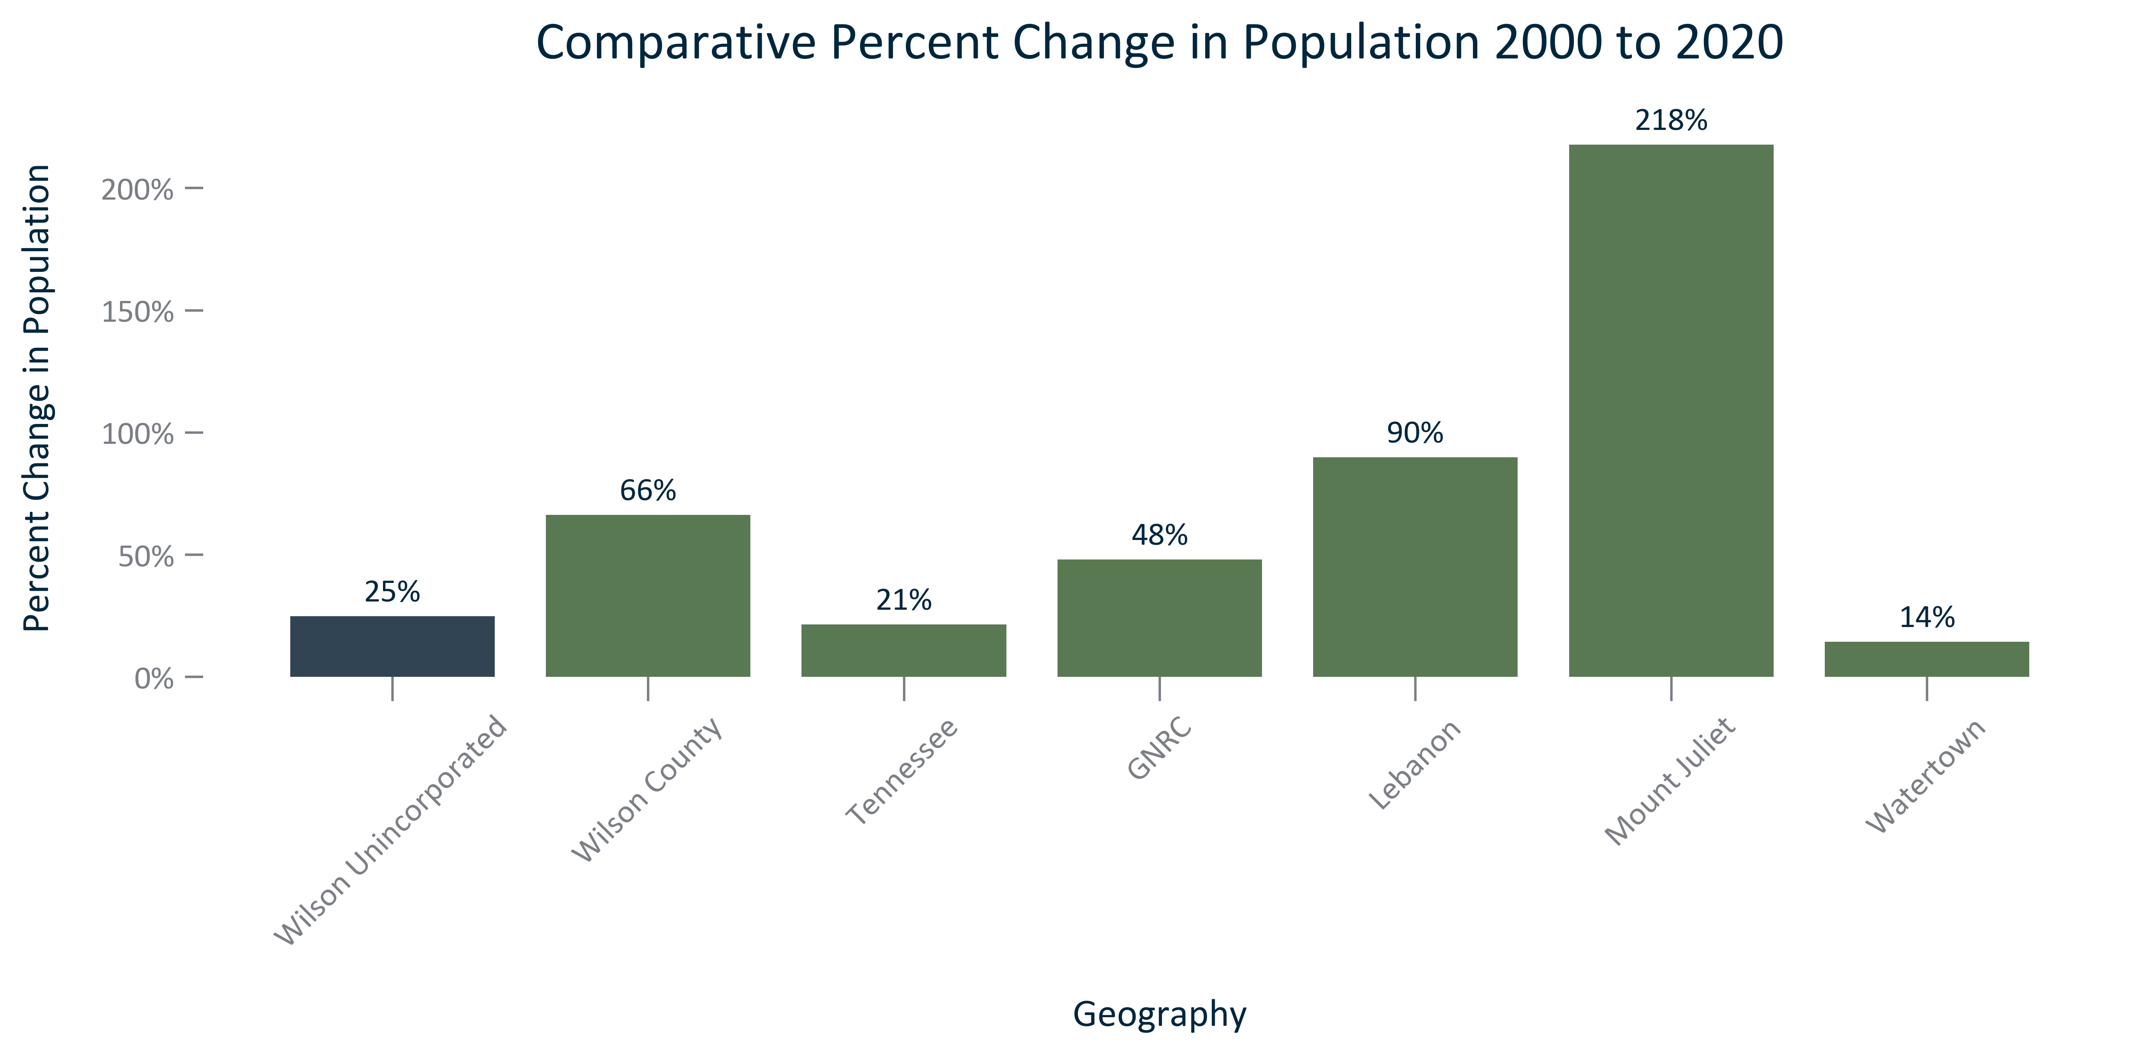

Citation: 2000 and 2020 Decennial Census

### POP_table_geocomparative_population_overtime:

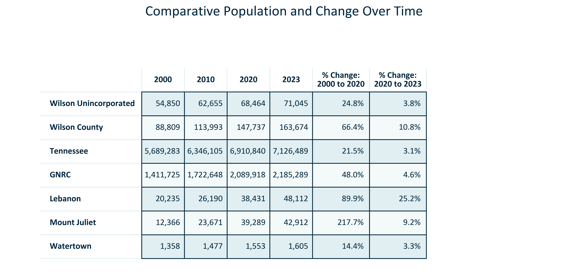

Citation: 2000, 2010, and 2020 Decennial Census, 2023 Population Estimates

### POP_bar_geocomparative_populationprojectionchange_overtime:

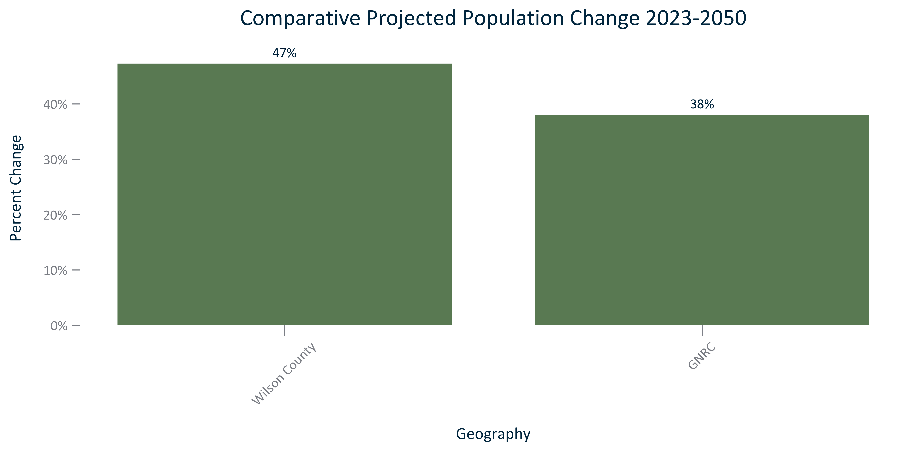

Citation: Woods and Poole Population Projections

### POP_table_geocomparative_populationprojectionandchange_overtime:

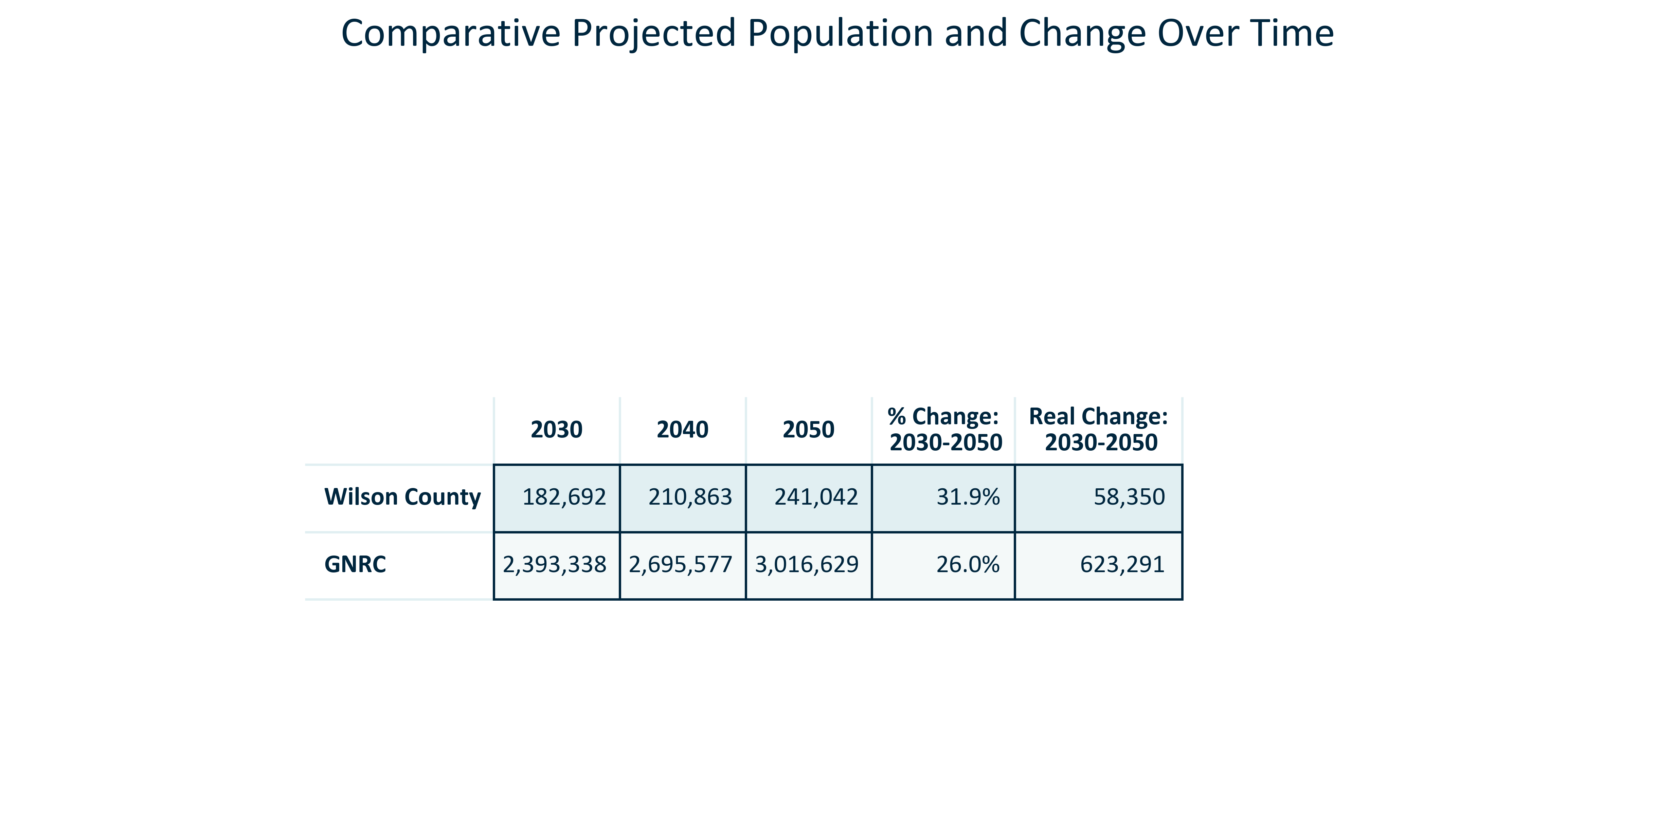

Citation: Woods and Poole Population Projections

# Age

### AGE_pyramid_primarygeo_populationpyramid_2023:

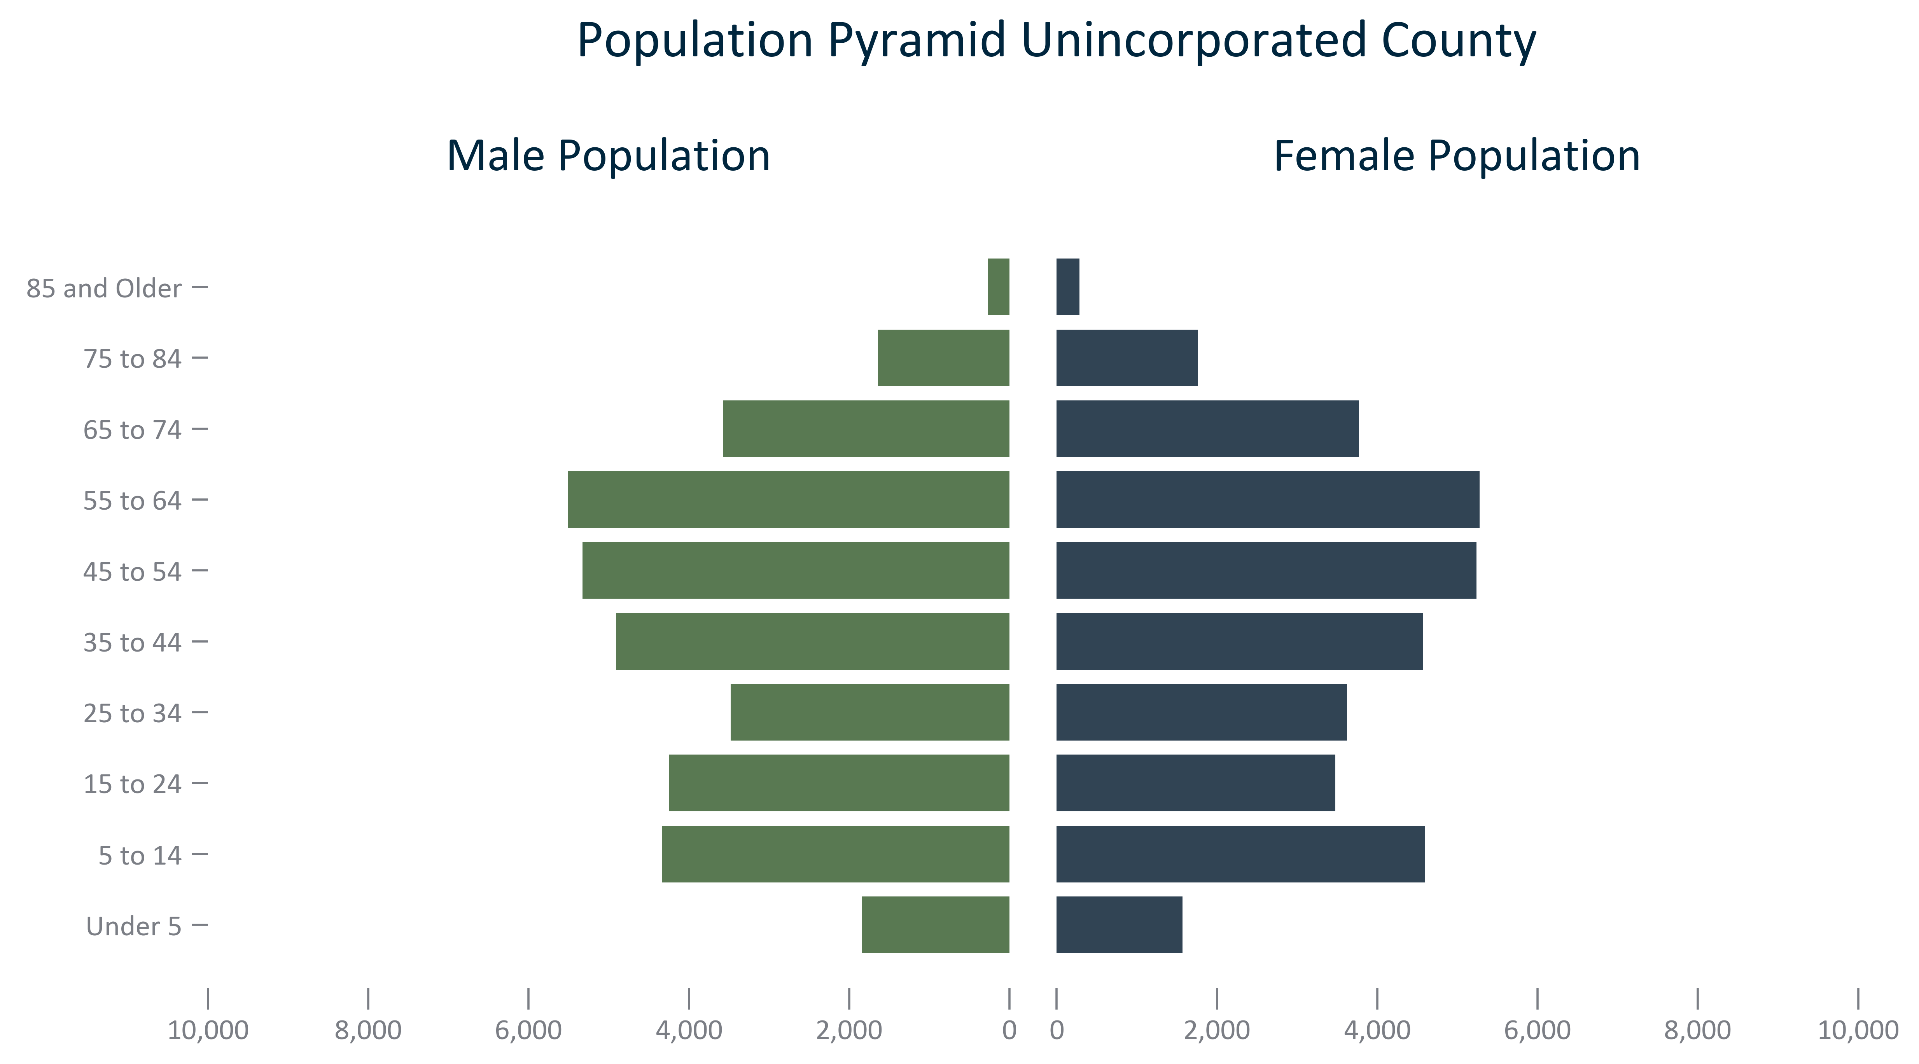

Citation: 2019 - 2023 American Community Survey 5-Year Estimates

### AGE_bar_primarygeo_under5_overtime:

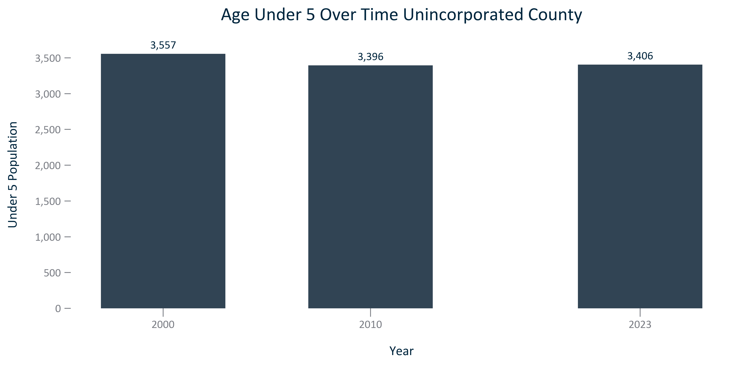

Citation: 2000 and 2010 Decennial Census, 2019 - 2023 American Community Survey 5-Year Estimates

### AGE_bar_primarygeo_under18_overtime:

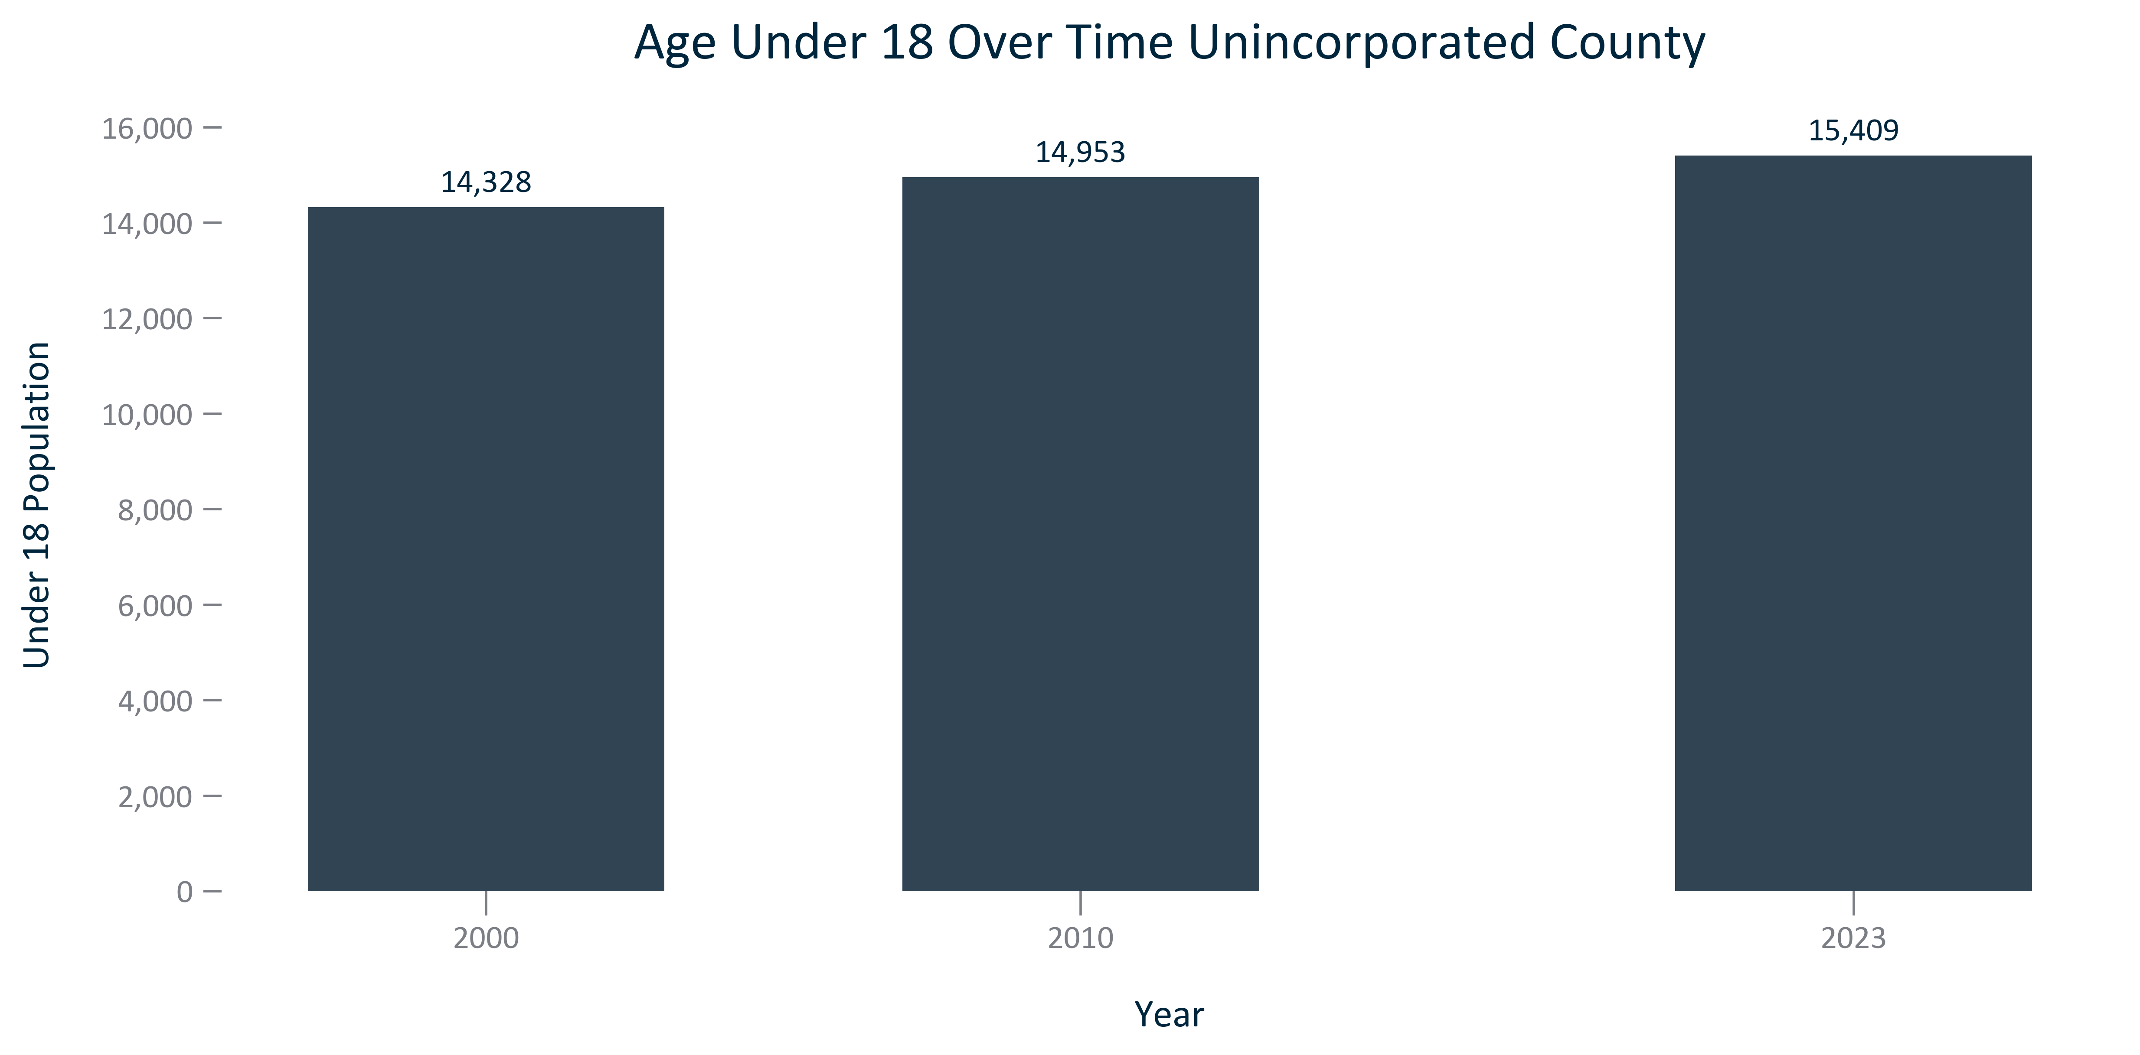

Citation: 2000 and 2010 Decennial Census, 2019 - 2023 American Community Survey 5-Year Estimates

### AGE_bar_primarygeo_18to54_overtime:

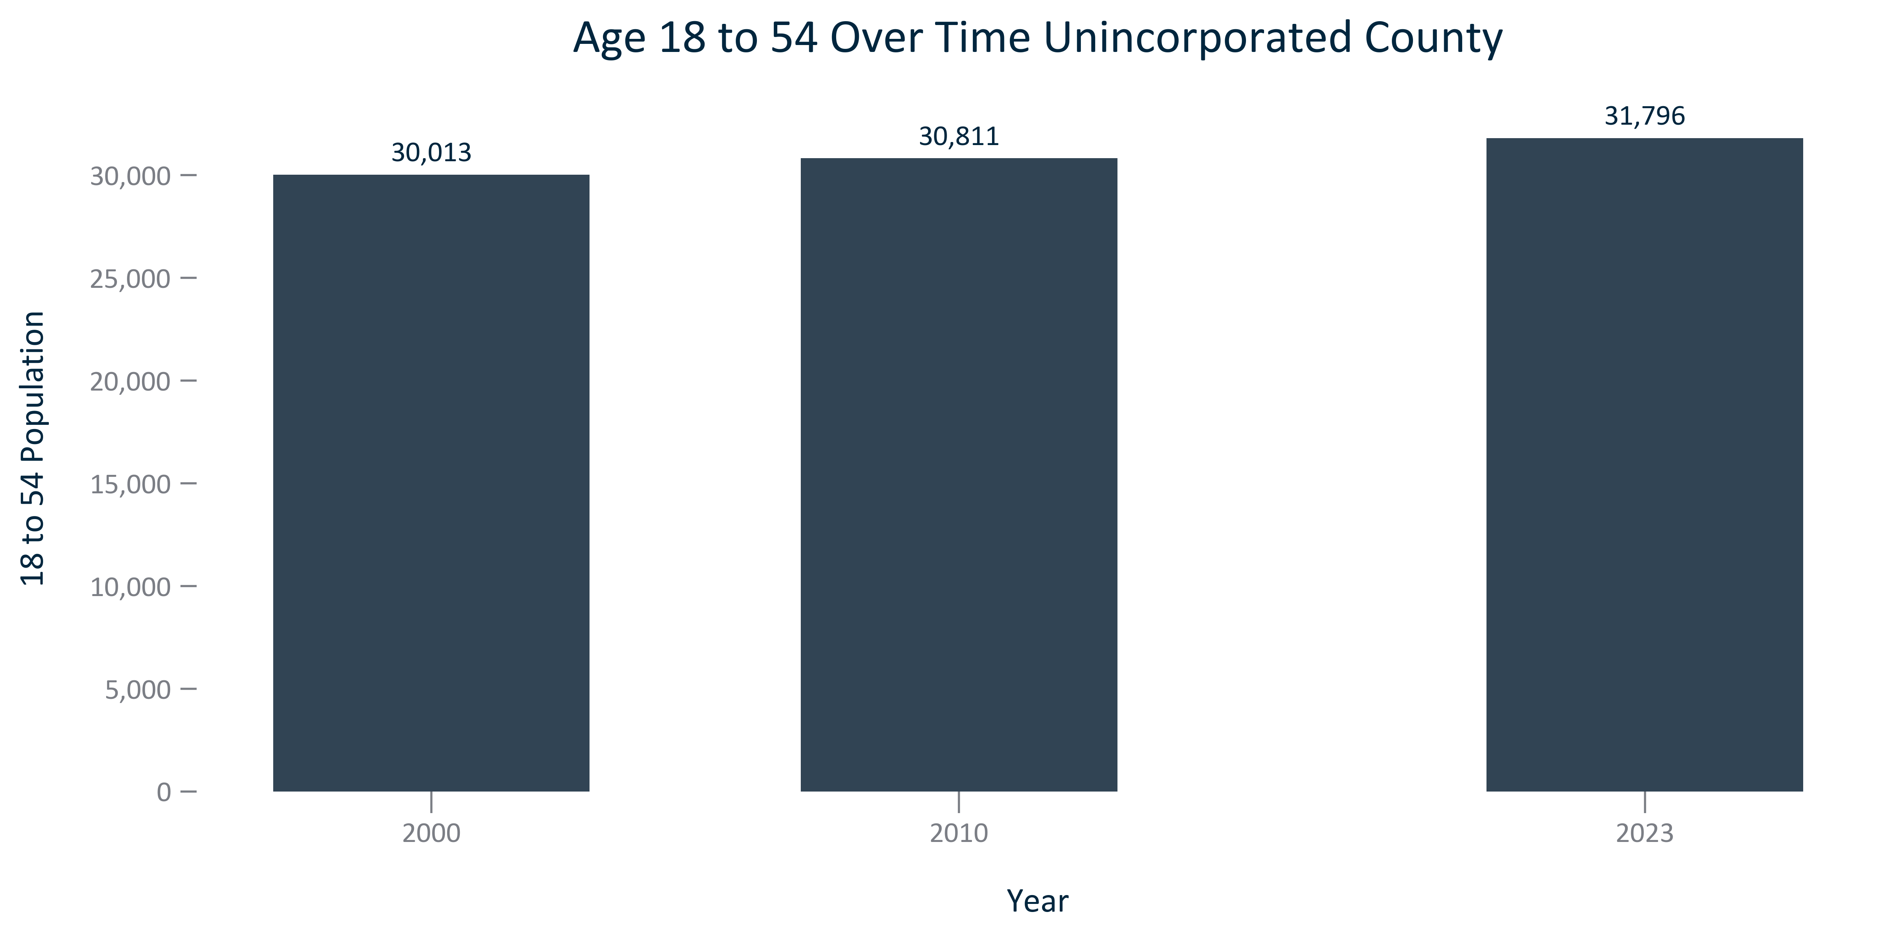

Citation: 2000 and 2010 Decennial Census, 2019 - 2023 American Community Survey 5-Year Estimates

### AGE_bar_primarygeo_55older_overtime:

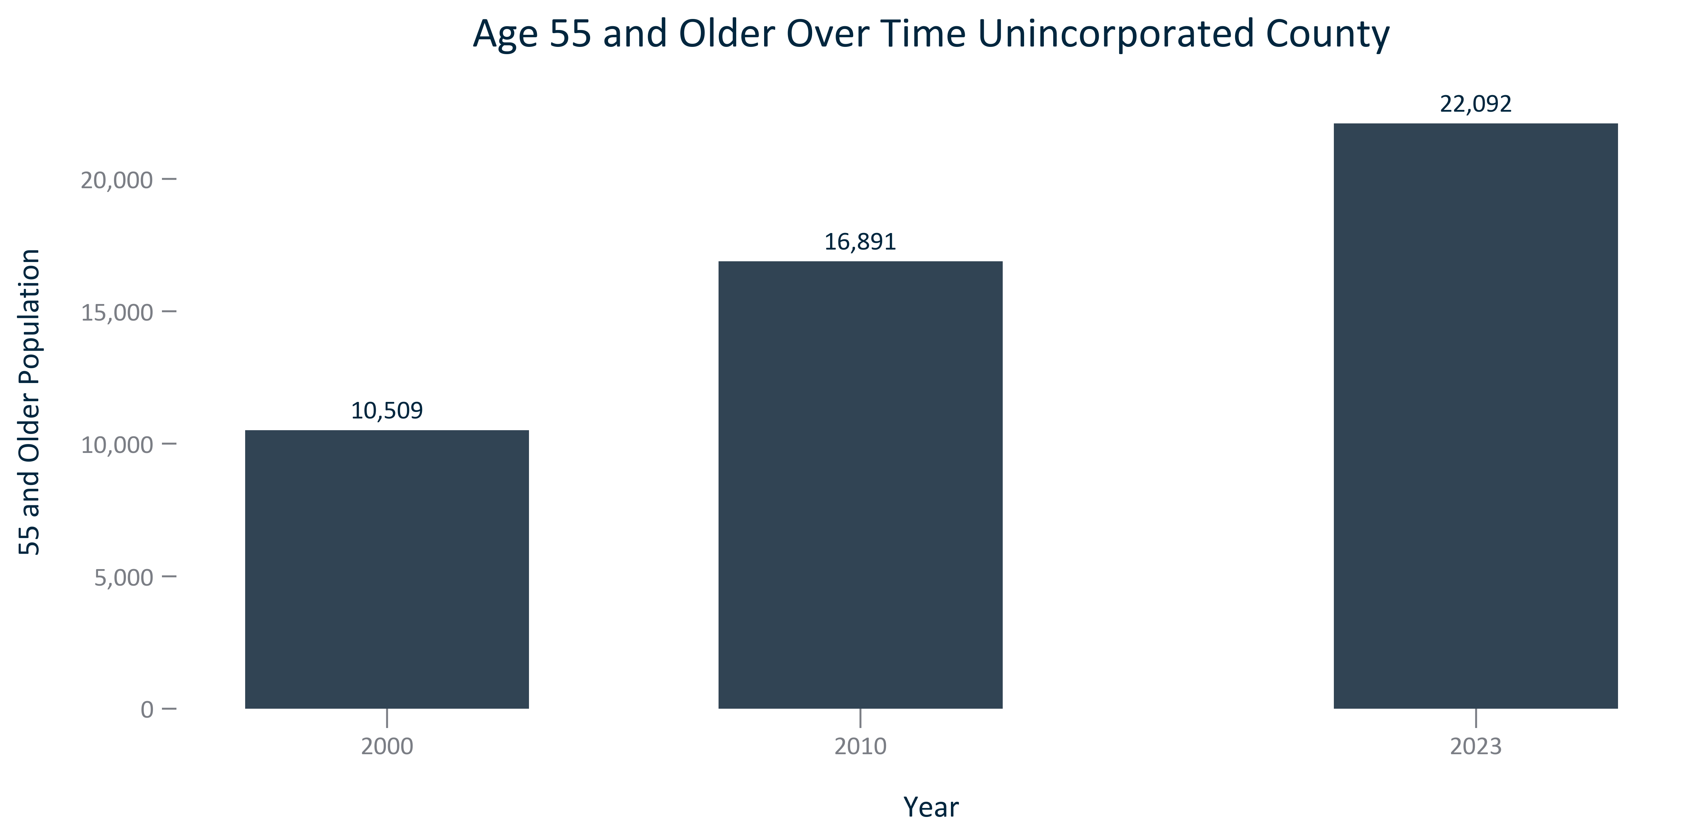

Citation: 2000 and 2010 Decennial Census, 2019 - 2023 American Community Survey 5-Year Estimates

### AGE_bar_primarygeo_65older_overtime:

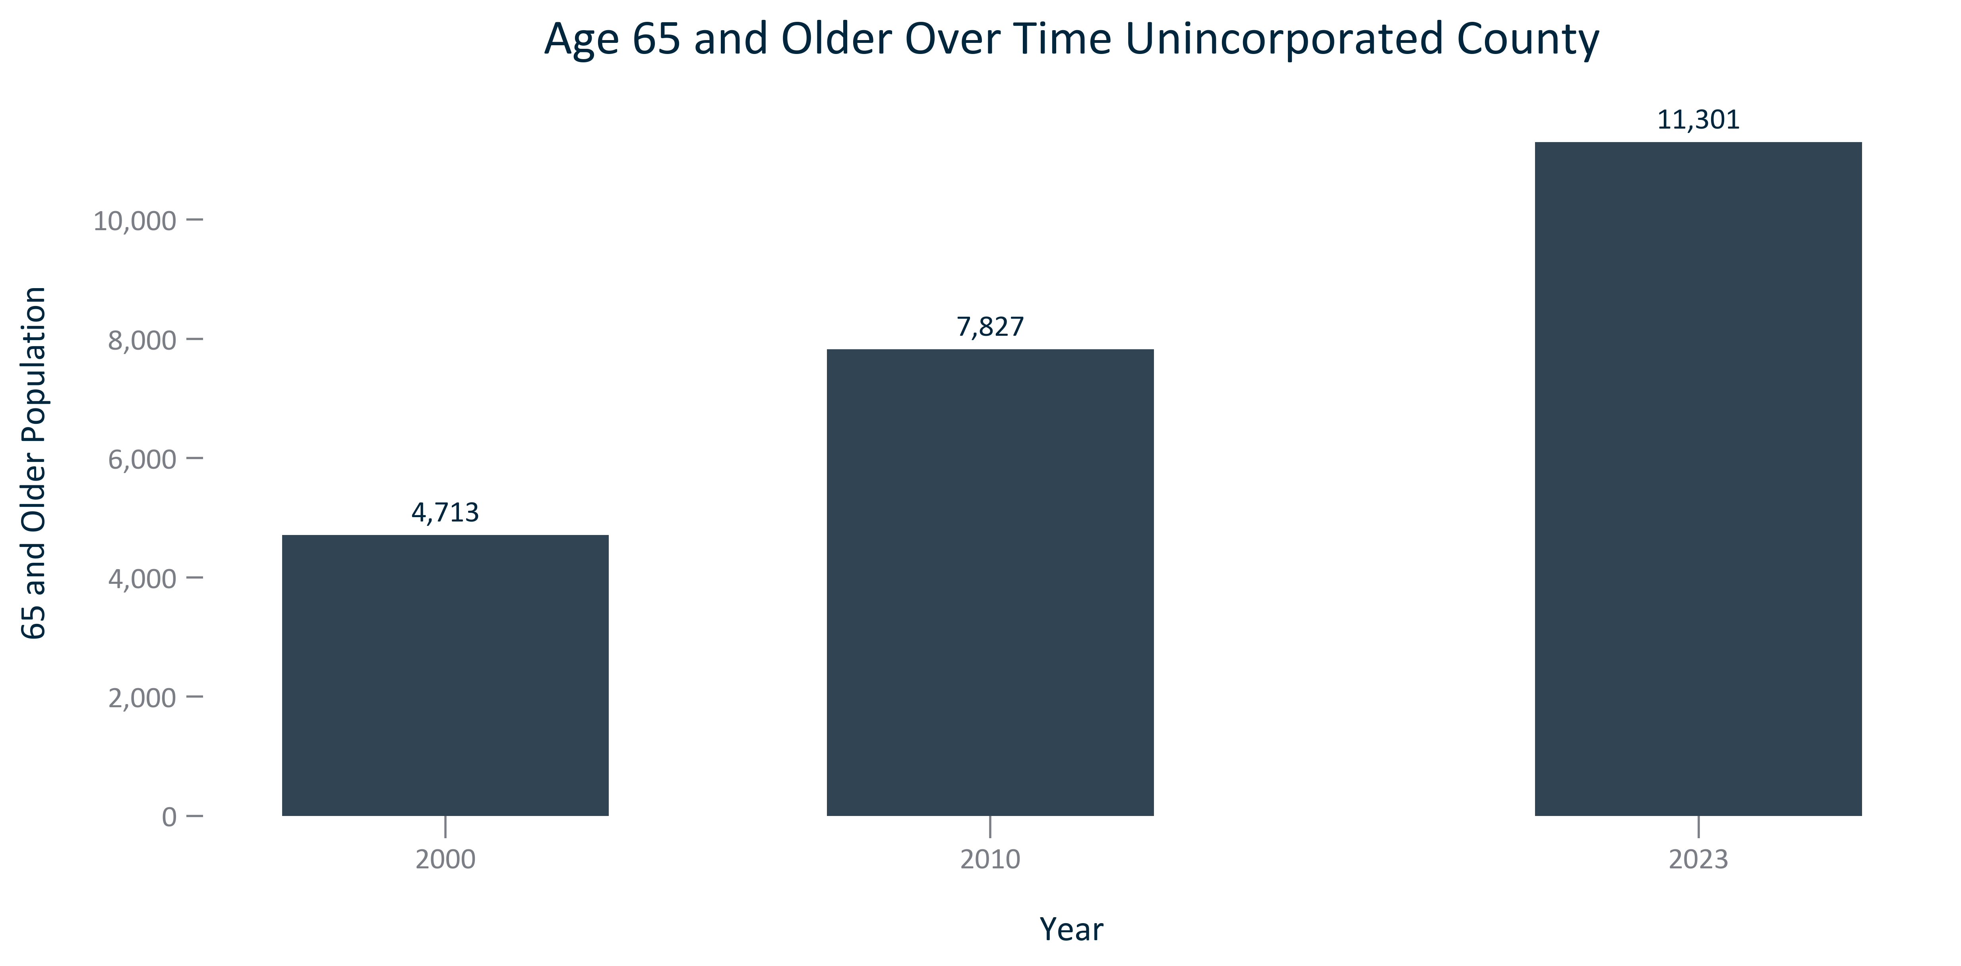

Citation: 2000 and 2010 Decennial Census, 2019 - 2023 American Community Survey 5-Year Estimates

### AGE_table_primarygeo_under18breakout_overtime:

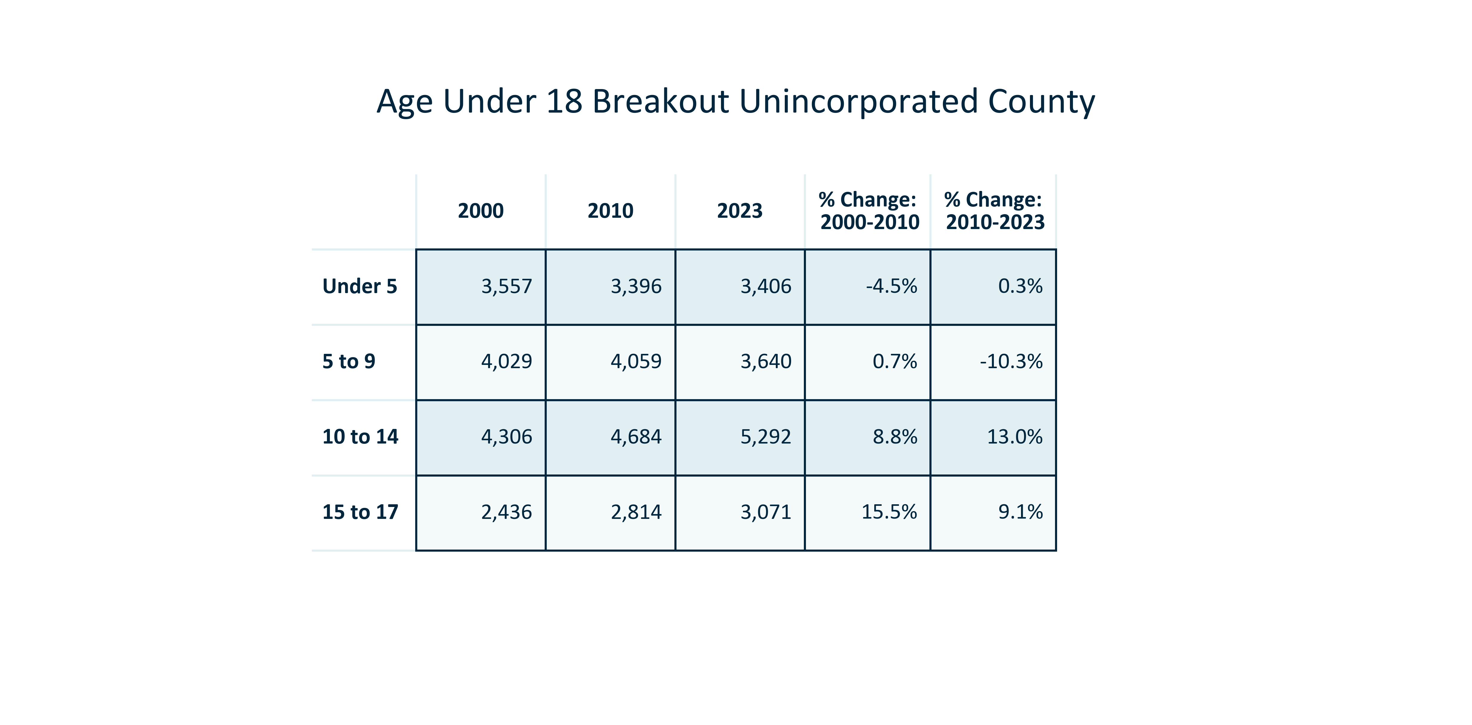

Citation: 2000 and 2010 Decennial Census, 2019 - 2023 American Community Survey 5-Year Estimates

### AGE_table_primarygeo_18to54breakout_overtime:

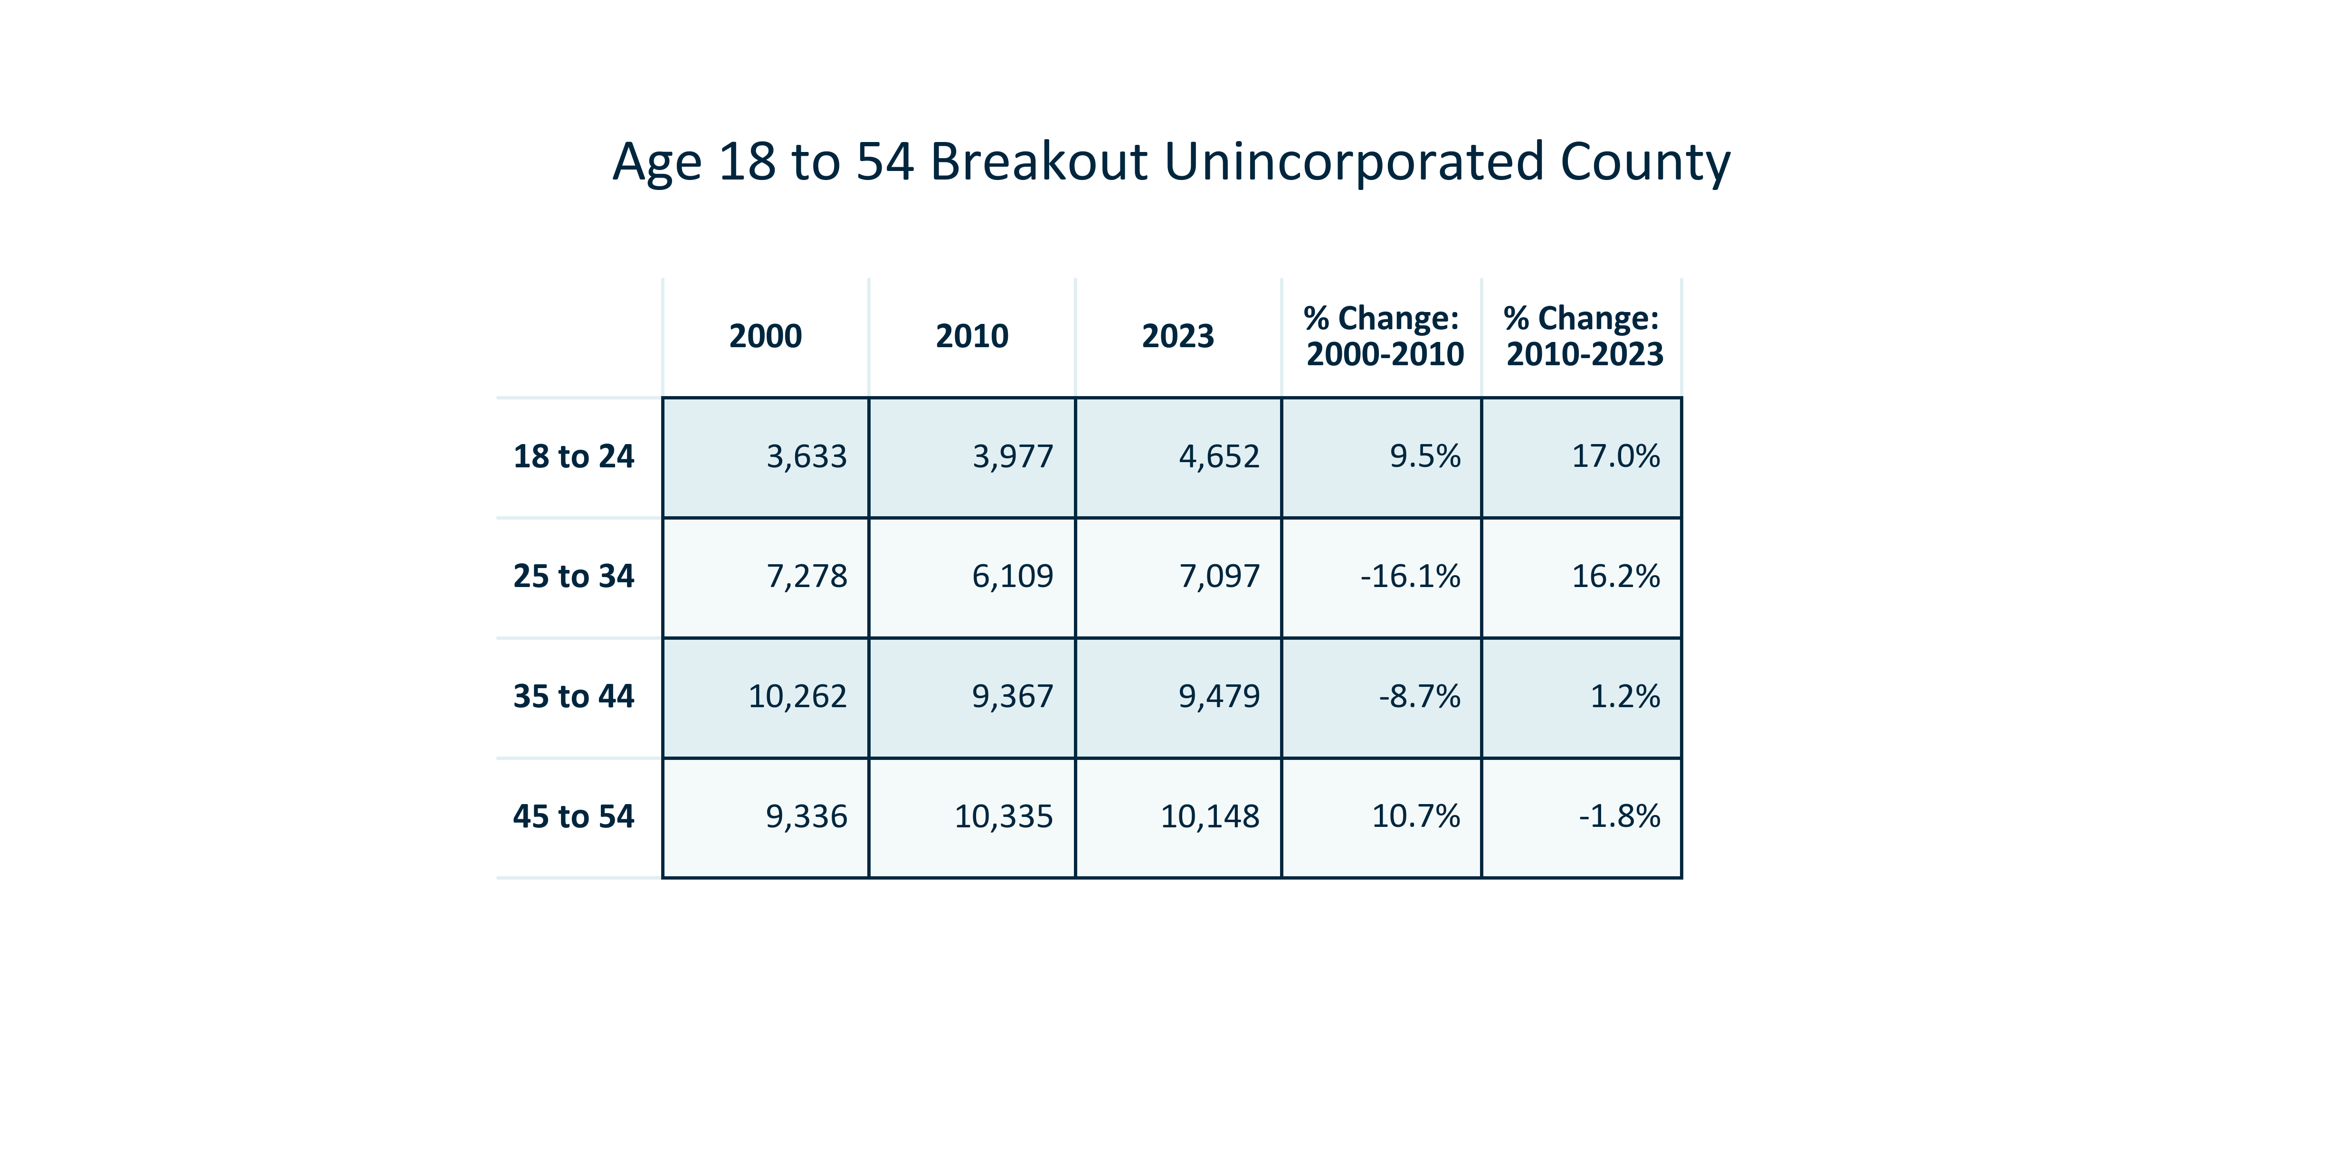

Citation: 2000 and 2010 Decennial Census, 2019 - 2023 American Community Survey 5-Year Estimates

### AGE_table_primarygeo_55olderbreakout_overtime:

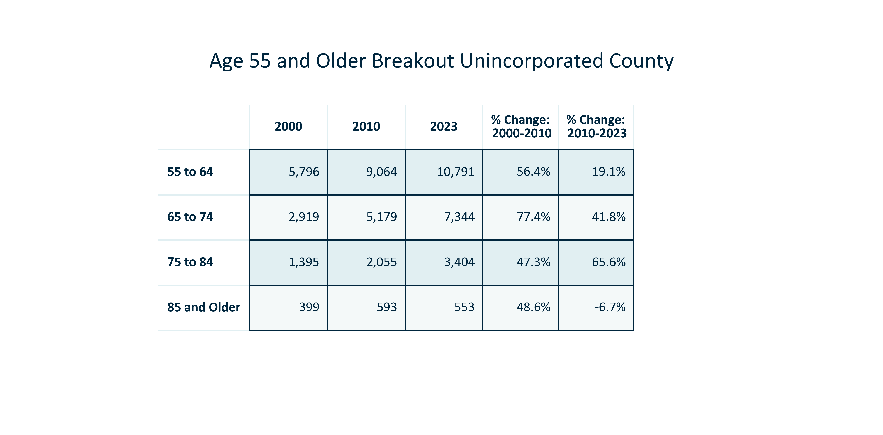

Citation: 2000 and 2010 Decennial Census, 2019 - 2023 American Community Survey 5-Year Estimates

### AGE_stackedbar_primarygeo_agegroups_overtime:

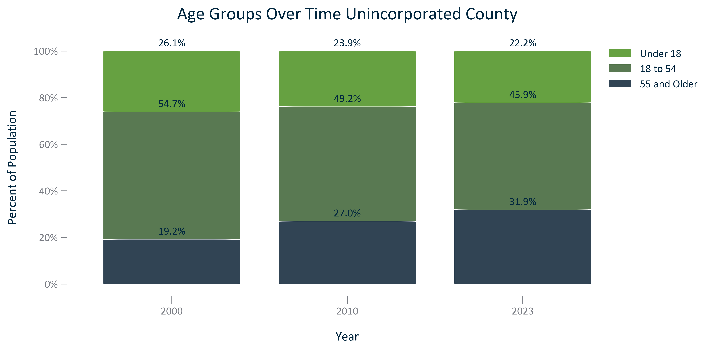

Citation: 2000 and 2010 Decennial Census, 2019 - 2023 American Community Survey 5-Year Estimates

### AGE_clusterbar_primarygeo_changeingroups_overtime:

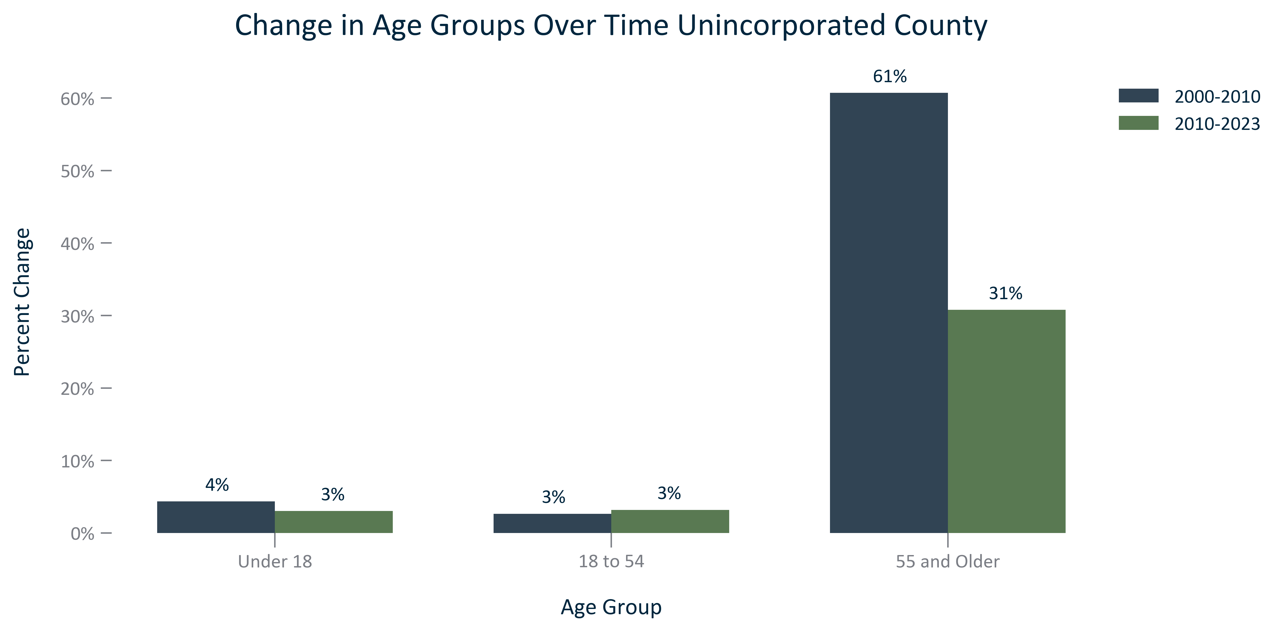

Citation: 2000 and 2010 Decennial Census, 2019 - 2023 American Community Survey 5-Year Estimates

### AGE_table_geocomparative_agecomposition_2000:

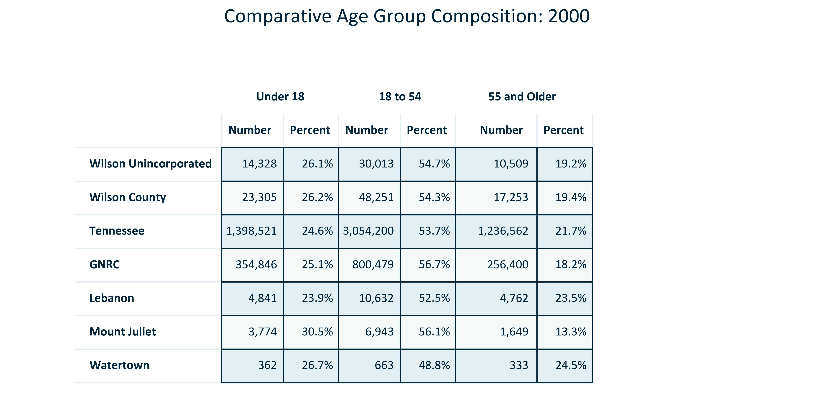

Citation: 2000 Decennial Census

### AGE_table_geocomparative_agecomposition_2010:

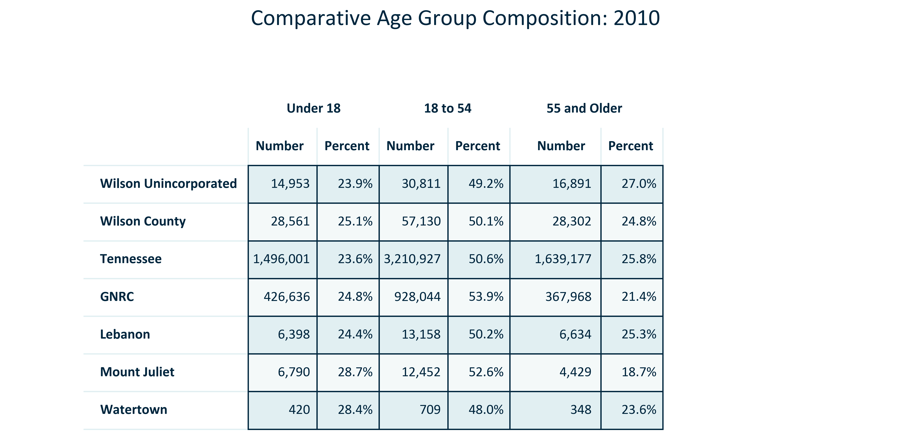

Citation: 2010 Decennial Census

### AGE_table_geocomparative_agecomposition_2023:

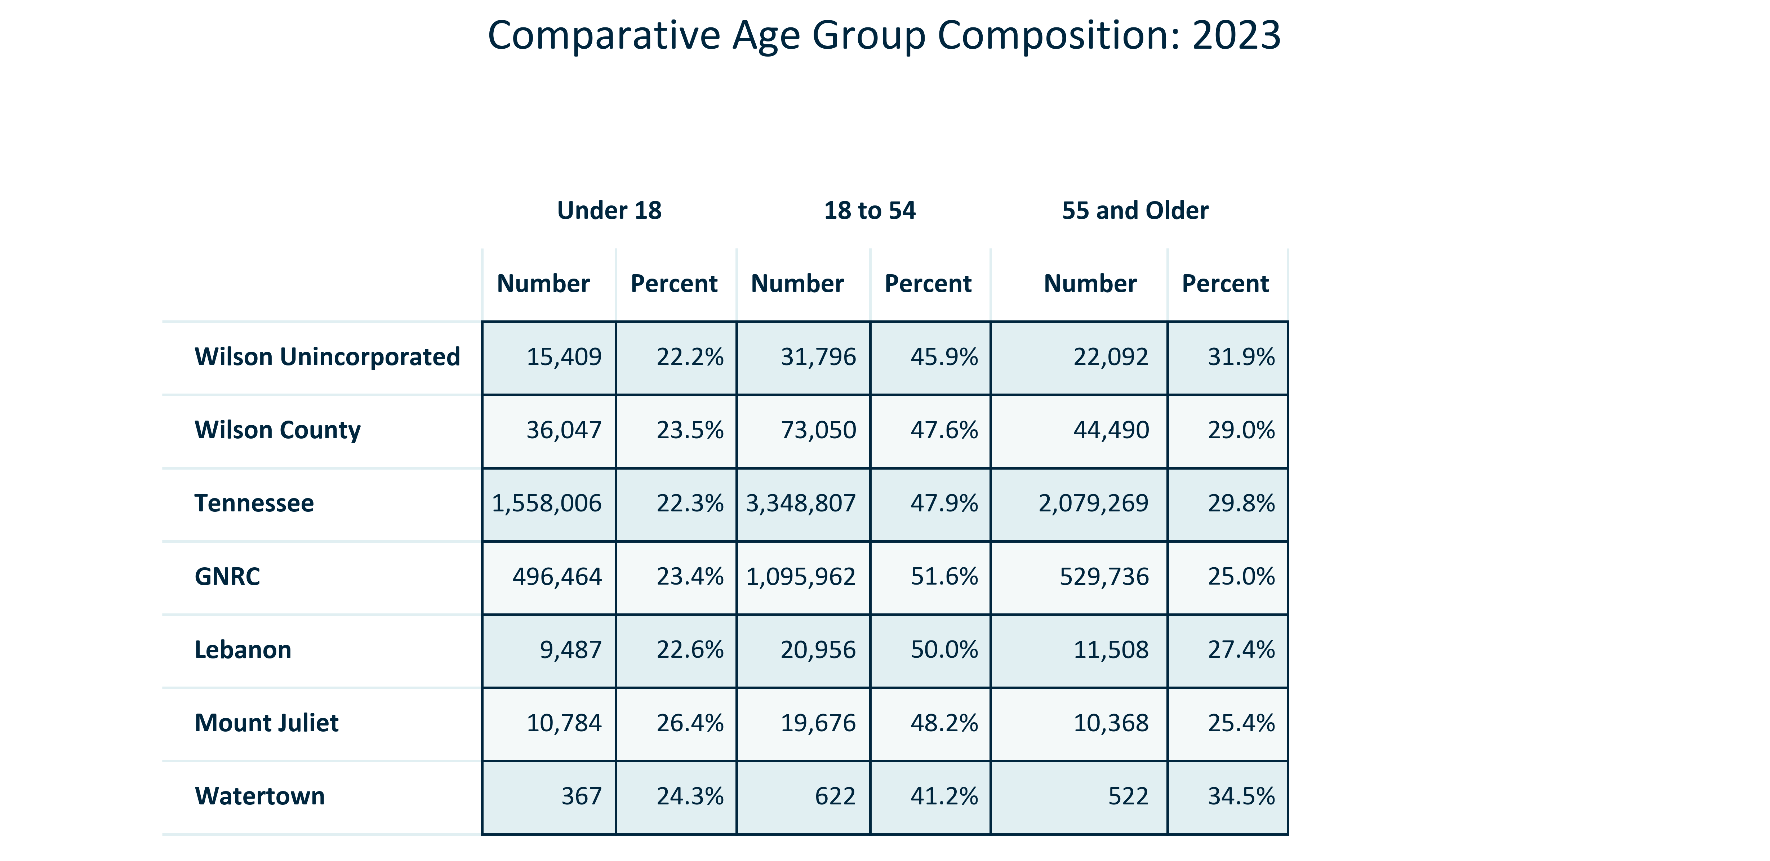

Citation: 2019 - 2023 American Community Survey 5-Year Estimates

### AGE_table_geocomparative_changeinagegroups_00to10:

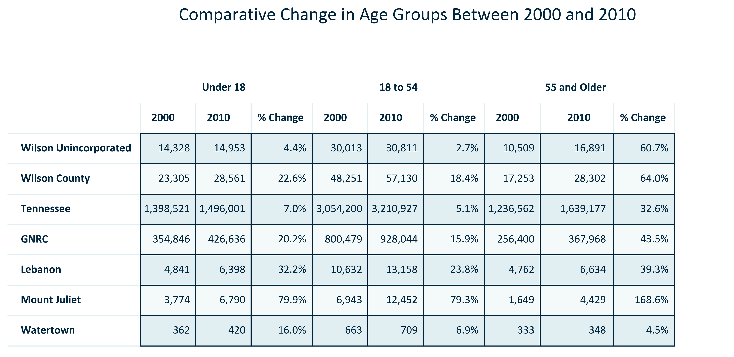

Citation: 2000 and 2010 Decennial Census

### AGE_table_geocomparative_changeinagegroups_10to2023:

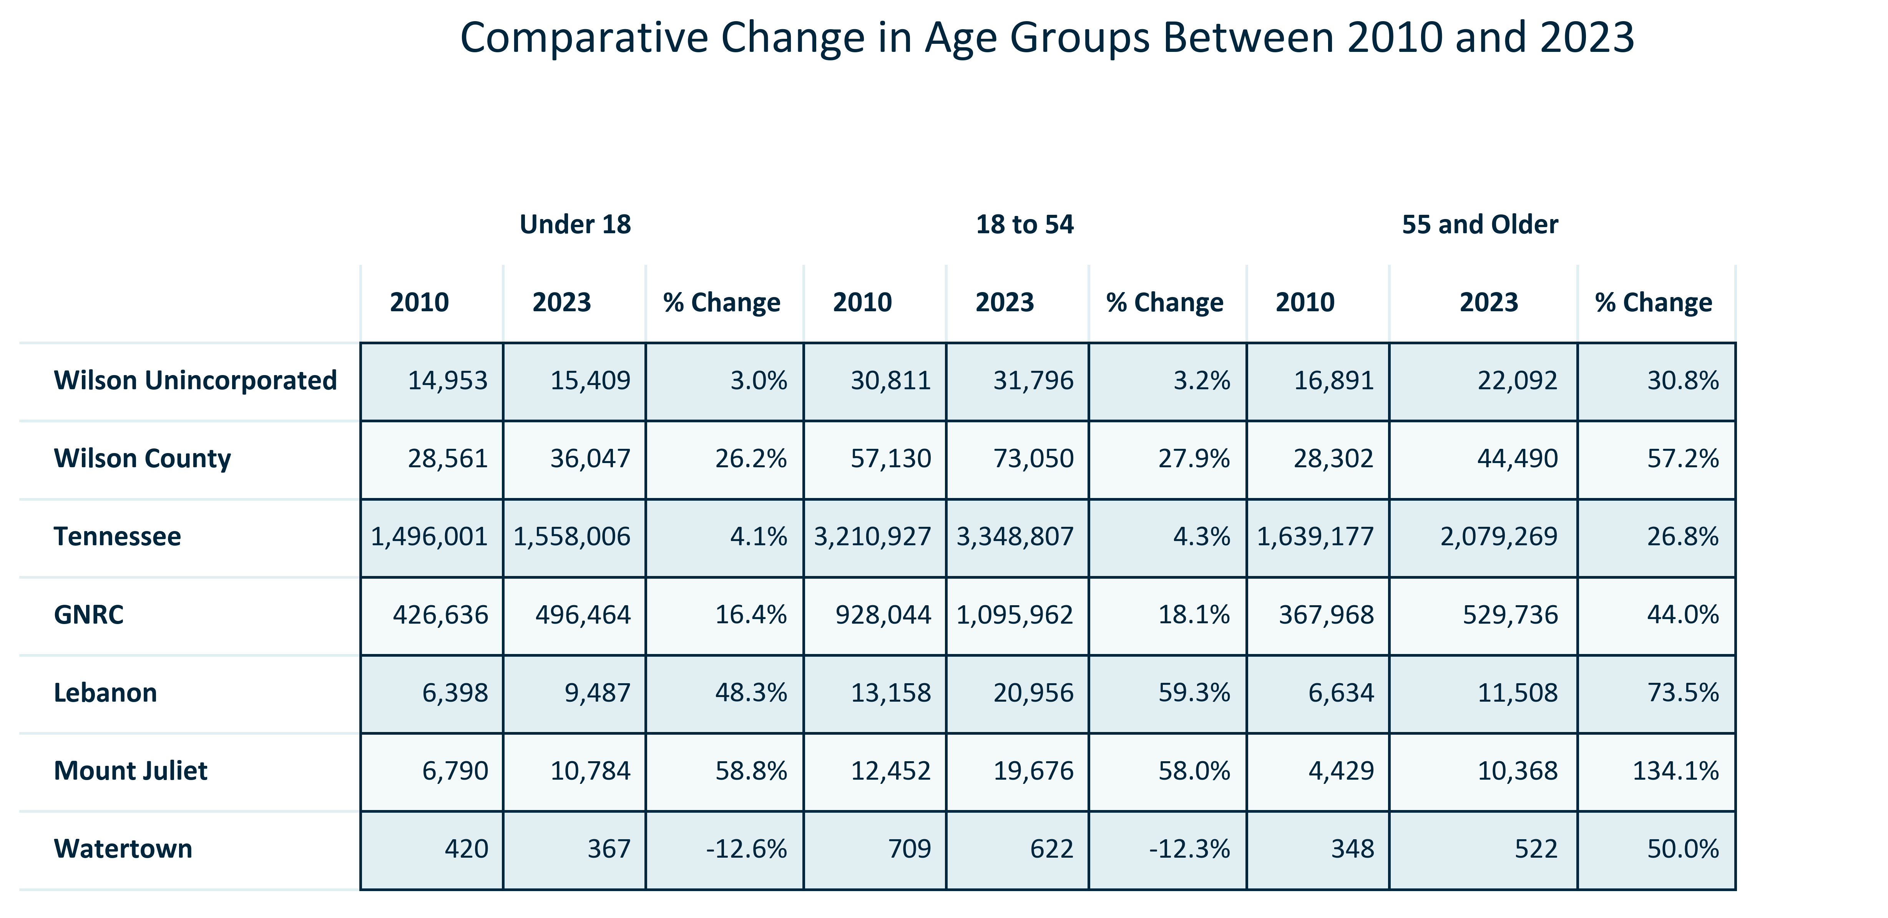

Citation: 2010 Decennial Census, 2019 - 2023 American Community Survey 5-Year Estimates

### AGE_table_geocomparative_changeinagegroups_00to2023:

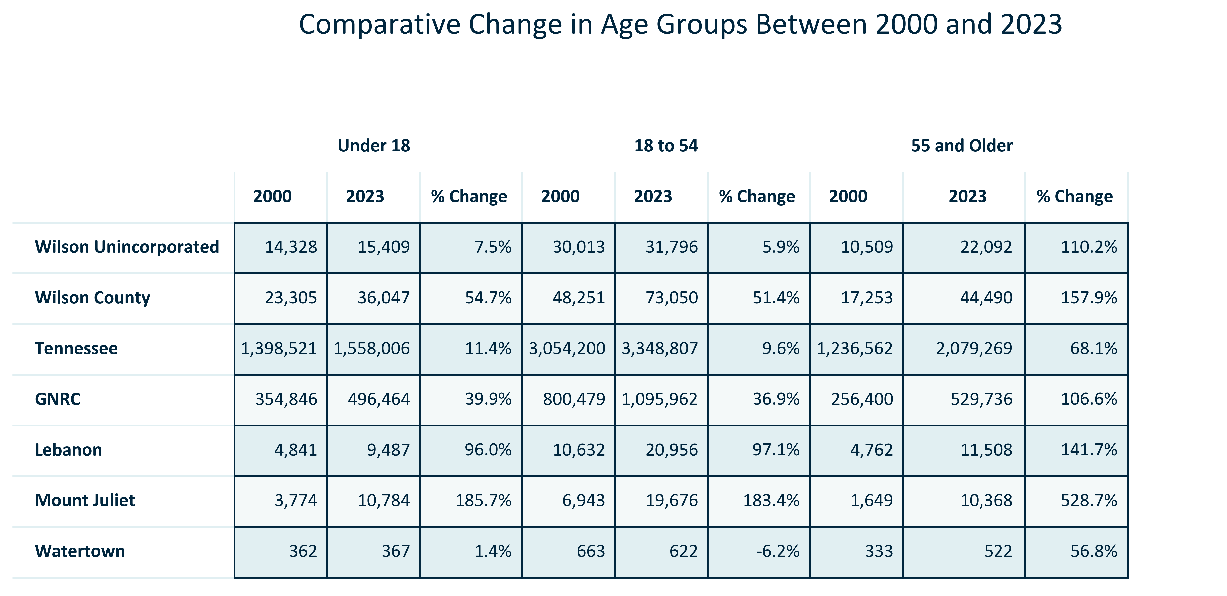

Citation: 2000 Decennial Census, 2019 - 2023 American Community Survey 5-Year Estimates

# Race and Ethnicity

### RACEETH_stackedbar_primarygeo_sharehispanicorlatino_overtime:

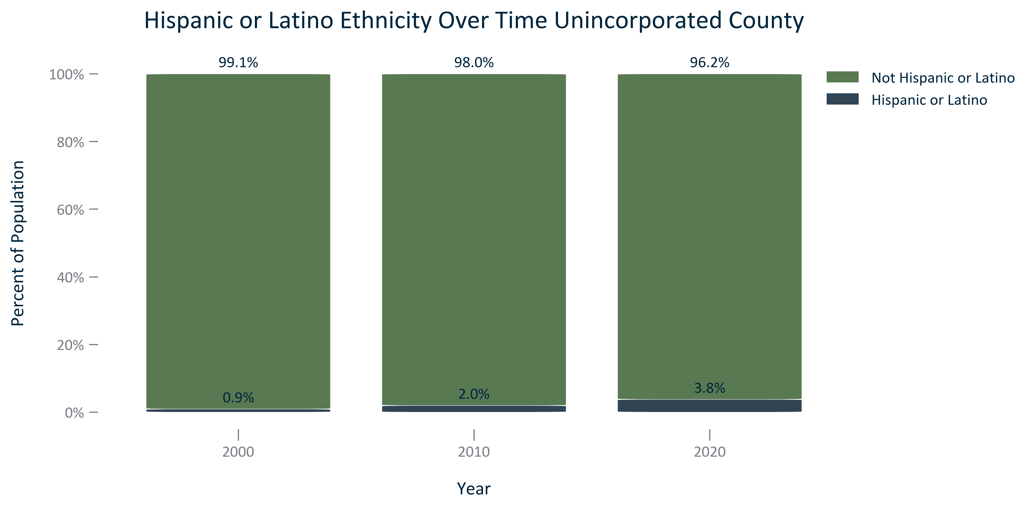

Citation: 2000, 2010, and 2020 Decennial Census

### RACEETH_table_primarygeo_hispaniclatinoethnicityandchange_overtime:

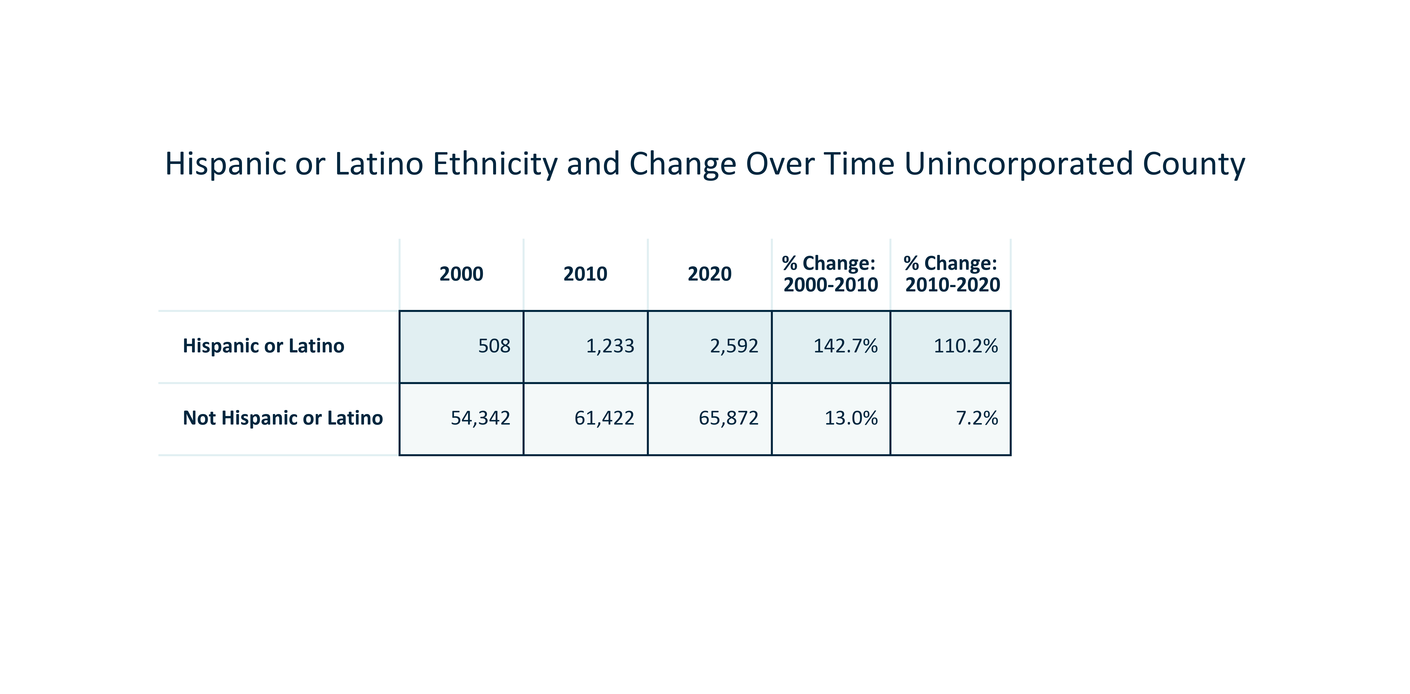

Citation: 2000, 2010, and 2020 Decennial Census

### RACEETH_stackedbar_primarygeo_minoritystatus_overtime:

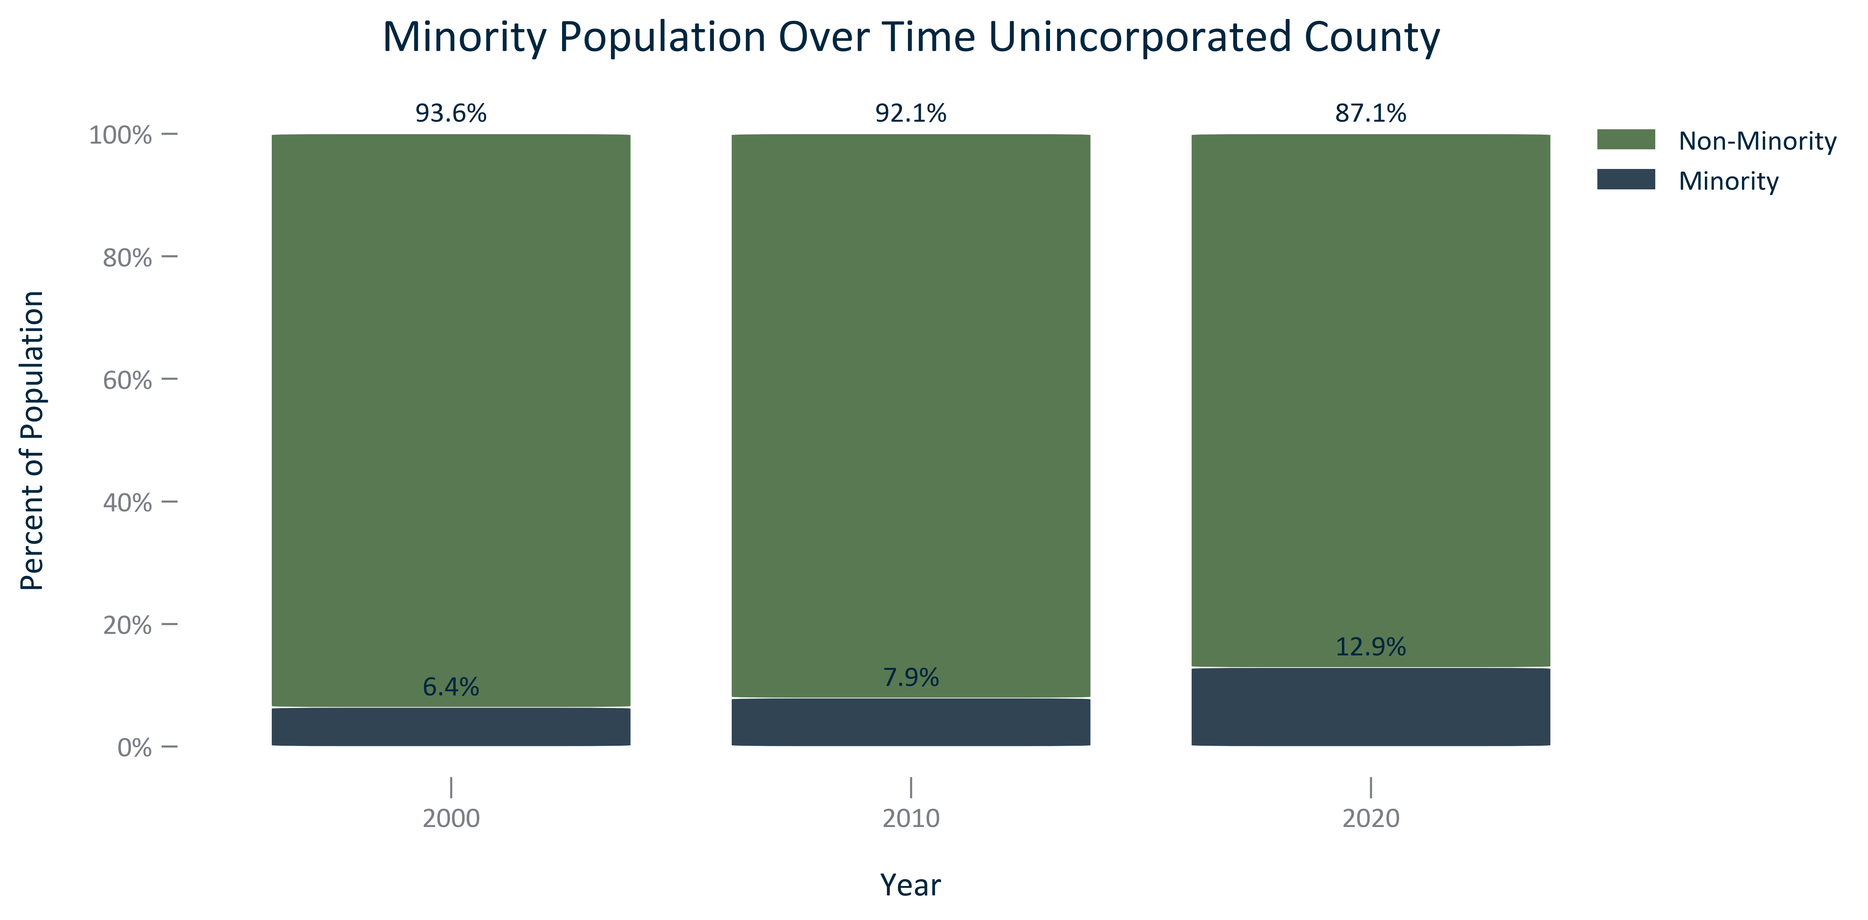

Citation: 2000, 2010, and 2020 Decennial Census

### RACEETH_table_primarygeo_minoritystatusandchange_overtime:

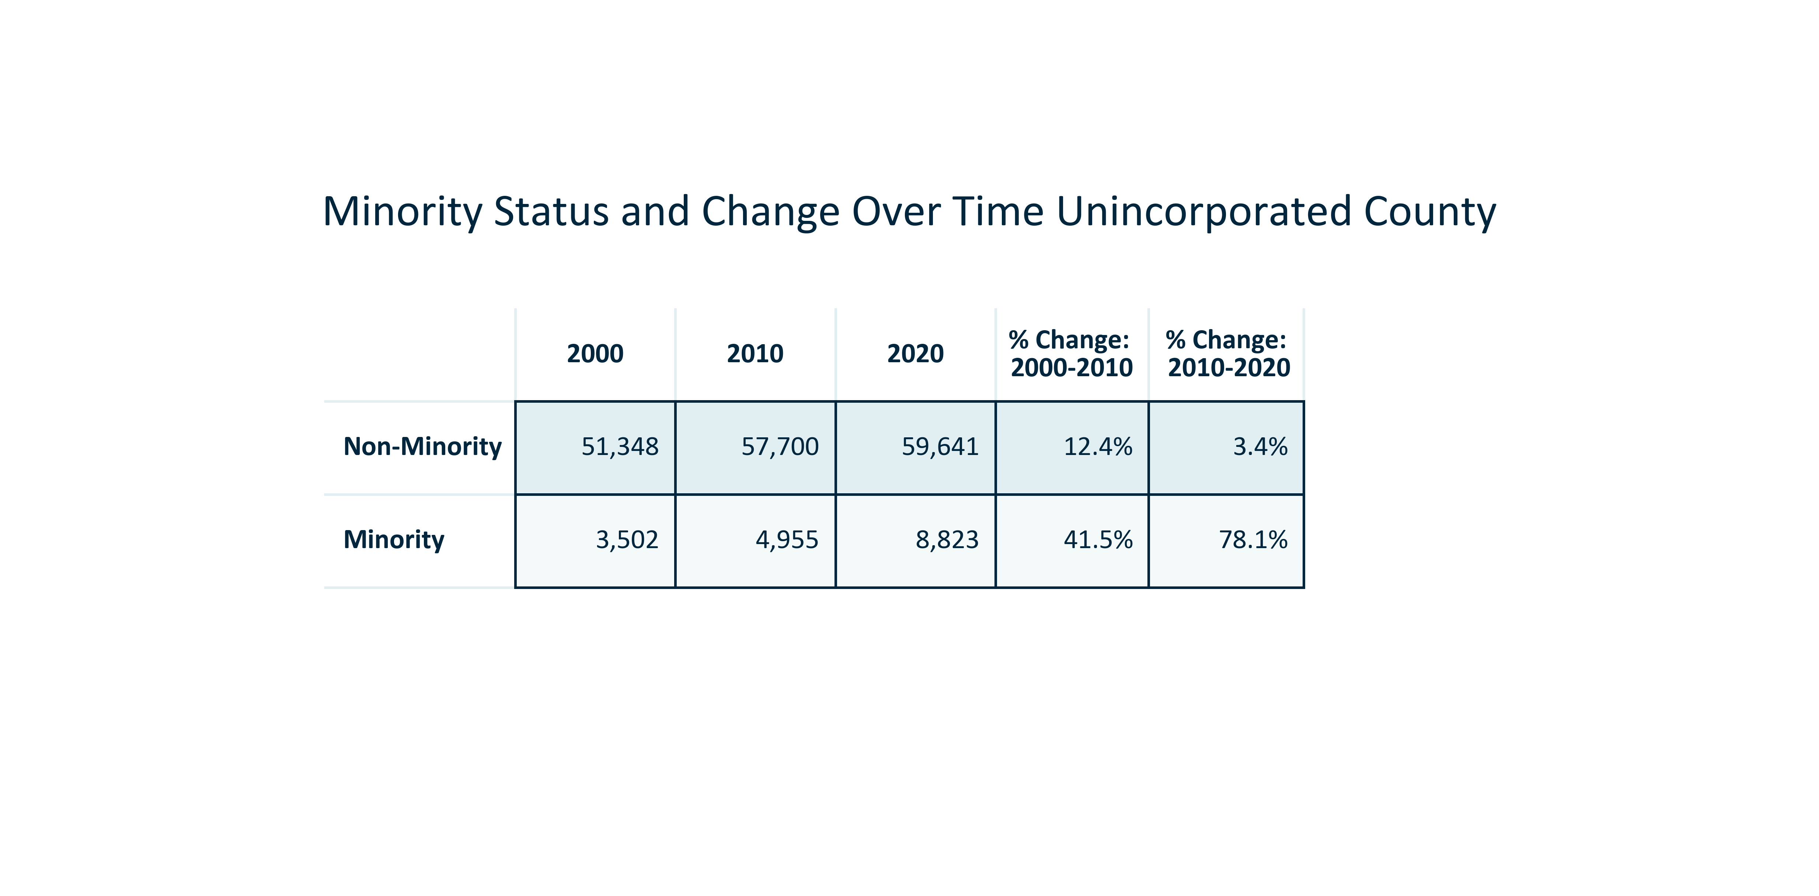

Citation: 2000, 2010, and 2020 Decennial Census

### RACEETH_clusterbar_geocomparative_percentchangetotalvsminority_overtime:

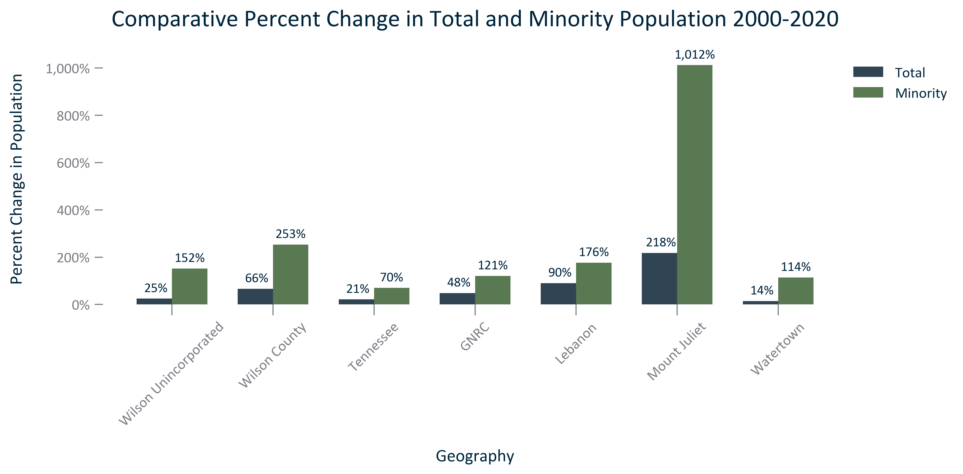

Citation: 2000 and 2020 Decennial Census

### RACEETH_table_geocomparative_allchangeminority_overtime:

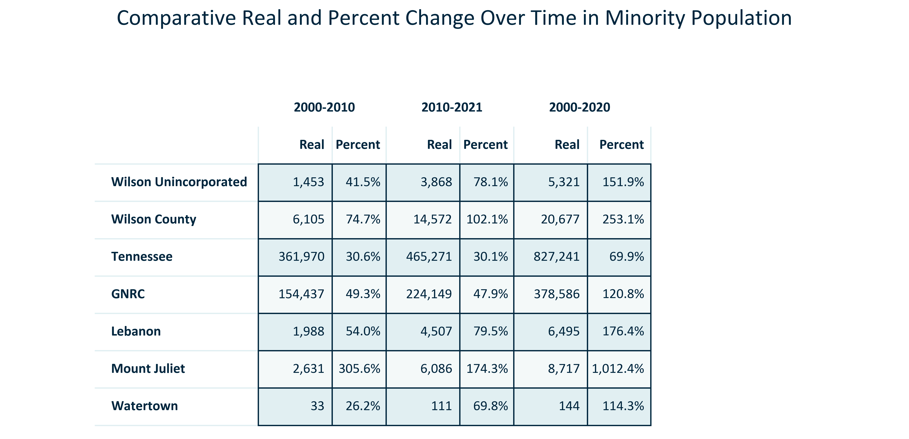

Citation: 2000, 2010, and 2020 Decennial Census

### RACEETH_bar_primarygeo_numberrace_2020:

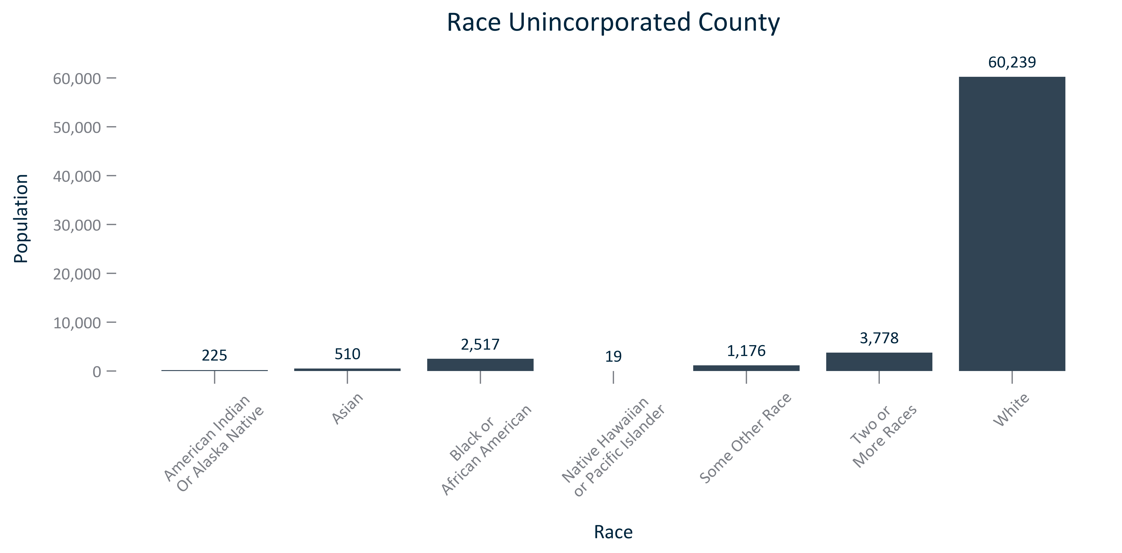

Citation: 2020 Decennial Census

### RACEETH_table_primarygeo_raceandchange_overtime:

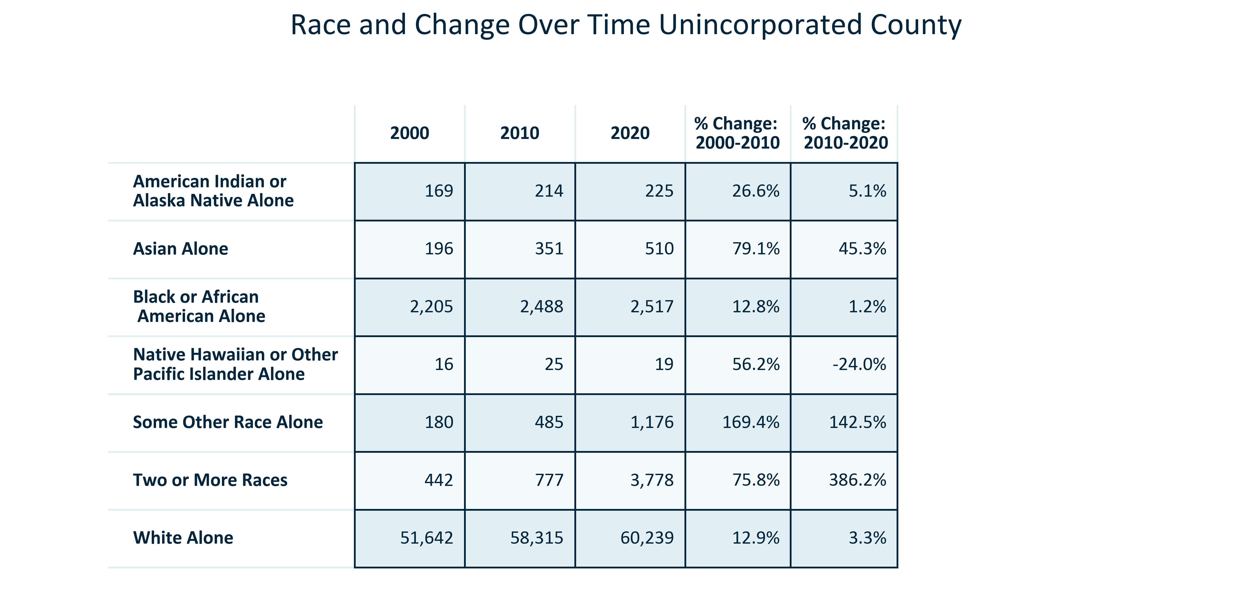

Citation: 2000, 2010, and 2020 Decennial Census

### RACEETH_clusterbar_primarygeo_changeinracialgroups_overtime:

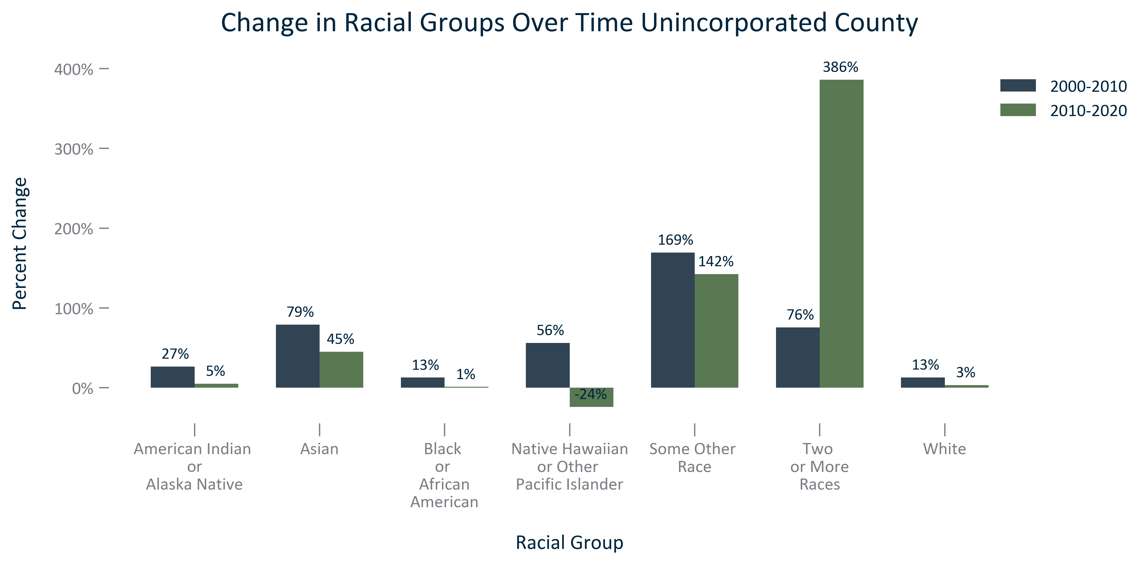

Citation: 2000, 2010, and 2020 Decennial Census

### RACEETH_stackedbar_primarygeo_sharenonwhite_overtime:

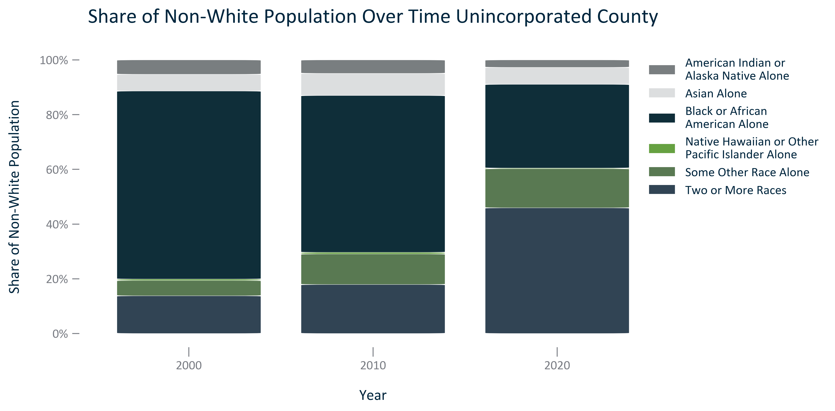

Citation: 2000, 2010, and 2020 Decennial Census

### RACEETH_table_primarygeo_nonwhite_overtime:

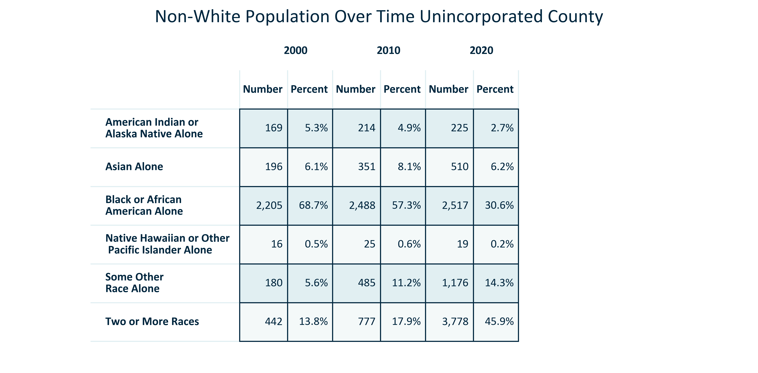

Citation: 2000, 2010, and 2020 Decennial Census

### RACEETH_table_geocomparative_percentracegroups_2000:

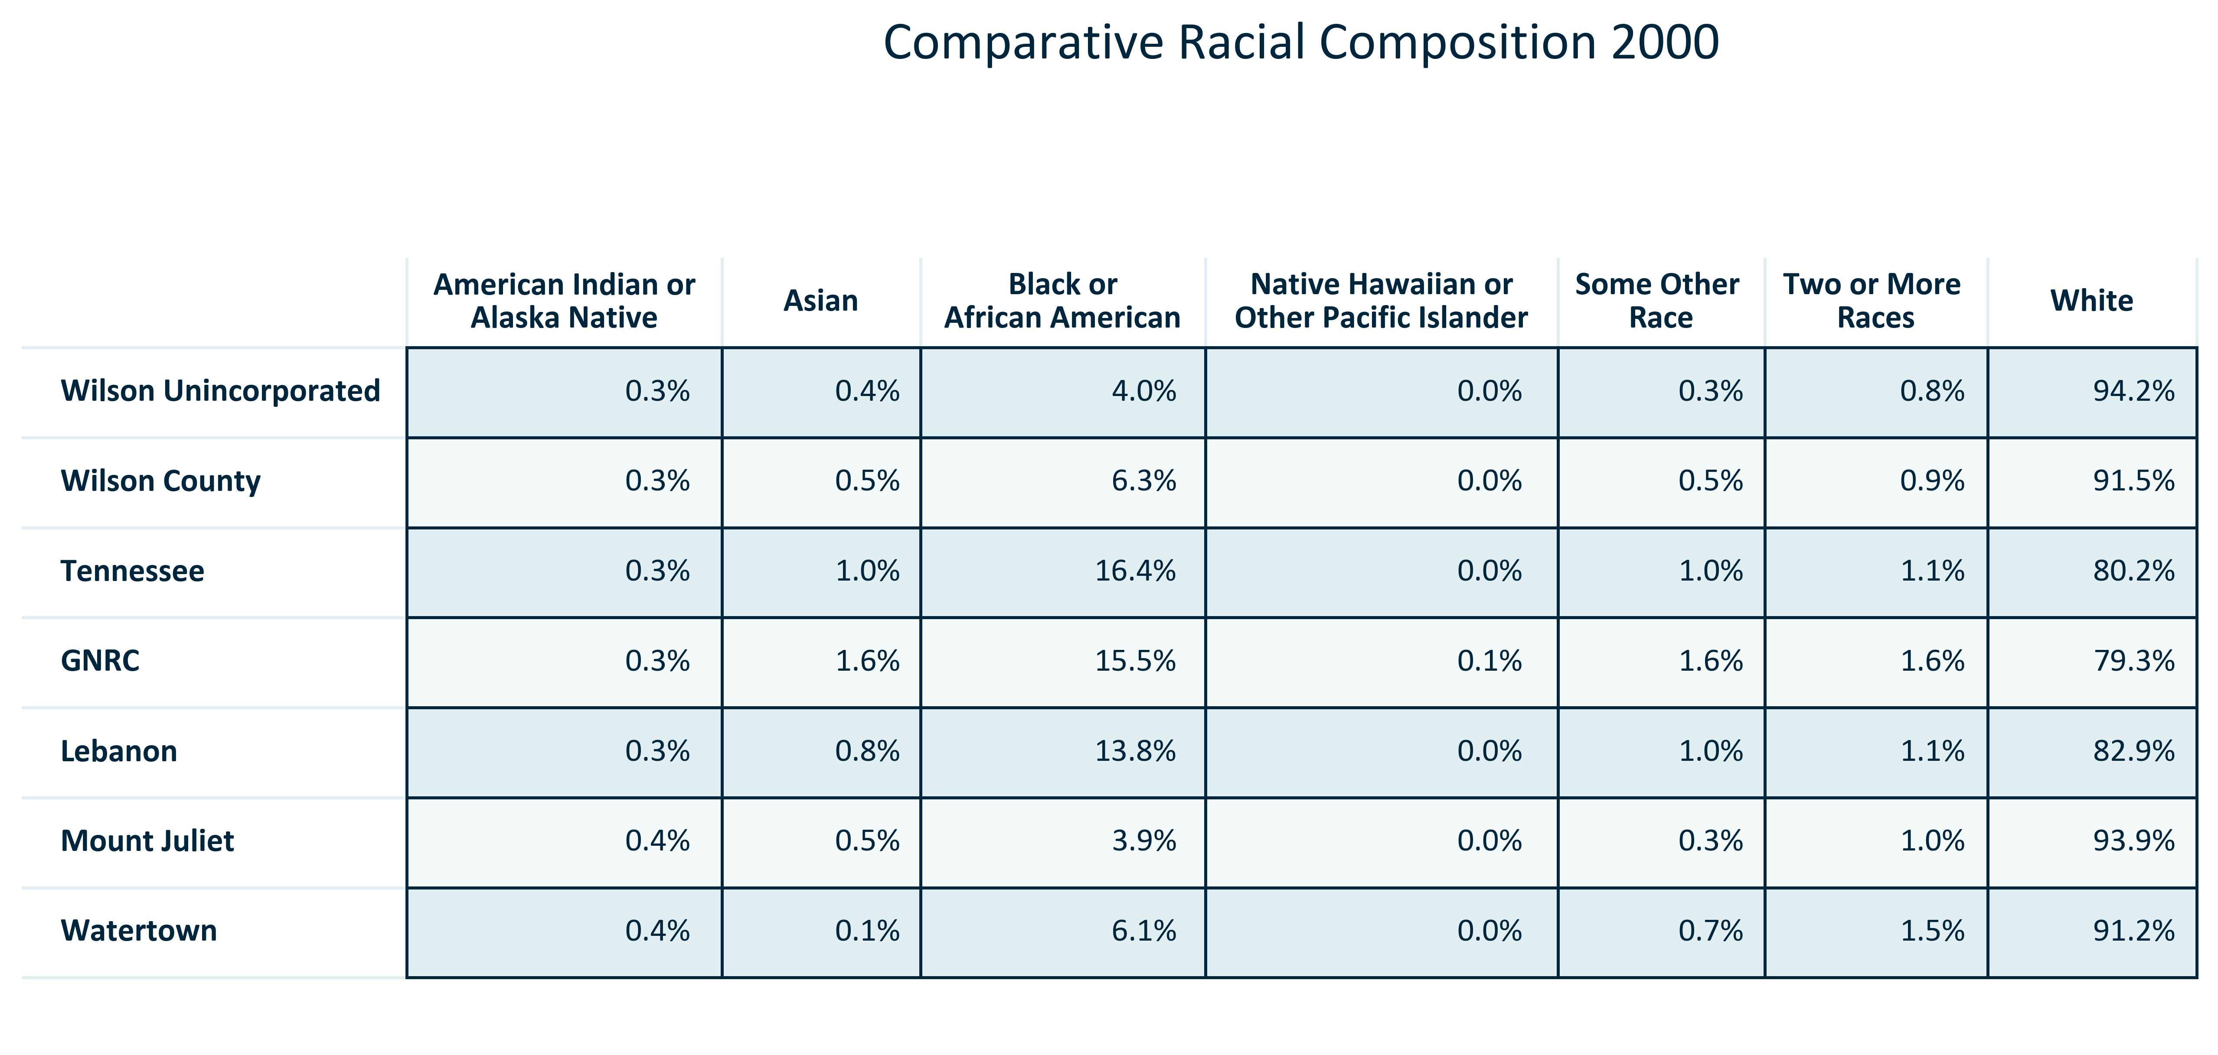

Citation: 2000 Decennial Census

### RACEETH_table_geocomparative_numberracegroups_2000:

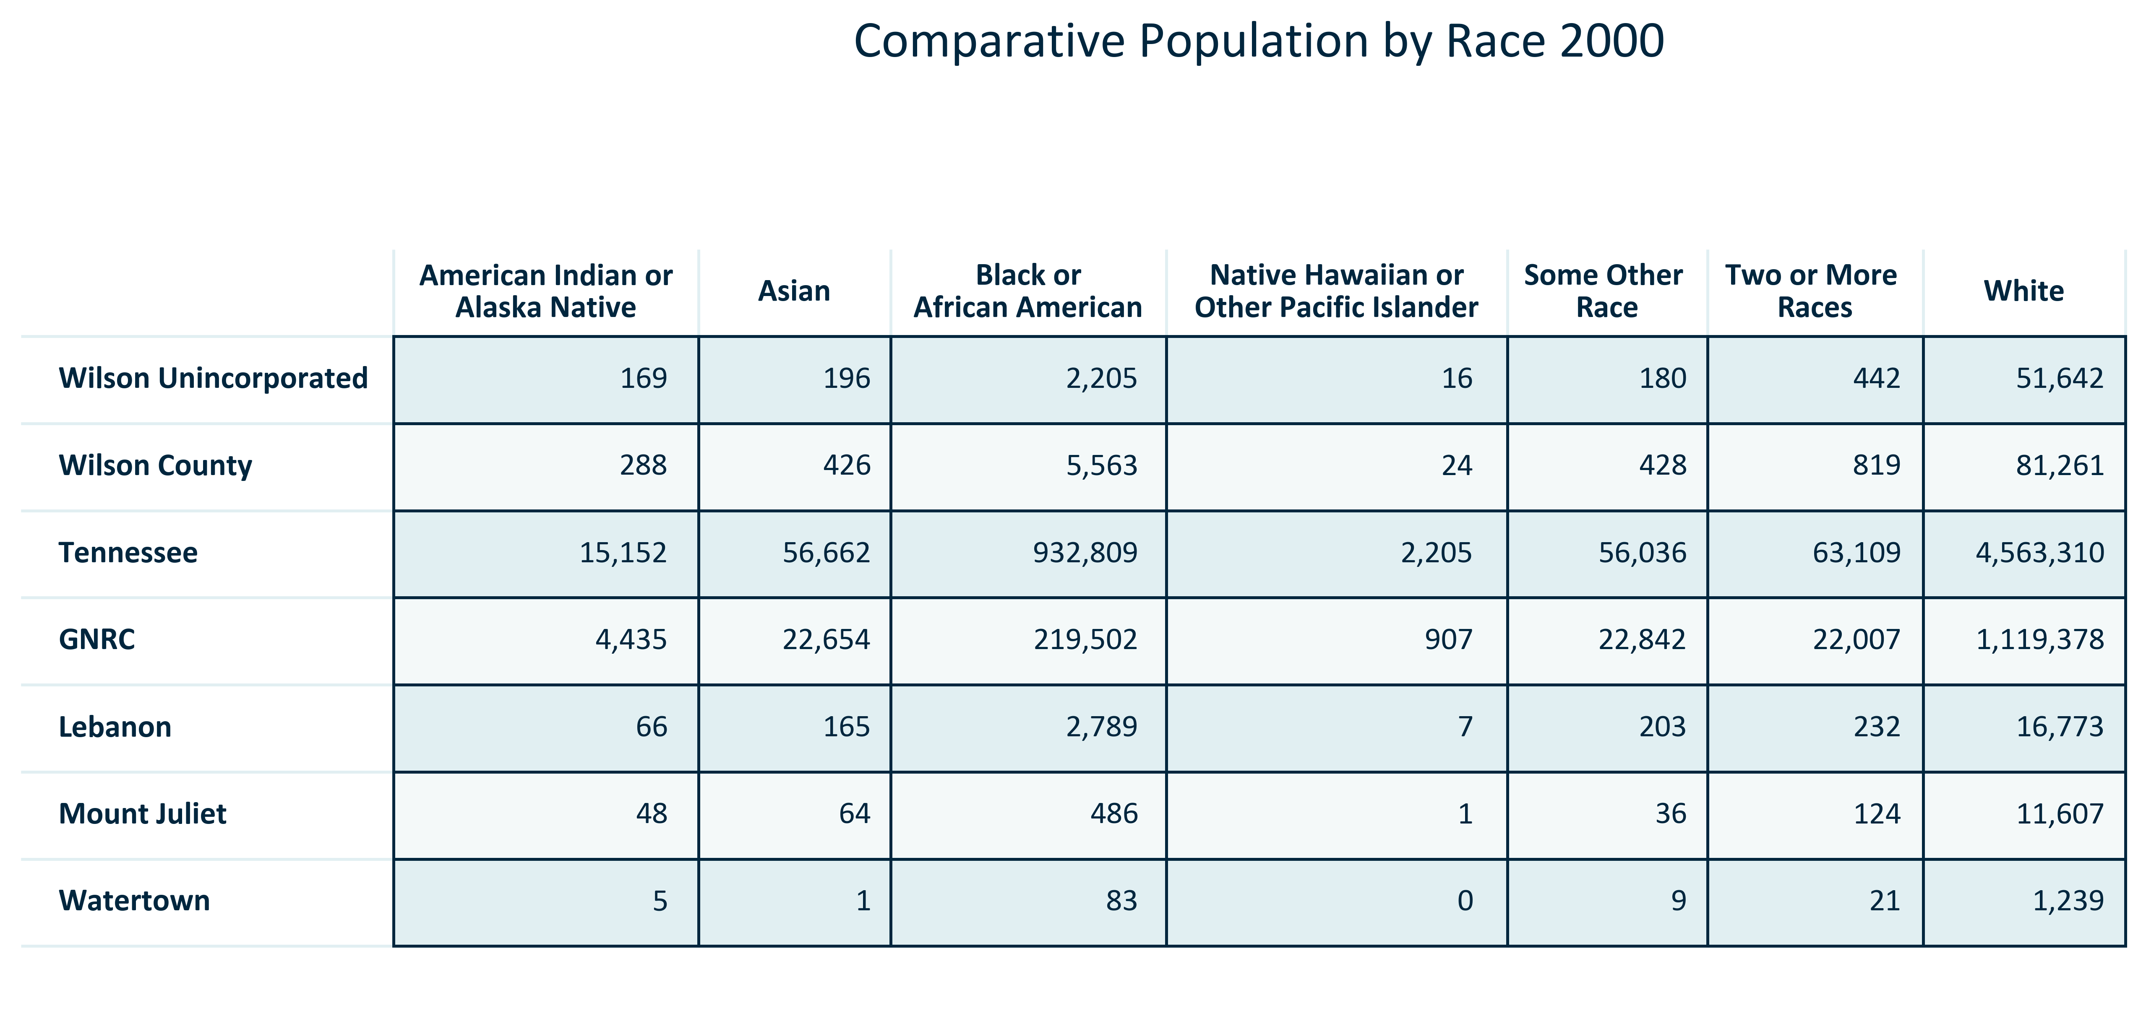

Citation: 2000 Decennial Census

### RACEETH_table_geocomparative_percentracegroups_2010:

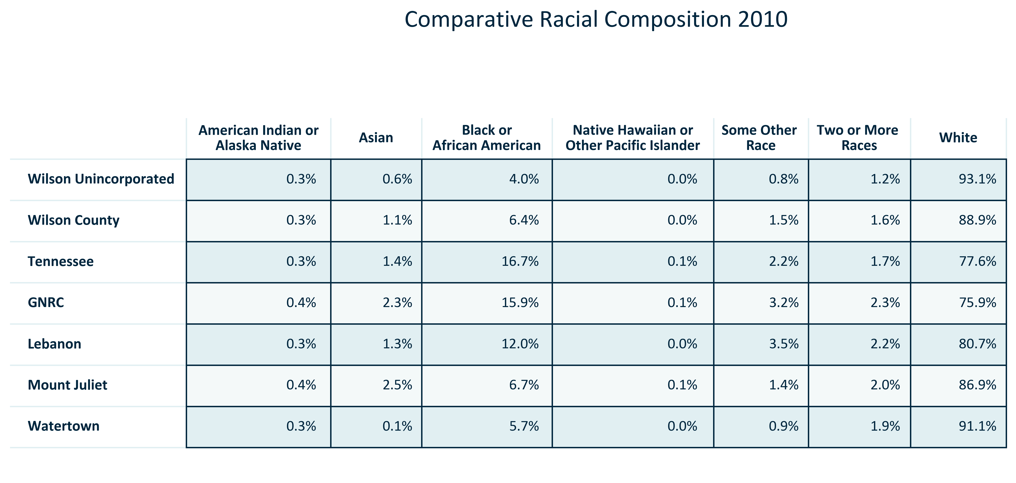

Citation: 2010 Decennial Census

### RACEETH_table_geocomparative_numberracegroups_2010:

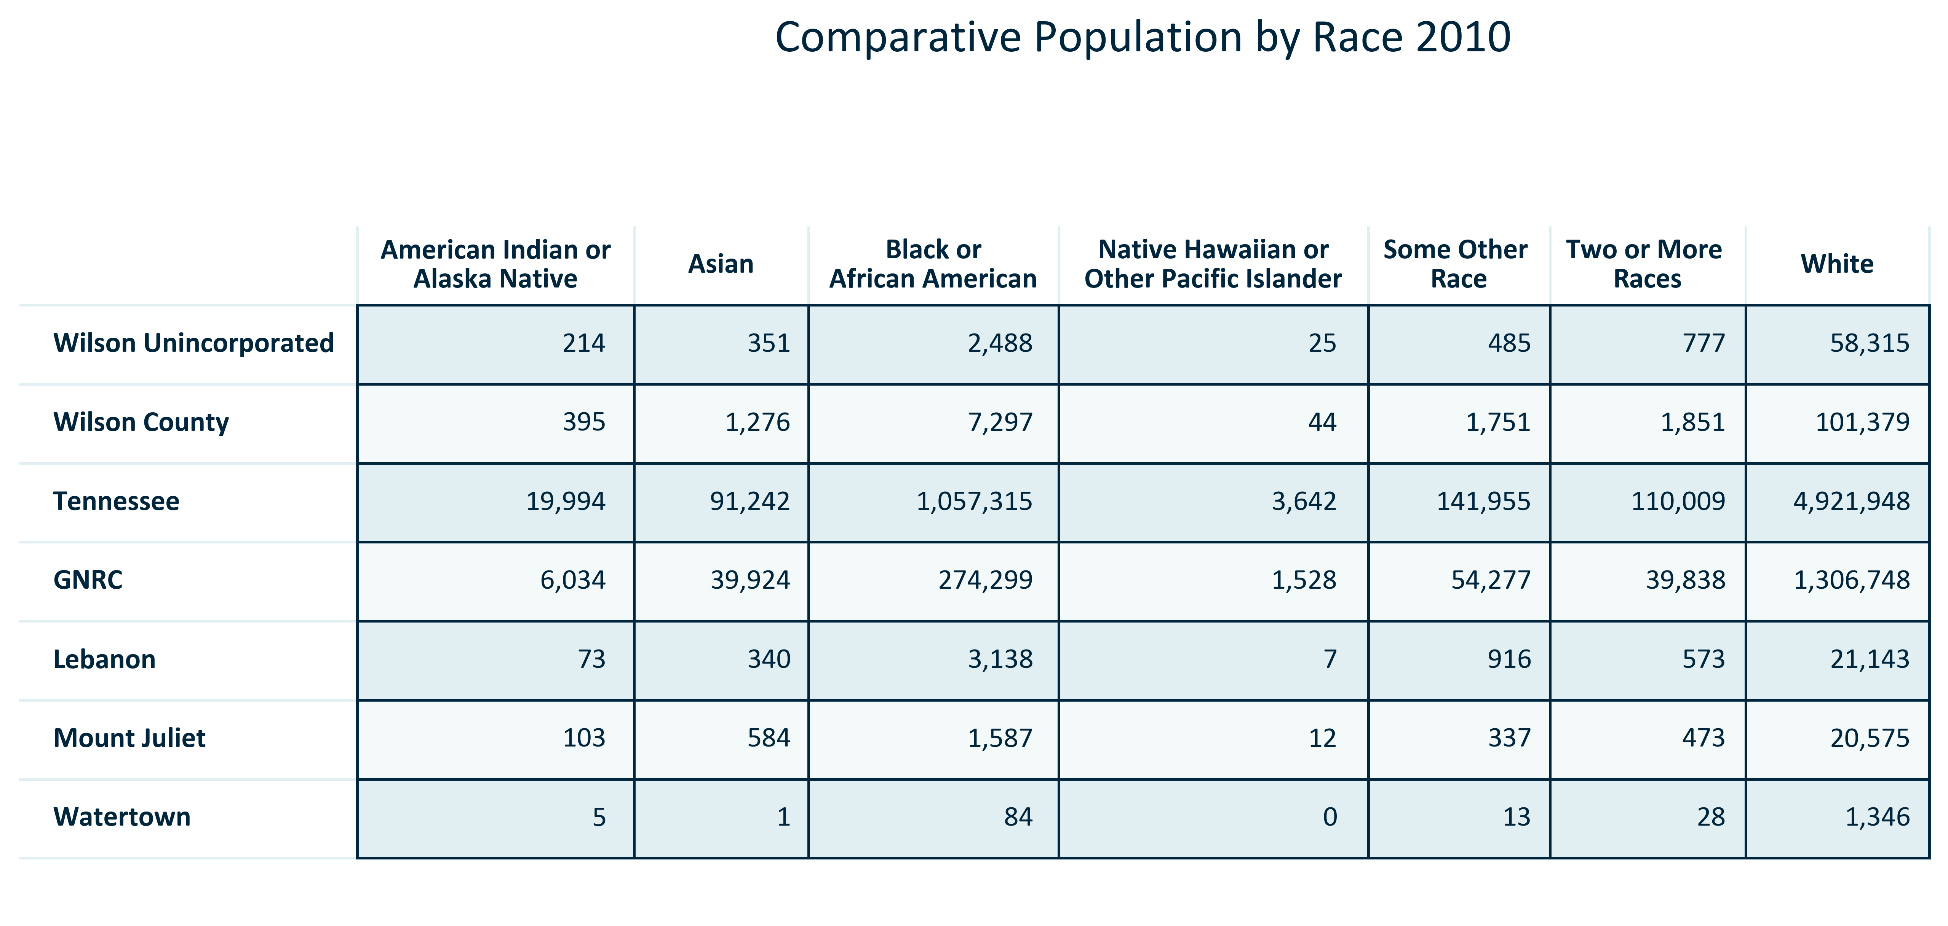

Citation: 2010 Decennial Census

### RACEETH_table_geocomparative_percentracegroups_2020:

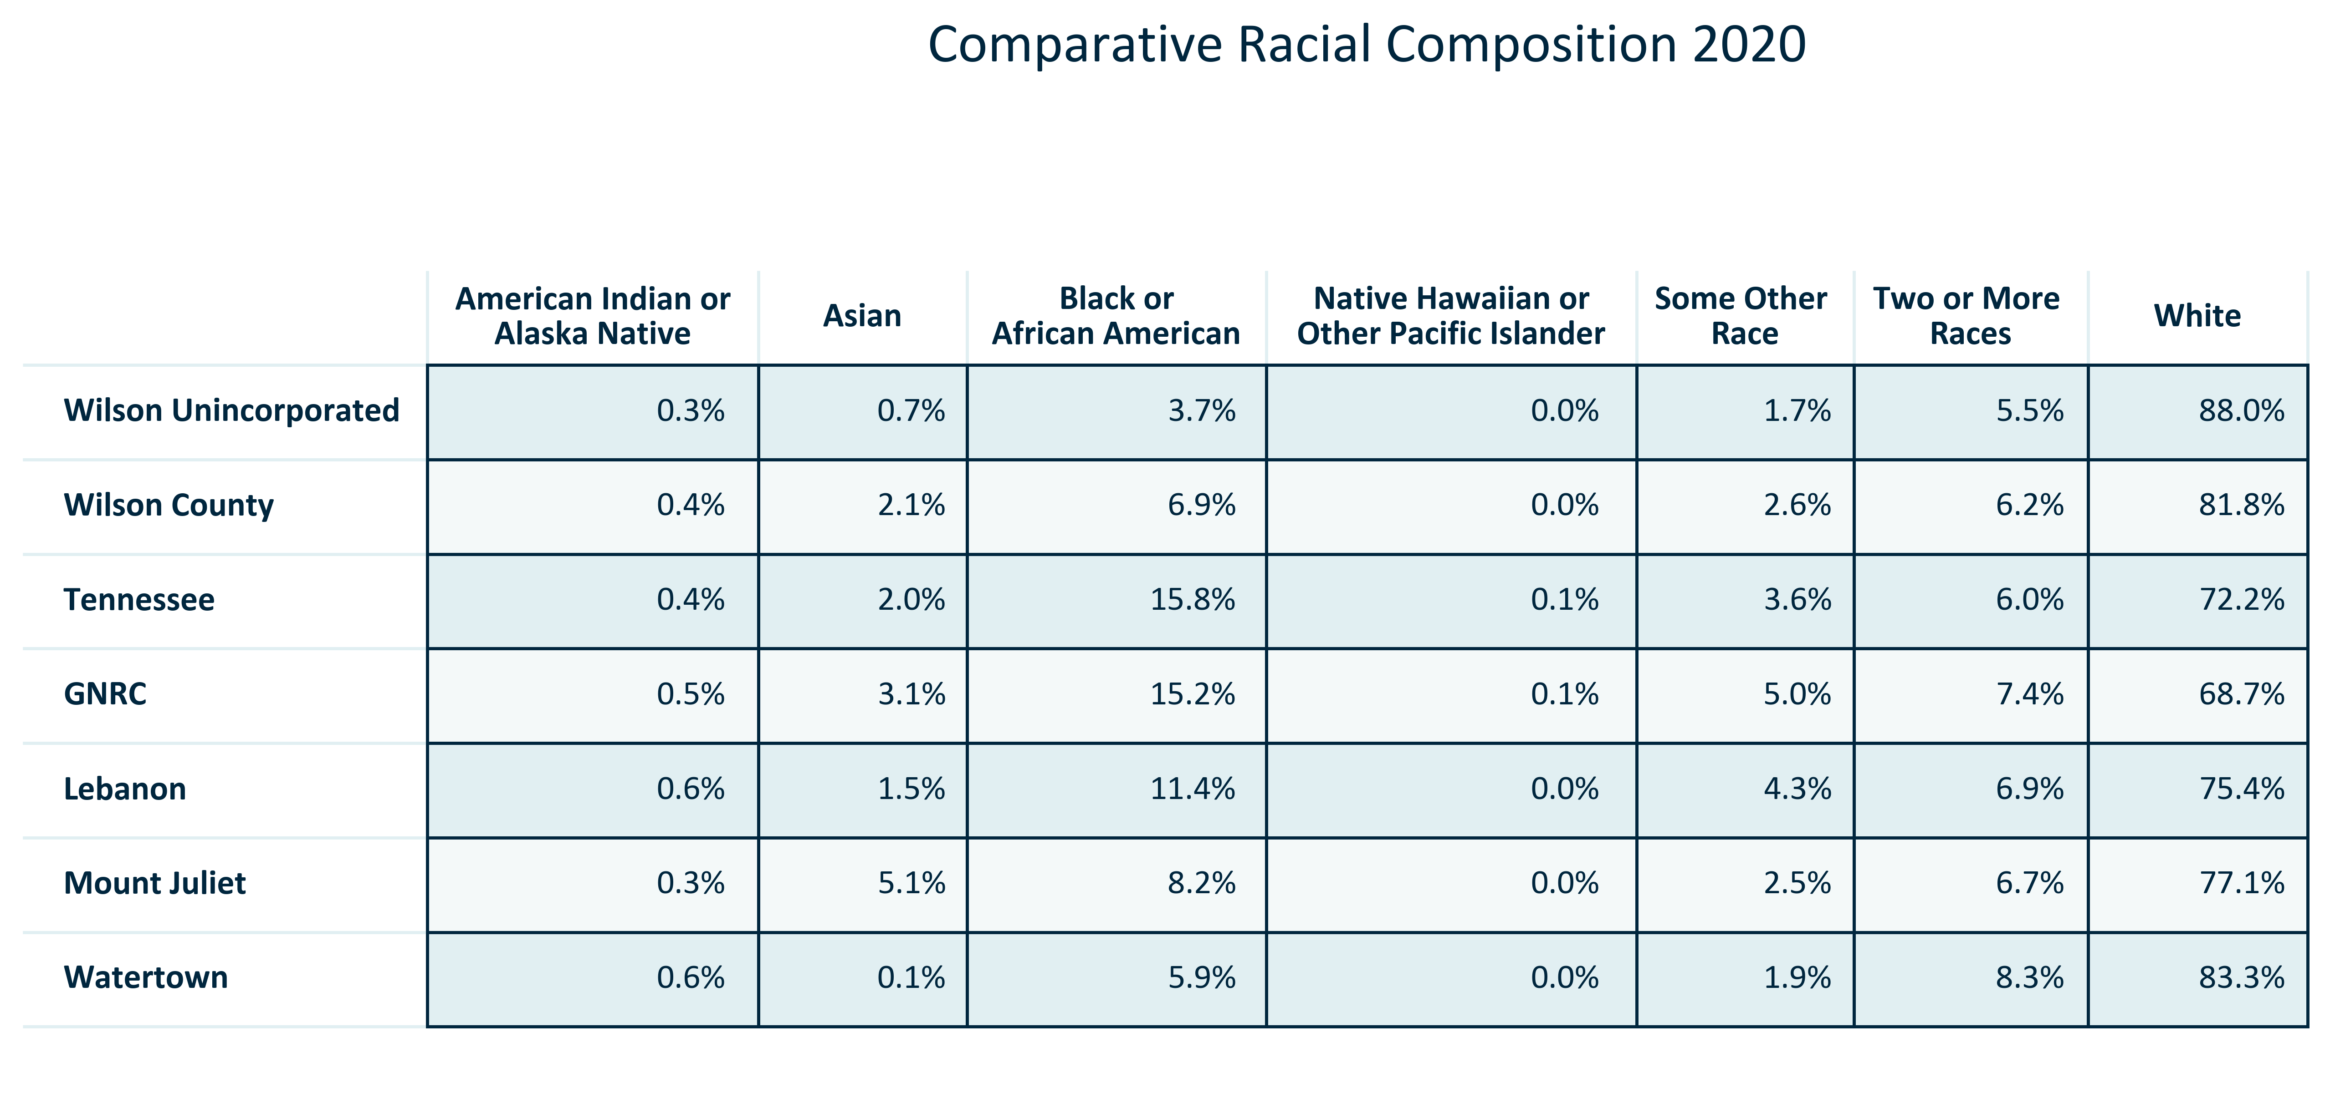

Citation: 2020 Decennial Census

### RACEETH_table_geocomparative_numberracegroups_2020:

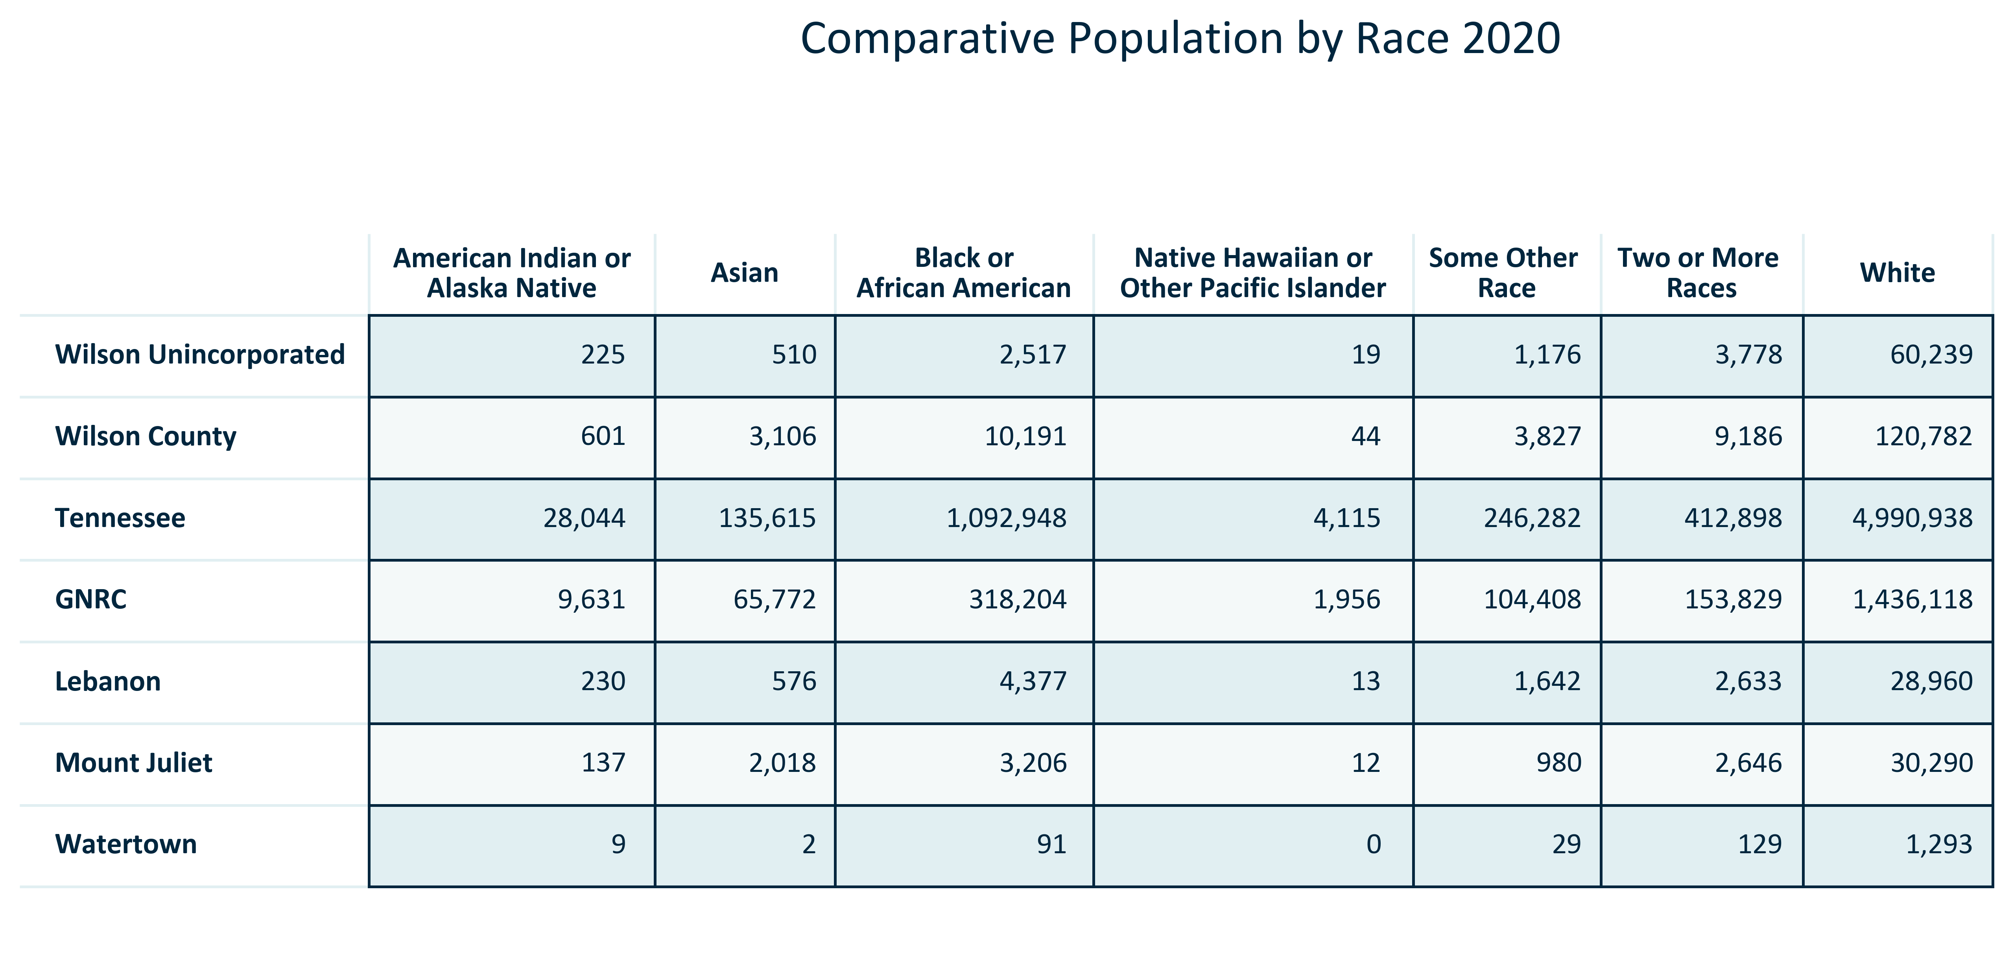

Citation: 2020 Decennial Census

### RACEETH_table_geocomparative_percentchangeracegroups_00to10:

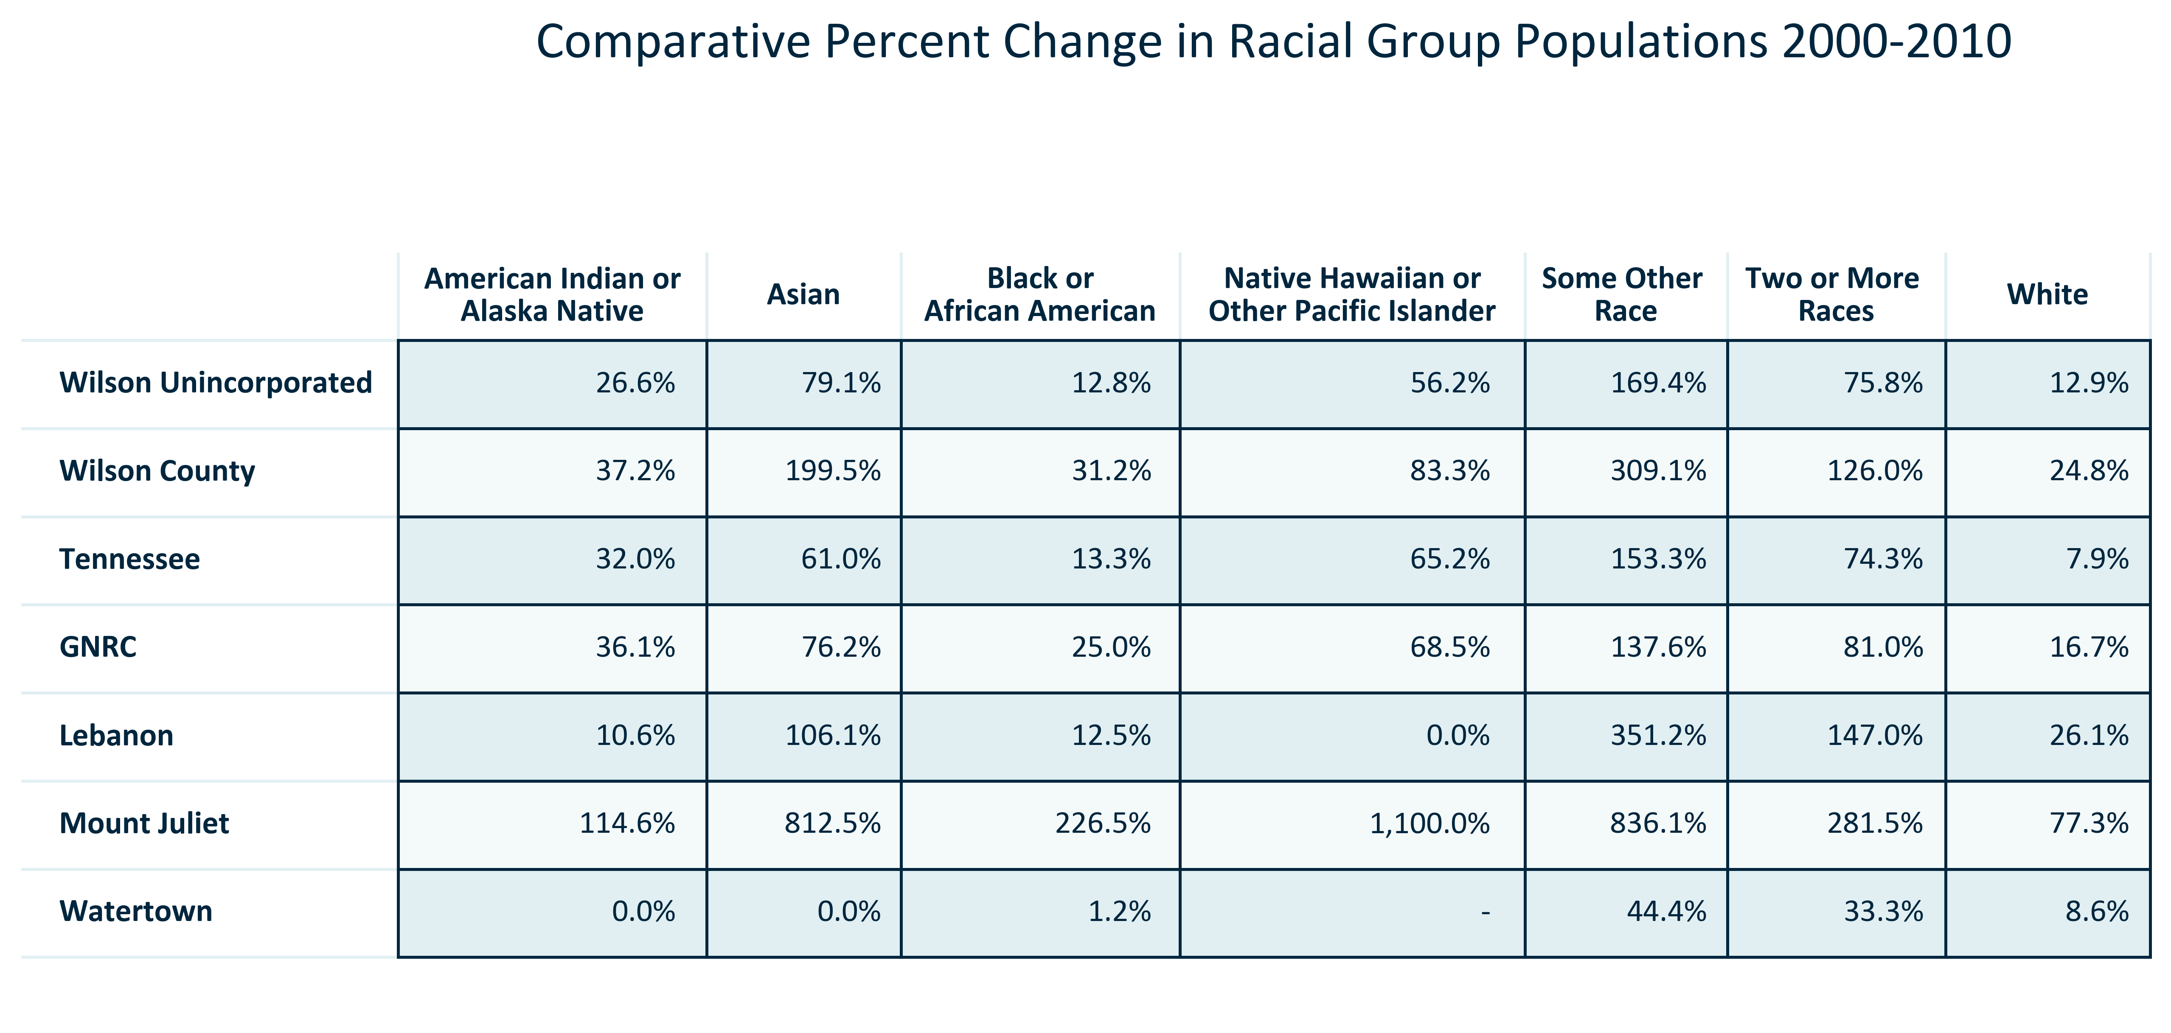

Citation: 2000 and 2010 Decennial Census

### RACEETH_table_geocomparative_realchangeracegroups_00to10:

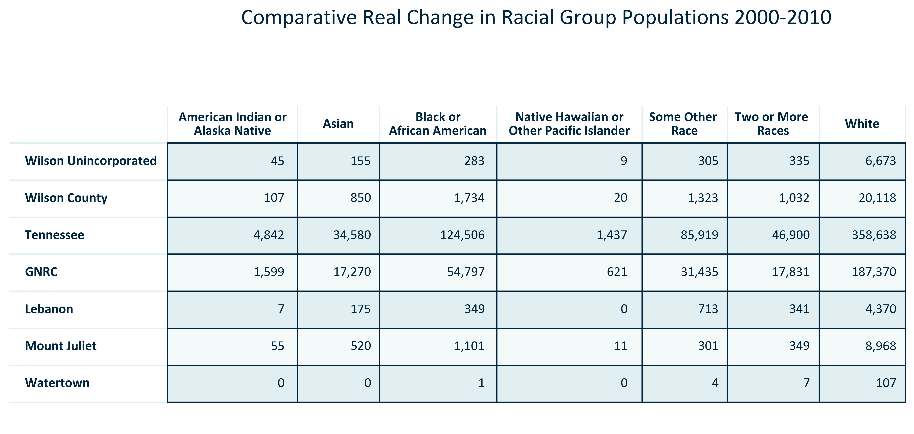

Citation: 2000 and 2010 Decennial Census

### RACEETH_table_geocomparative_percentchangeracegroups_10to20:

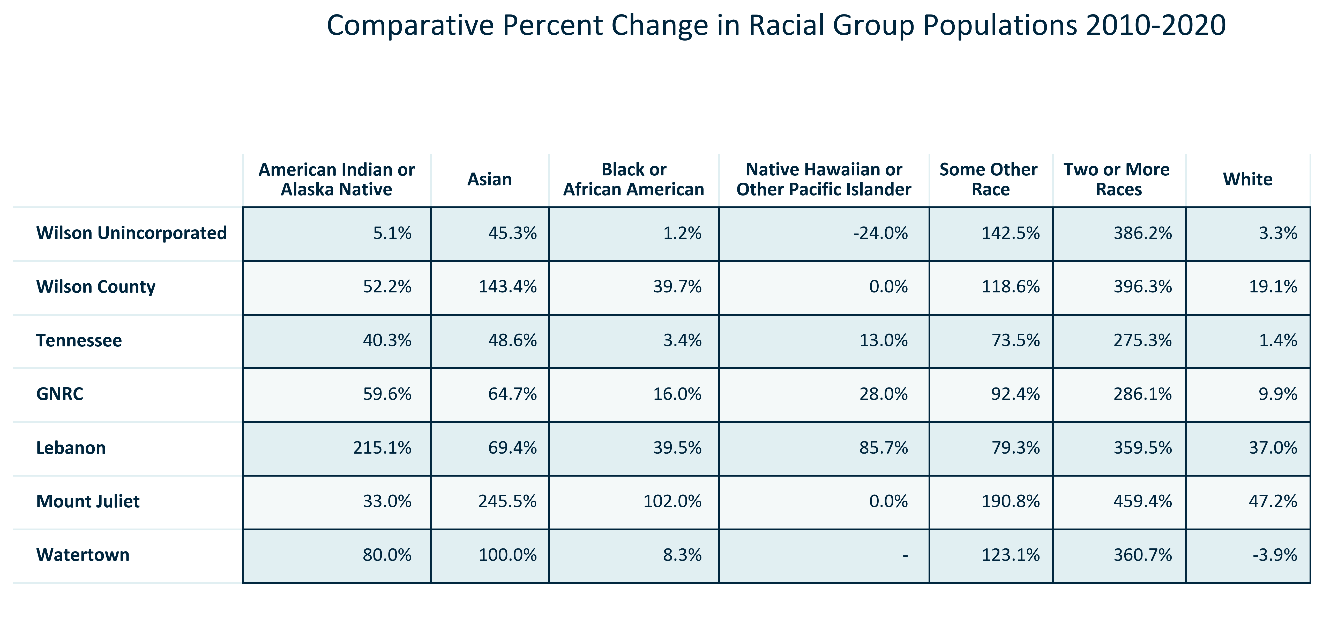

Citation: 2010 and 2020 Decennial Census

### RACEETH_table_geocomparative_realchangeracegroups_10to20:

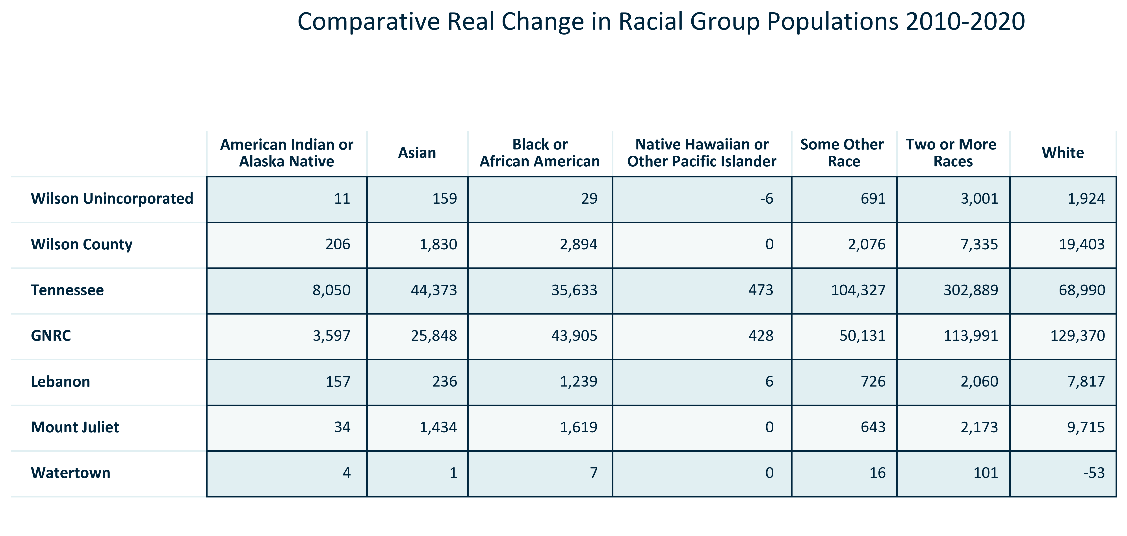

Citation: 2010 and 2020 Decennial Census

### RACEETH_table_geocomparative_percentchangeracegroups_00to20:

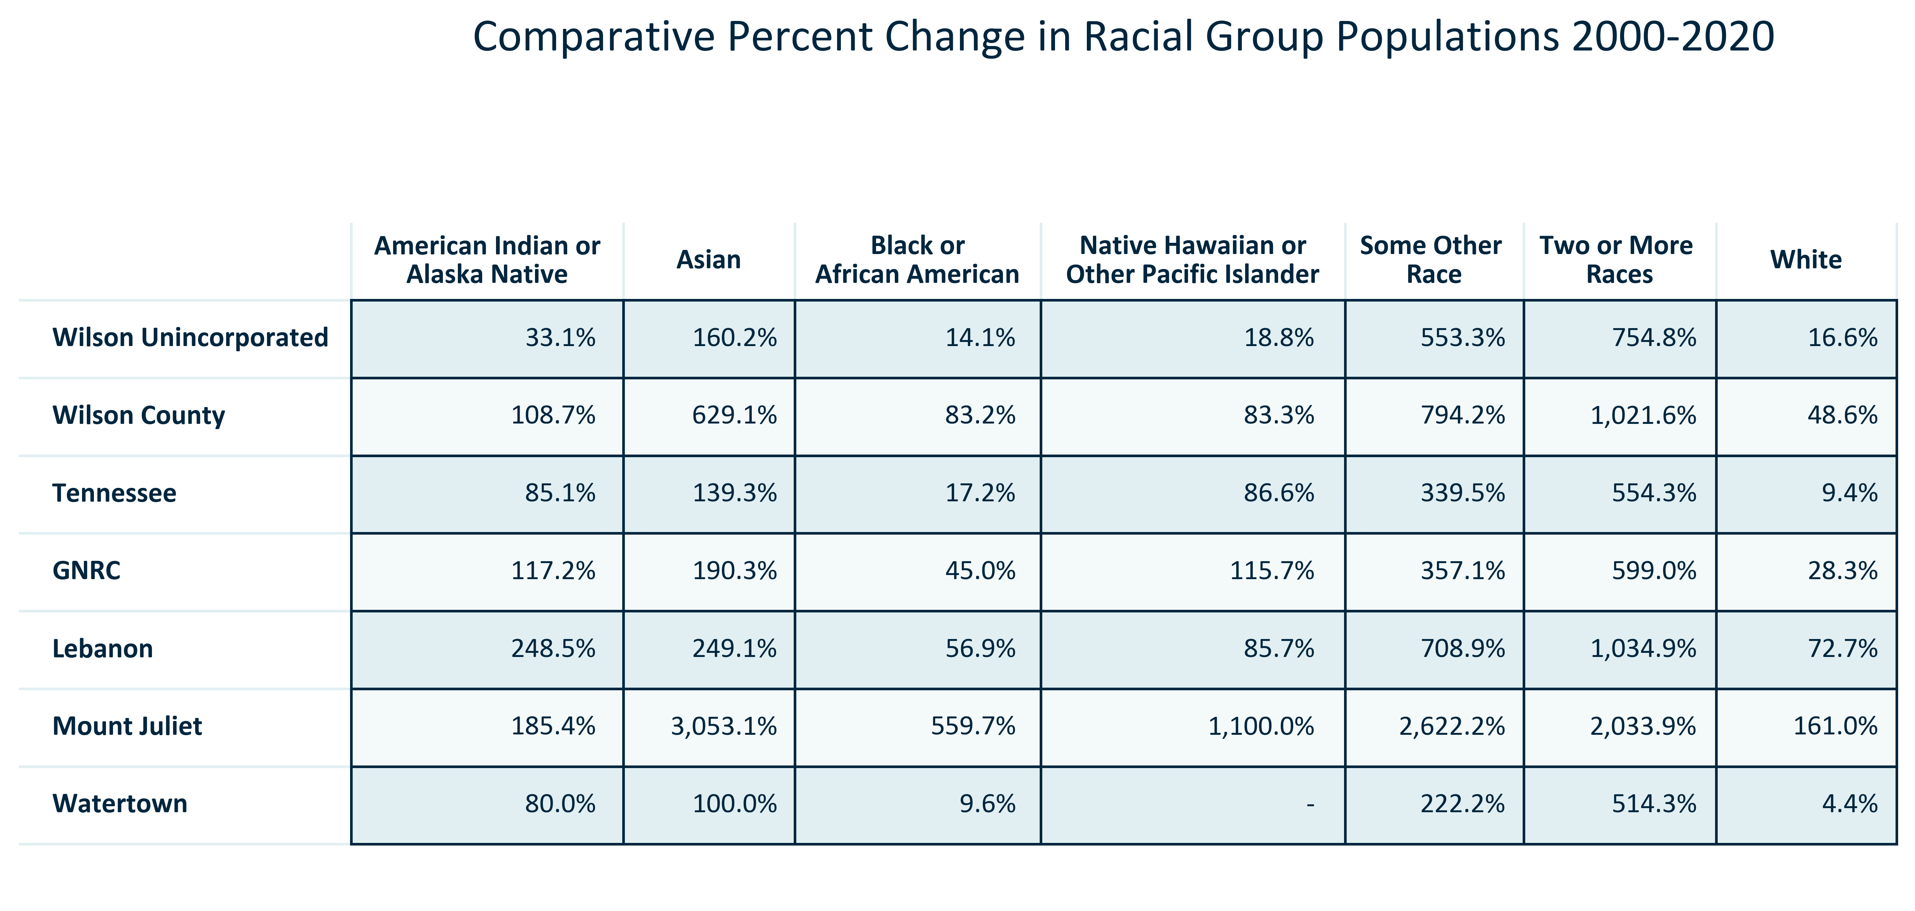

Citation: 2000 and 2020 Decennial Census

### RACEETH_table_geocomparative_realchangeracegroups_00to20:

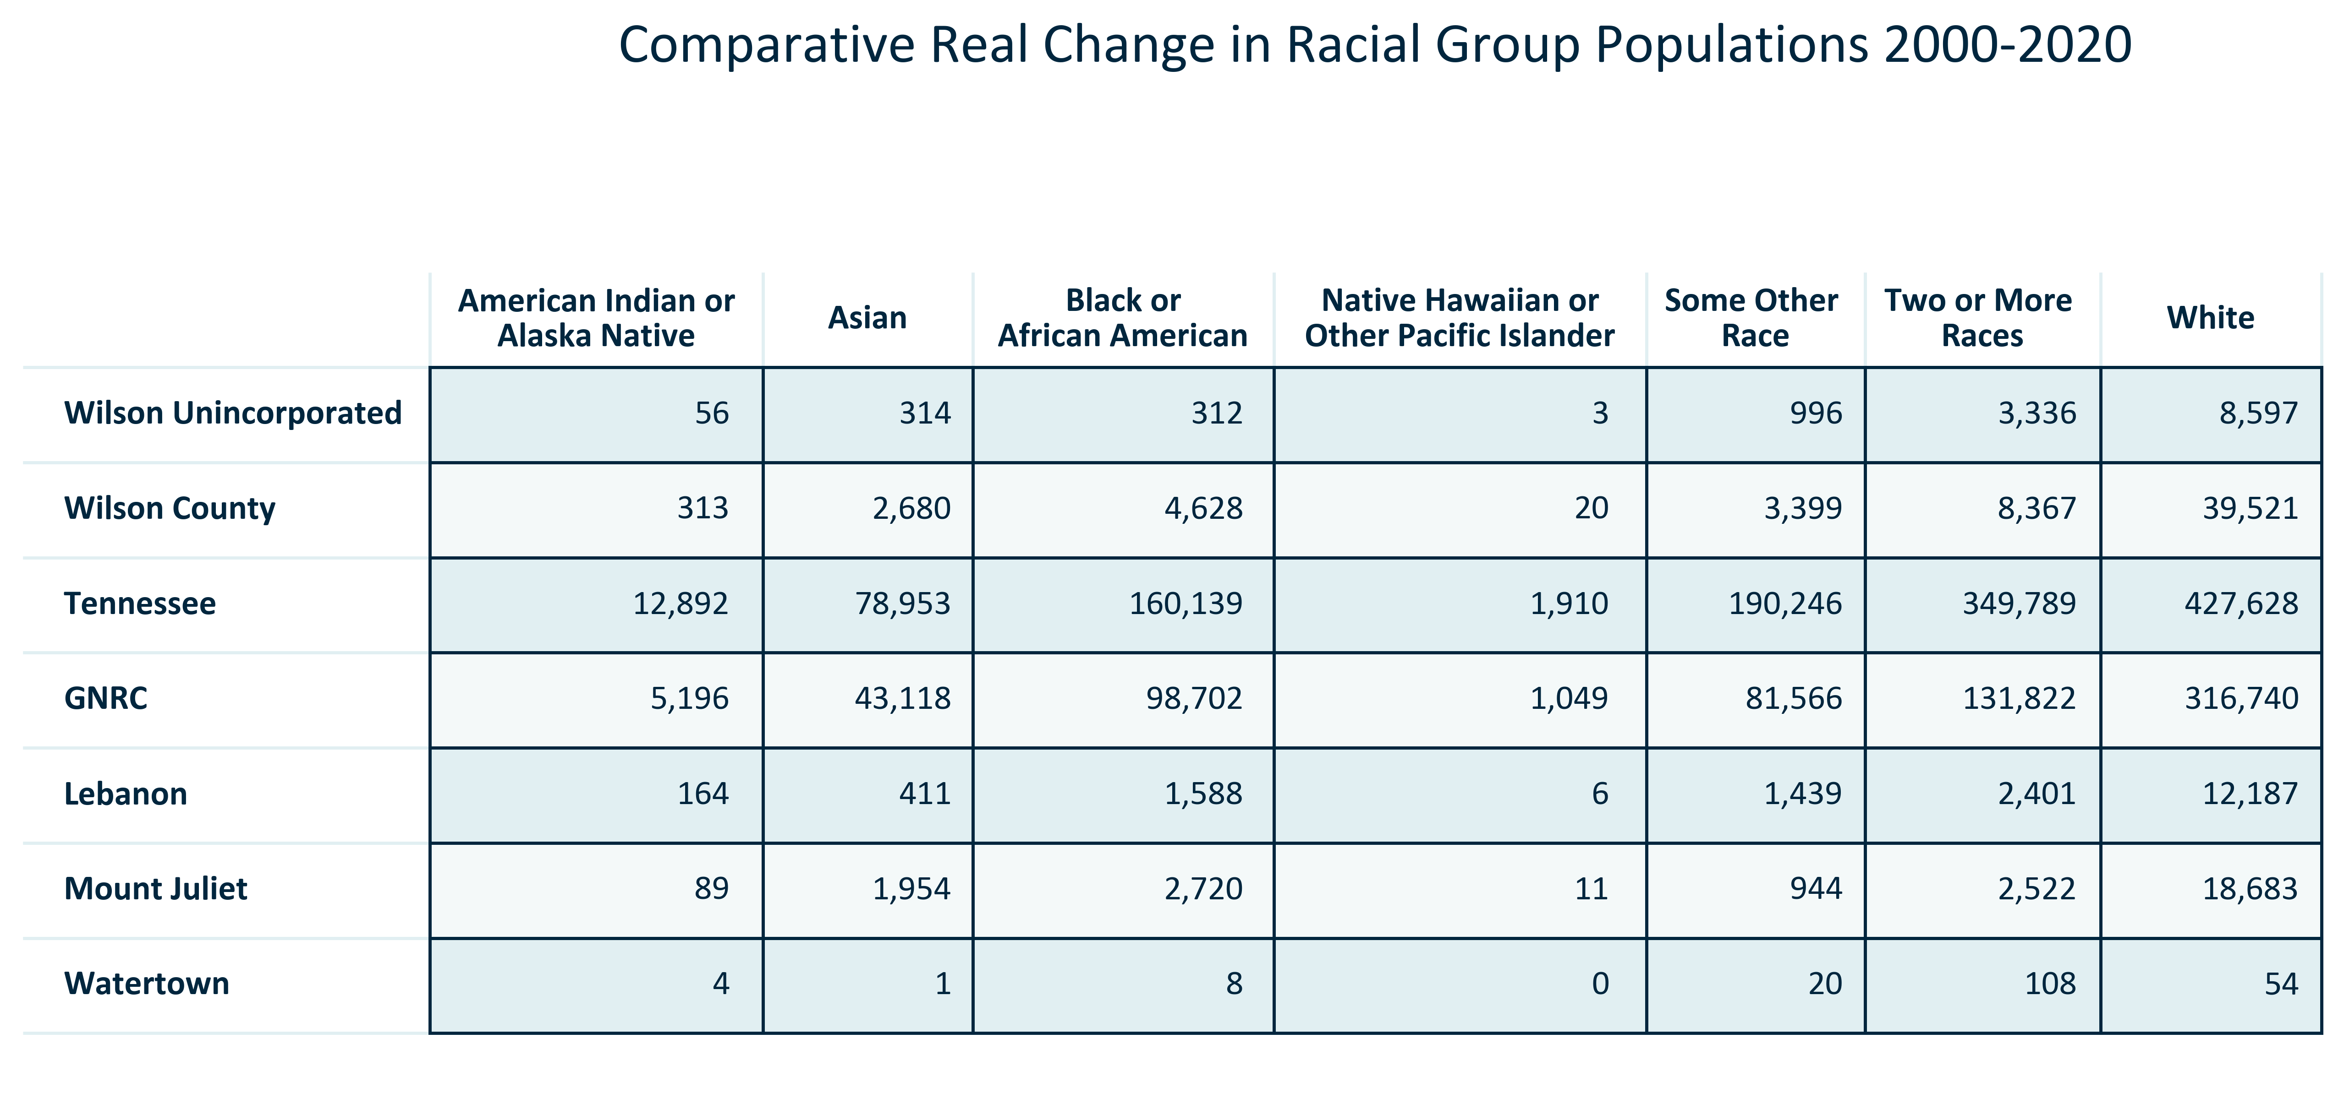

Citation: 2000 and 2020 Decennial Census

# Foreign-Born Population

### FOREIGNBORN_stackedbar_primarygeo_shareforeignandnativeborn_overtime:

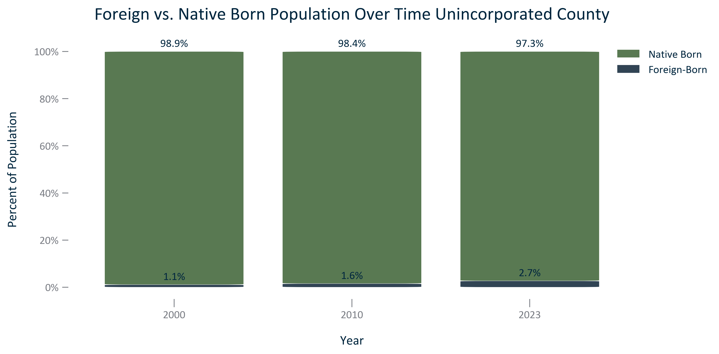

Citation: 2000 Decennial Census, 2019 - 2023 American Community Survey 5-Year Estimates

### FOREIGNBORN_table_primarygeo_foreignbornstatusandchange_overtime:

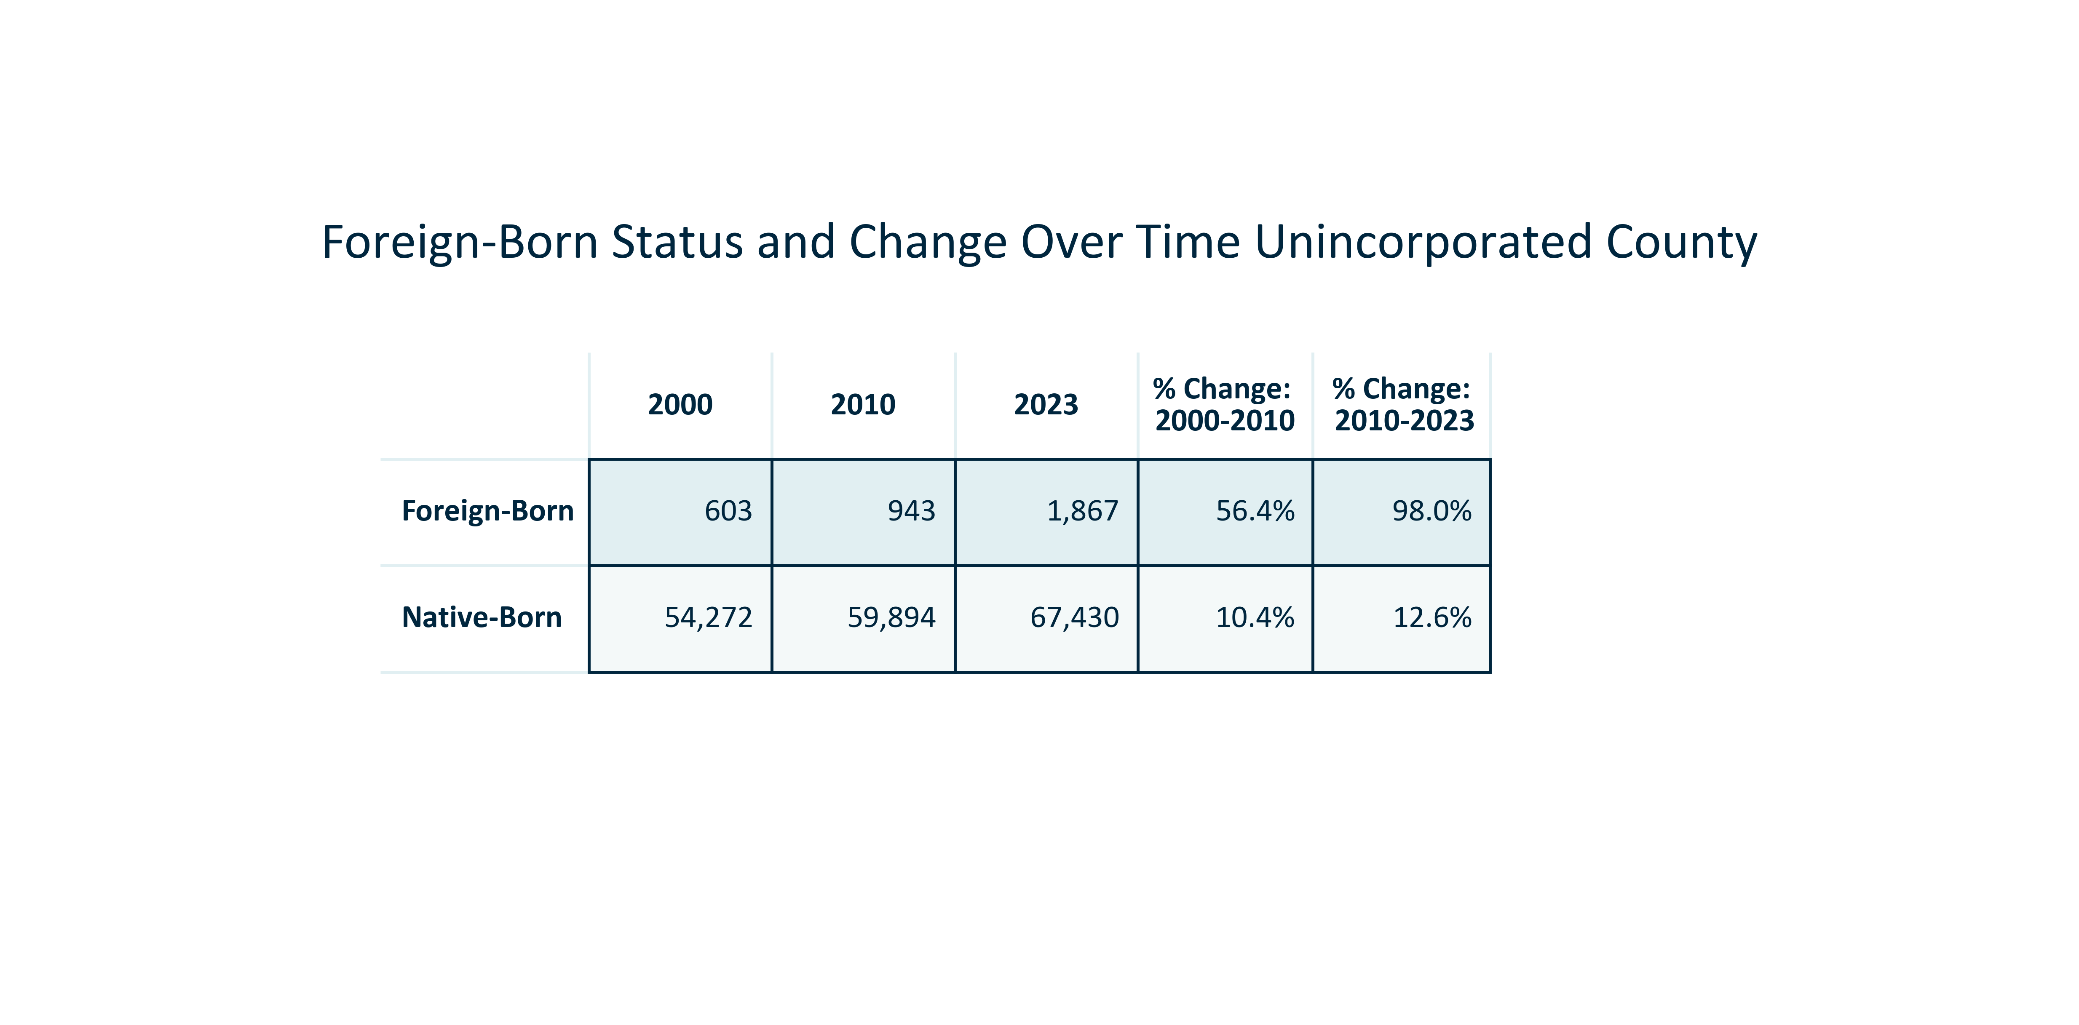

Citation: 2000 Decennial Census, 2006-2010 and , 2019 - 2023 American Community Survey 5-Year Estimates

### FOREIGNBORN_table_primarygeo_foreignbornorigin_overtime:

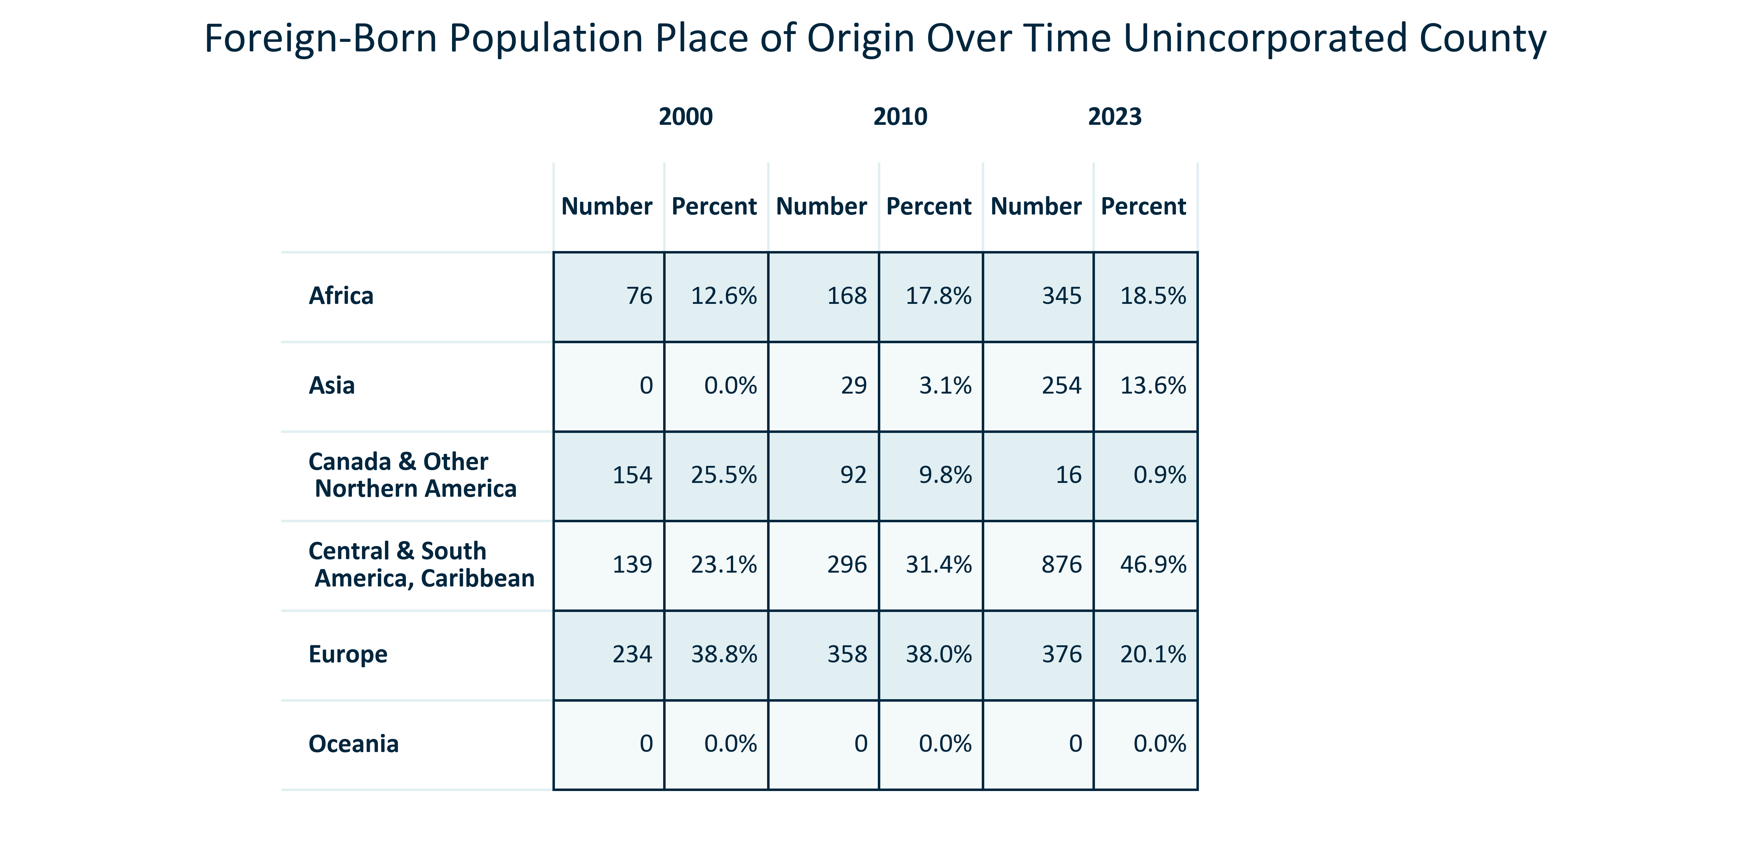

Citation: 2000, 2010, 2019 - 2023 American Community Survey 5-Year Estimates

### FOREIGNBORN_table_geocomparative_percentplaceoforigin_2000:

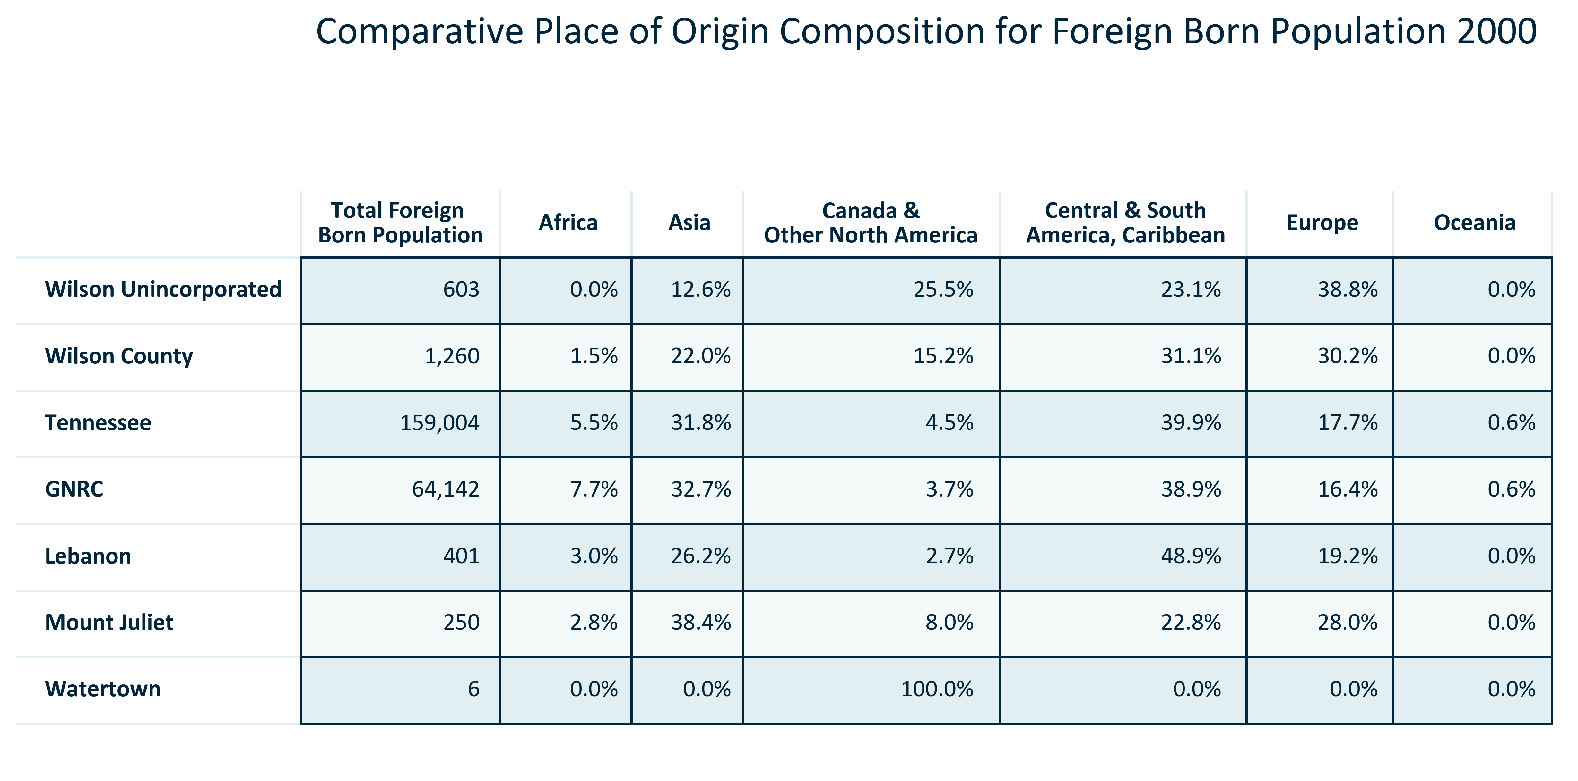

Citation: 2000 Decennial Census

### FOREIGNBORN_table_geocomparative_numberplaceoforigin_2000:

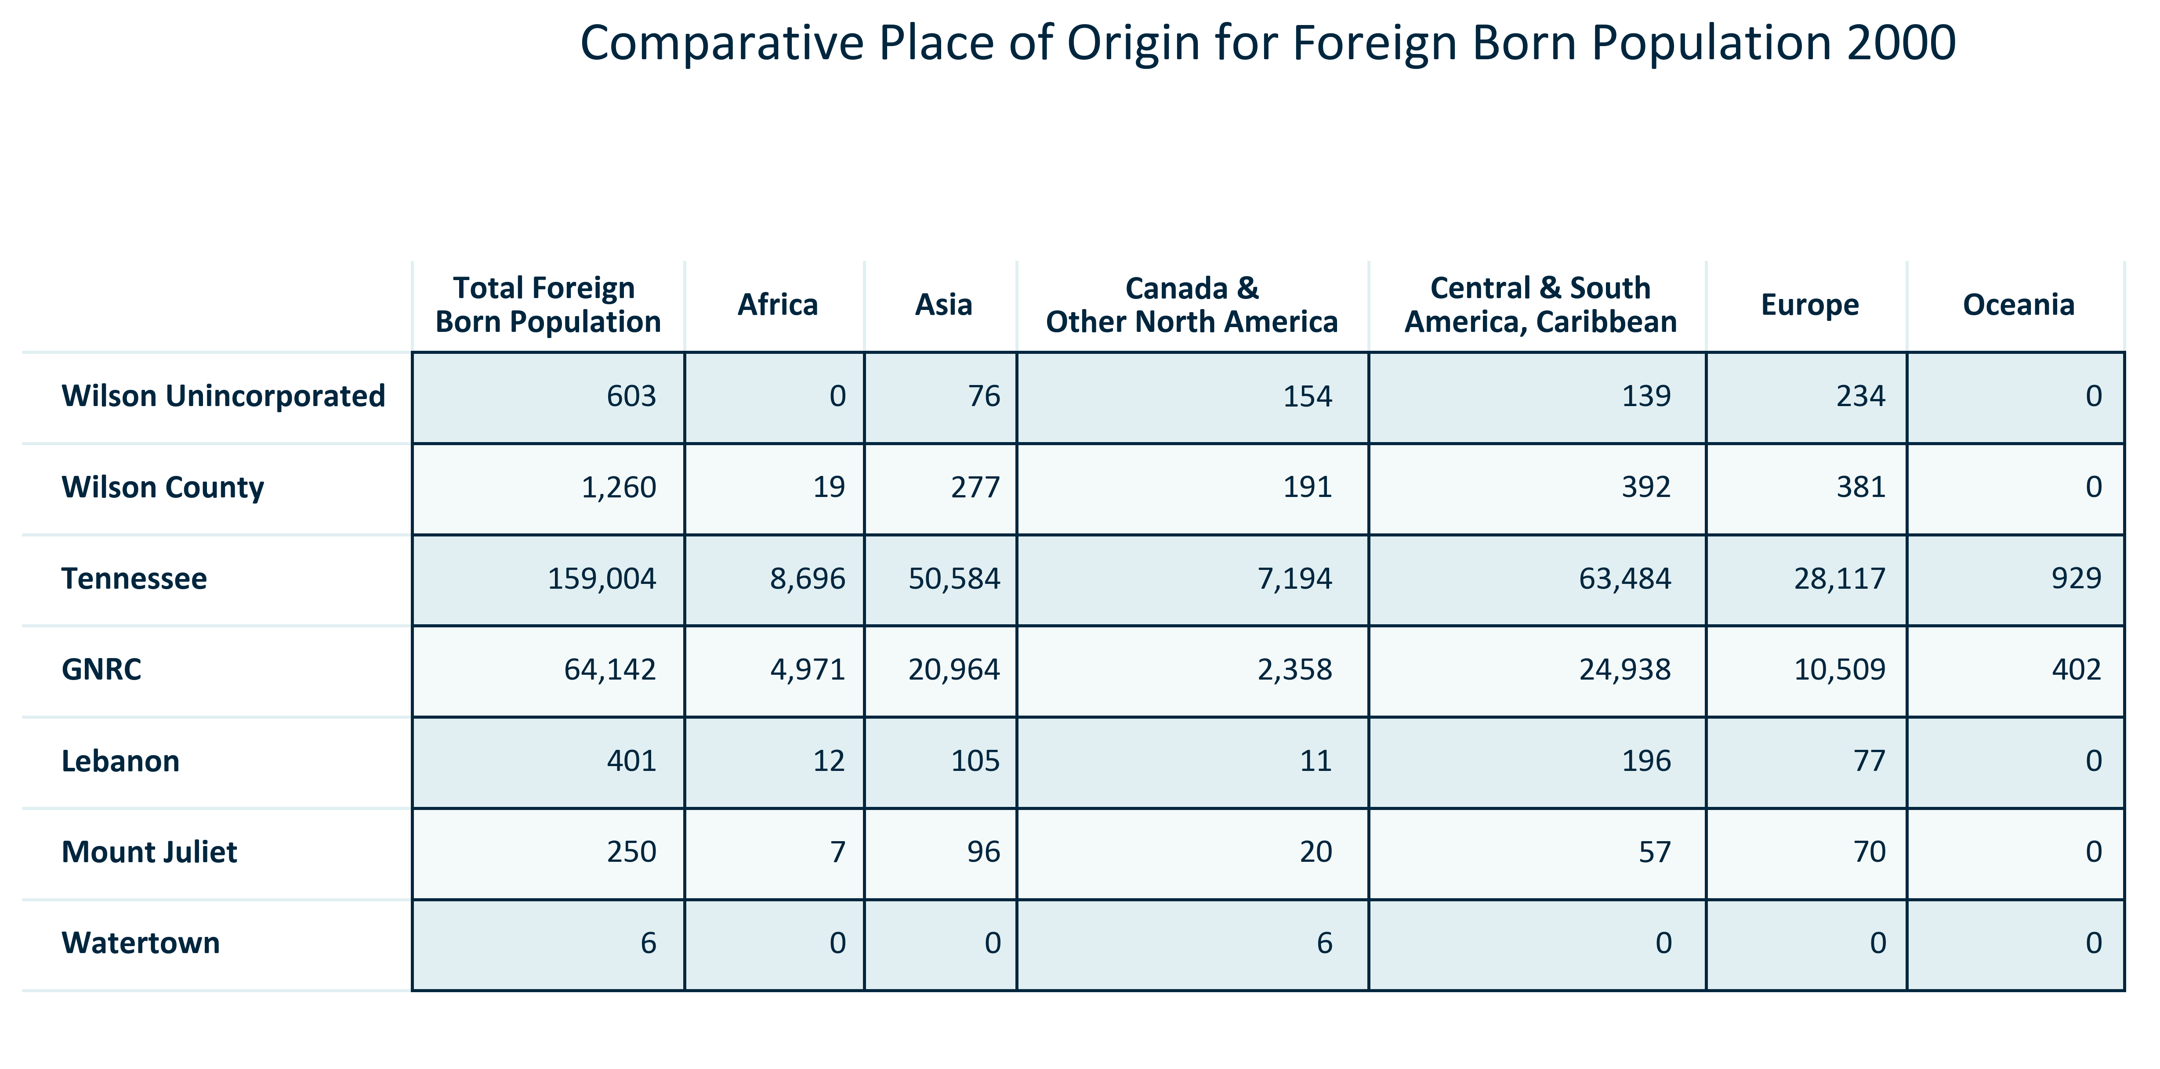

Citation: 2000 Decennial Census

### FOREIGNBORN_table_geocomparative_percentplaceoforigin_2010:

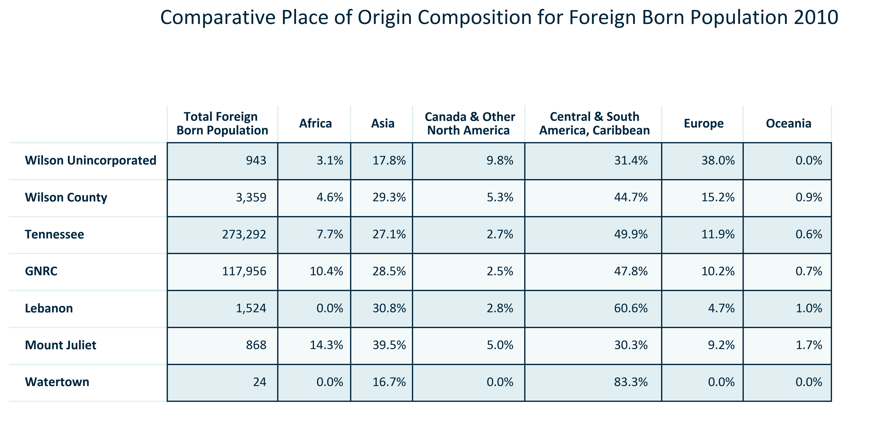

Citation: 2006-2010 American Community Survey 5-Year Estimates

### FOREIGNBORN_table_geocomparative_numberplaceoforigin_2010:

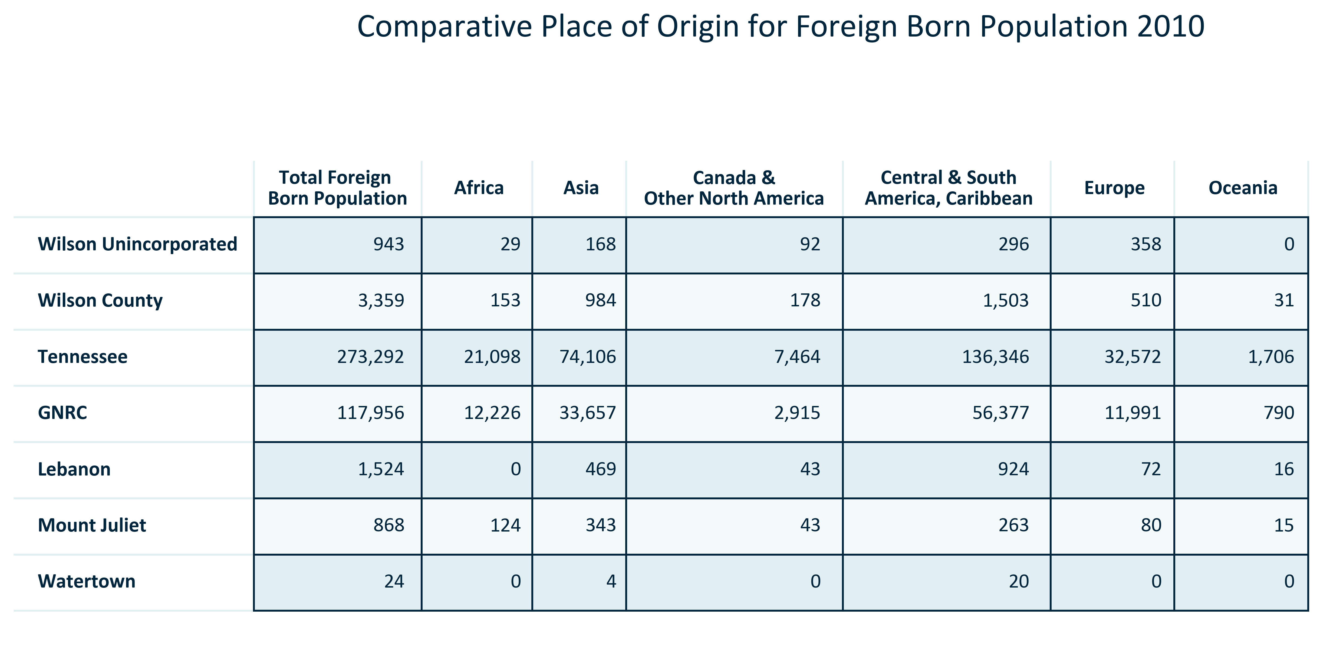

Citation: 2006-2010 American Community Survey 5-Year Estimates

### FOREIGNBORN_table_geocomparative_percentplaceoforigin_2023:

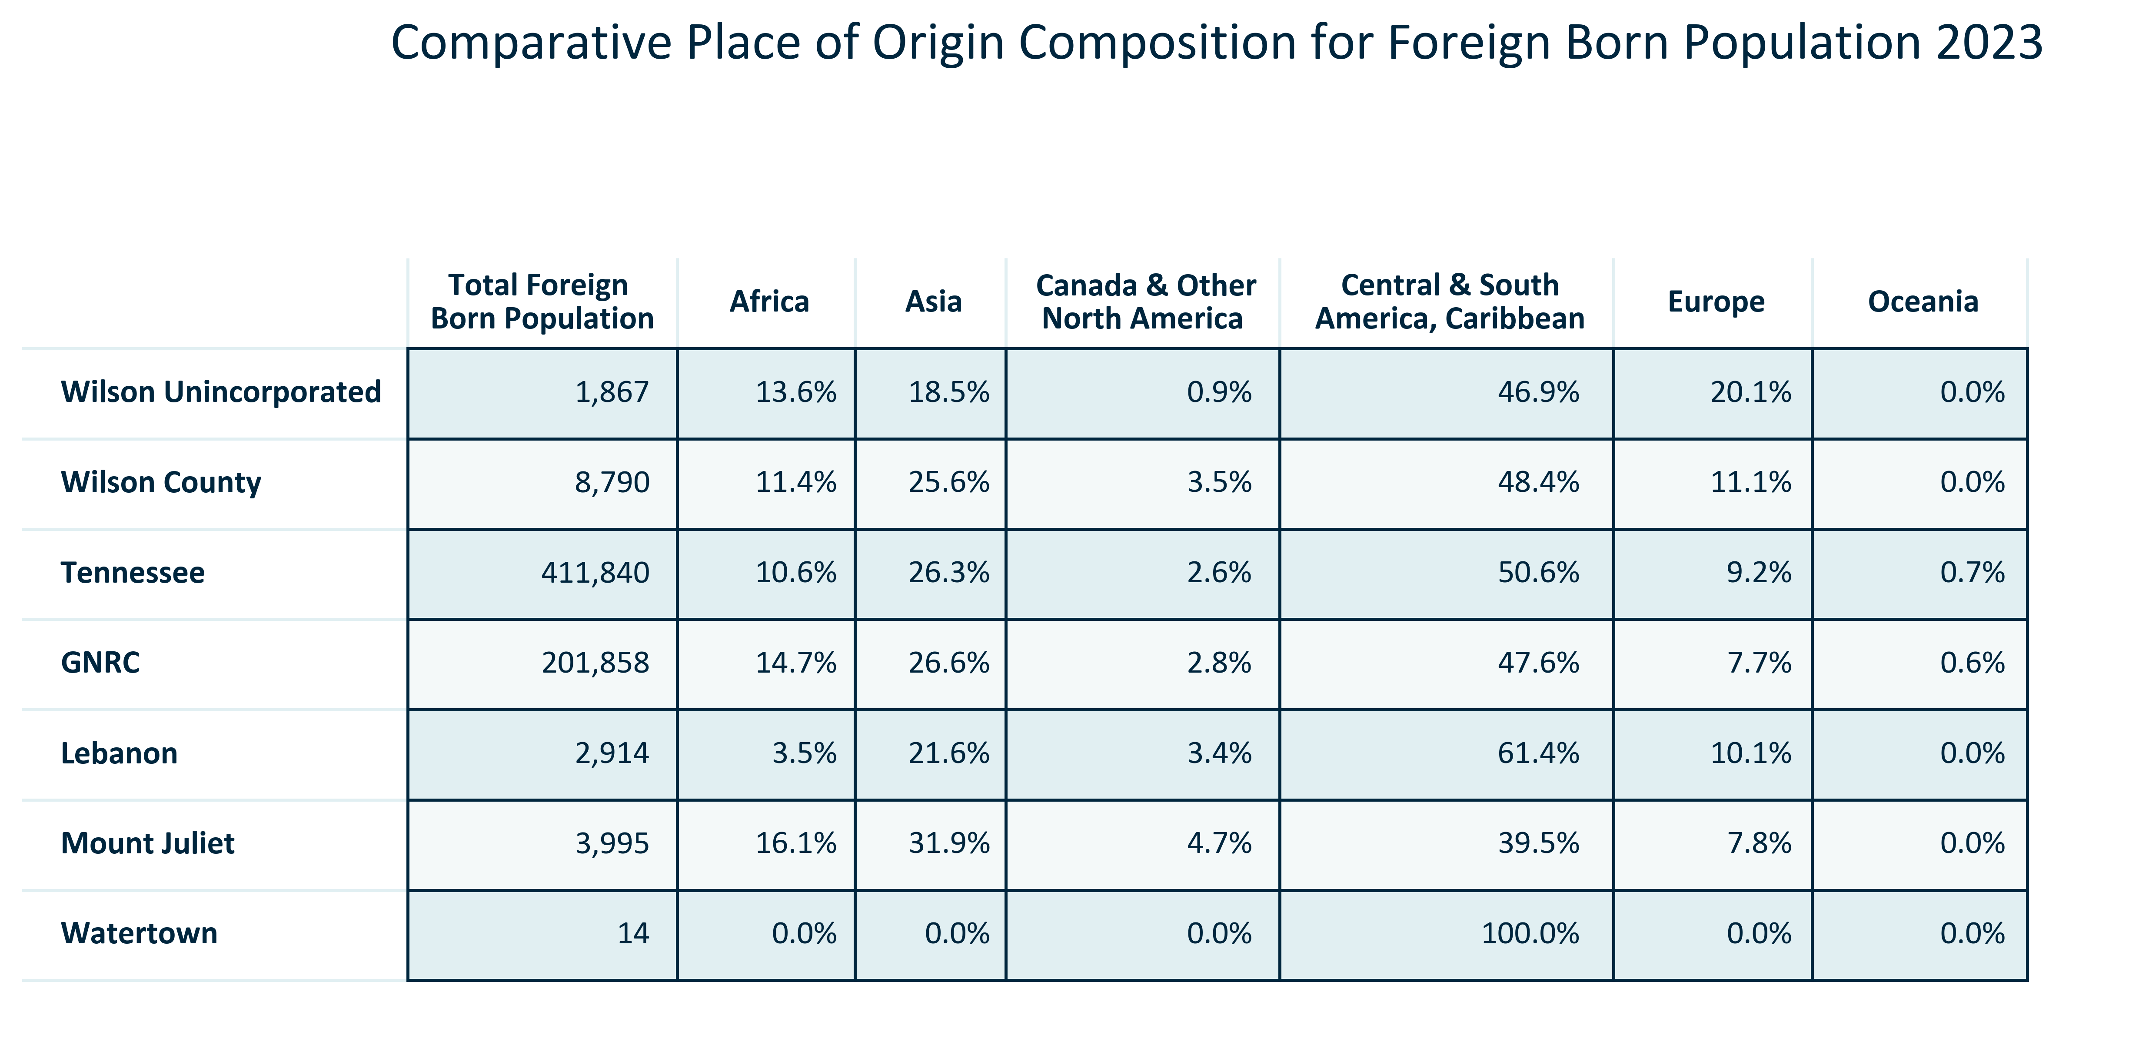

Citation: 2019 - 2023 American Community Survey 5-Year Estimates

### FOREIGNBORN_table_geocomparative_numberplaceoforigin_2023:

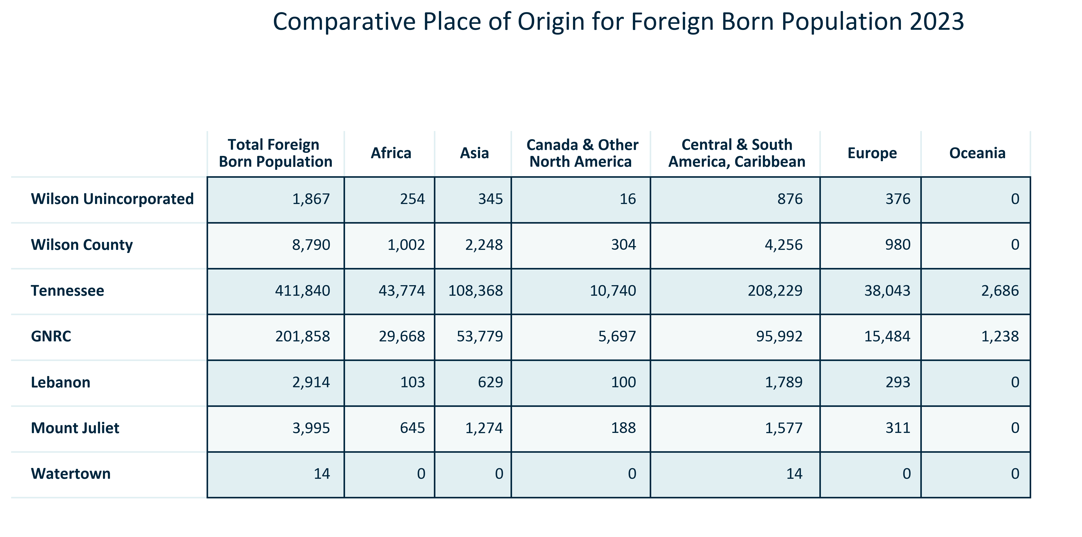

Citation: 2019 - 2023 American Community Survey 5-Year Estimates

### FOREIGNBORN_table_geocomparative_allchangeforeignborn_overtime:

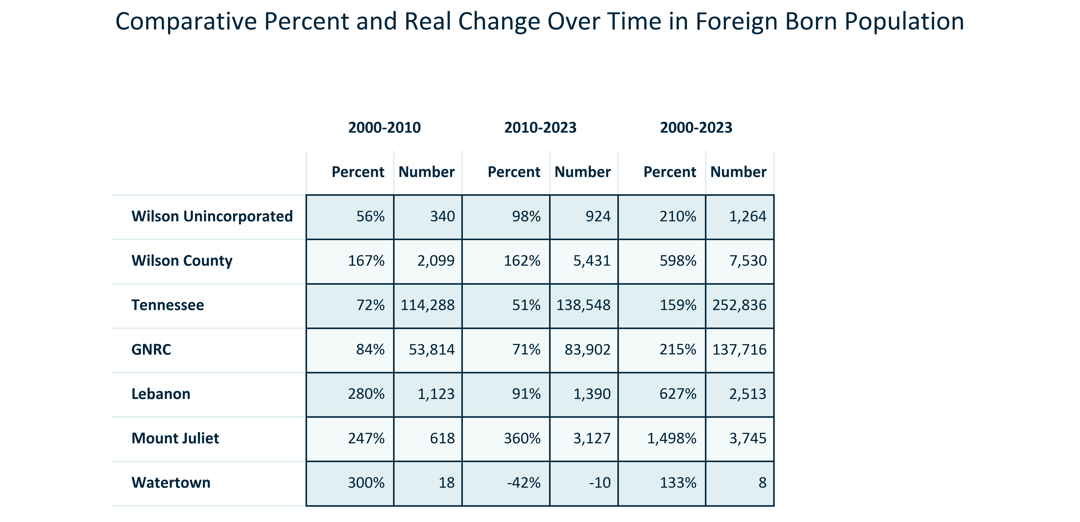

Citation: 2000 Decennial Census, 2006-2010 and 2019 - 2023 American Community Survey 5-Year Estimates

### FOREIGNBORN_clusterbar_geocomparative_realchangetotalvsforeignborn_overtime:

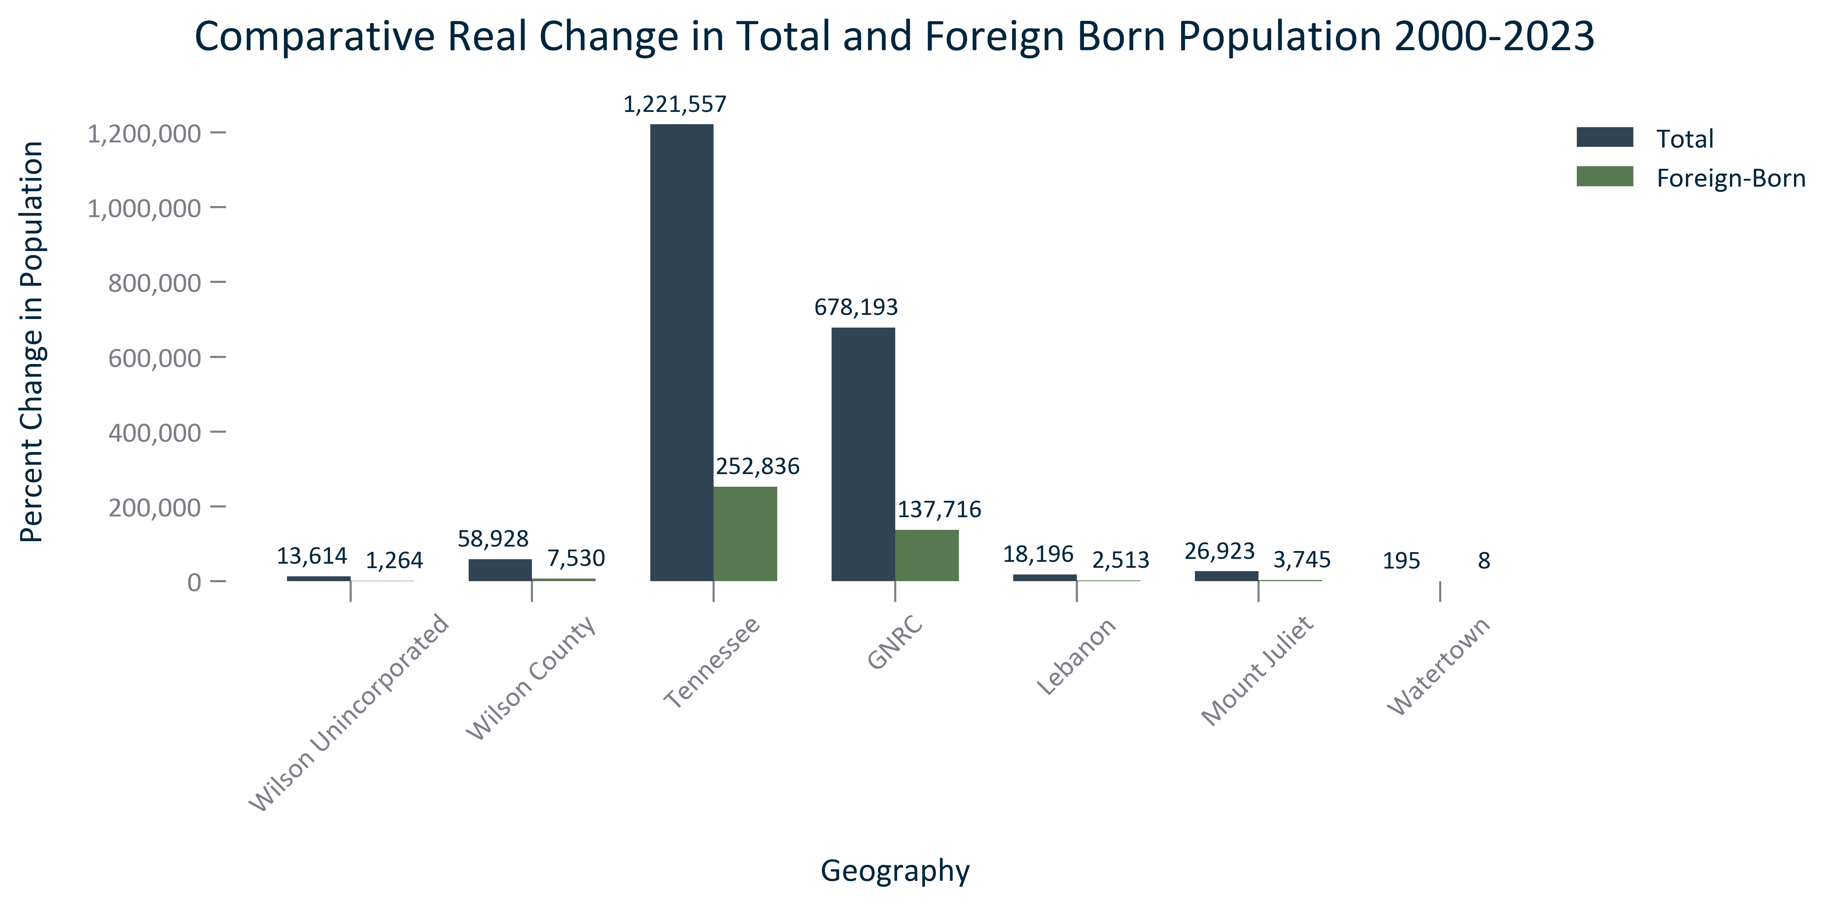

Citation: 2000 Decennial Census, 2019 - 2023 American Community Survey 5-Year Estimates, 2020 PL

### FOREIGNBORN_clusterbar_geocomparative_percentchangetotalvsforeignborn_overtime:

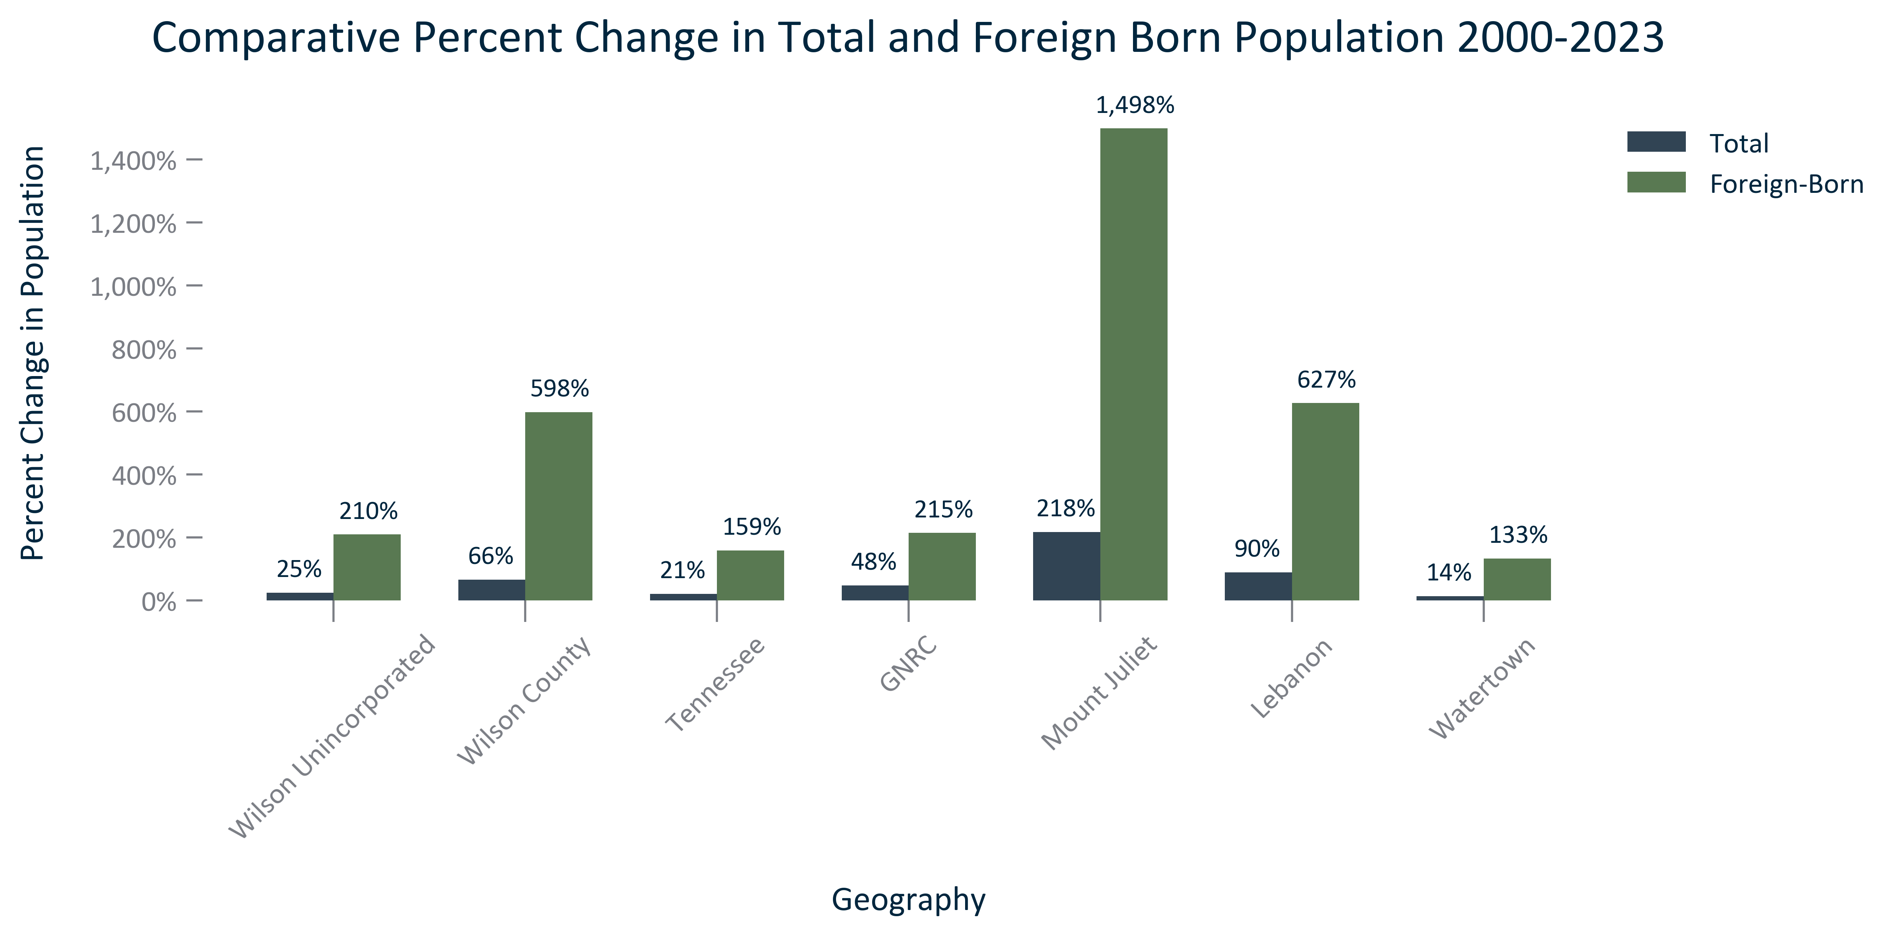

Citation: 2000 Decennial Census, 2019 - 2023 American Community Survey 5-Year Estimates, 2020 PL

### FOREIGNBORN_stackedbar_primarygeo_sharefbcitizenandnot_overtime:

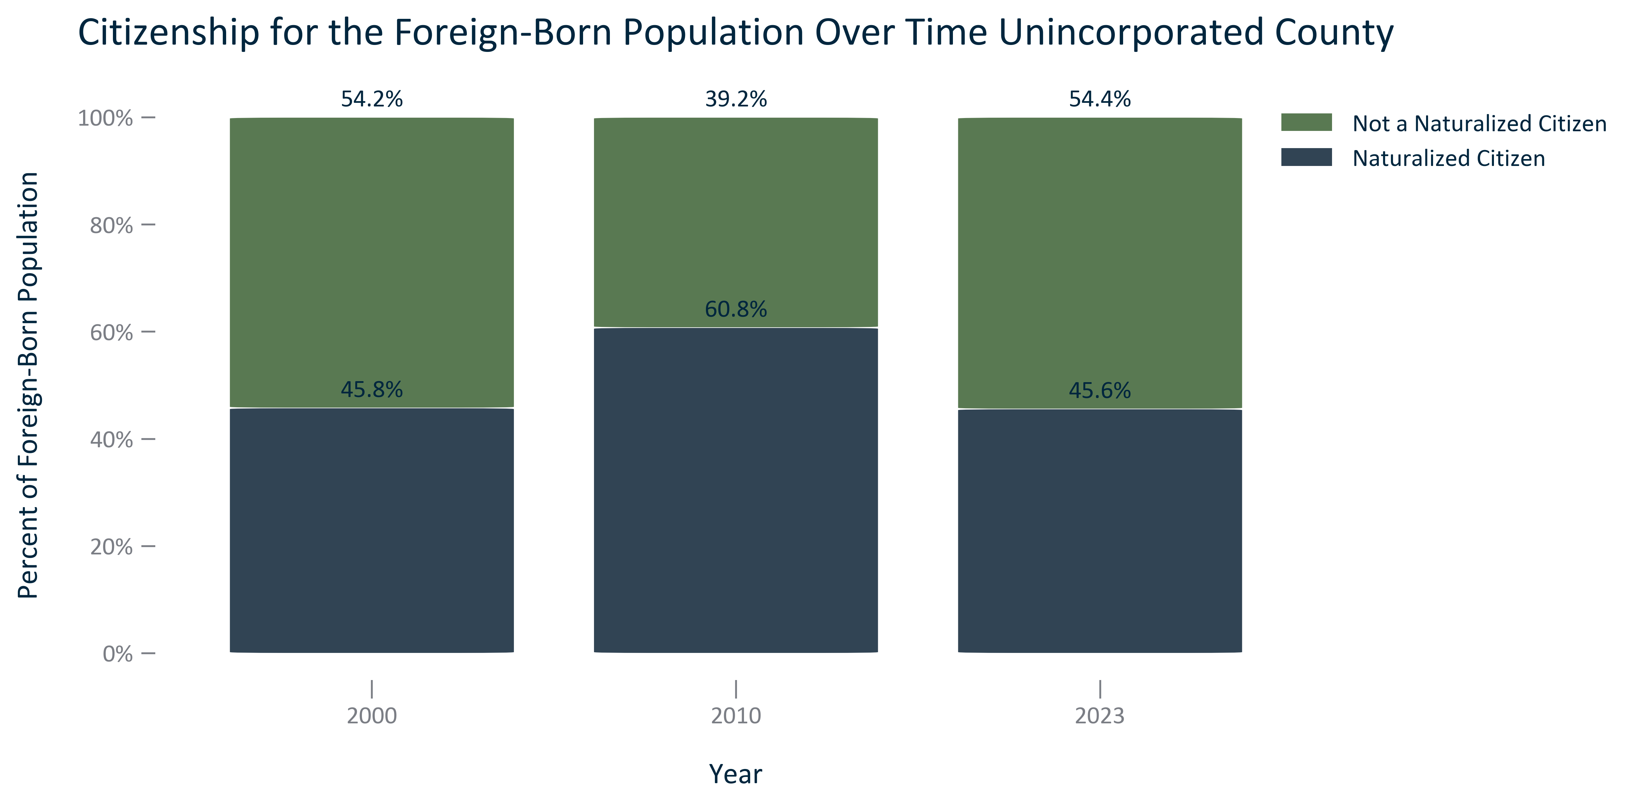

Citation: 2000 Decennial Census, 2006-2010 and 2019 - 2023 American Community Survey 5-Year Estimates

### FOREIGNBORN_table_primarygeo_citizenshipstatus_overtime:

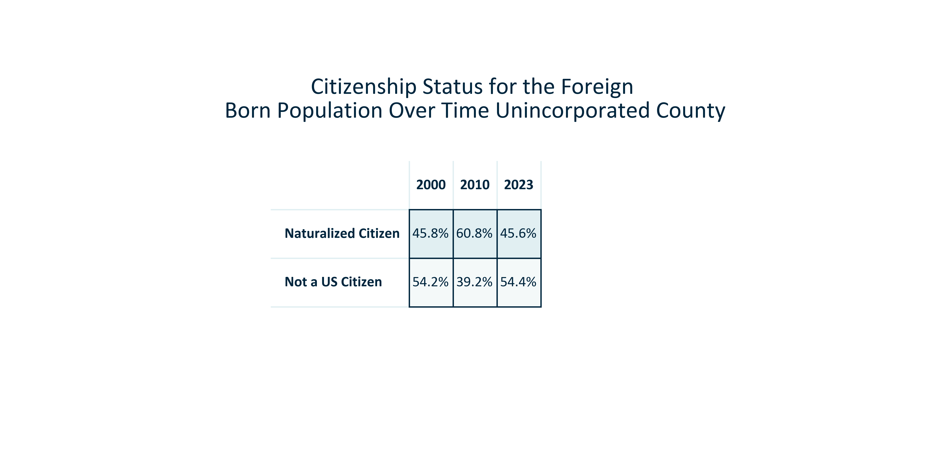

Citation: 2000 Decennial Census, 2006-2010 and 2019 - 2023 American Community Survey 5-Year Estimates

# Language

### LANGUAGE_stackedbar_primarygeo_shareenglishornon_overtime:

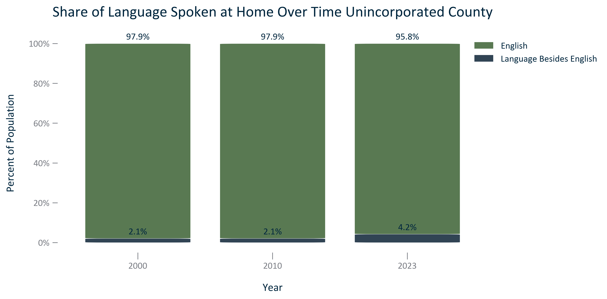

Citation: 2000 Decennial Census, 2006-2010 and 2019 - 2023 American Community Survey 5-Year Estimates

### LANGUAGE_stackedbar_primarygeo_sharenonenglishlanguages_overtime:

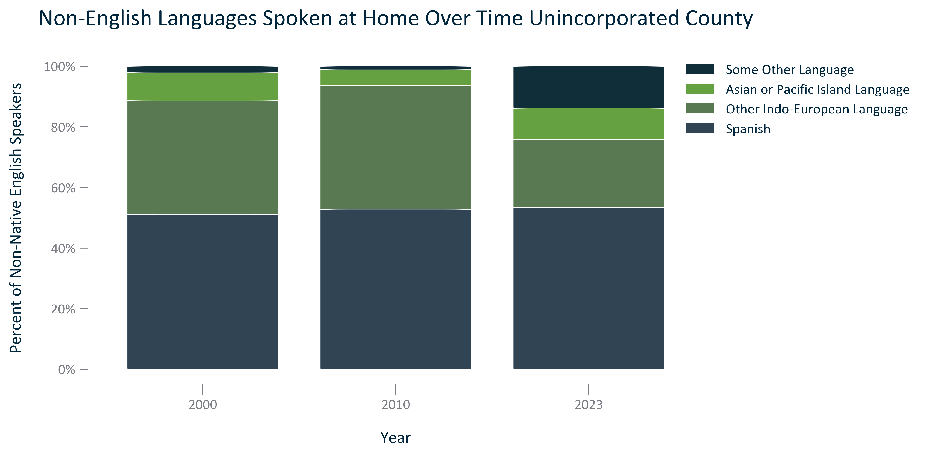

Citation: 2000 Decennial Census, 2006-2010 and 2019 - 2023 American Community Survey 5-Year Estimates

### LANGUAGE_table_primarygeo_languagebesidesenglish_2023:

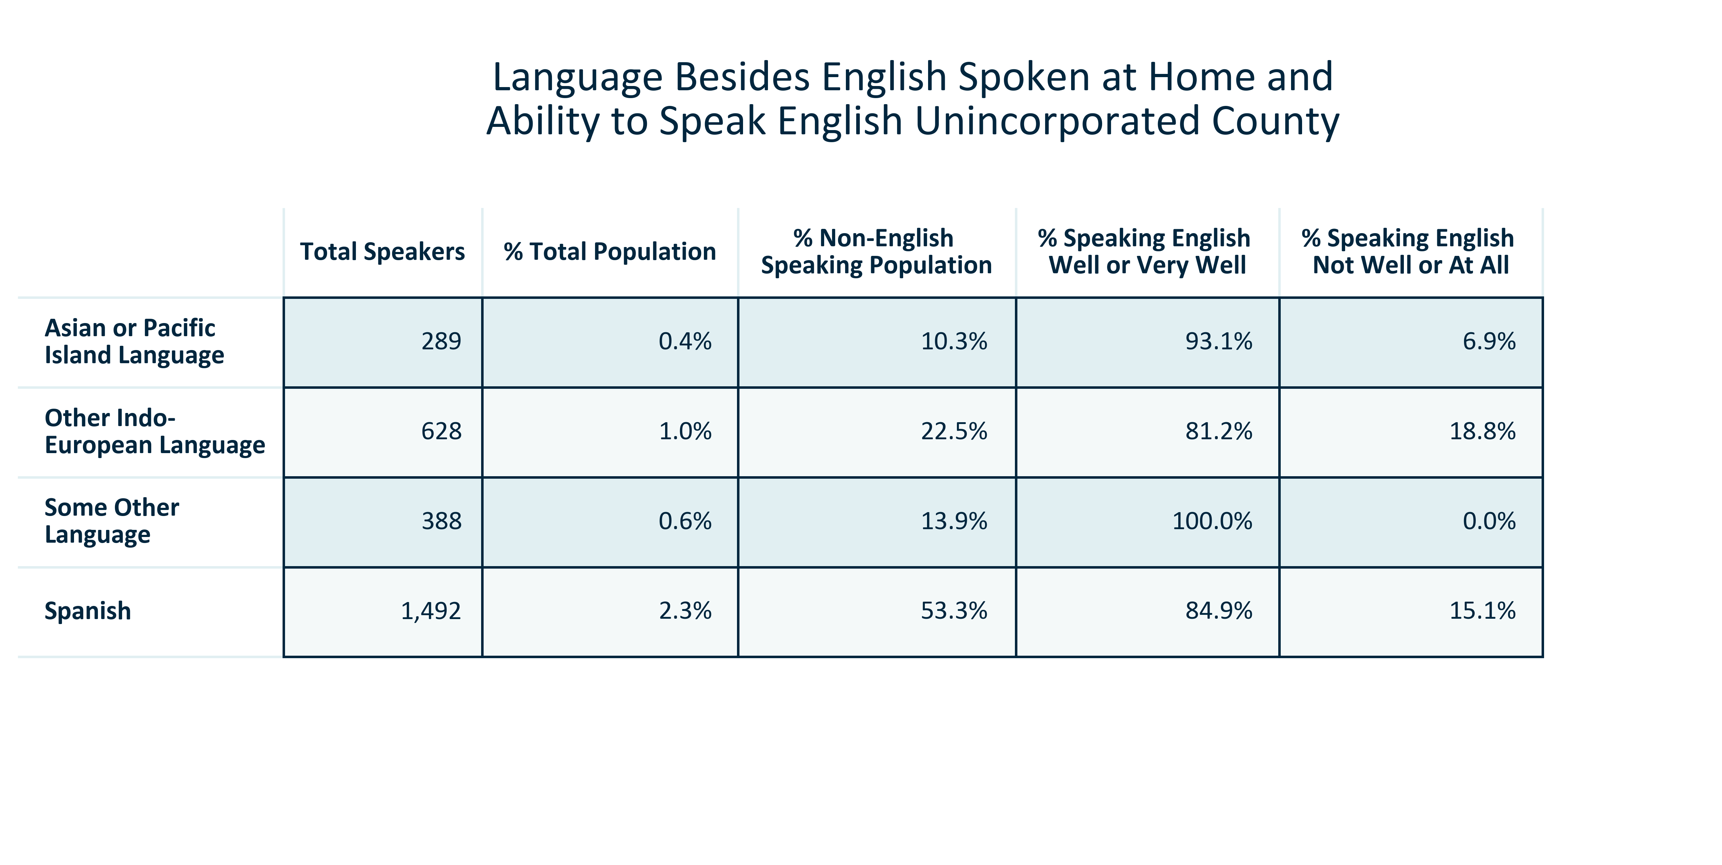

Citation: 2019 - 2023 American Community Survey 5-Year Estimates

### LANGUAGE_table_primarygeo_languagespokenathome_overtime:

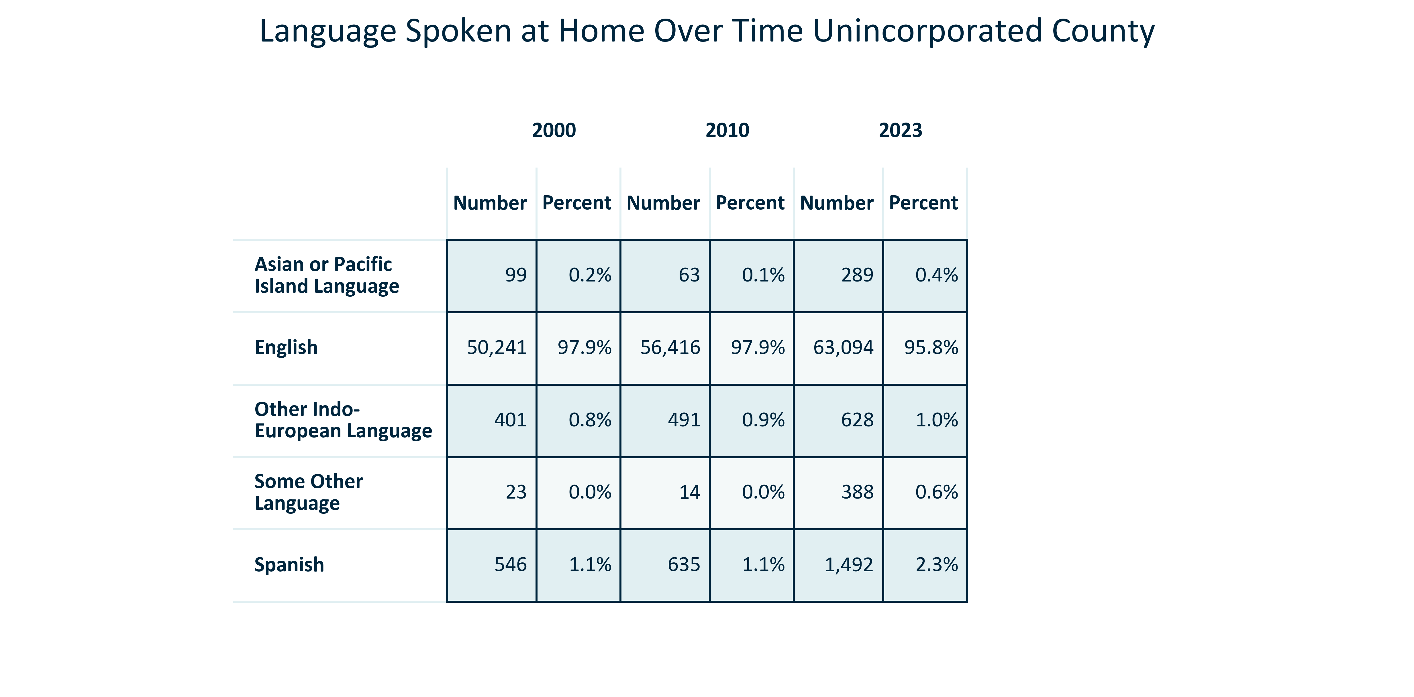

Citation: 2000 Decennial Census, 2006-2010 and 2019 - 2023 American Community Survey 5-Year Estimates

### LANGUAGE_bar_primarygeo_englishwellorverywell_2023:

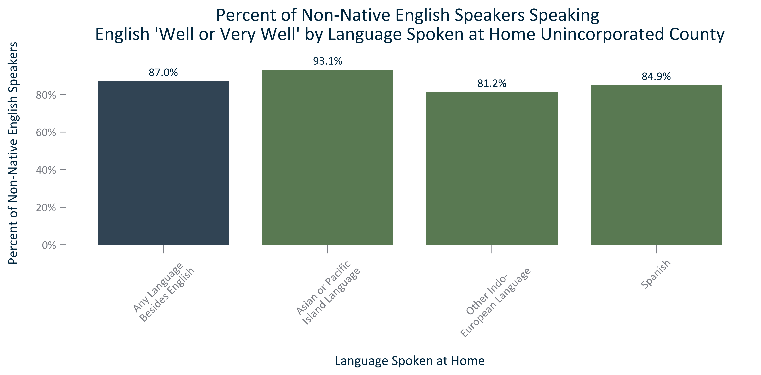

Citation: 2019 - 2023 American Community Survey 5-Year Estimates

### LANGUAGE_bar_primarygeo_englishnotwelloratall_2023:

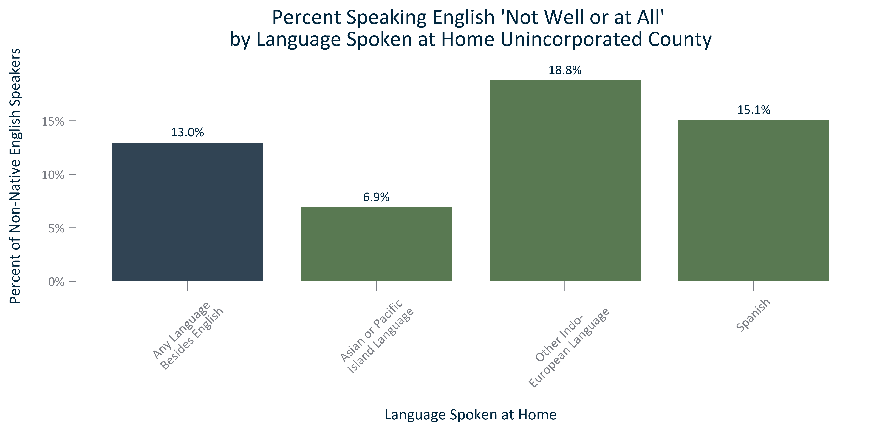

Citation: 2019 - 2023 American Community Survey 5-Year Estimates

### LANGUAGE_table_geocomparative_englishornon_overtime:

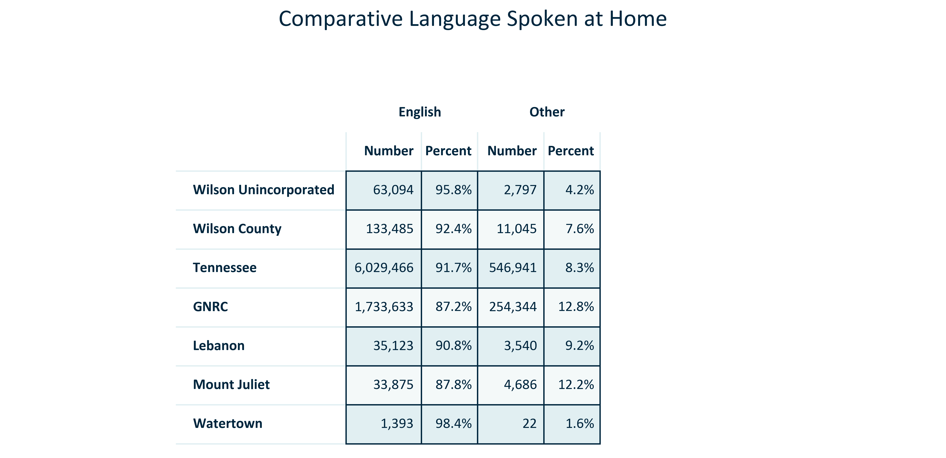

Citation: 2019 - 2023 American Community Survey 5-Year Estimates

# Poverty

### POVERTY_bar_primarygeo_populationbelowpovertylevel_overtime:

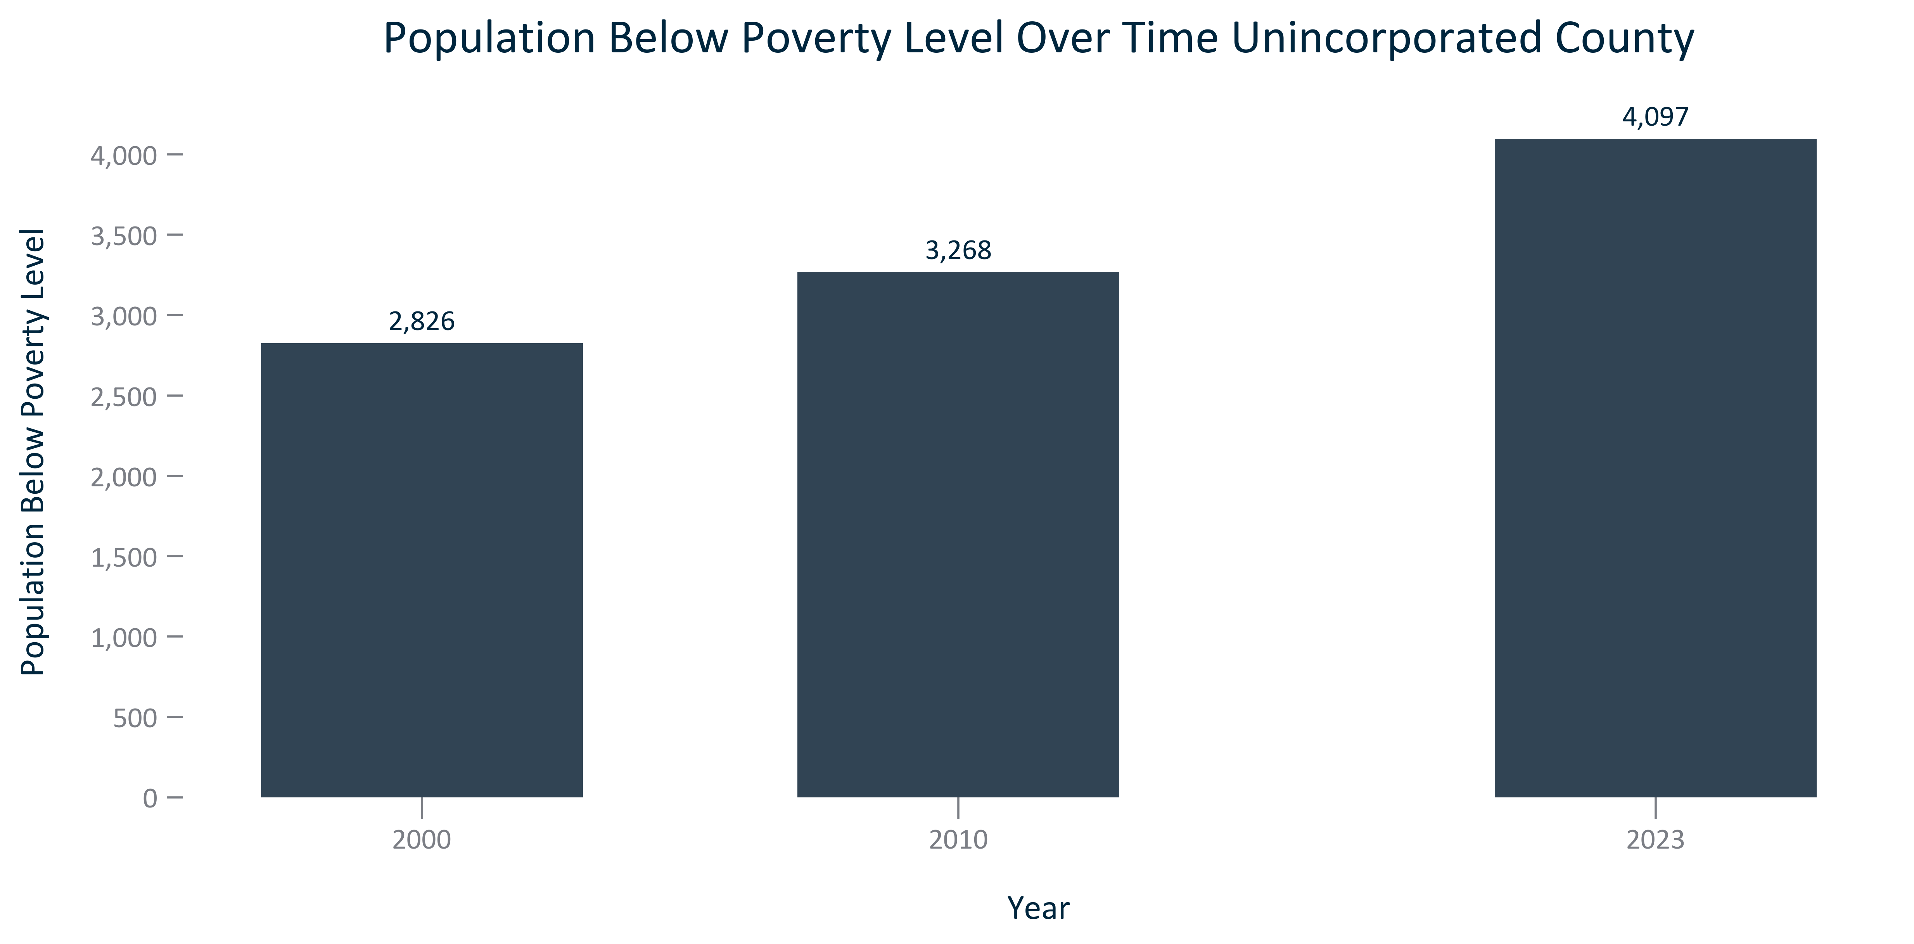

Citation: 2000 Decennial Census, 2006-2010 and 2019 - 2023 American Community Survey 5-Year Estimates

### POVERTY_bar_primarygeo_percentpopulationbelowpovertylevel_overtime:

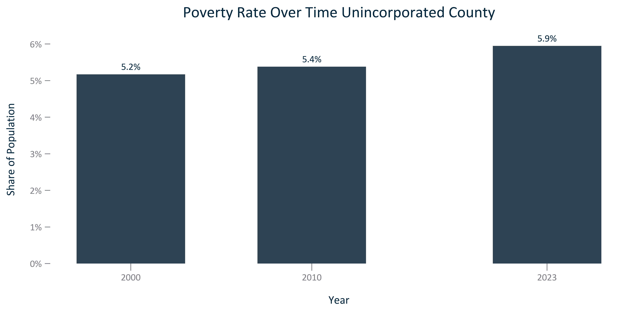

Citation: 2000 Decennial Census, 2006-2010 and 2019 - 2023 American Community Survey 5-Year Estimates

### POVERTY_bar_geocomparative_povertyrate_2023:

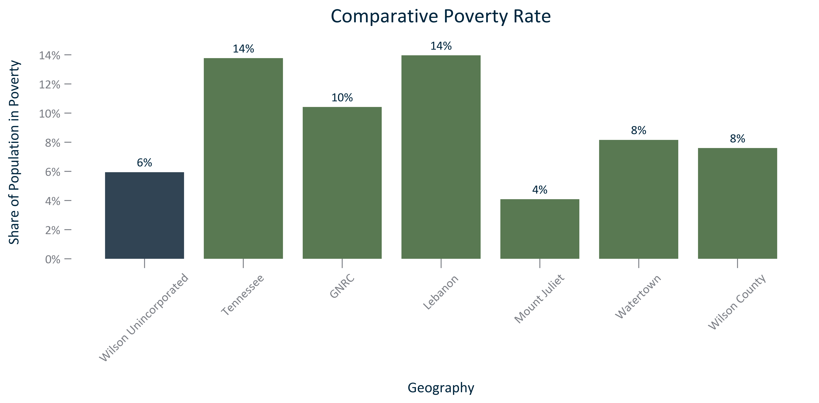

Citation: 2019 - 2023 American Community Survey 5-Year Estimates

### POVERTY_line_geocomparative_sharebelowpovertylevel_overtime:

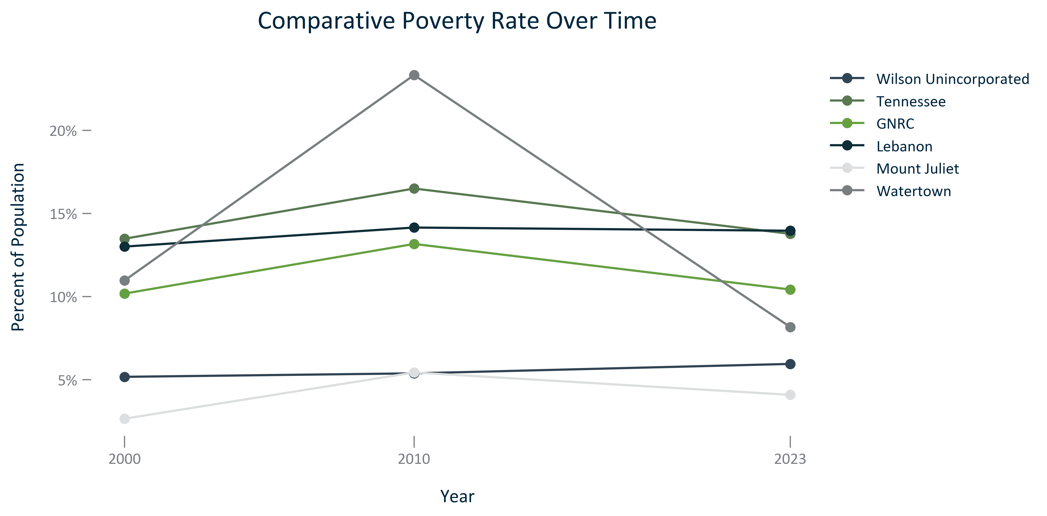

Citation: 2000 Decennial Census, 2006-2010 and 2019 - 2023 American Community Survey 5-Year Estimates

### POVERTY_table_geocomparative_rateandchange_overtime:

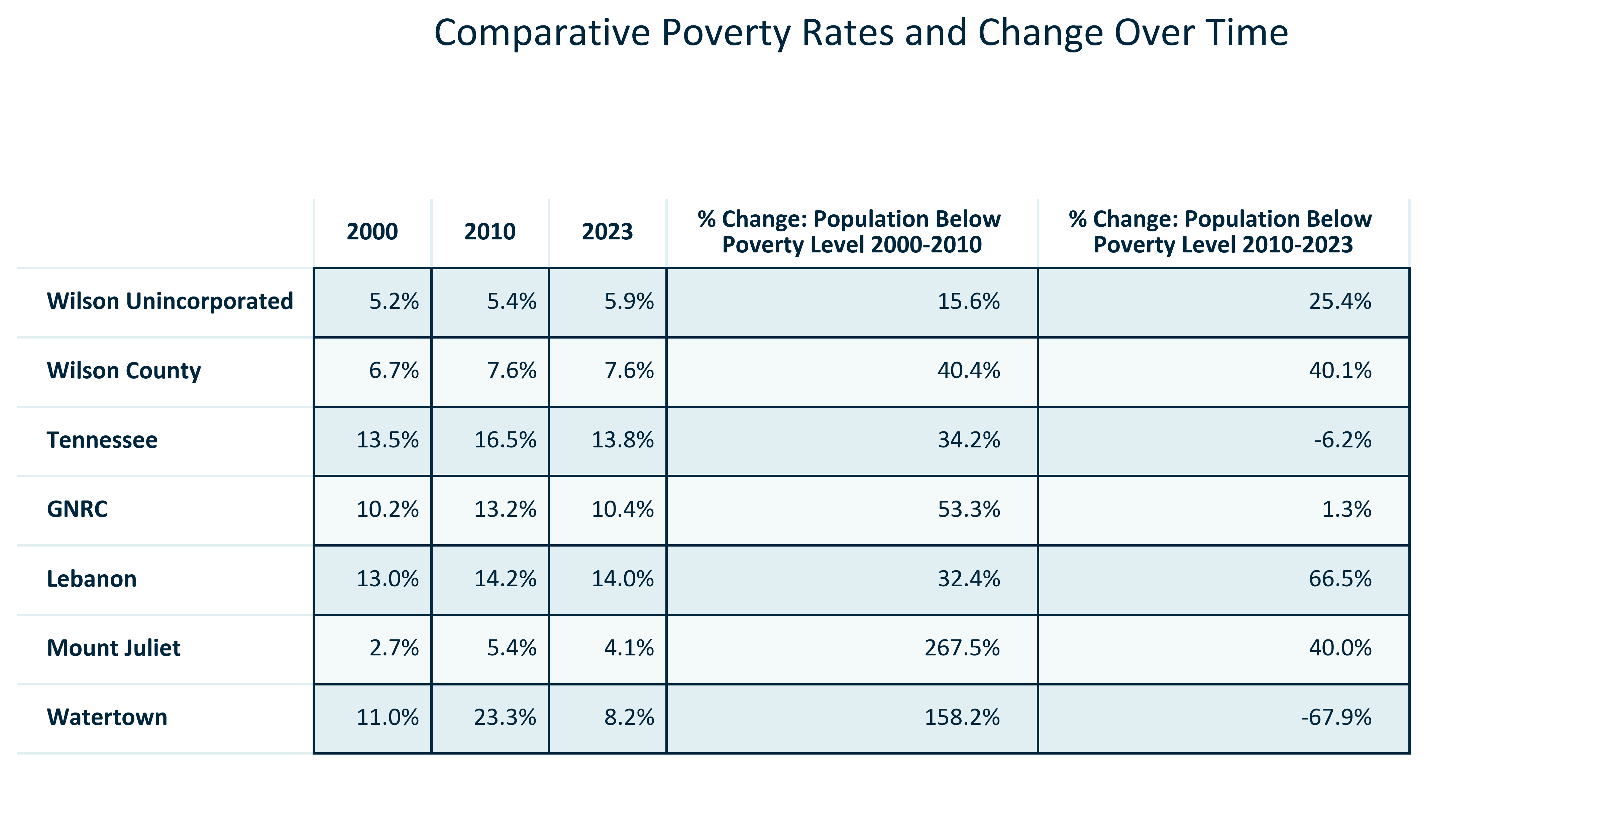

Citation: 2000 Decennial Census, 2006-2010 and 2019 - 2023 American Community Survey 5-Year Estimates

### POVERTY_clusterbar_primarygeo_u18popsharevspovertypopshare_overtime:

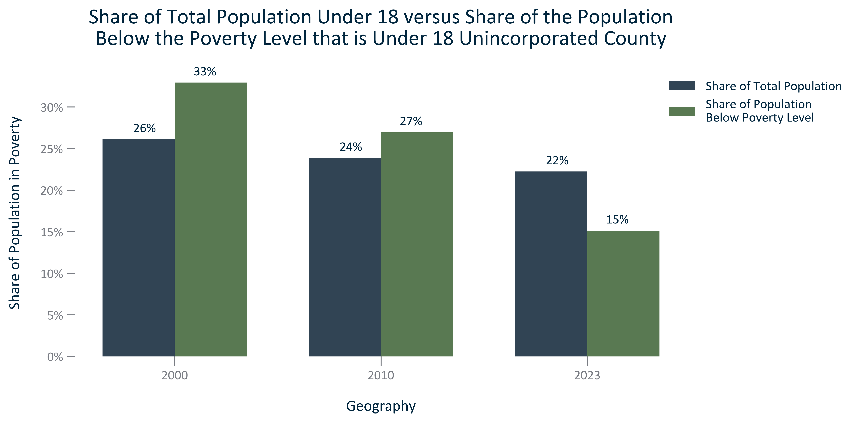

Citation: 2000 Decennial Census, 2006-2010 and 2019 - 2023 American Community Survey 5-Year Estimates

### POVERTY_clusterbar_primarygeo_18to64popsharevspovertypopshare_overtime:

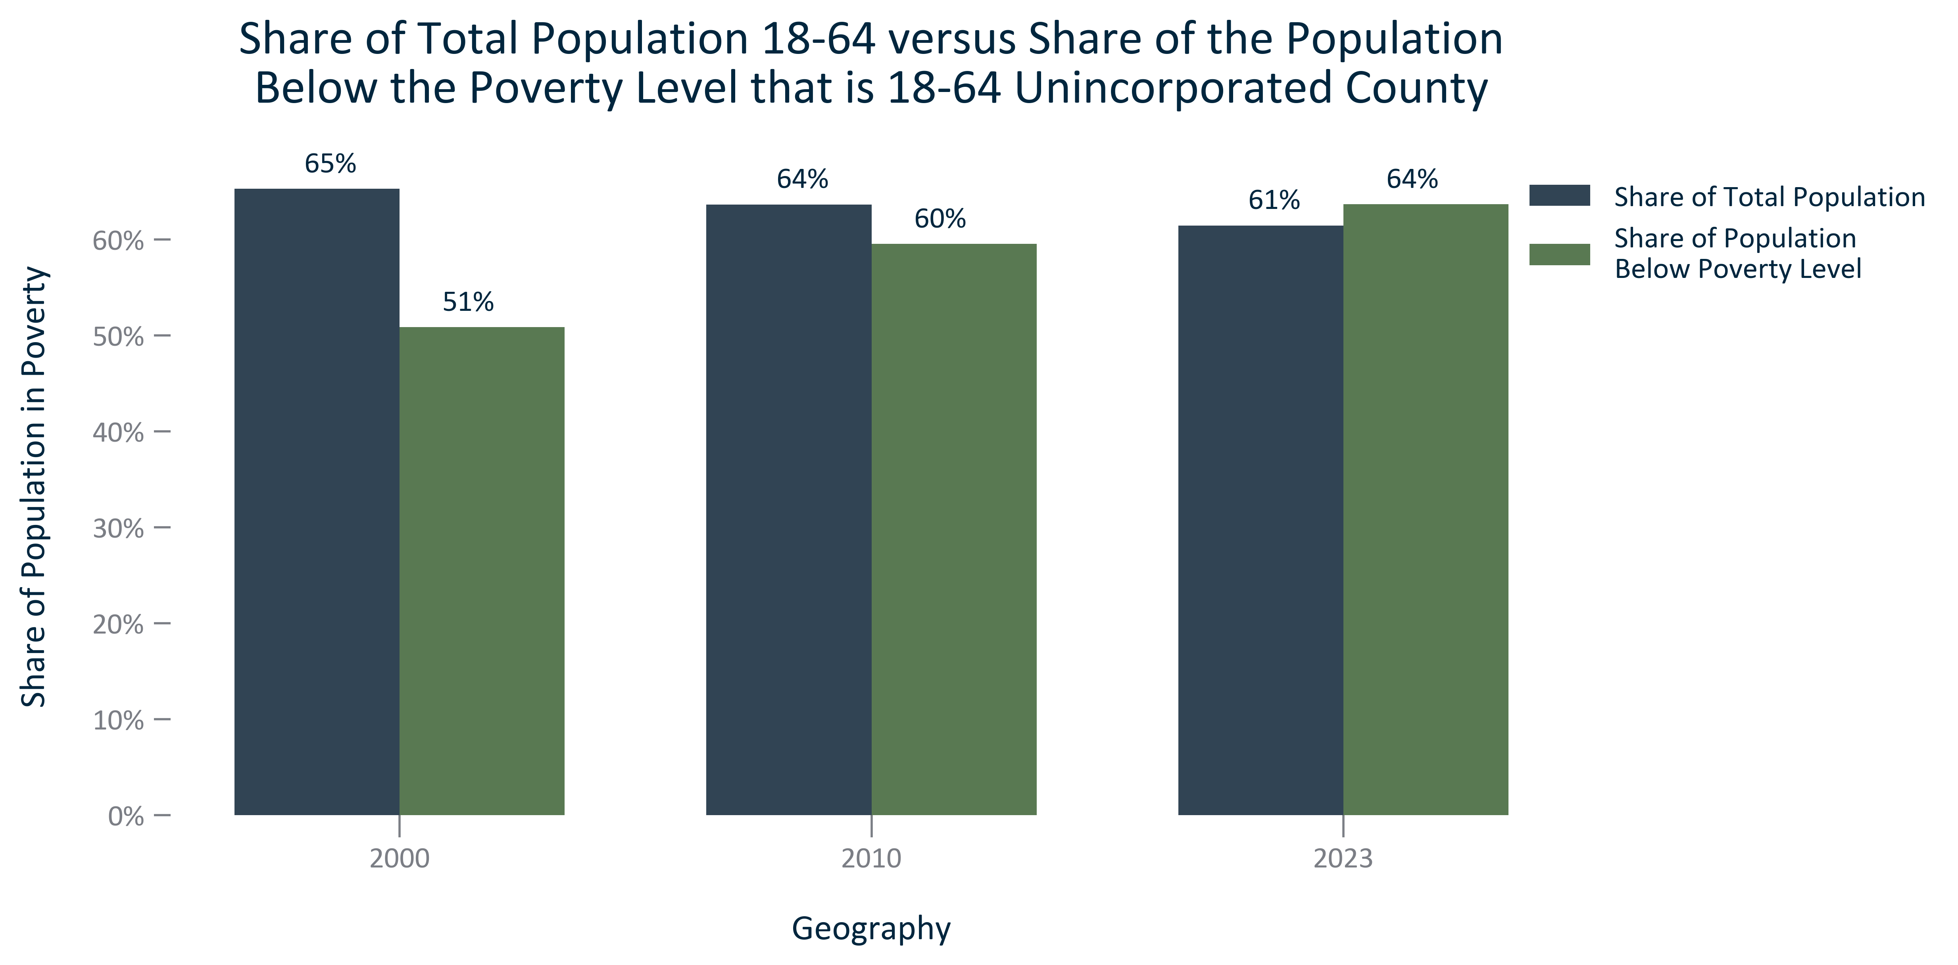

Citation: 2000 Decennial Census, 2006-2010 and 2019 - 2023 American Community Survey 5-Year Estimates

### POVERTY_clusterbar_primarygeo_65overpopsharevspovertypopshare_overtime:

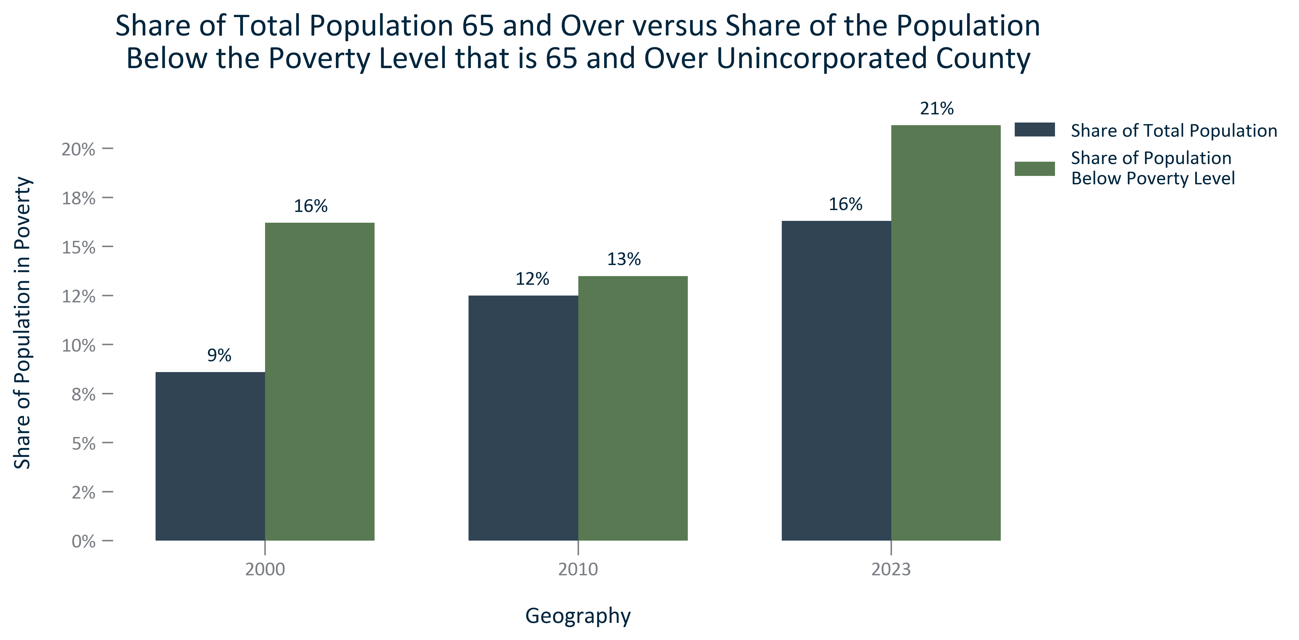

Citation: 2000 Decennial Census, 2006-2010 and 2019 - 2023 American Community Survey 5-Year Estimates

### POVERTY_table_primarygeo_byagegroups_2023:

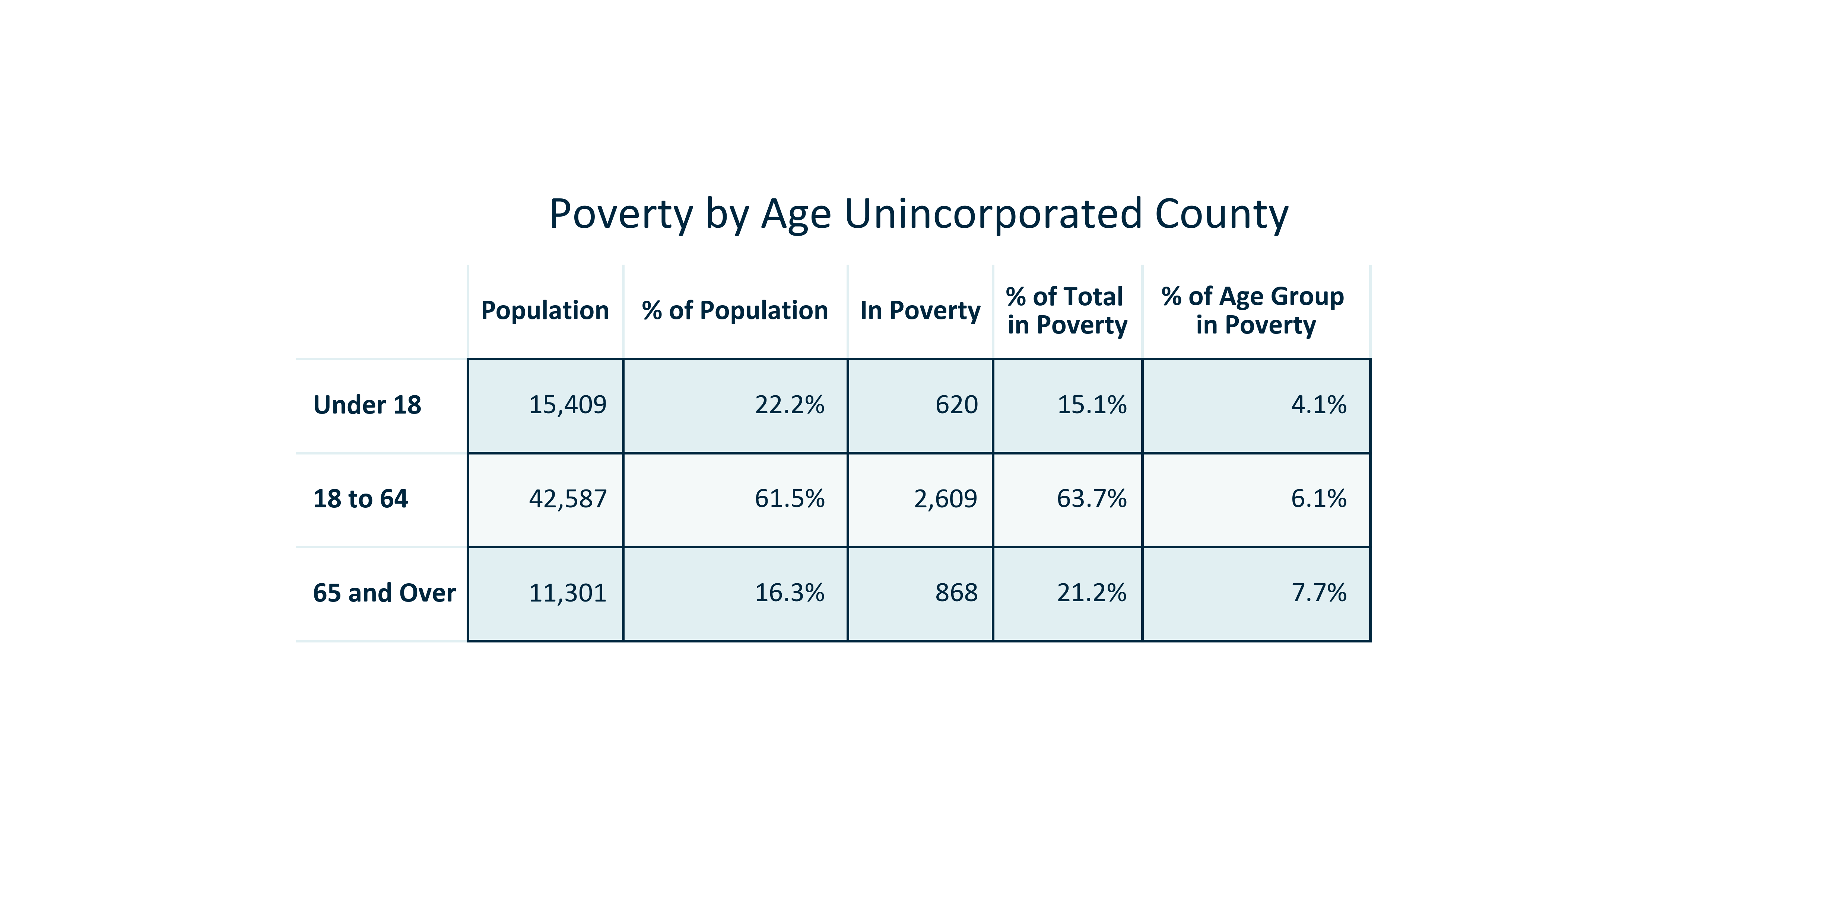

Citation: 2019 - 2023 American Community Survey 5-Year Estimates

### POVERTY_clusterbar_primarygeo_raceethpopulationsharevspovertypopulationshare_2023:

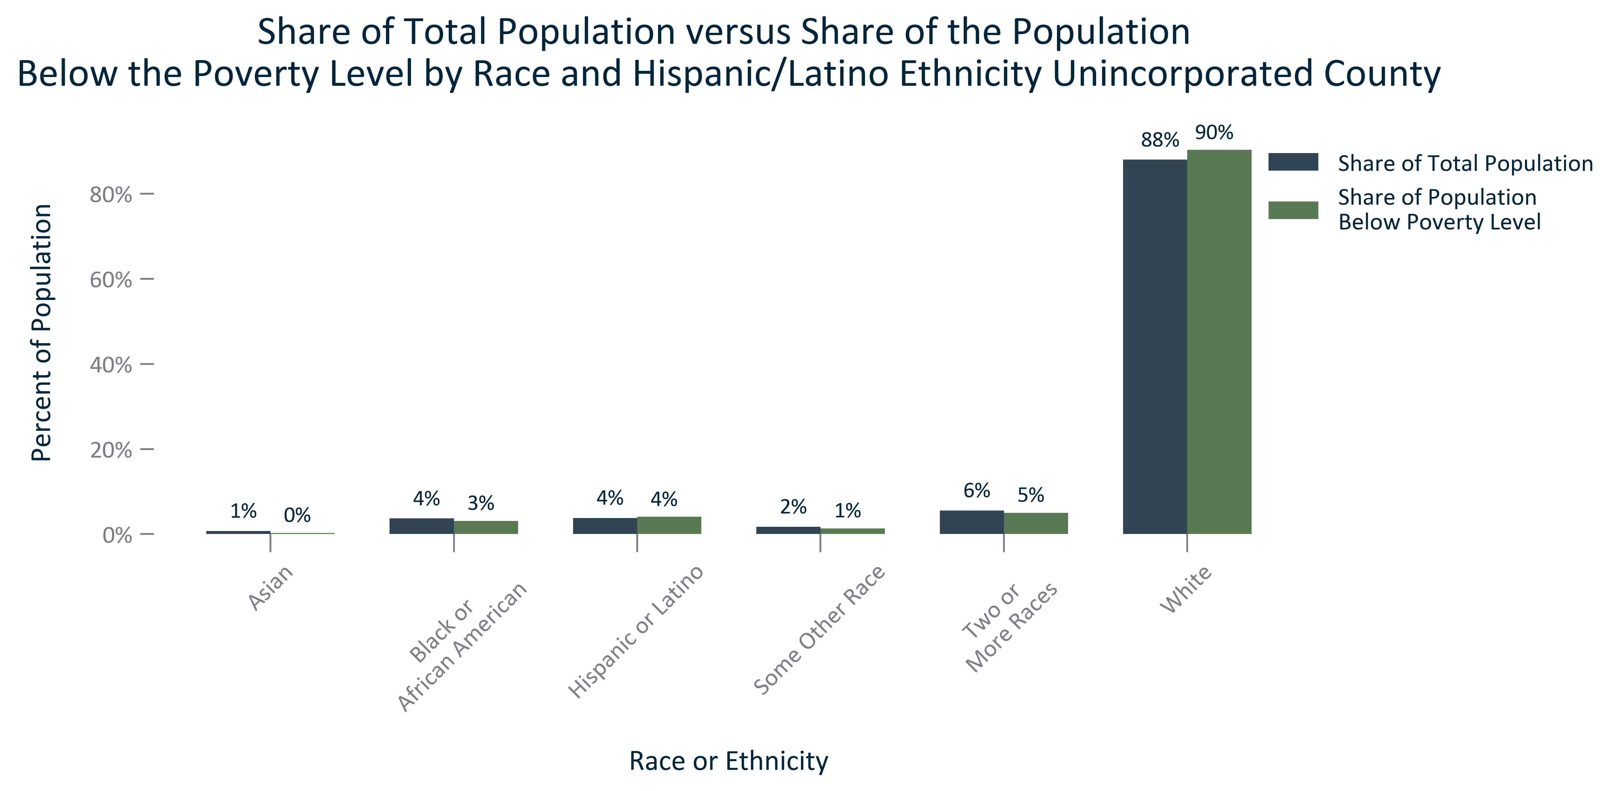

Citation: 2019 - 2023 American Community Survey 5-Year Estimates and 2020 PL.... other races excluded because they make up less than 1% of population

### POVERTY_table_primarygeo_byraceeth_2023:

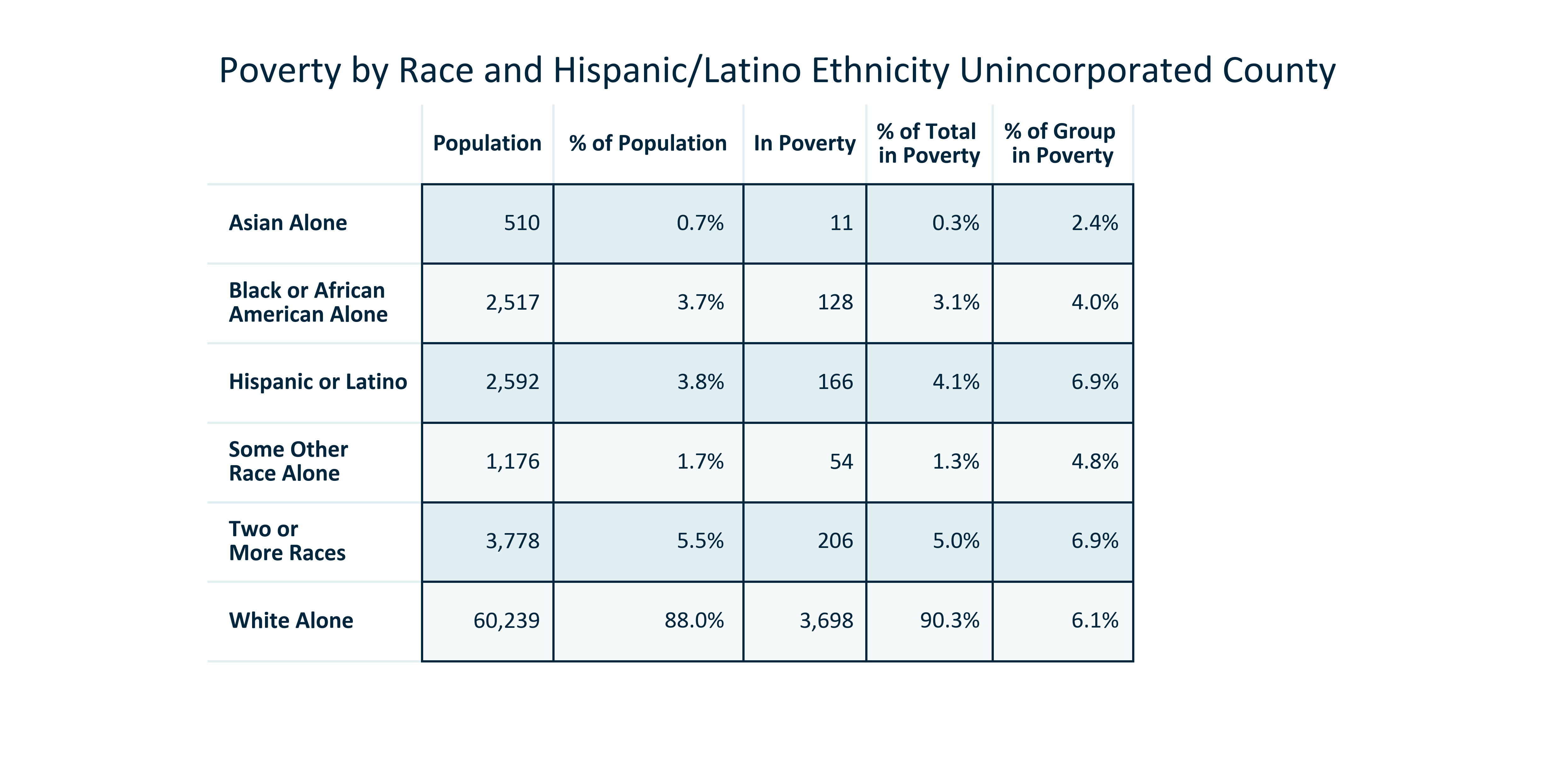

Citation: 2019 - 2023 American Community Survey 5-Year Estimates

# Income

### INCOME_bar_primarygeo_medianhouseholdincome_overtime:

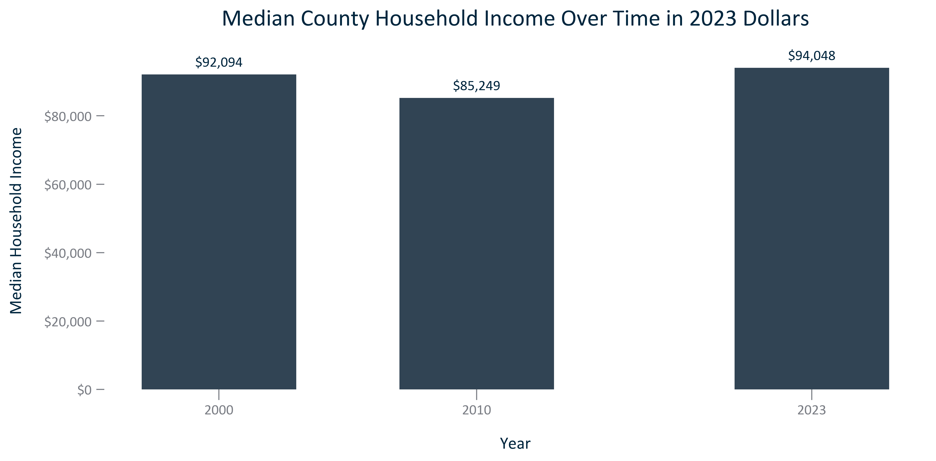

Citation: 2000 Decennial Census, 2006-2010 and 2019 - 2023 American Community Survey 5-Year Estimates in 2023 dollars

### INCOME_bar_primarygeo_medianhhincomedistribution_2023:

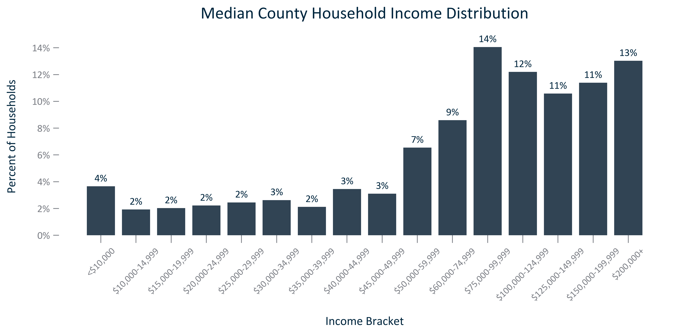

Citation: 2019 - 2023 American Community Survey 5-Year Estimates

### INCOME_table_geocomparative_medianhhincomeandchange_overtime:

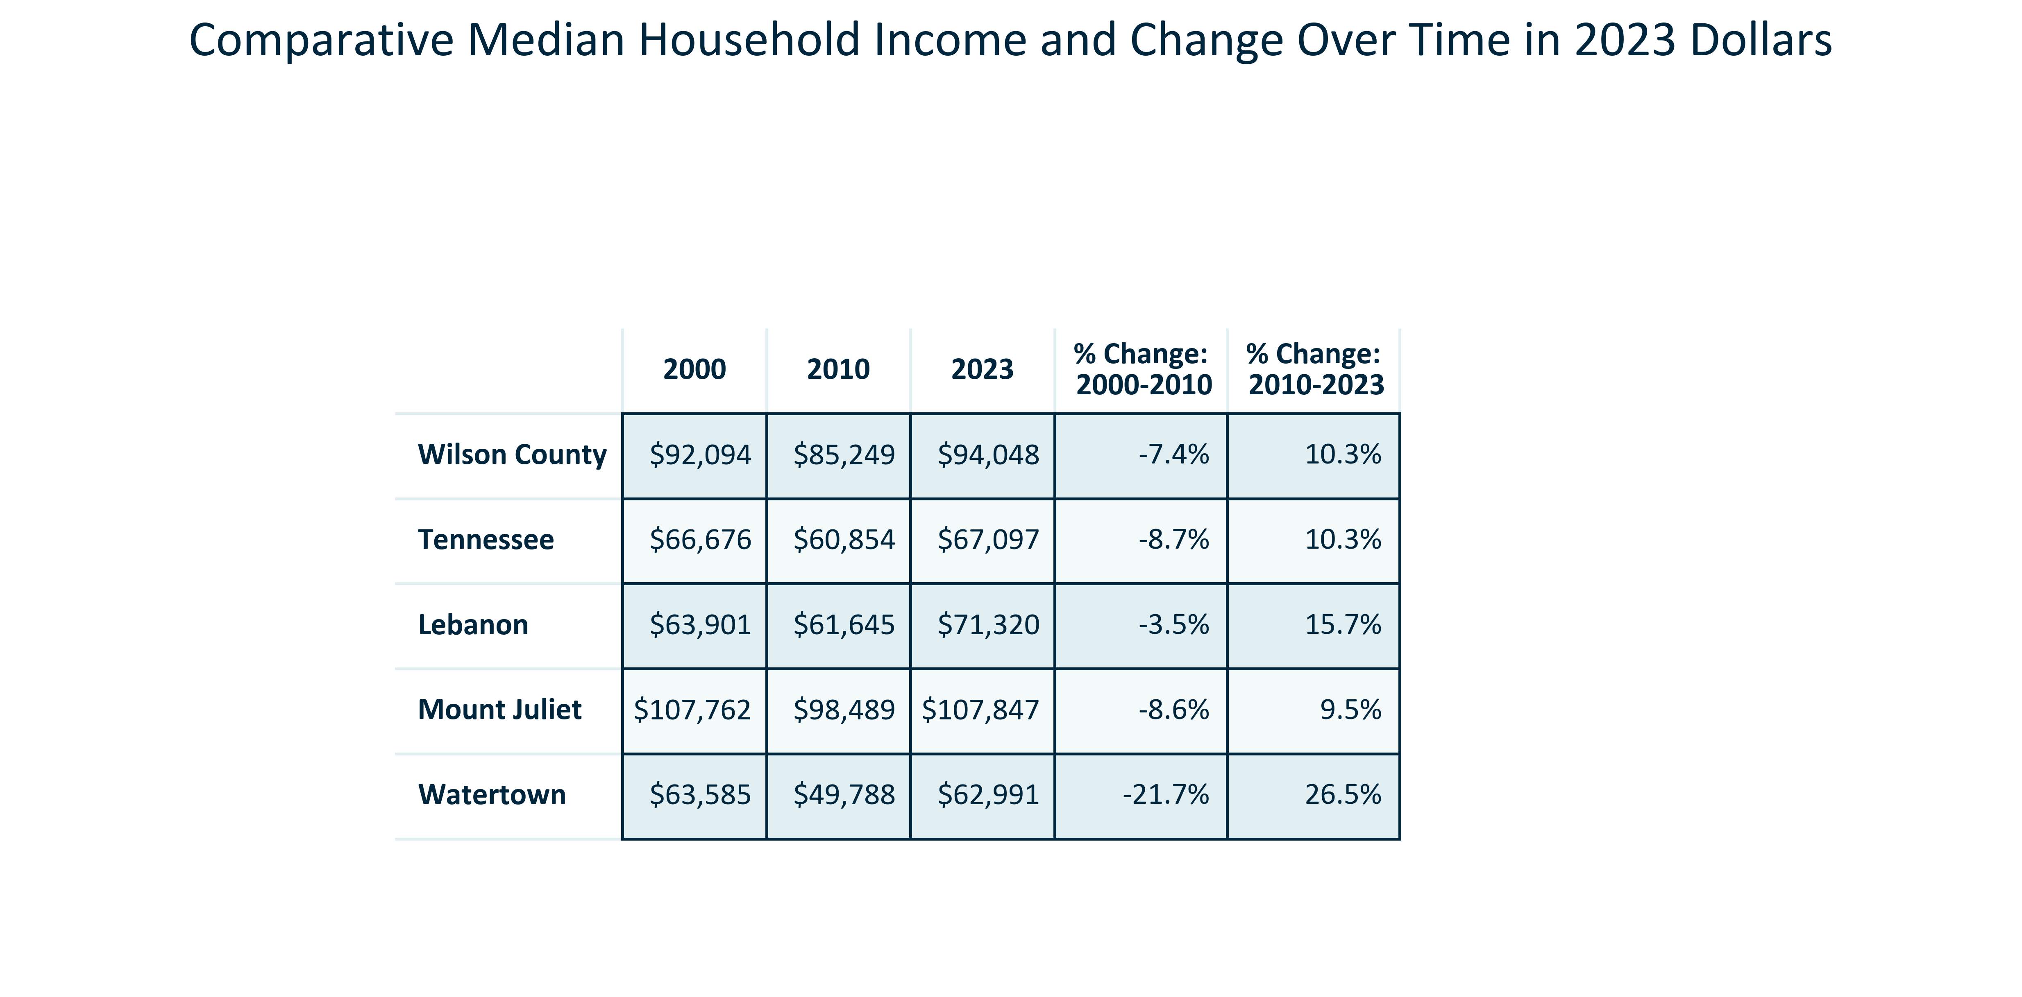

Citation: 2000 Decennial Census, 2006-2010 and 2019 - 2023 American Community Survey 5-Year Estimates in 2023 dollars

### INCOME_bar_geocomparative_changemedianhhincomevsinflation_overtime:

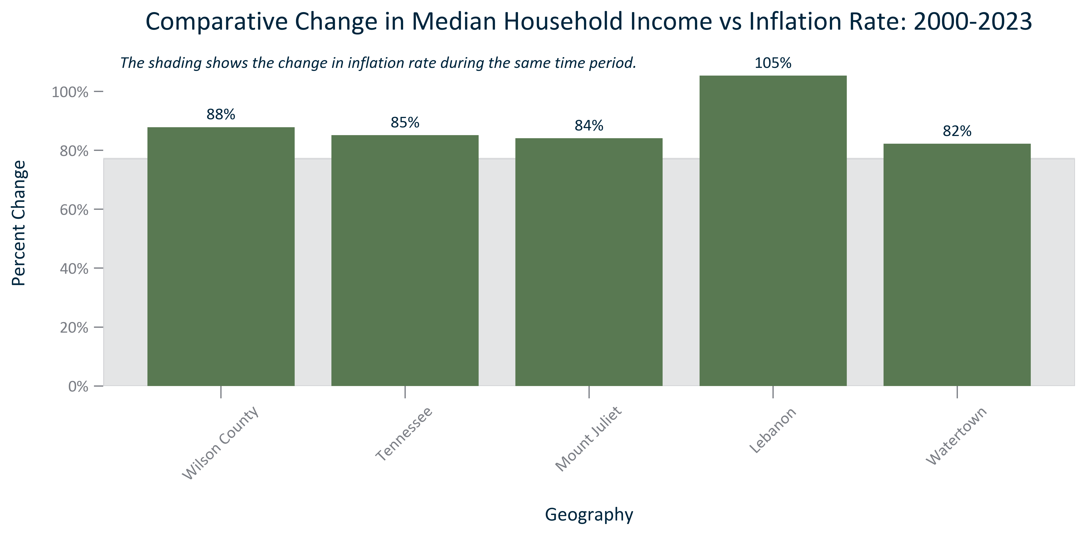

Citation: 2000 Decennial Census, 2019 - 2023 American Community Survey 5-Year Estimates, BLS CPI All Urban Consumers South Region 2000 and 2023

# Households

### HOUSEHOLDS_bar_primarygeo_avgsize_overtime:

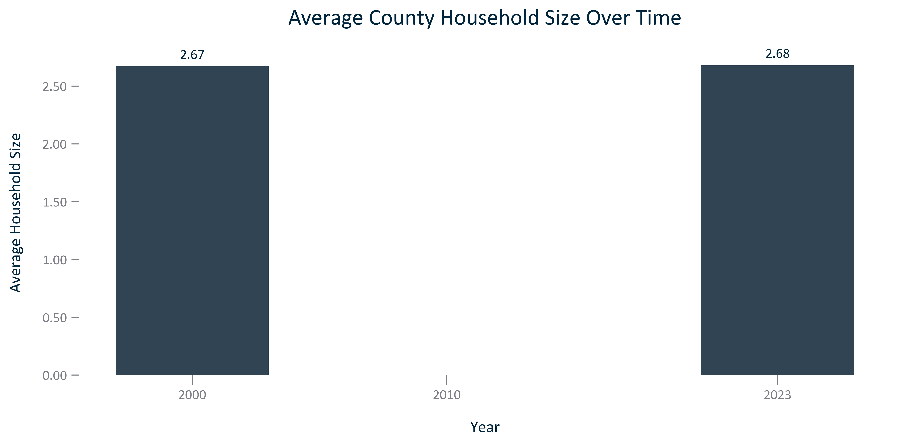

Citation: 2000 Decennial Census, 2006-2010 and 2019 - 2023 American Community Survey 5-Year Estimates

### HOUSEHOLDS_bar_geocomparative_avgsize_2023:

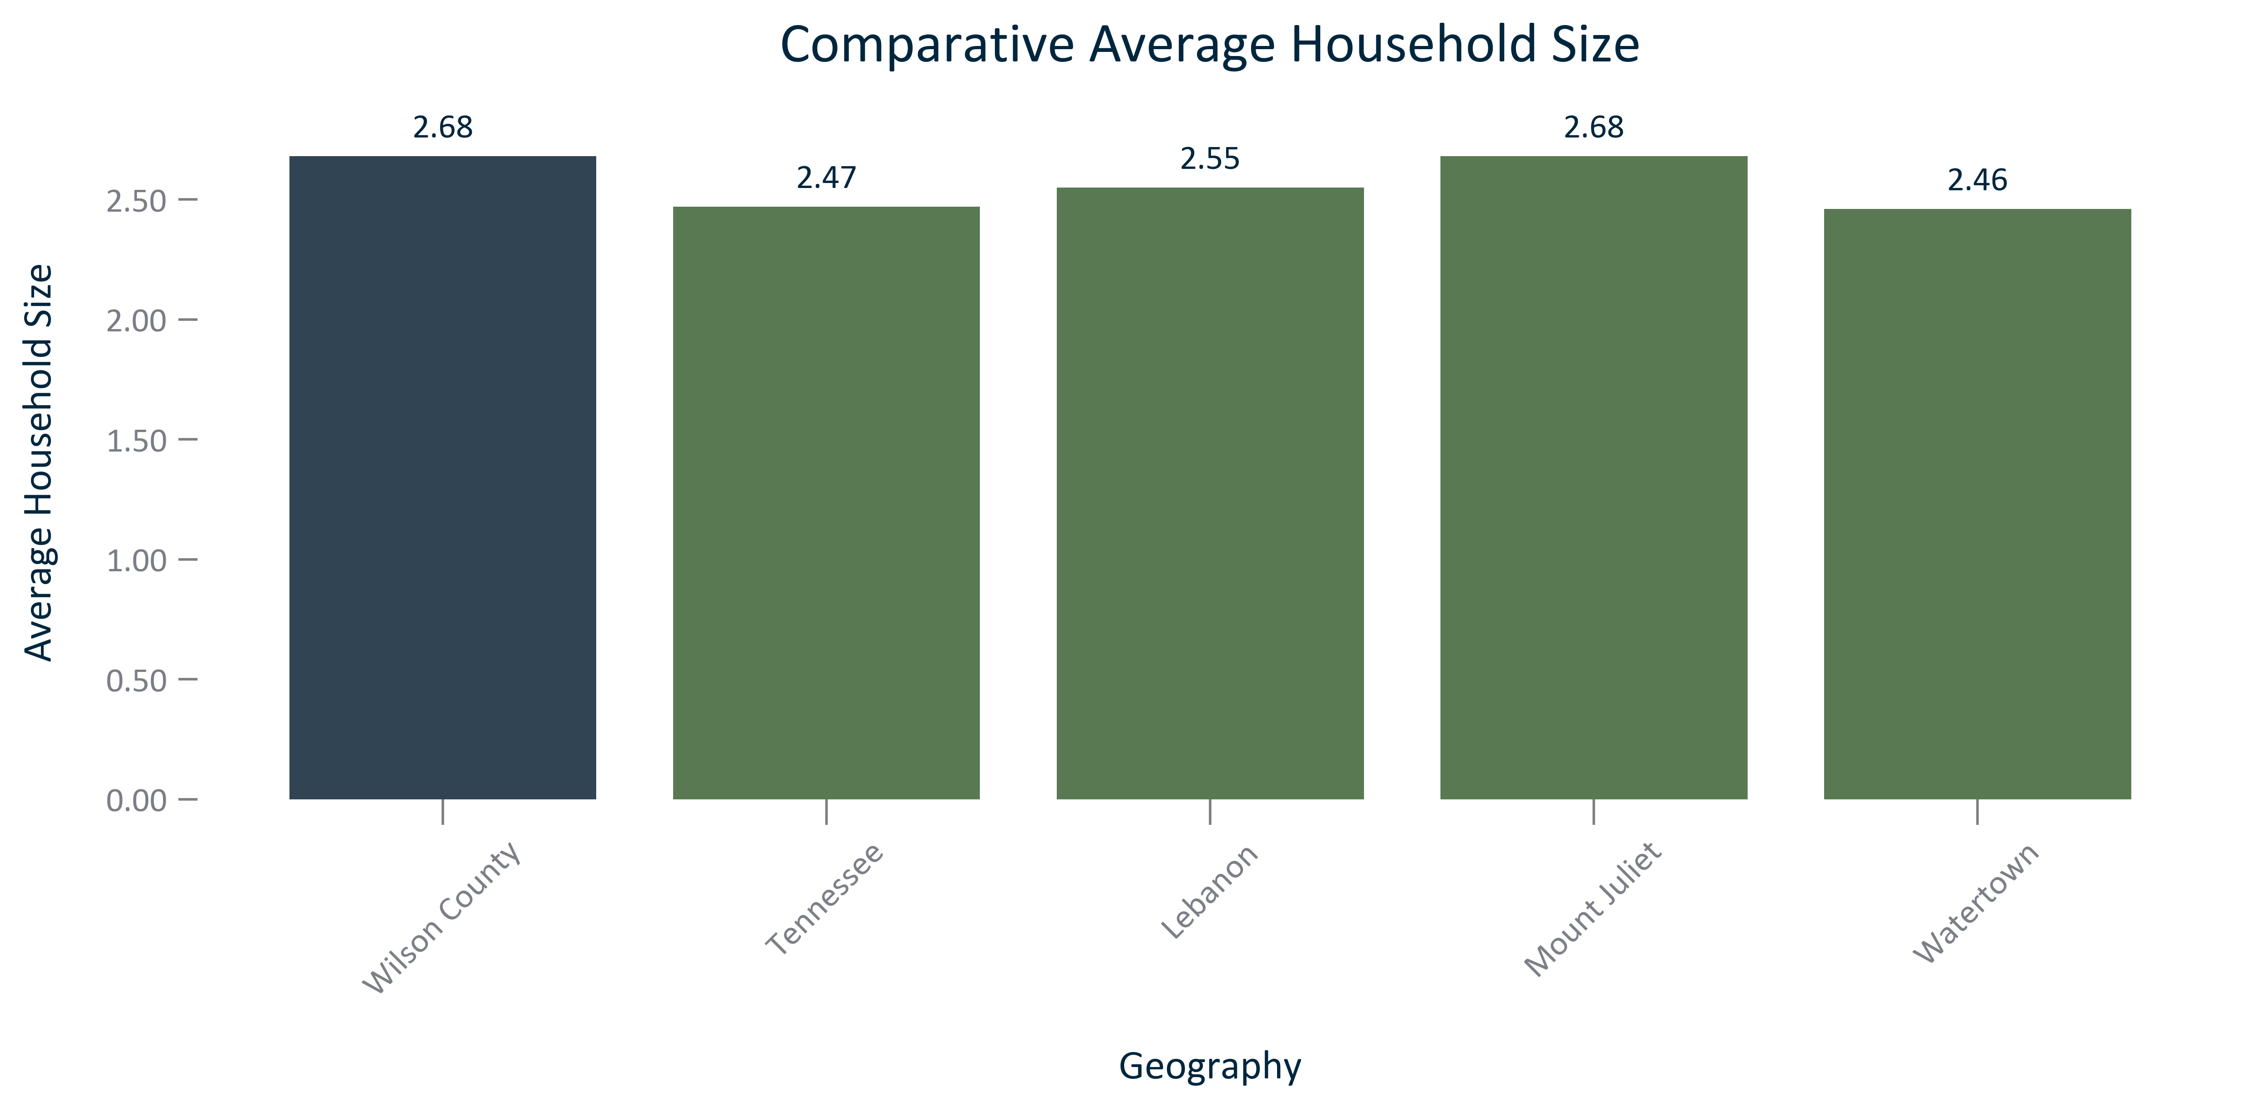

Citation: 2019 - 2023 American Community Survey 5-Year Estimates

### HOUSEHOLDS_line_geocomparative_HUDresidentialpermits_overtime:

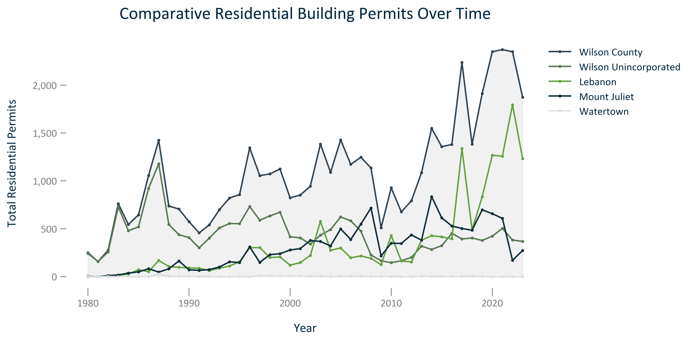

Citation: HUD SOC Data 1980 - 2023

### HOUSEHOLDS_stackedbar_geocomparative_HUDresidentialbuildingtypeandmix_current:

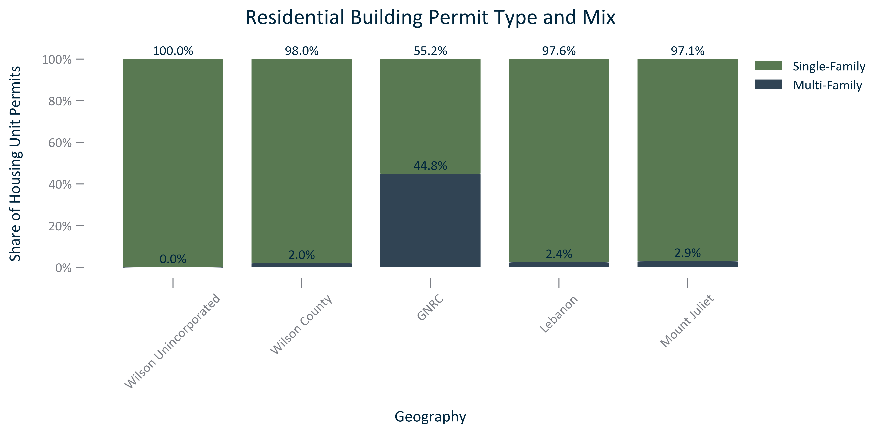

Citation: HUD SOC Data 2023

### HOUSEHOLDS_table_geocomparative_HUDresidentialpermitperunittype_current:

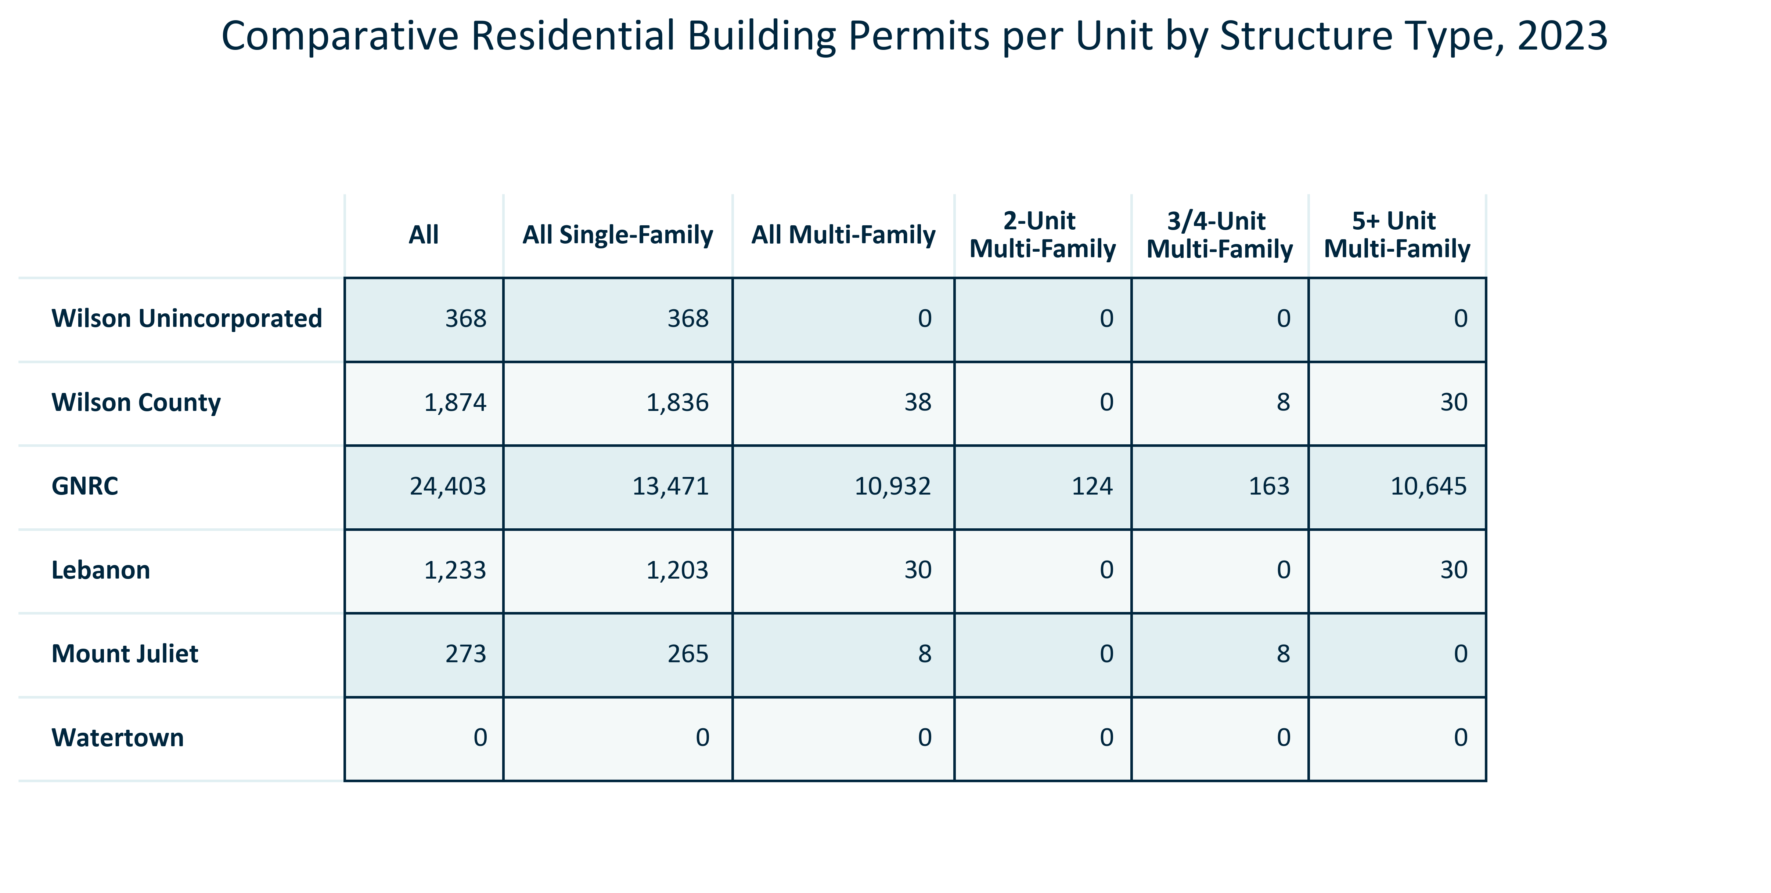

Citation: HUD SOC Data 2023

### HOUSEHOLDS_stackedbar_primarygeo_type_overtime:

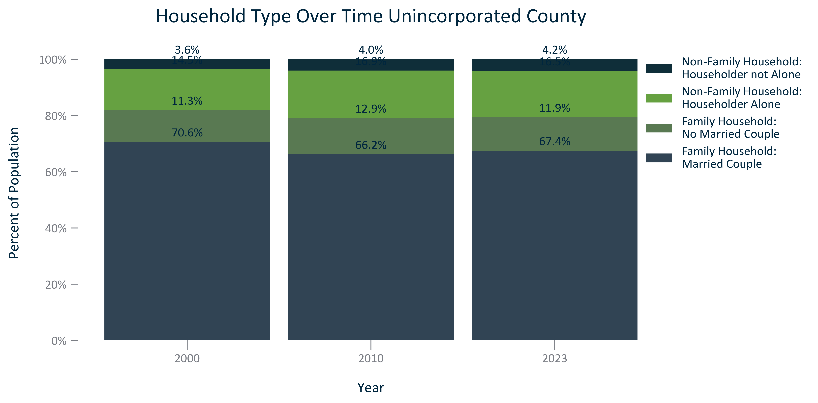

Citation: 2000 and 2010 Decennial Census, 2019 - 2023 American Community Survey 5-Year Estimates

### HOUSEHOLDS_stackedbar_geocomparative_type_2023:

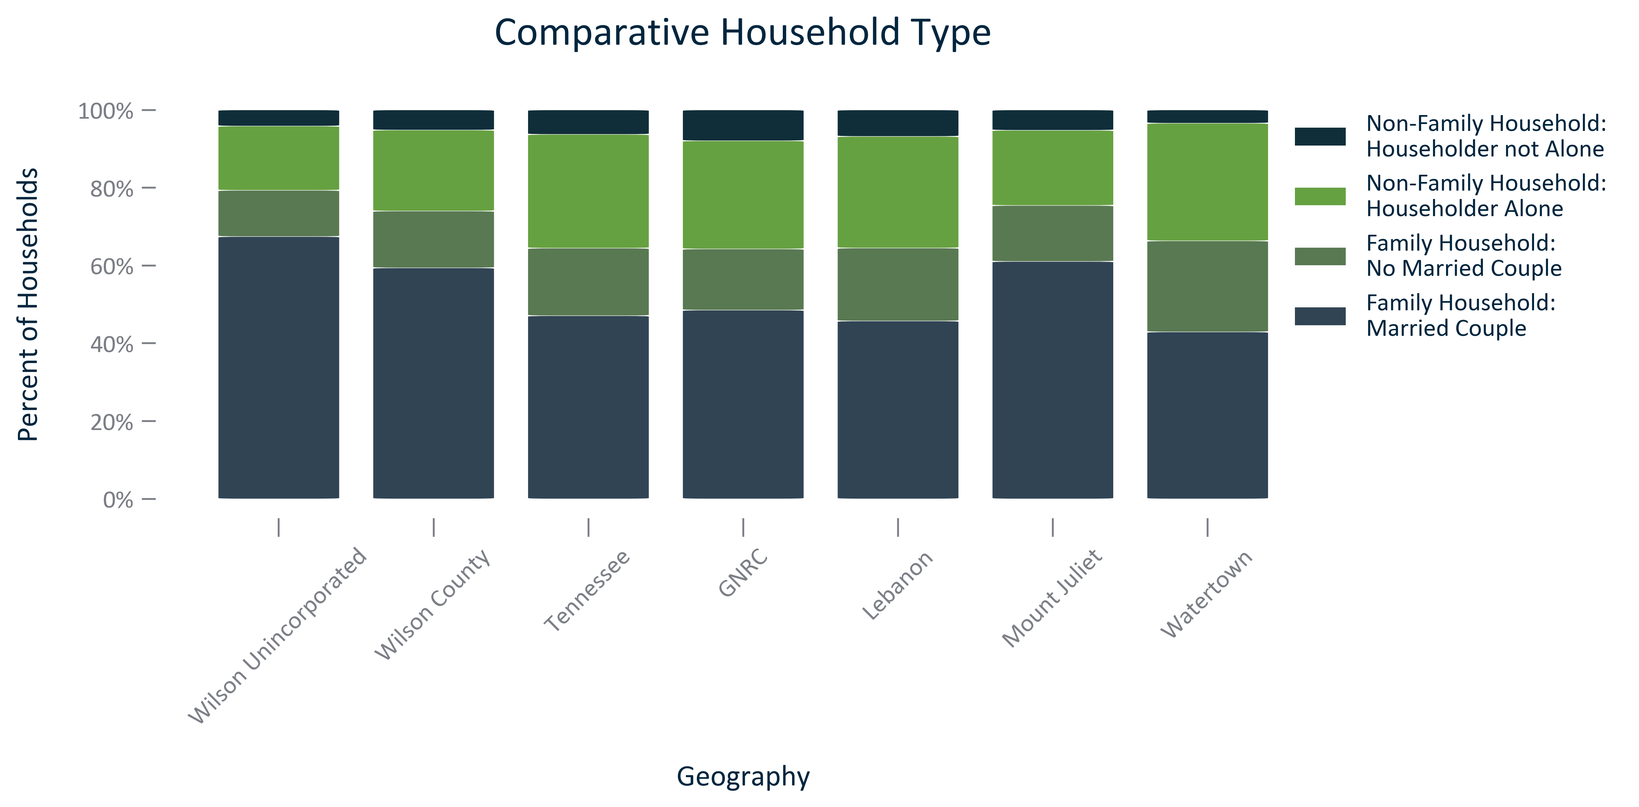

Citation: 2019 - 2023 American Community Survey 5-Year Estimates

### HOUSEHOLDS_table_primarygeo_type_overtime:

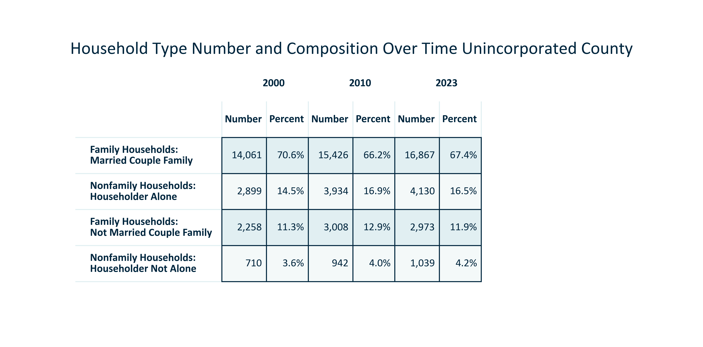

Citation: 2000 and 2010 Decennial Census, 2019 - 2023 American Community Survey 5-Year Estimates

### HOUSEHOLDS_bar_primarygeo_ageofhousingstock_2023:

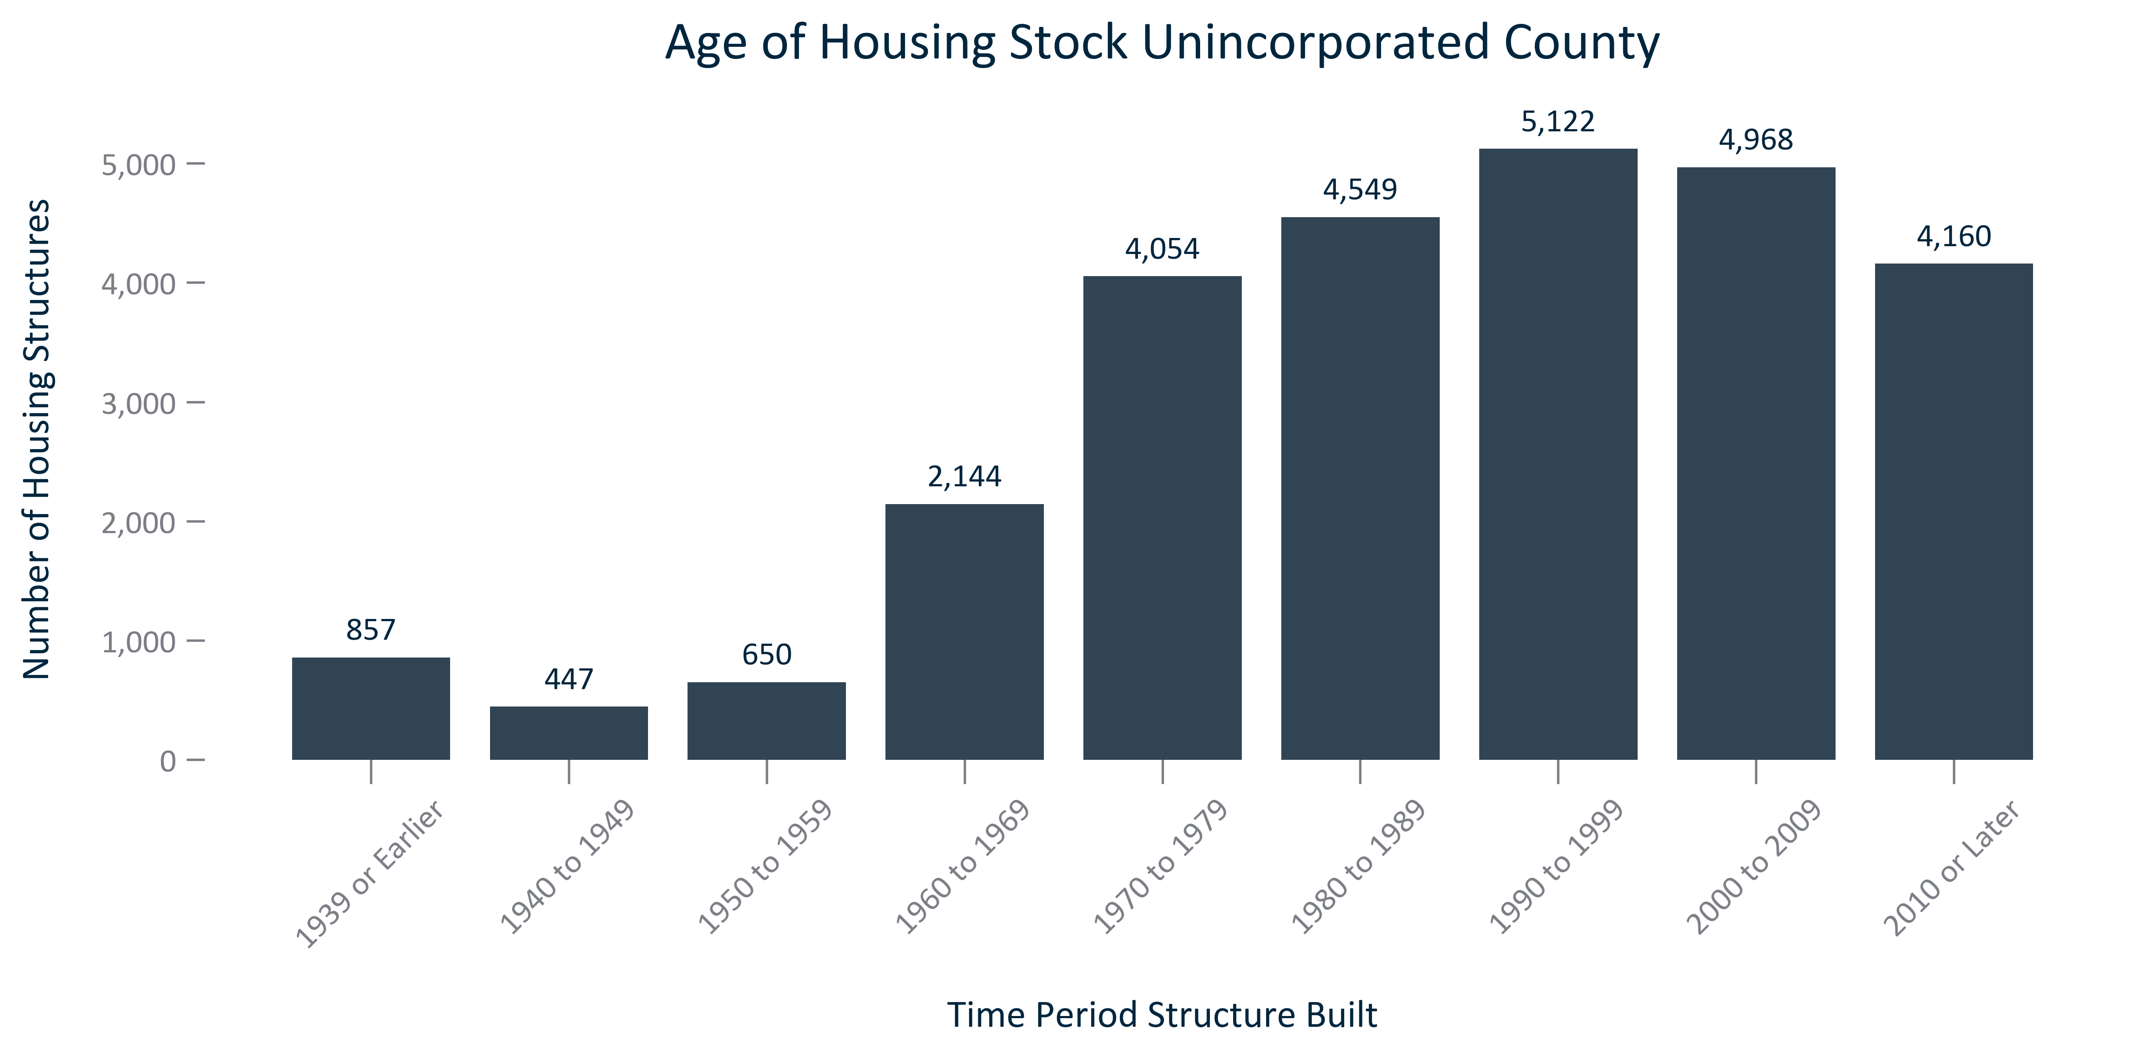

Citation: 2019 - 2023 American Community Survey 5-Year Estimates

### HOUSEHOLDS_table_geocomparative_medianyearbuiltandageforresidentialstructures_2023:

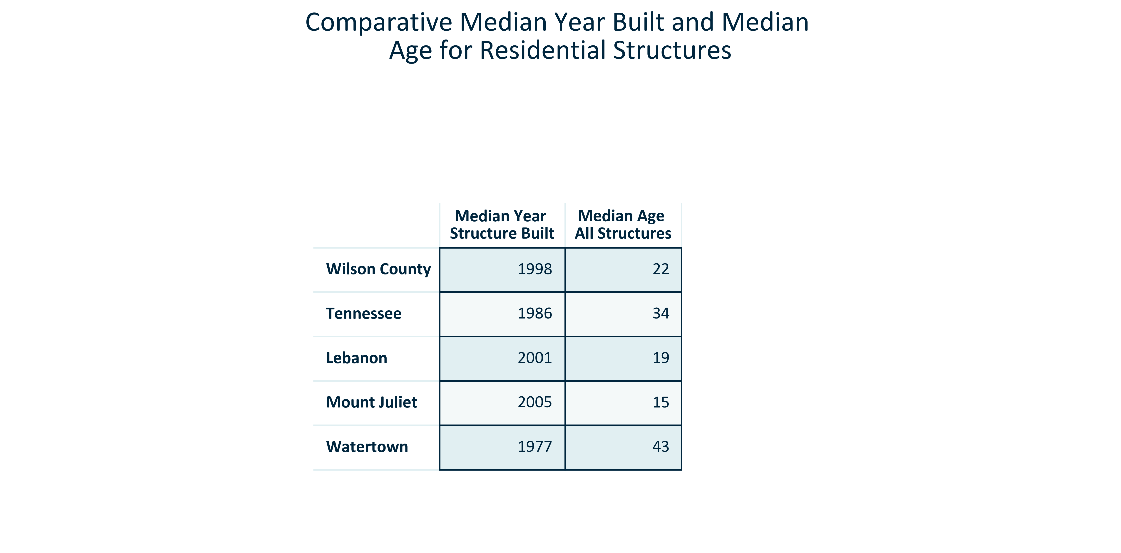

Citation: 2019 - 2023 American Community Survey 5-Year Estimates

### HOUSEHOLDS_bar_primarygeo_changeinunitsbytype_overtime:

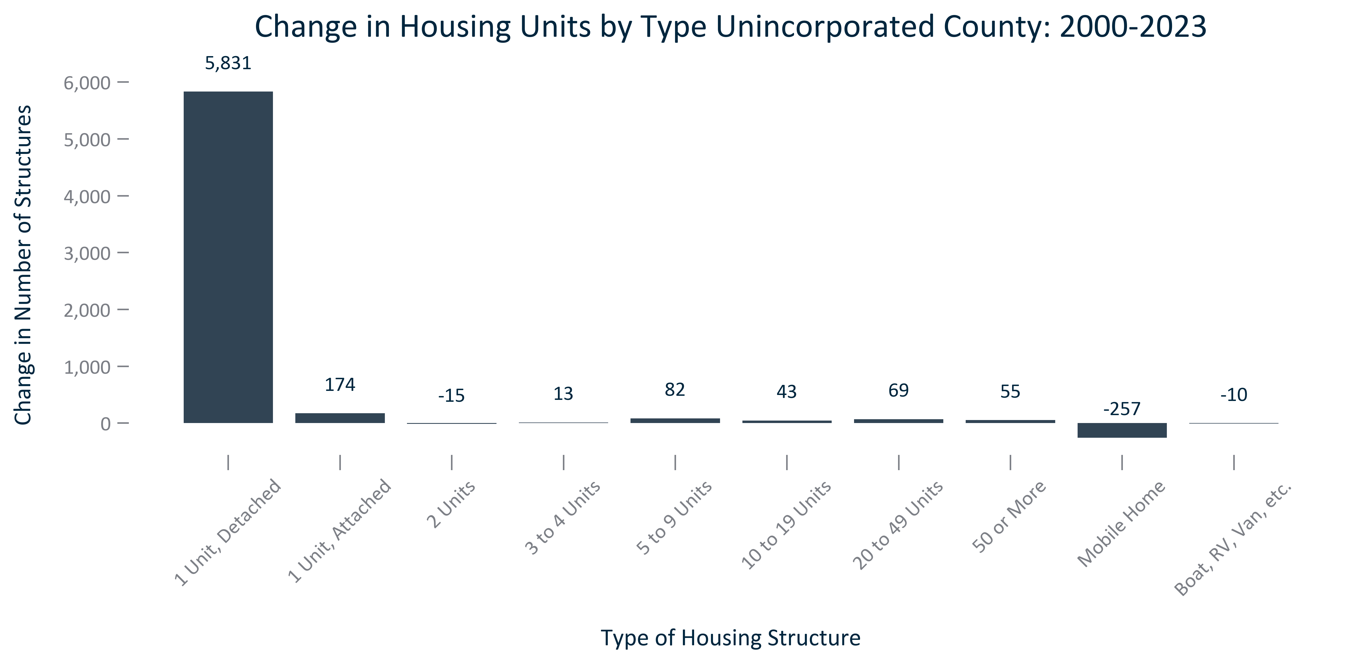

Citation: 2000 Decennial Census, 2019 - 2023 American Community Survey 5-Year Estimates

# Vacancy

### VACANCY_bar_primarygeo_vacantunits_overtime:

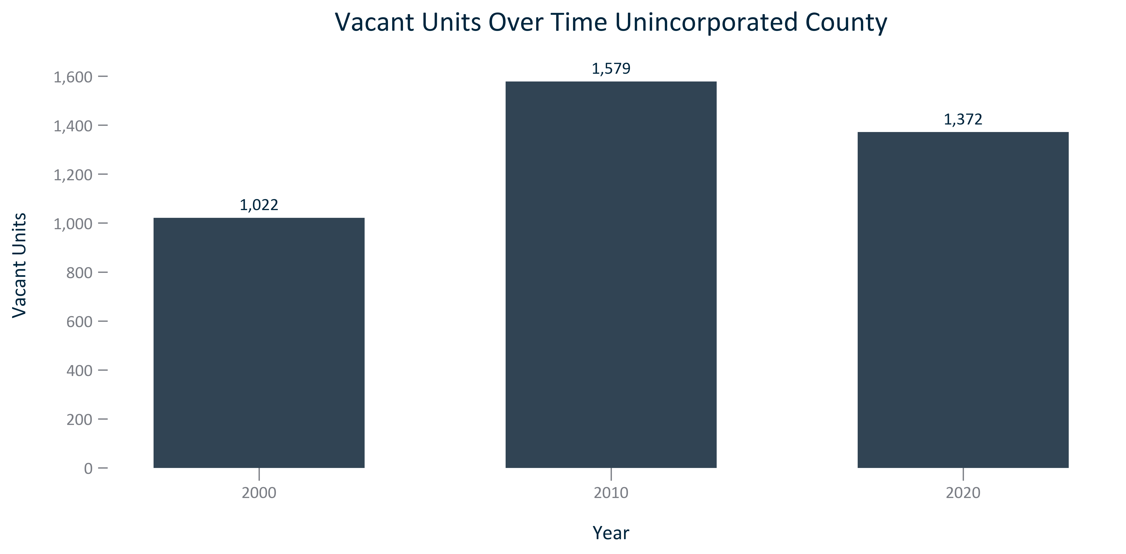

Citation: 2000, 2010, and 2020 Decennial Census

### VACANCY_bar_primarygeo_vacancyrate_overtime:

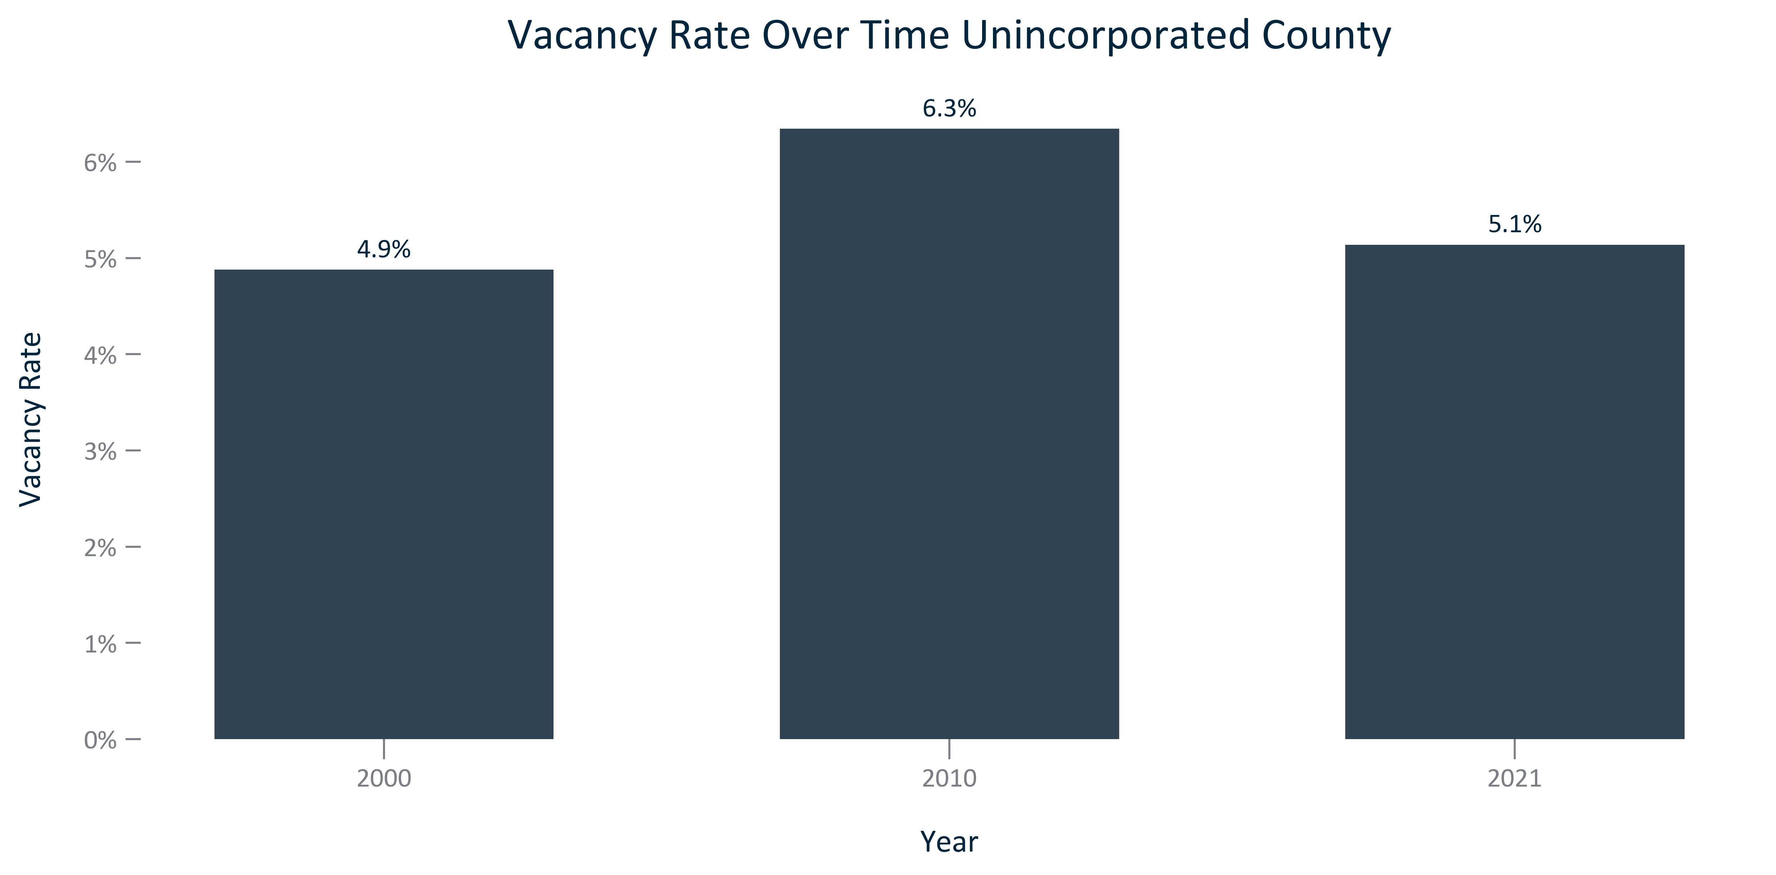

Citation: 2000, 2010, and 2020 Decennial Census

### VACANCY_bar_geocomparative_vacantunits_2020:

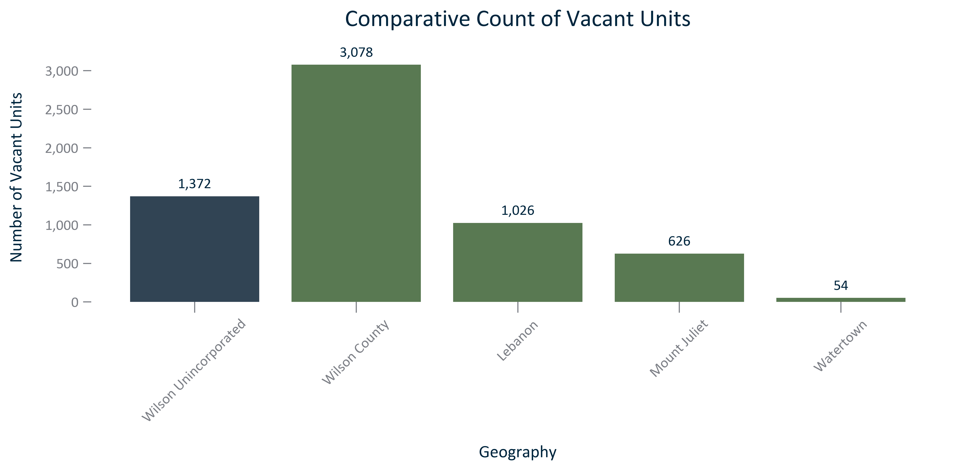

Citation: 2020 Decennial Census

### VACANCY_bar_geocomparative_vacancyrate_2020:

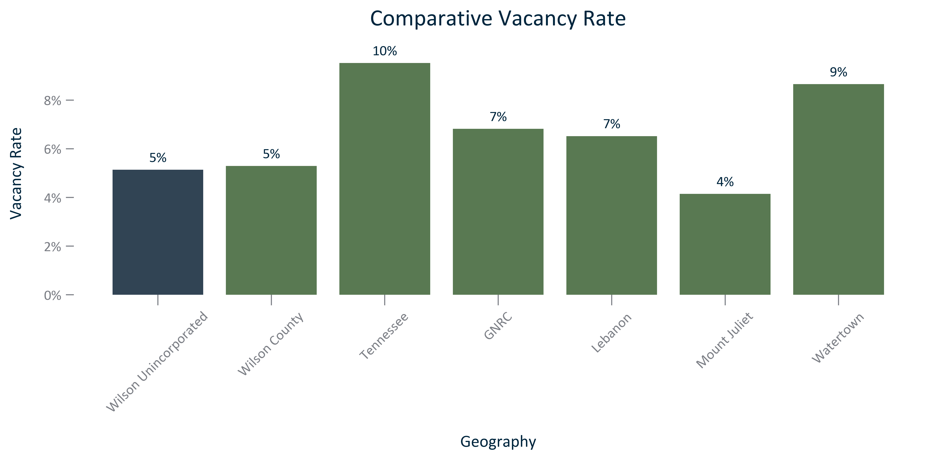

Citation: 2020 Decennial Census

### VACANCY_table_geocomparative_vacancyratesandchange_overtime:

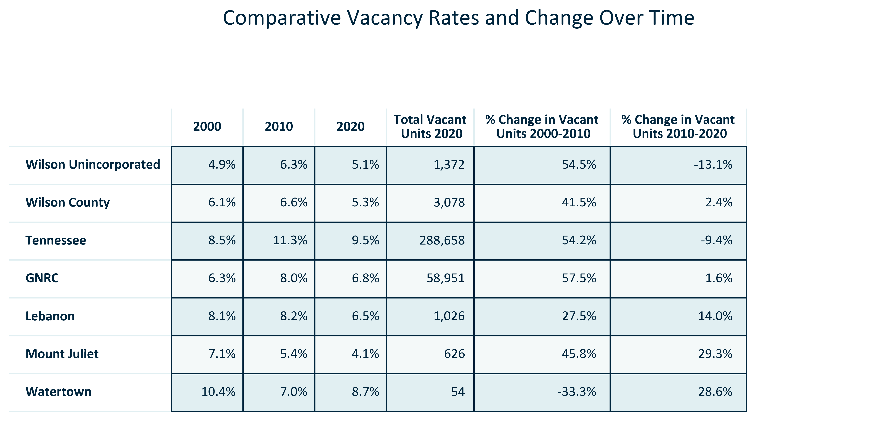

Citation: 2000, 2010, and 2020 Decennial Census

# Tenure & Cost

### TENURECOST_stackedbar_primarygeo_shareownvsrent_overtime:

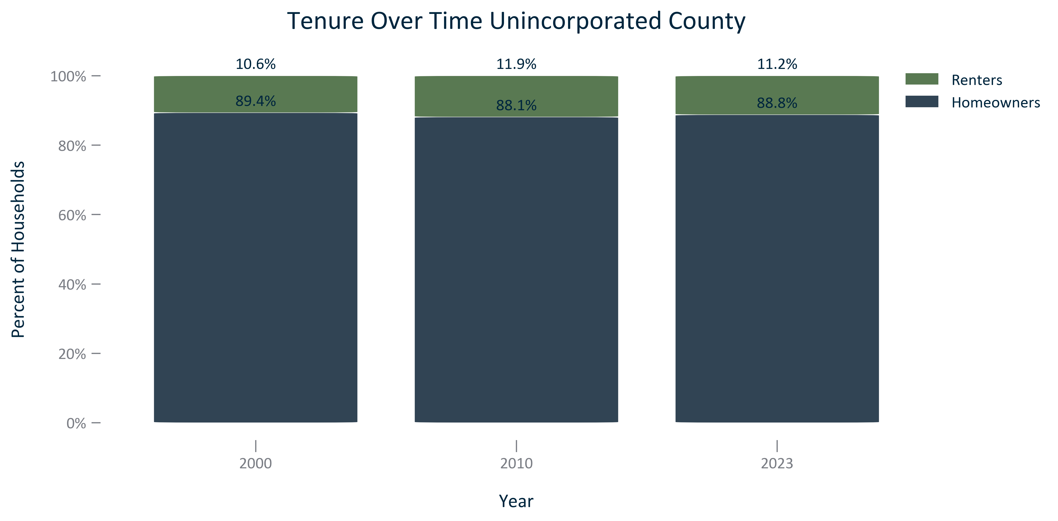

Citation: 2000 Decennial Census, 2006-2010 and 2019 - 2023 American Community Survey 5-Year Estimates

### TENURECOST_stackedbar_primarygeo_mortgagestatus_overtime:

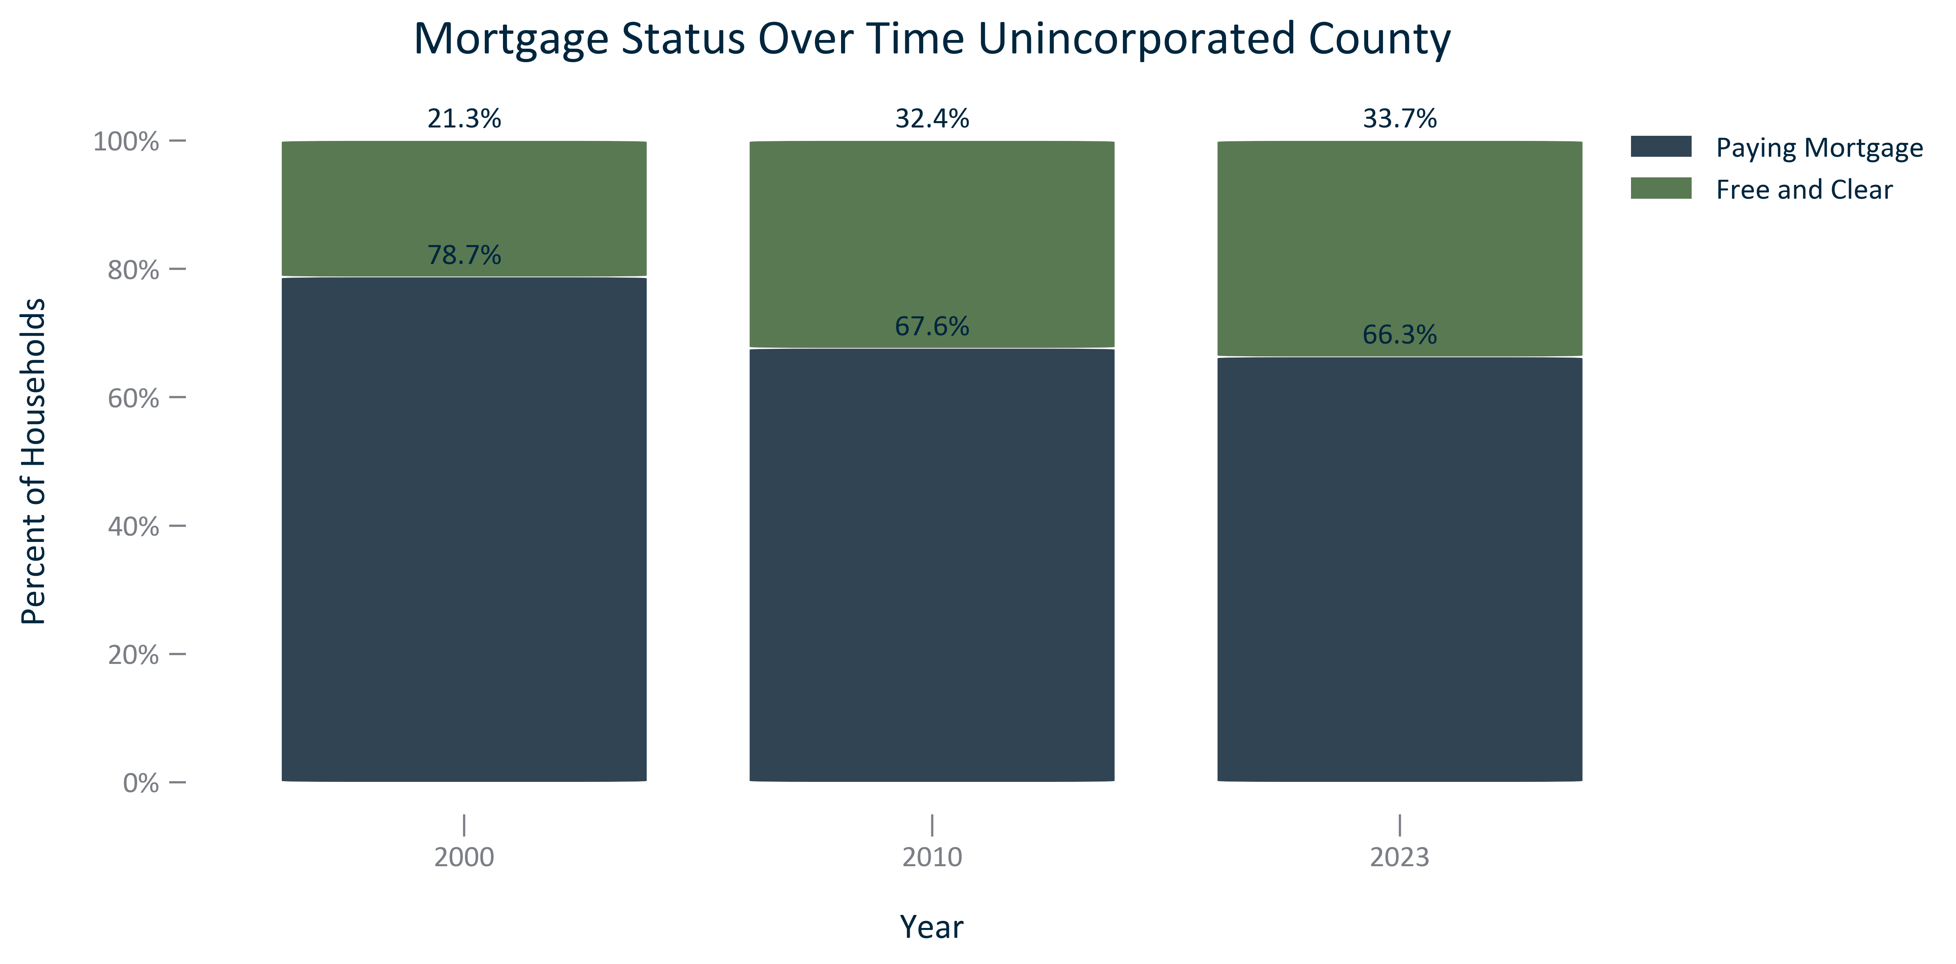

Citation: 2000 Decennial Census, 2006-2010 and 2019 - 2023 American Community Survey 5-Year Estimates

### TENURECOST_bar_geocomparative_homeownershiprate_2023:

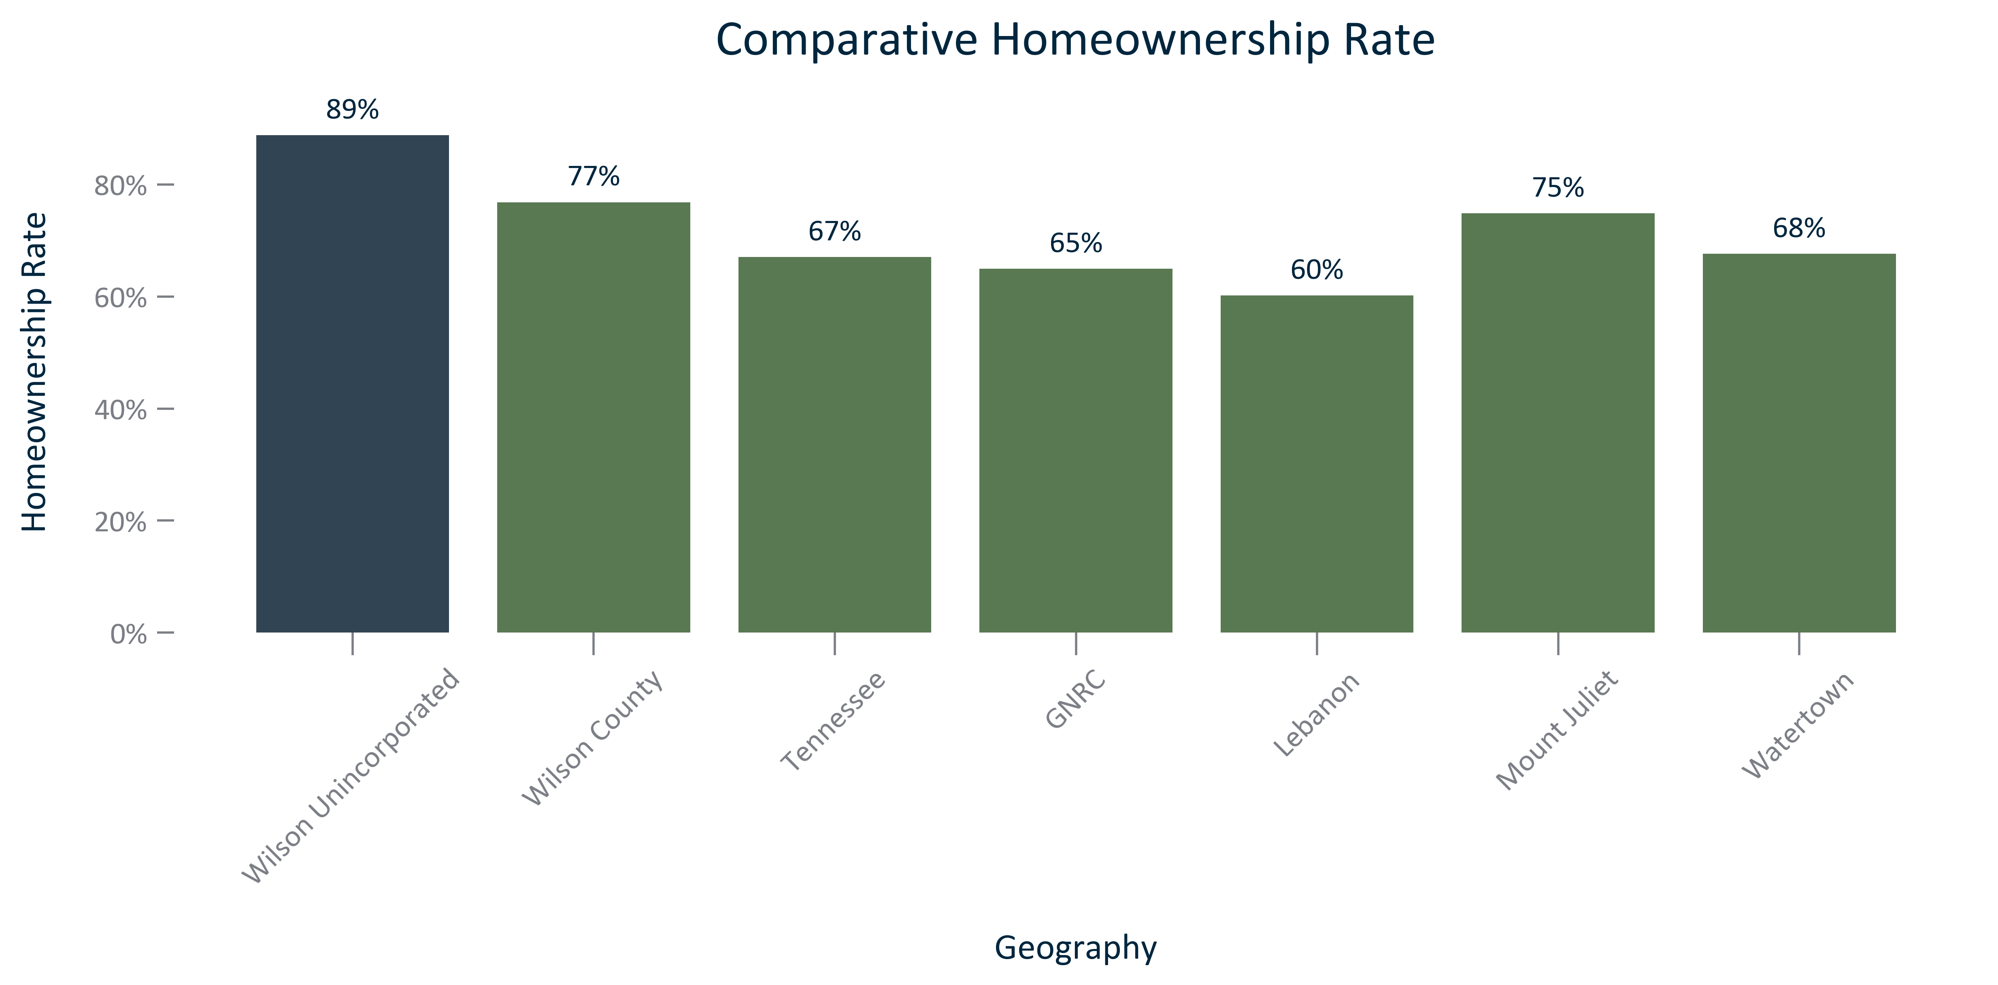

Citation: 2019 - 2023 American Community Survey 5-Year Estimates

### TENURECOST_clusterbar_geocomparative_homeownershiprate_overtime:

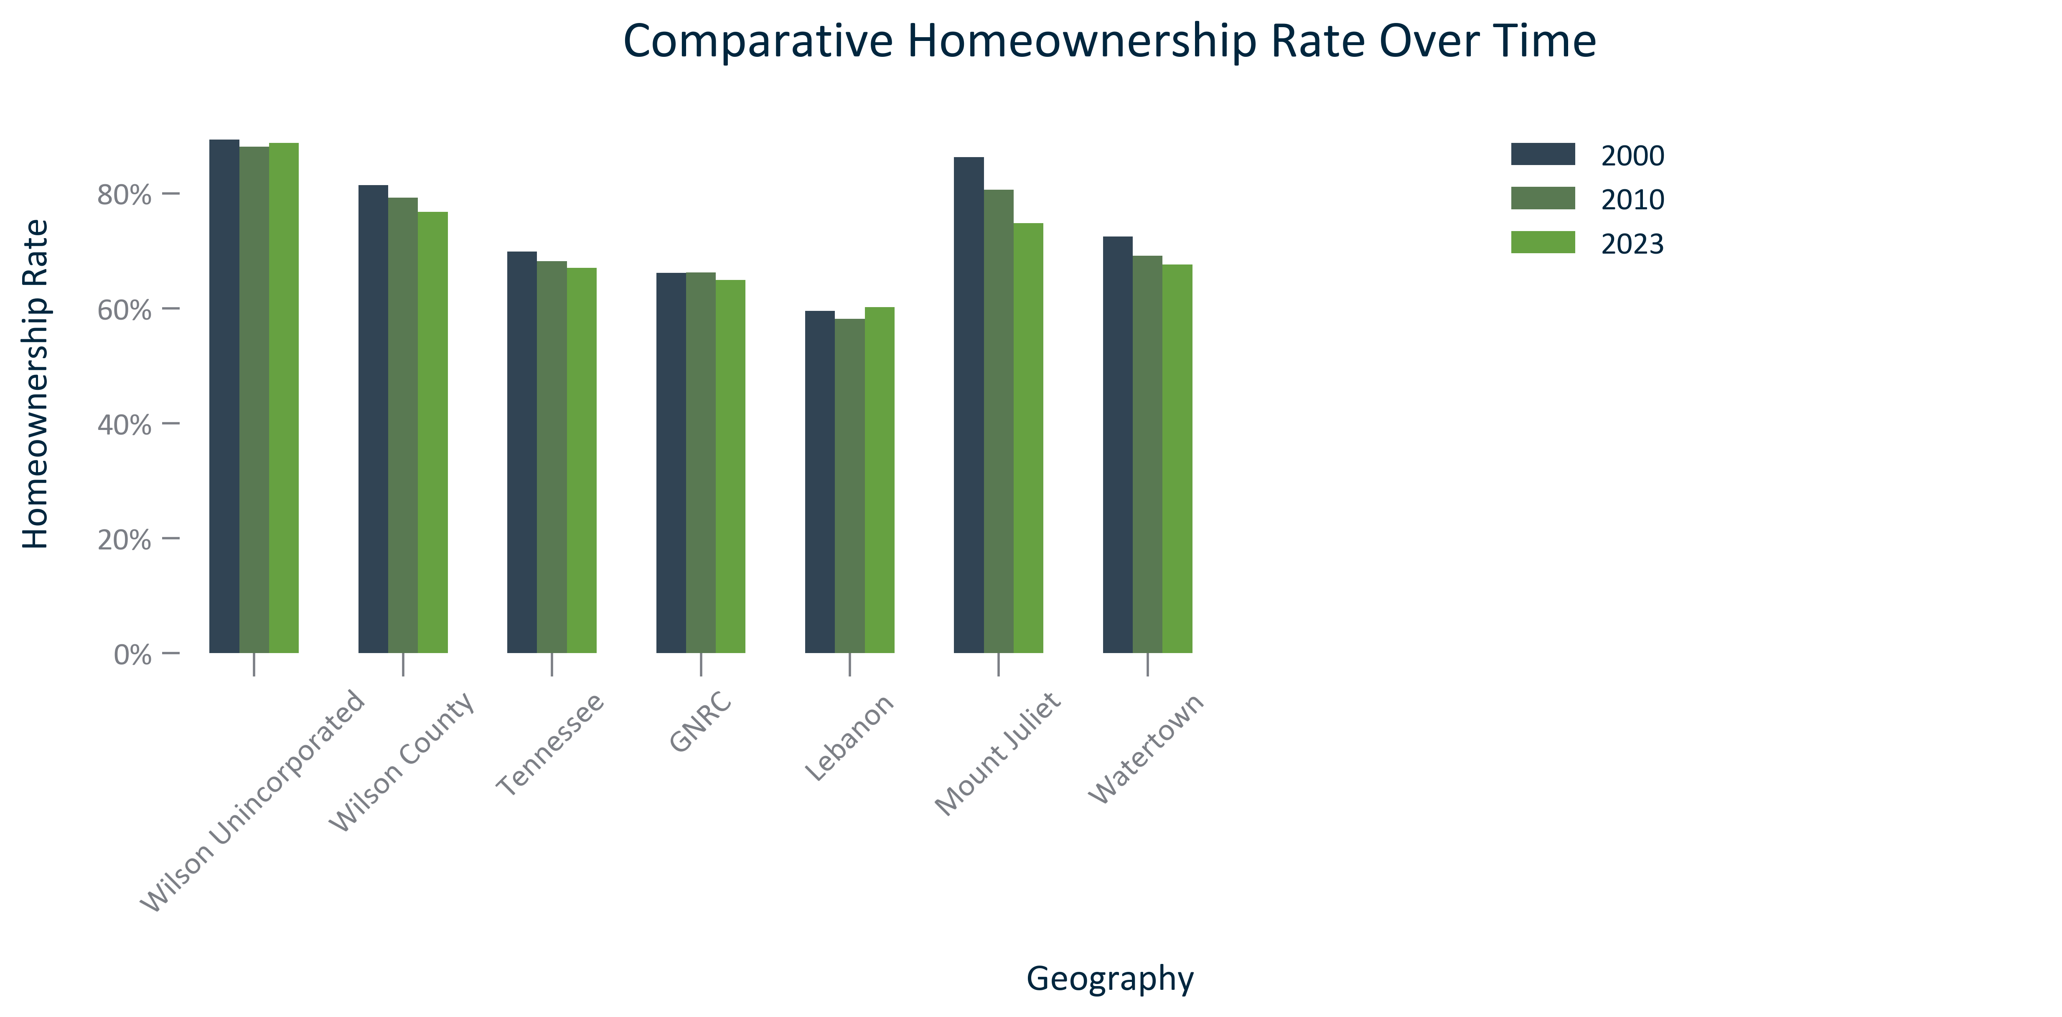

Citation: 2000 Decennial Census, 2006-2010 and 2019 - 2023 American Community Survey 5-Year Estimates

### TENURECOST_bar_geocomparative_rentalrate_2023:

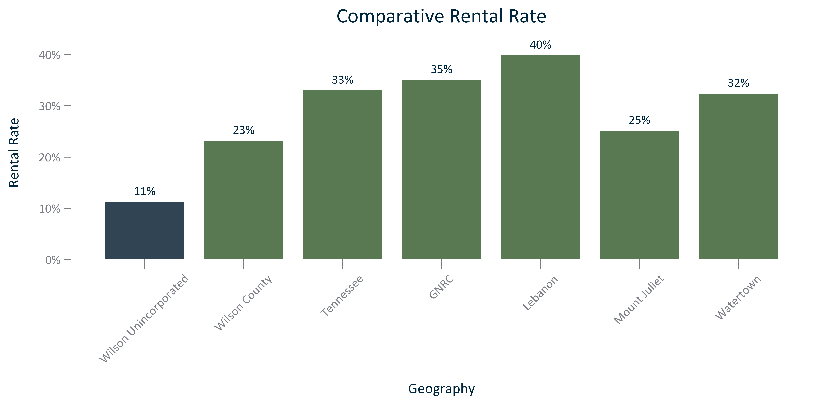

Citation: 2019 - 2023 American Community Survey 5-Year Estimates

### TENURECOST_clusterbar_geocomparative_rentalrate_overtime:

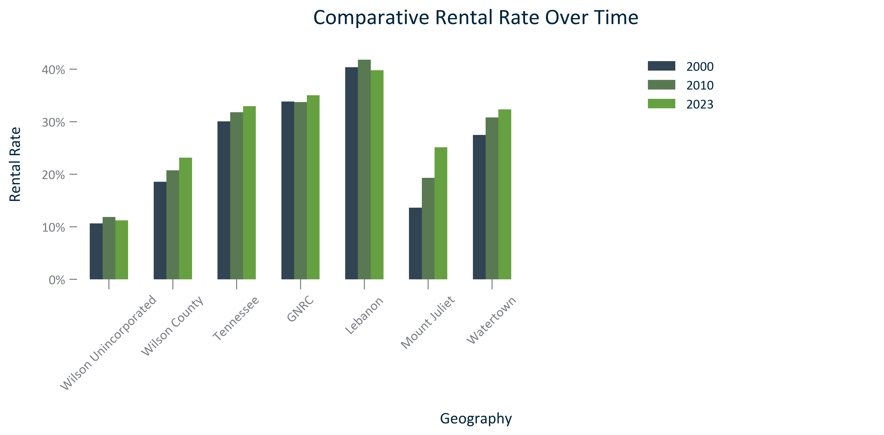

Citation: 2000 Decennial Census, 2006-2010 and 2019 - 2023 American Community Survey 5-Year Estimates

### TENURECOST_table_geocomparative_tenureandchange_overtime:

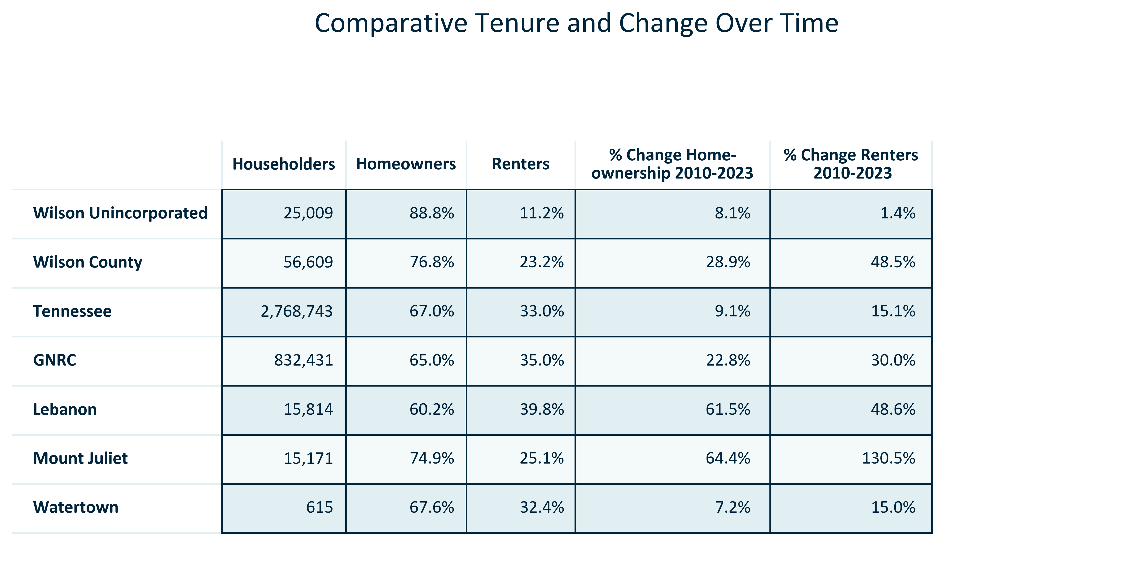

Citation: 2006-2010 and 2019 - 2023 American Community Survey 5-Year Estimates

### TENURECOST_table_primarygeo_tenurebyraceandethnicity_overtime:

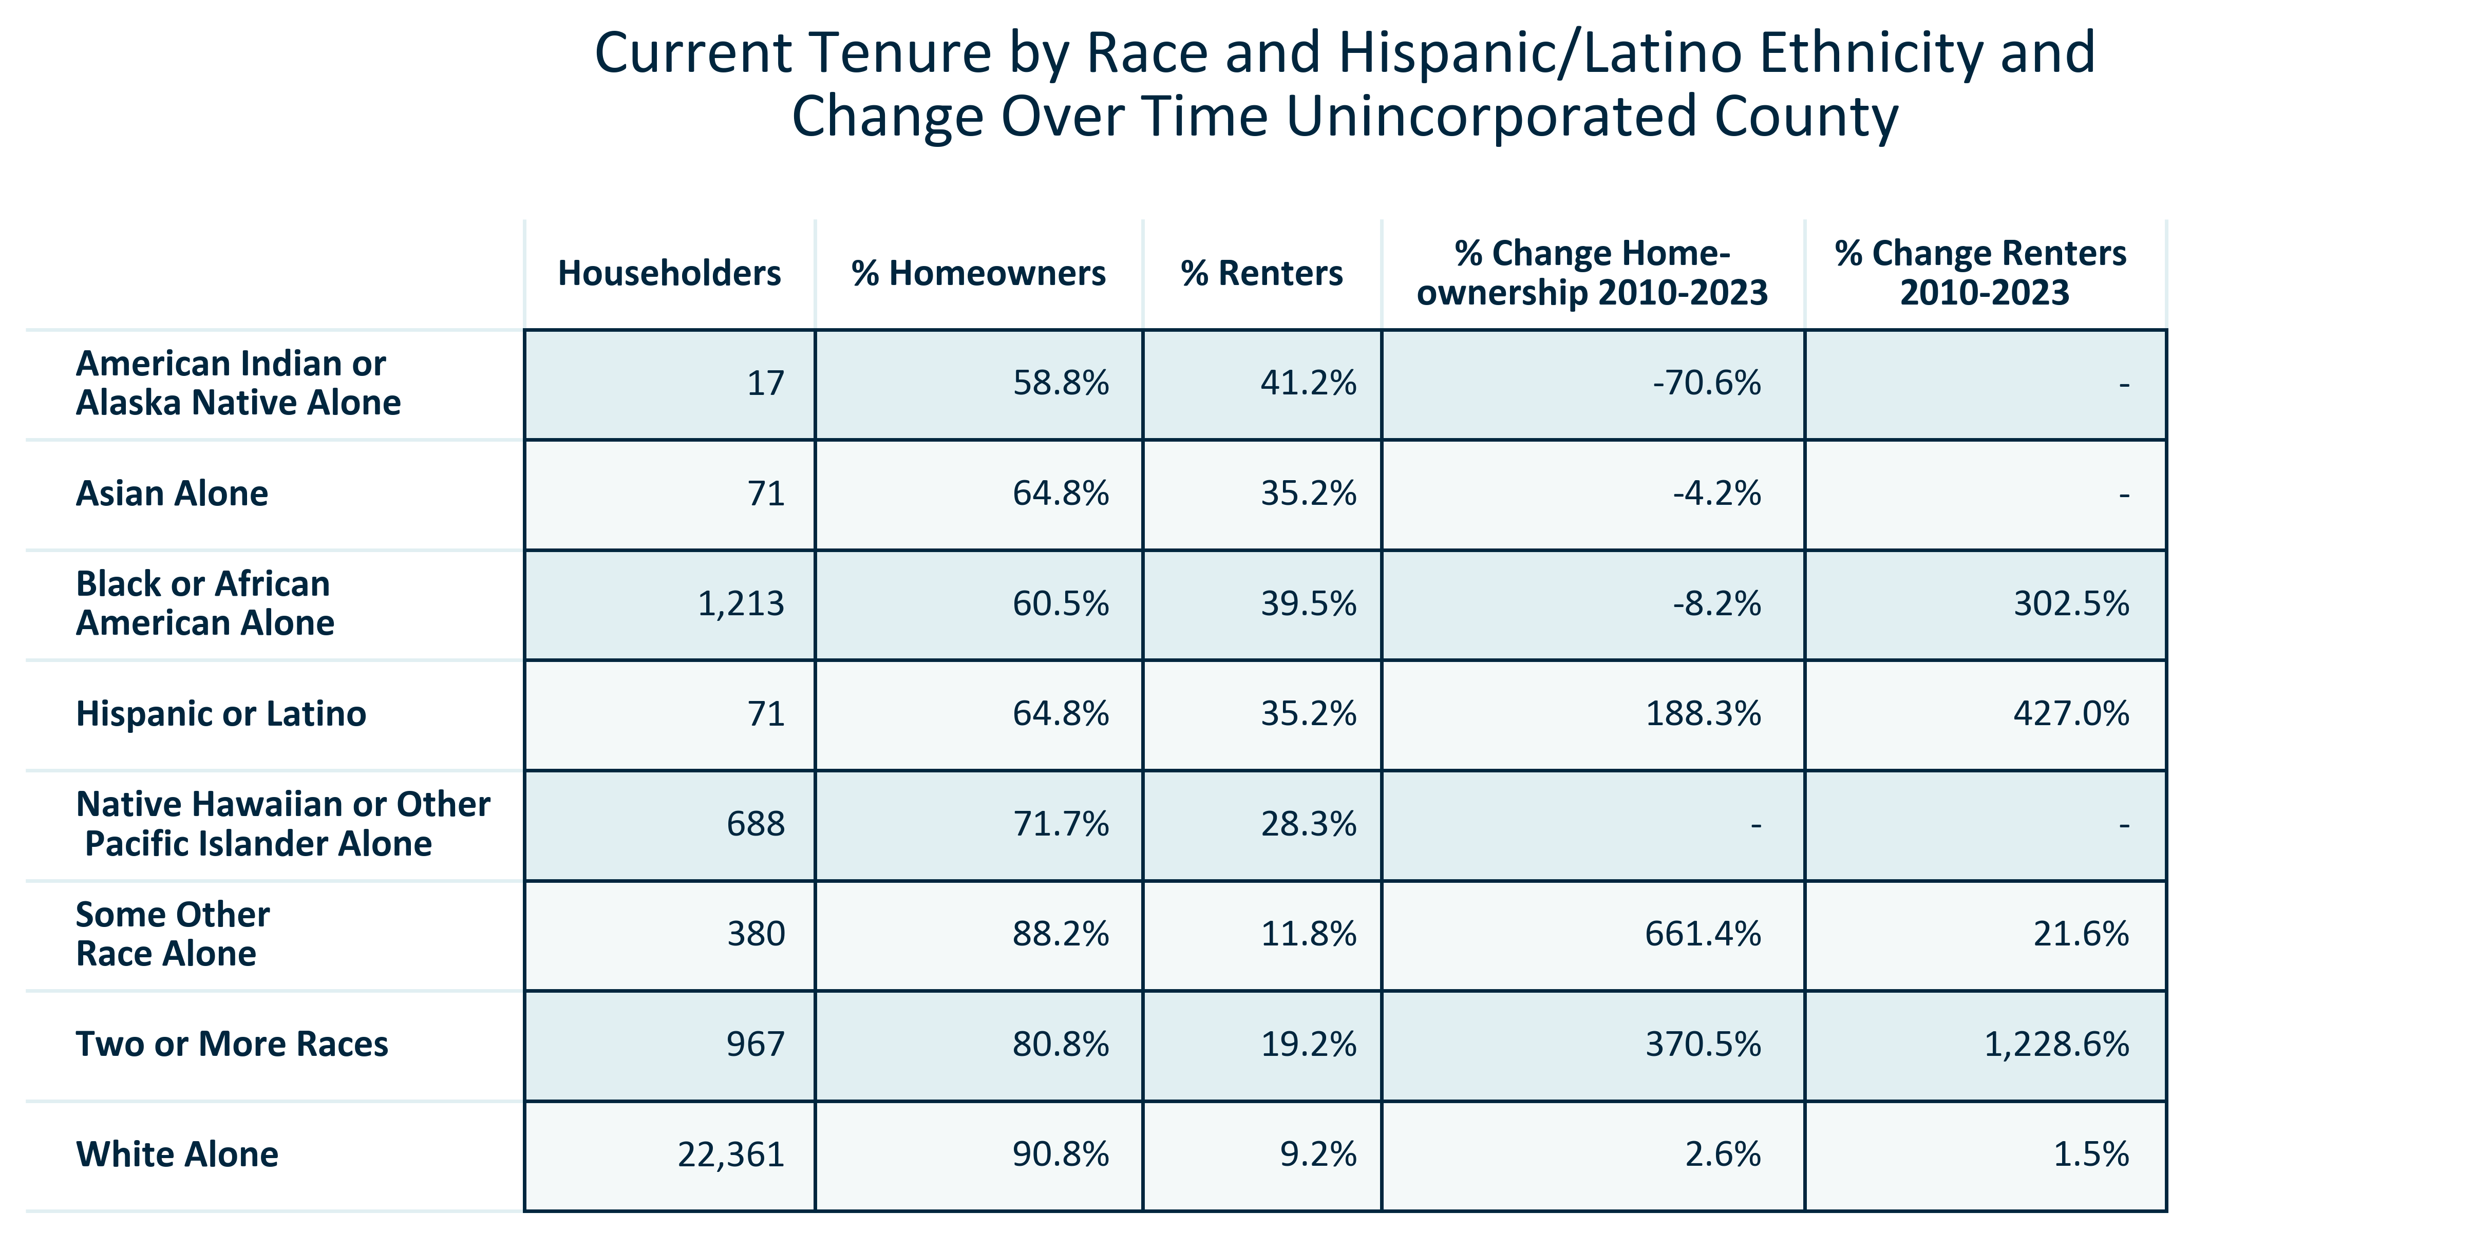

Citation: 2006-2010 and 2019 - 2023 American Community Survey 5-Year Estimates

### TENURECOST_table_primarygeo_tenureandchangebyagegroup_overtime:

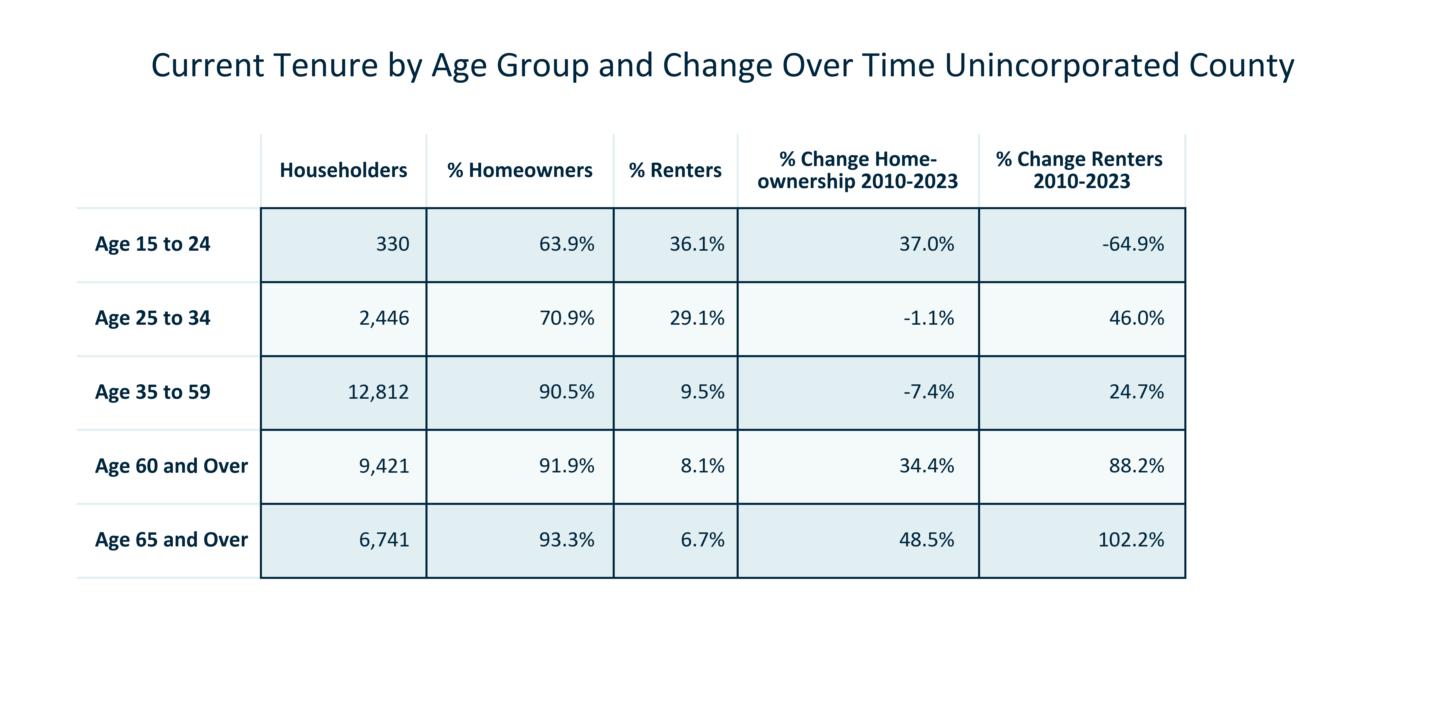

Citation: 2006-2010 and 2019 - 2023 American Community Survey 5-Year Estimates

### TENURECOST_bar_primarygeo_mediangrossrent_overtime:

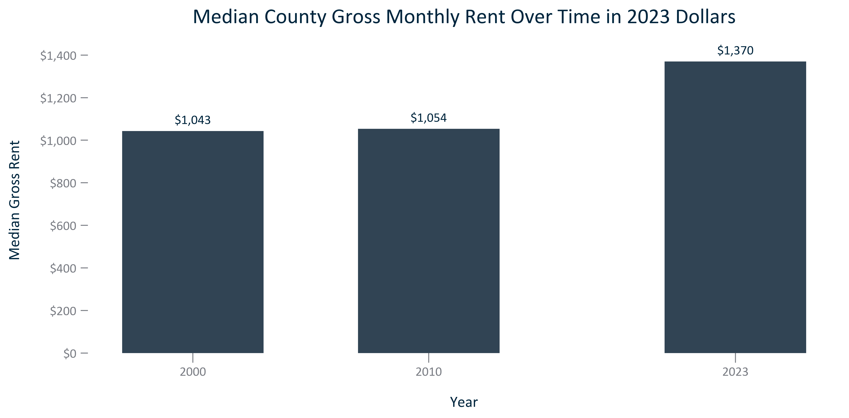

Citation: 2000 Decennial Census, 2006-2010 and 2019 - 2023 American Community Survey 5-Year Estimates in 2023 Dollars

### TENURECOST_clusterbar_geocomparative_changemediangrossrent_overtime:

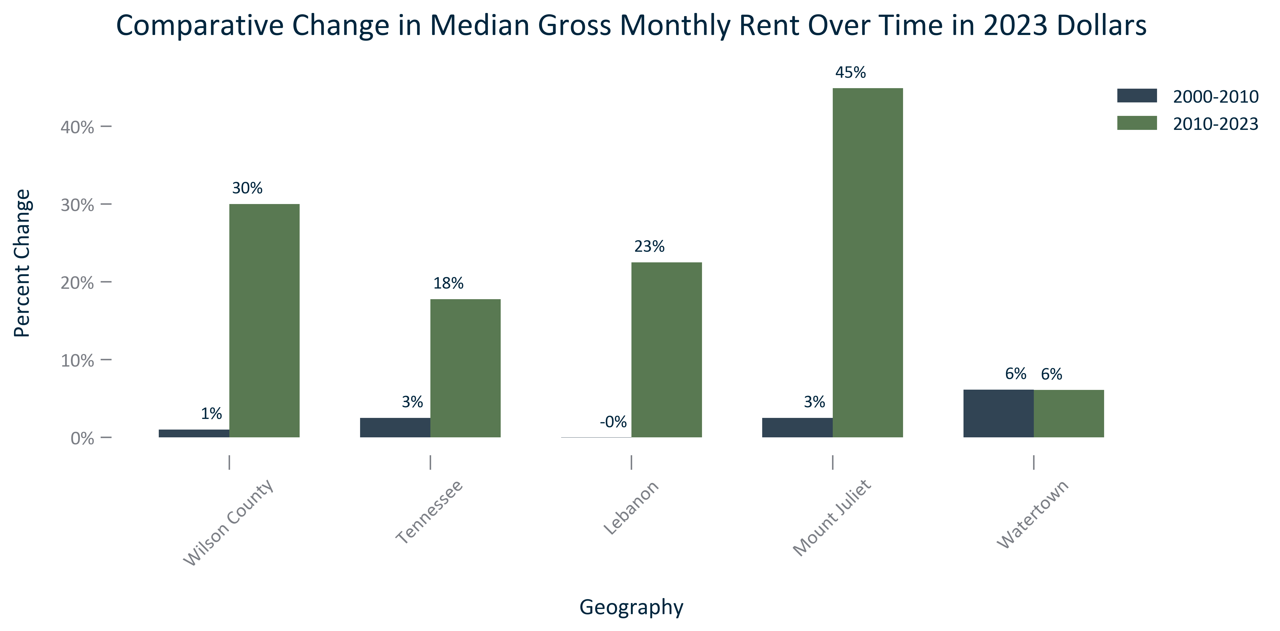

Citation: 2000 Decennial Census, 2006-2010 and 2019 - 2023 American Community Survey 5-Year Estimates in 2023 Dollars

### INCOME_table_geocomparative_mediangrossrentandchange_overtime:

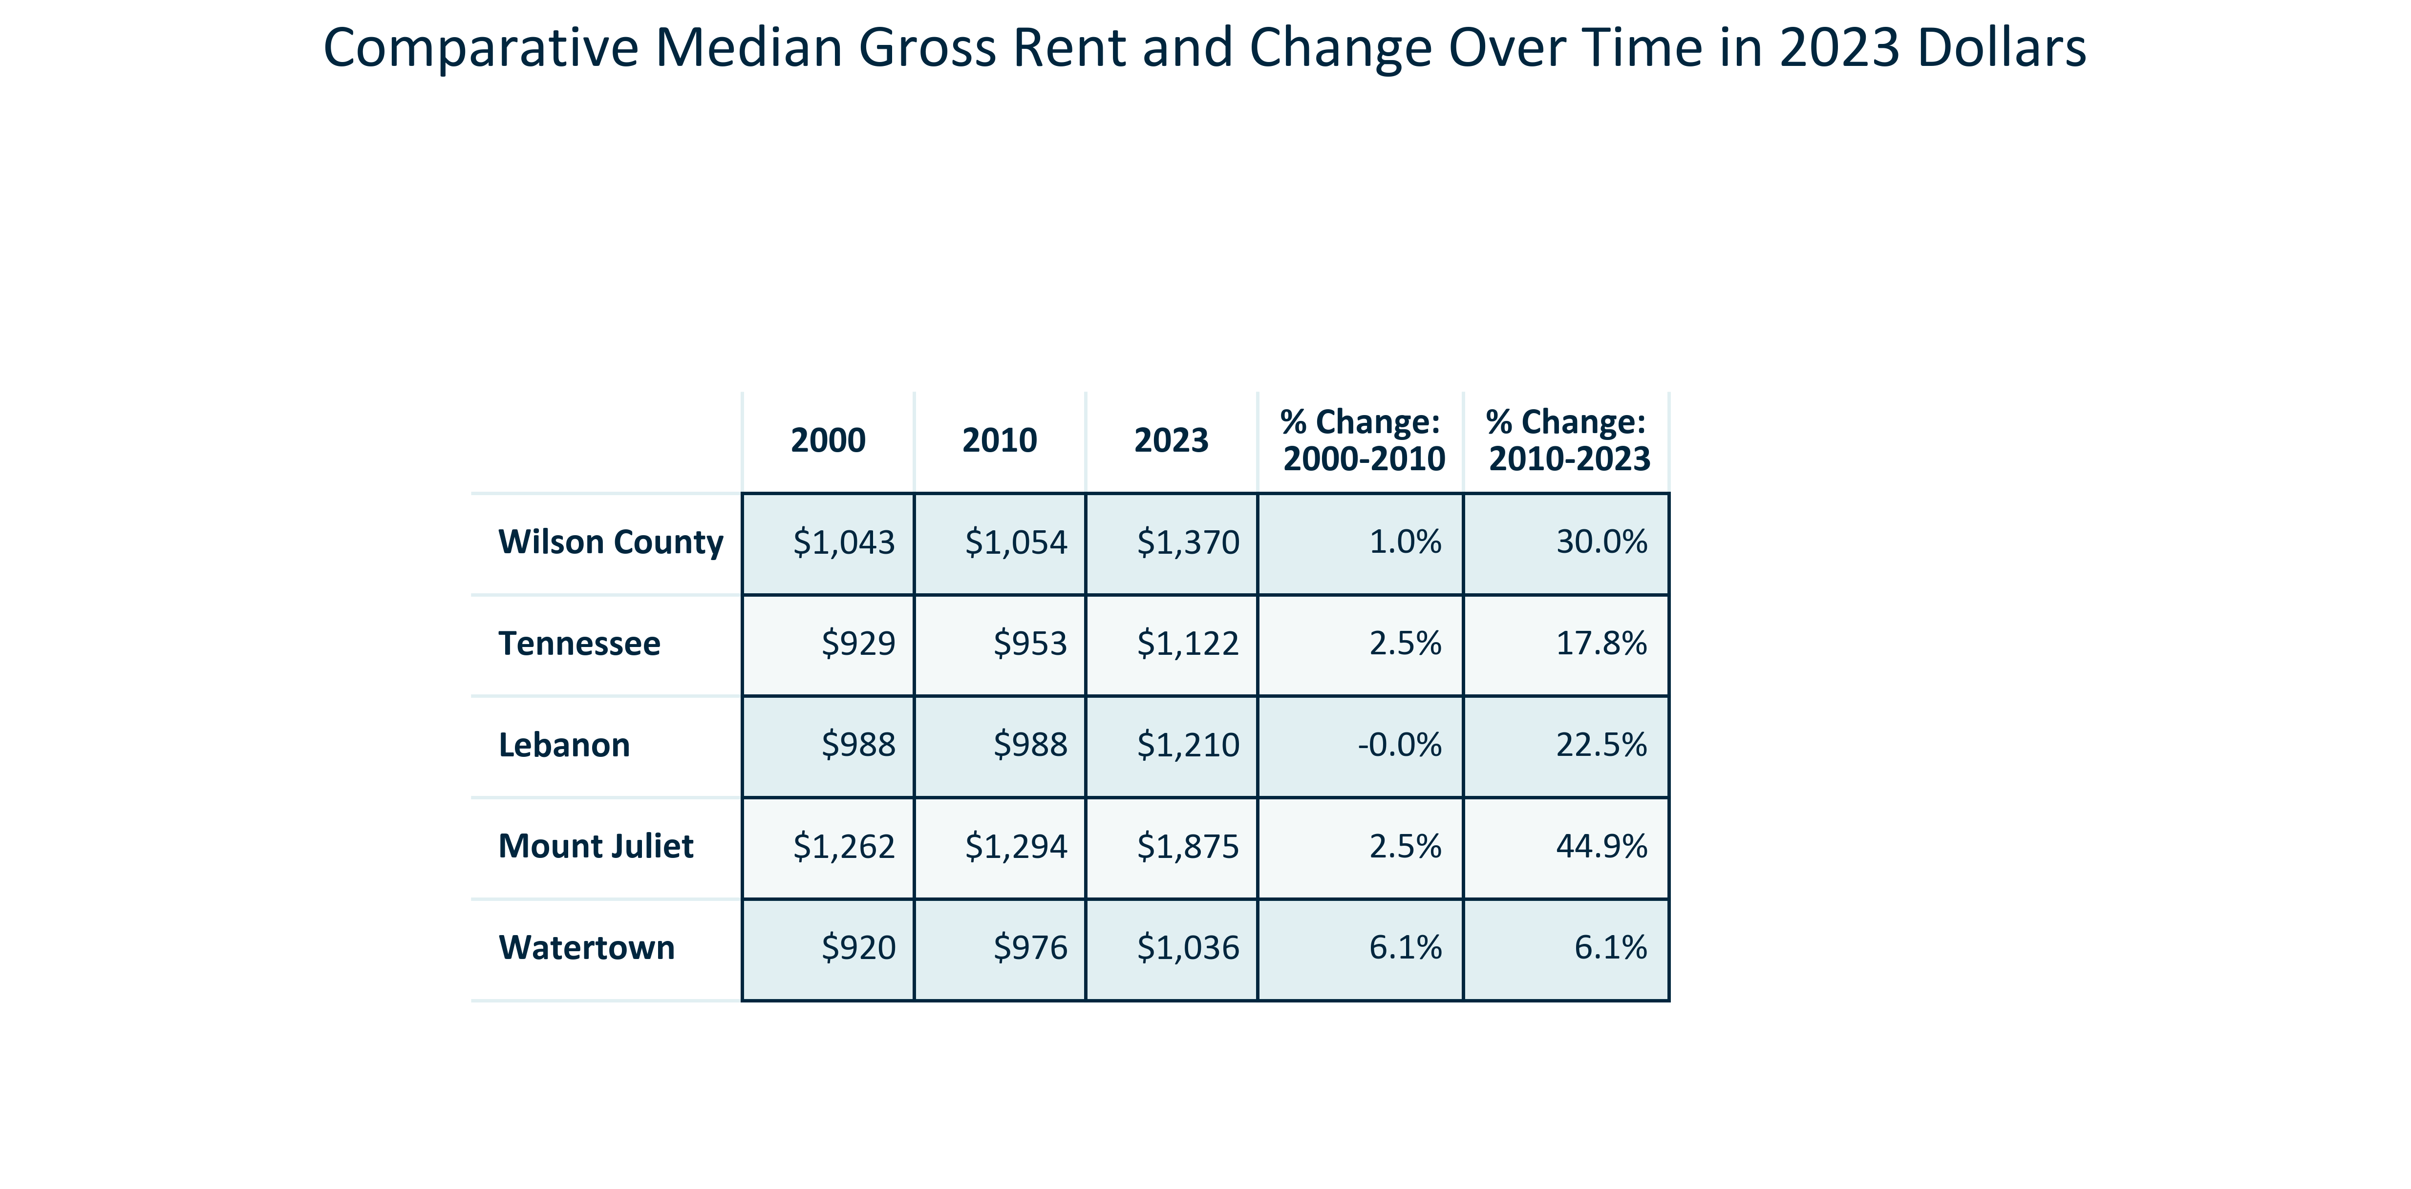

Citation: 2000 Decennial Census, 2006-2010 and 2019 - 2023 American Community Survey 5-Year Estimates in 2023 dollars

### TENURECOST_line_geocomparative_ZILLOWannualaveragerent_overtime:

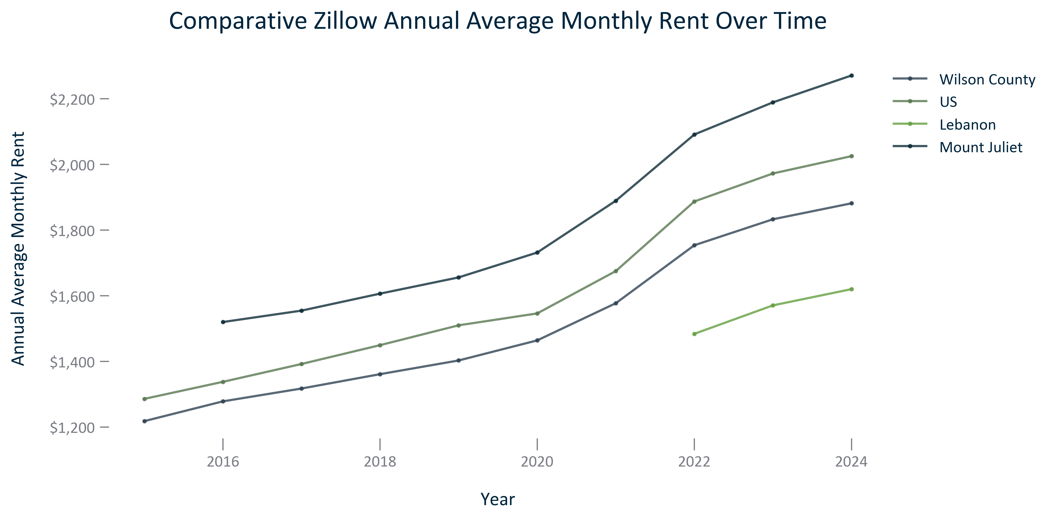

Citation: Zillow, 2015-2024

### TENURECOST_clusterbar_geocomparative_ZILLOWpercentchangeannualaveragerent_overtime:

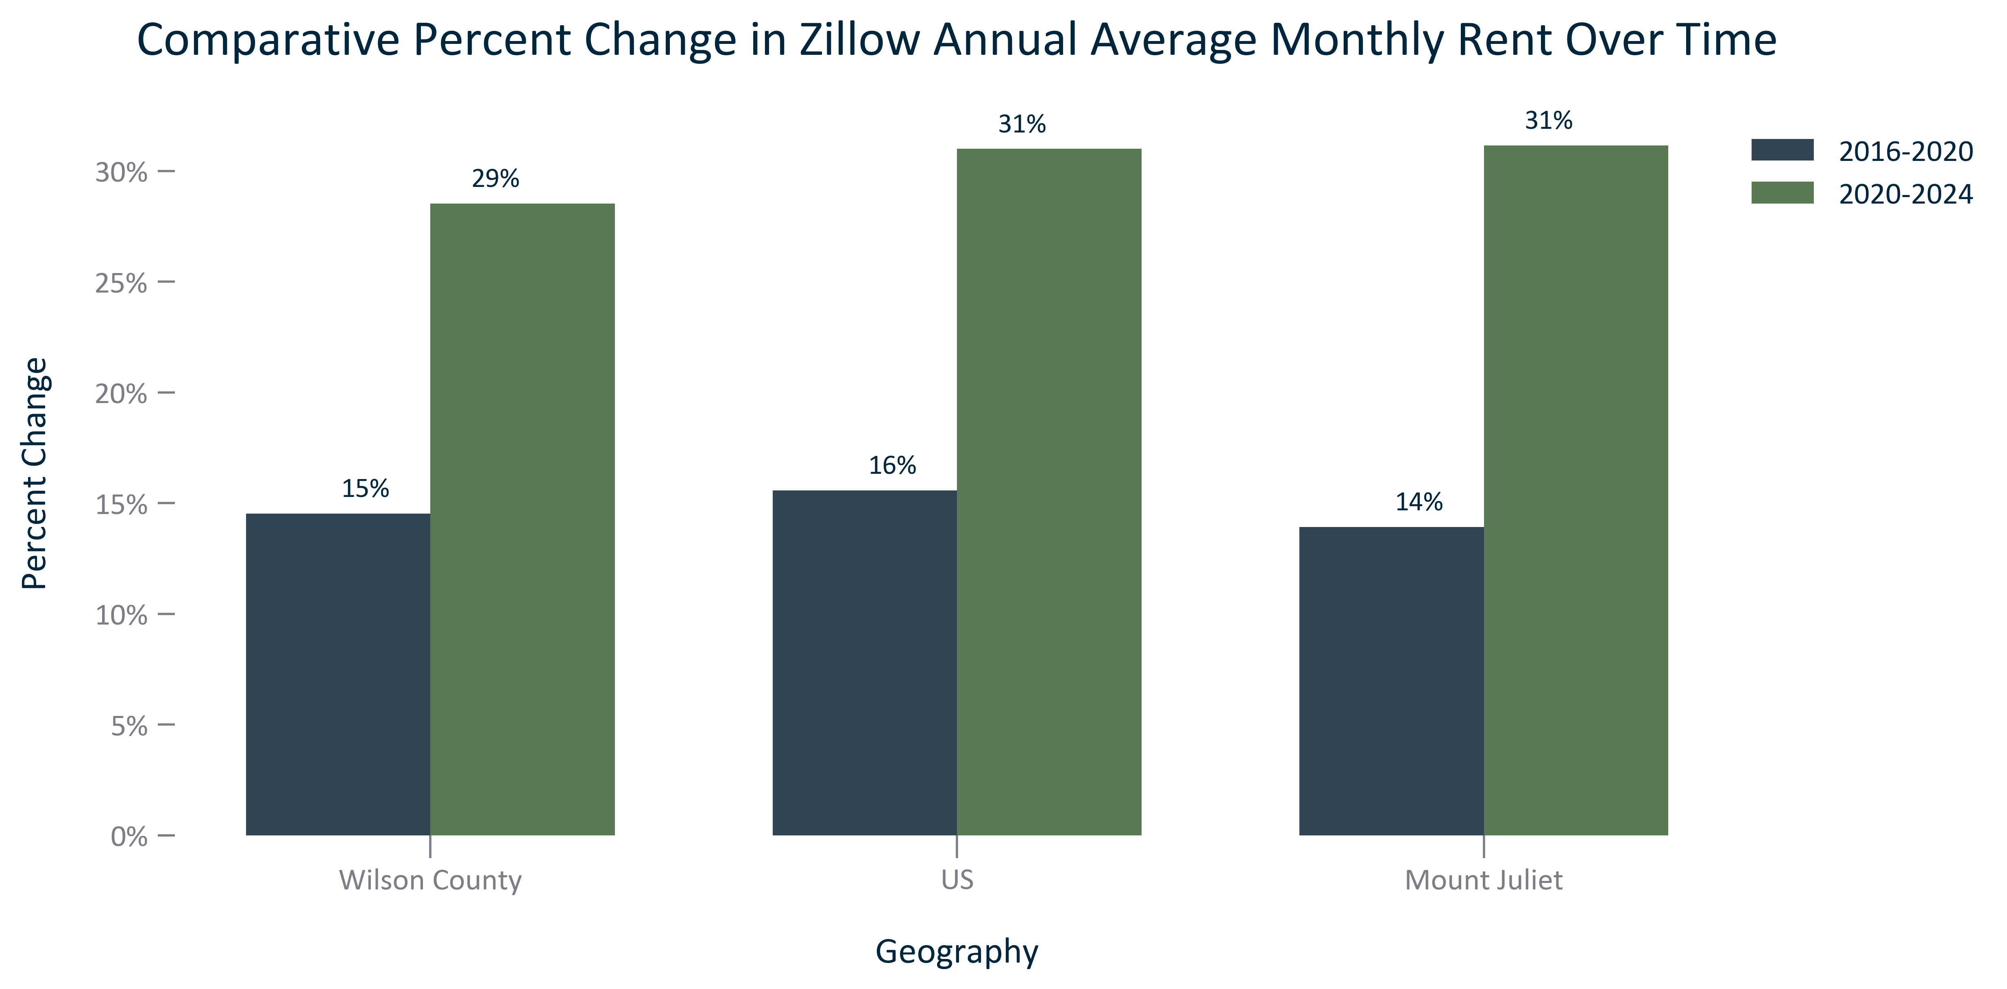

Citation: Zillow, 2016-2024

### TENURECOST_clusterbar_primarygeo_ownercostsbymortgagestatus_overtime:

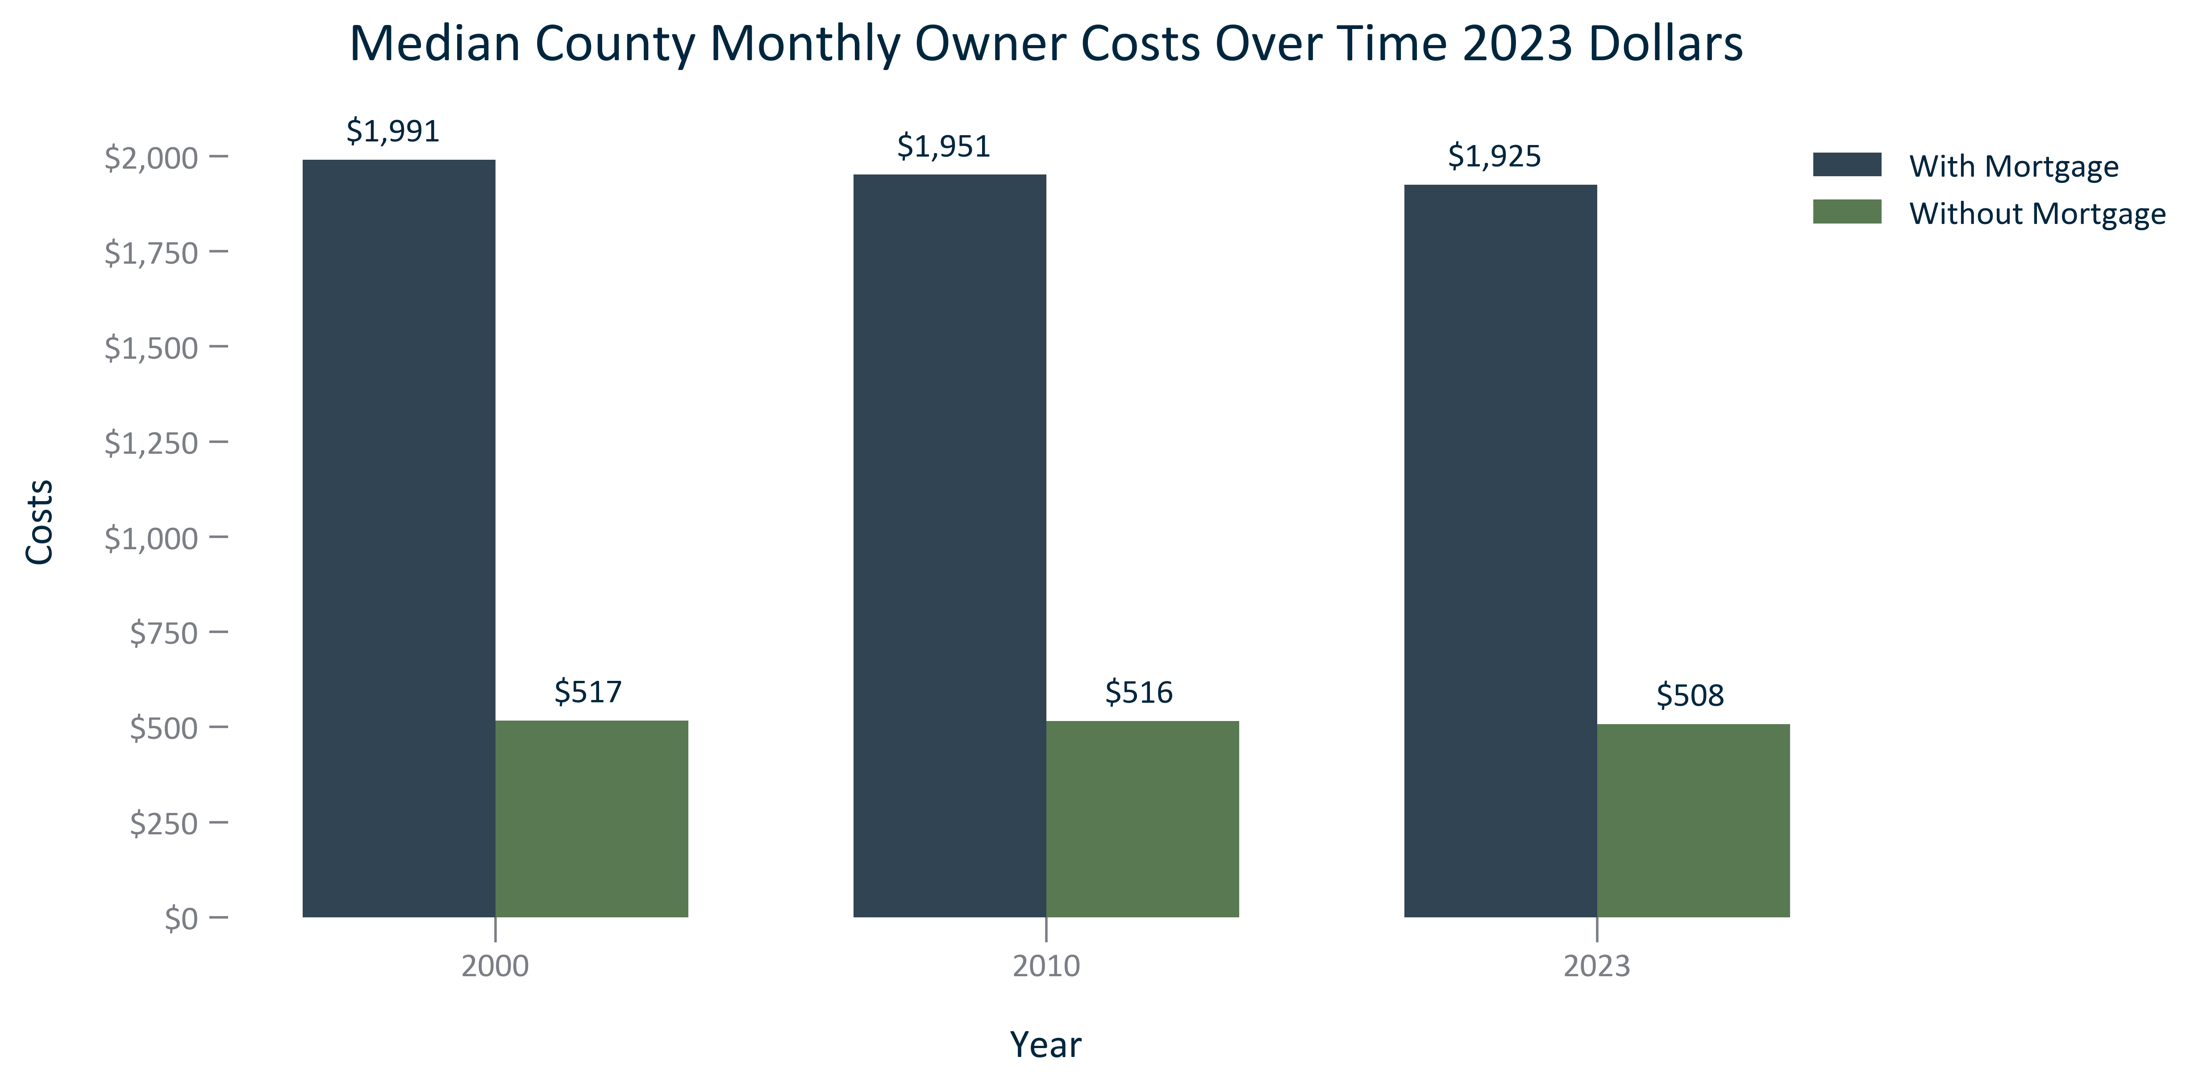

Citation: 2000 Decennial Census, 2006-2010 and 2019 - 2023 American Community Survey 5-Year Estimates in 2023 Dollars

### TENURECOST_clusterbar_geocomparative_changemedianownerwithmortgagecost_overtime:

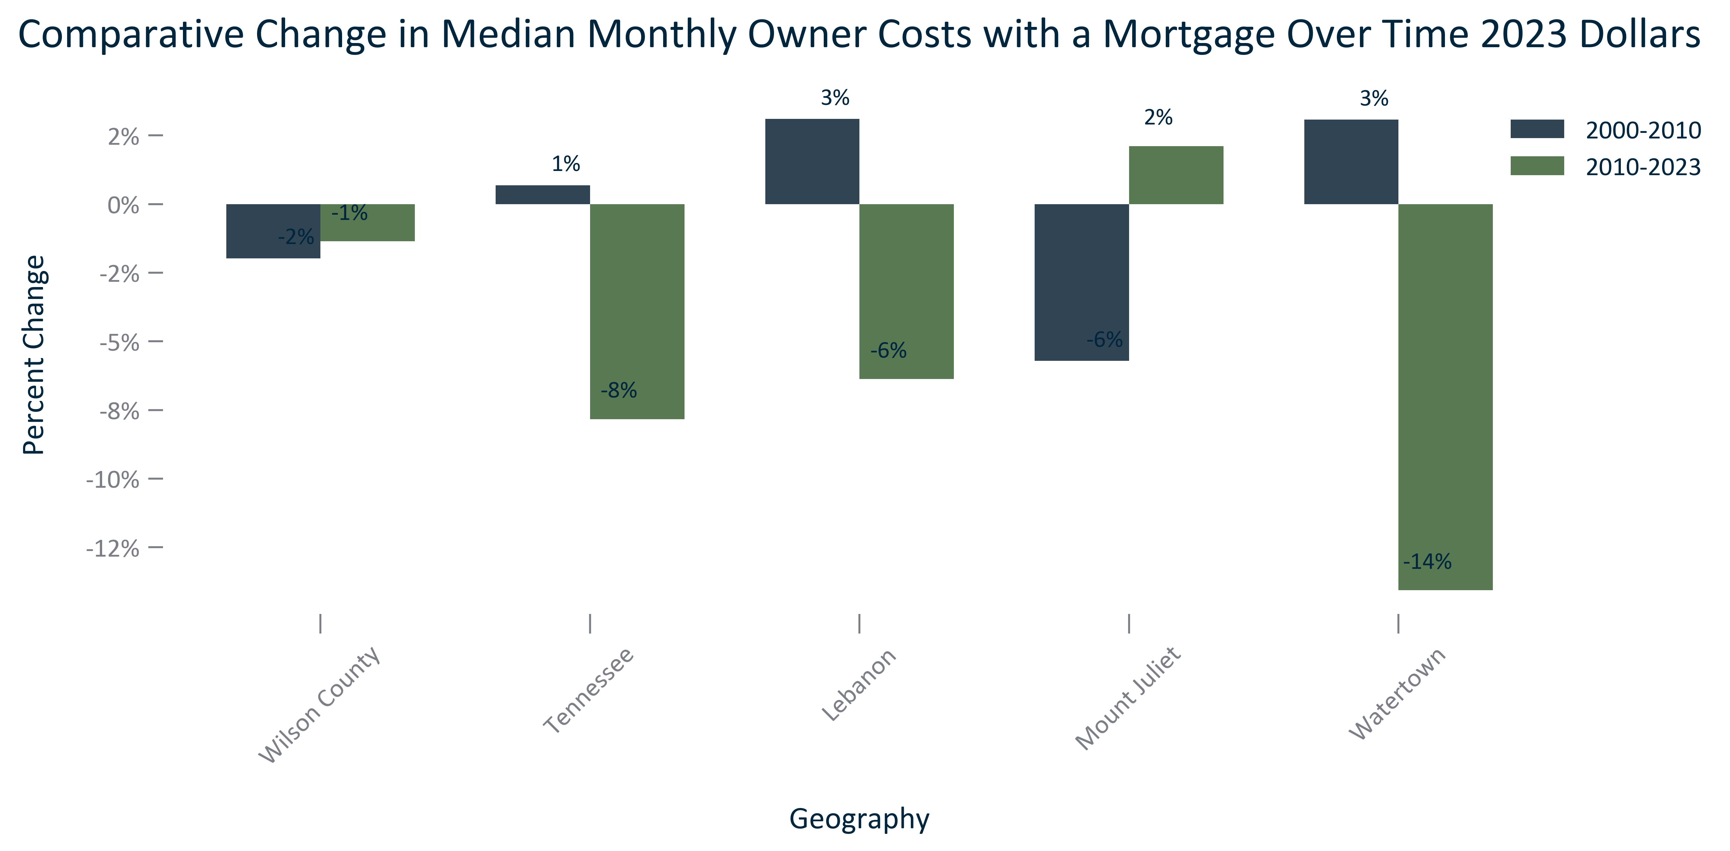

Citation: 2000 Decennial Census, 2006-2010 and 2019 - 2023 American Community Survey 5-Year Estimates in 2023 Dollars

### TENURECOST_bar_primarygeo_valueowneroccupiedhousing_overtime:

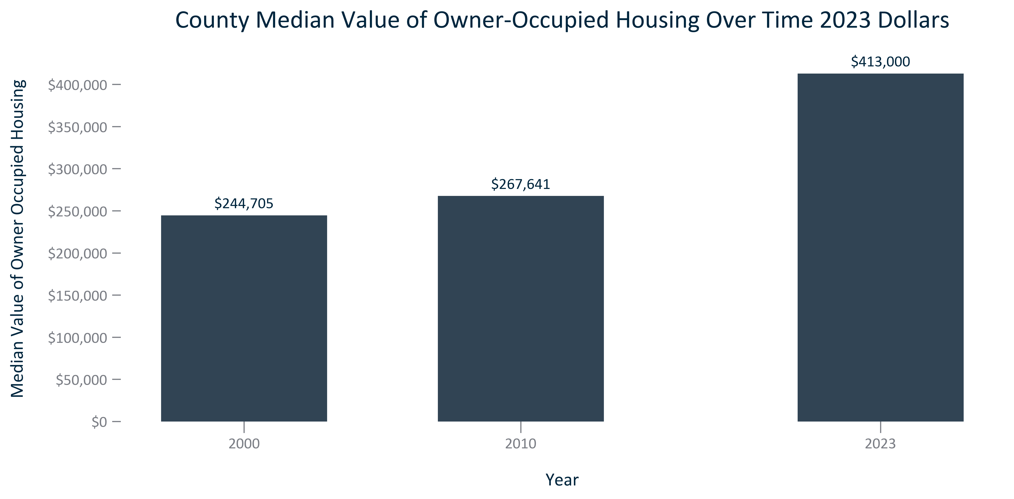

Citation: 2000 Decennial Census, 2006-2010 and 2019 - 2023 American Community Survey 5-Year Estimates in 2023 Dollars

### TENURECOST_clusterbar_geocomparative_changemedianhomevalueowneroccupied_overtime:

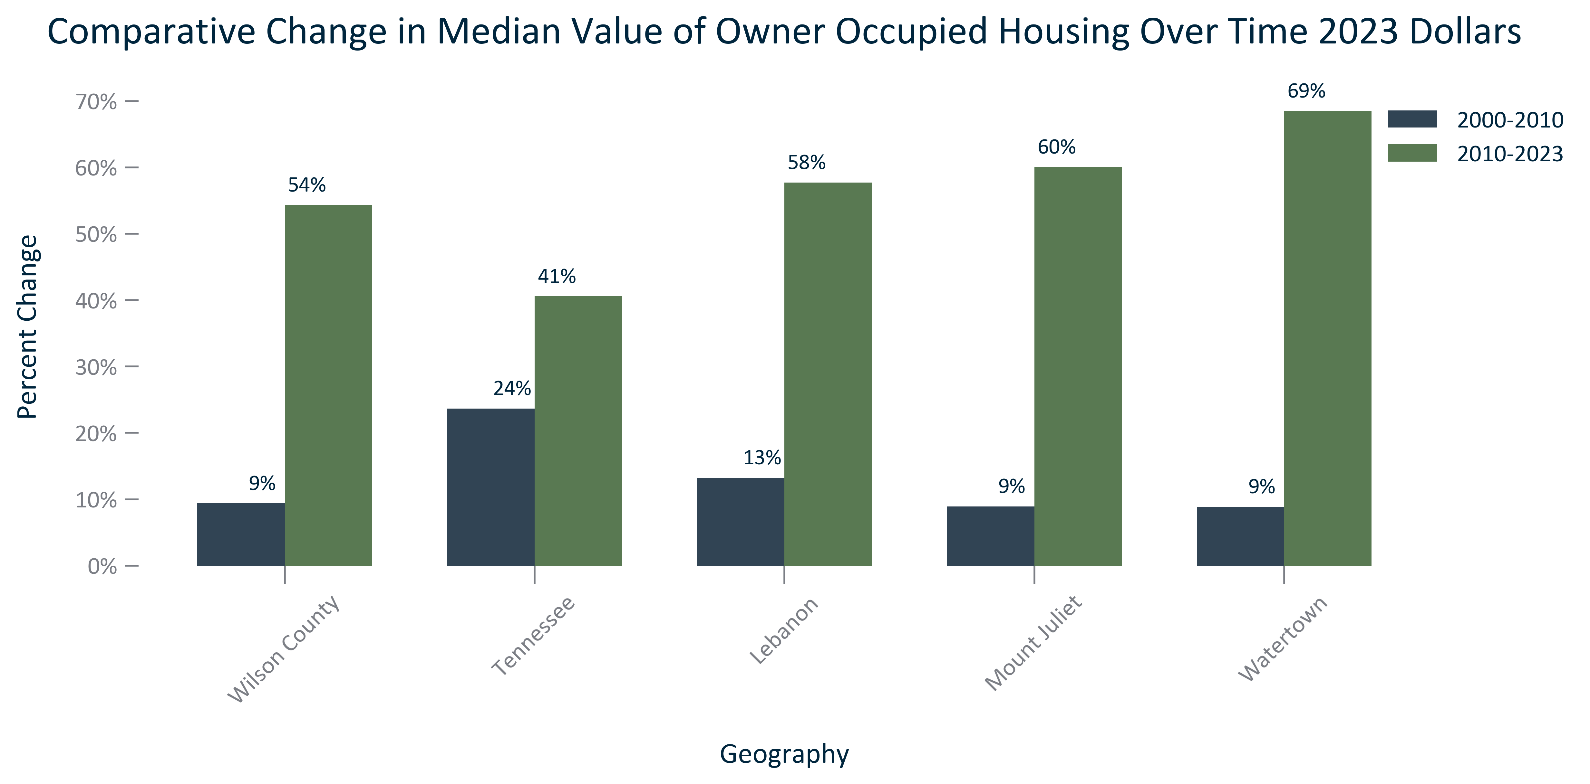

Citation: 2000 Decennial Census, 2006-2010 and 2019 - 2023 American Community Survey 5-Year Estimates in 2023 Dollars

### TENURECOST_line_geocomparative_ZILLOWannualhomevalueestimates_overtime:

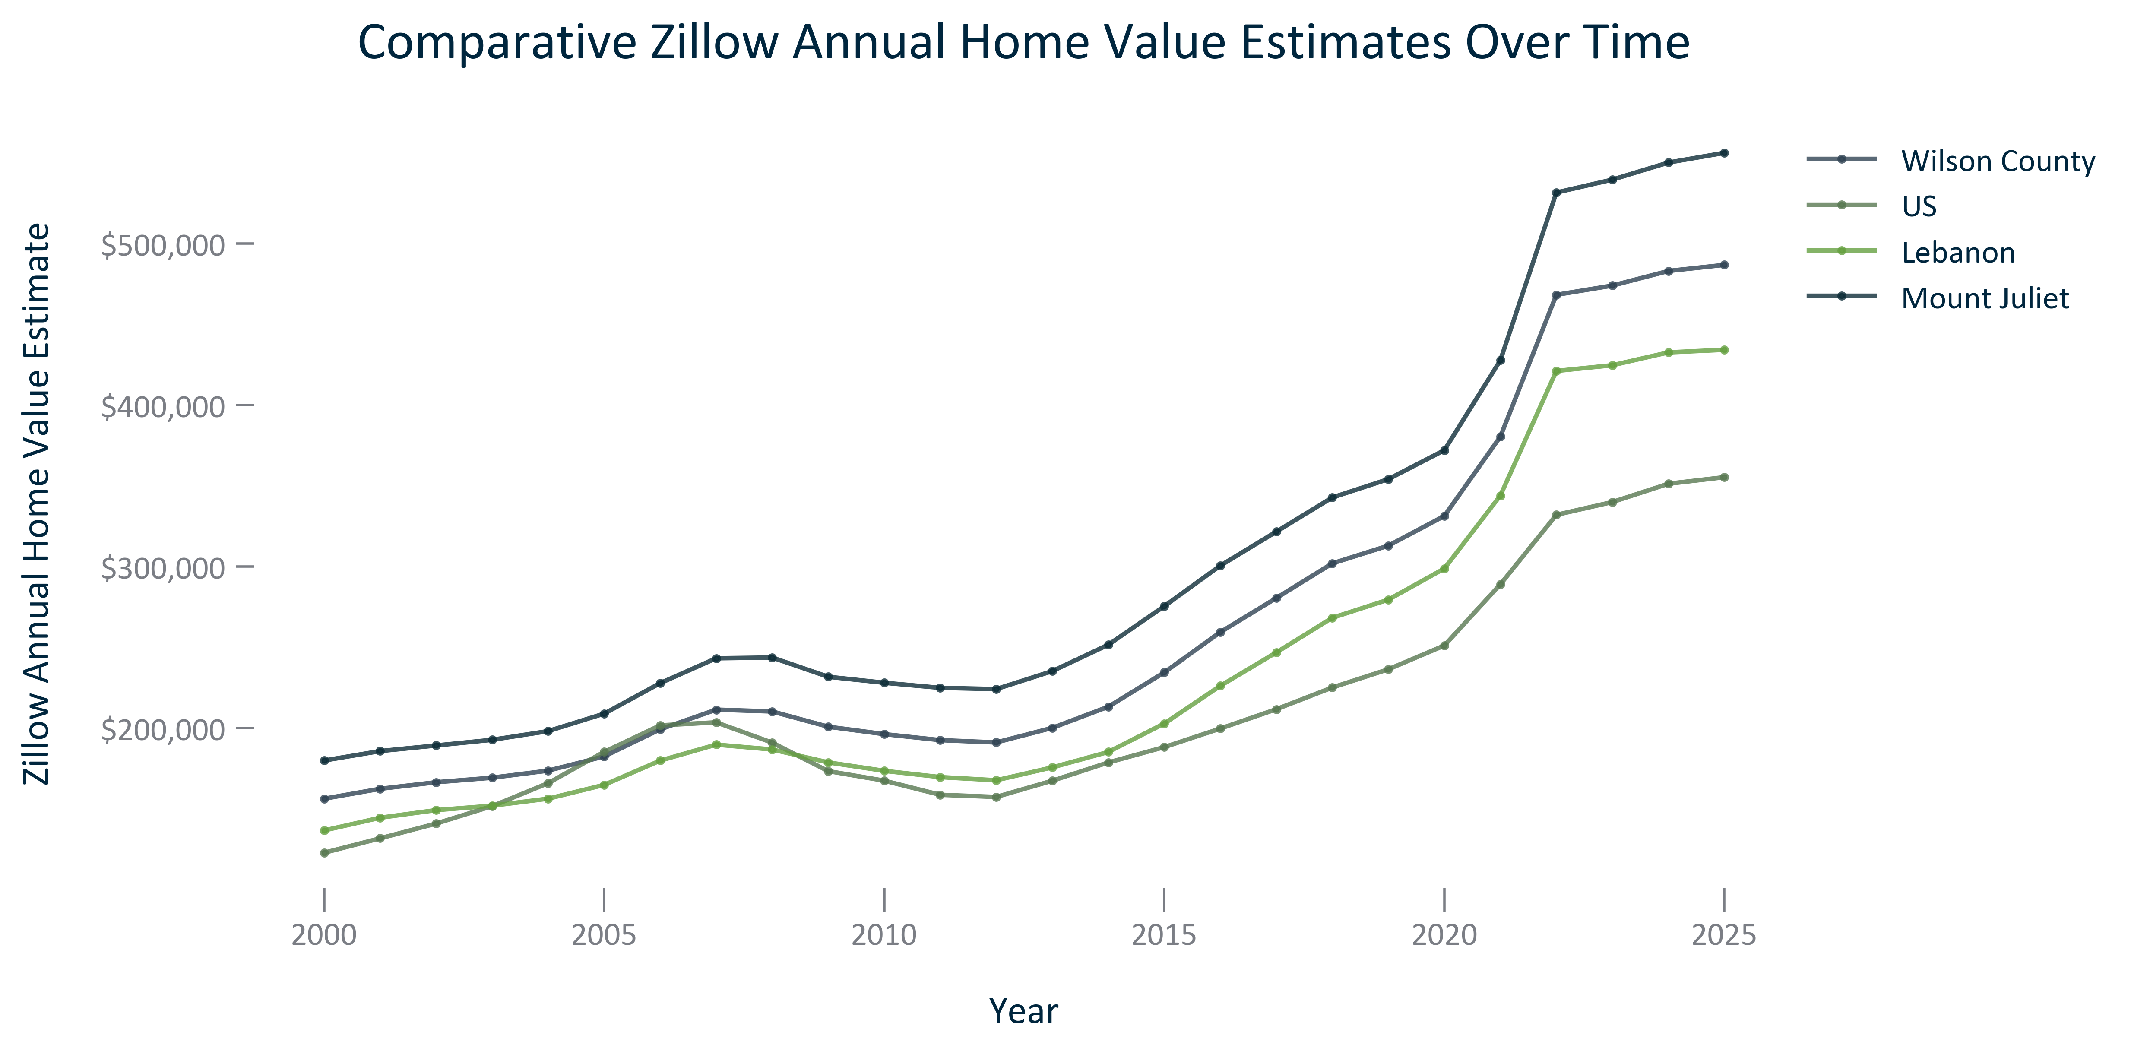

Citation: Zillow, 2000-2024

### TENURECOST_bar_primarygeo_costburdenedhouseholds_overtime:

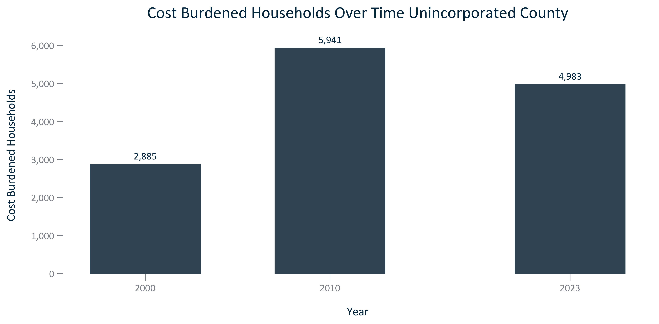

Citation: 2000 Decennial Census, 2006-2010 and 2019 - 2023 American Community Survey 5-Year Estimates

### TENURECOST_bar_primarygeo_sharehouseholdscostburdened_overtime:

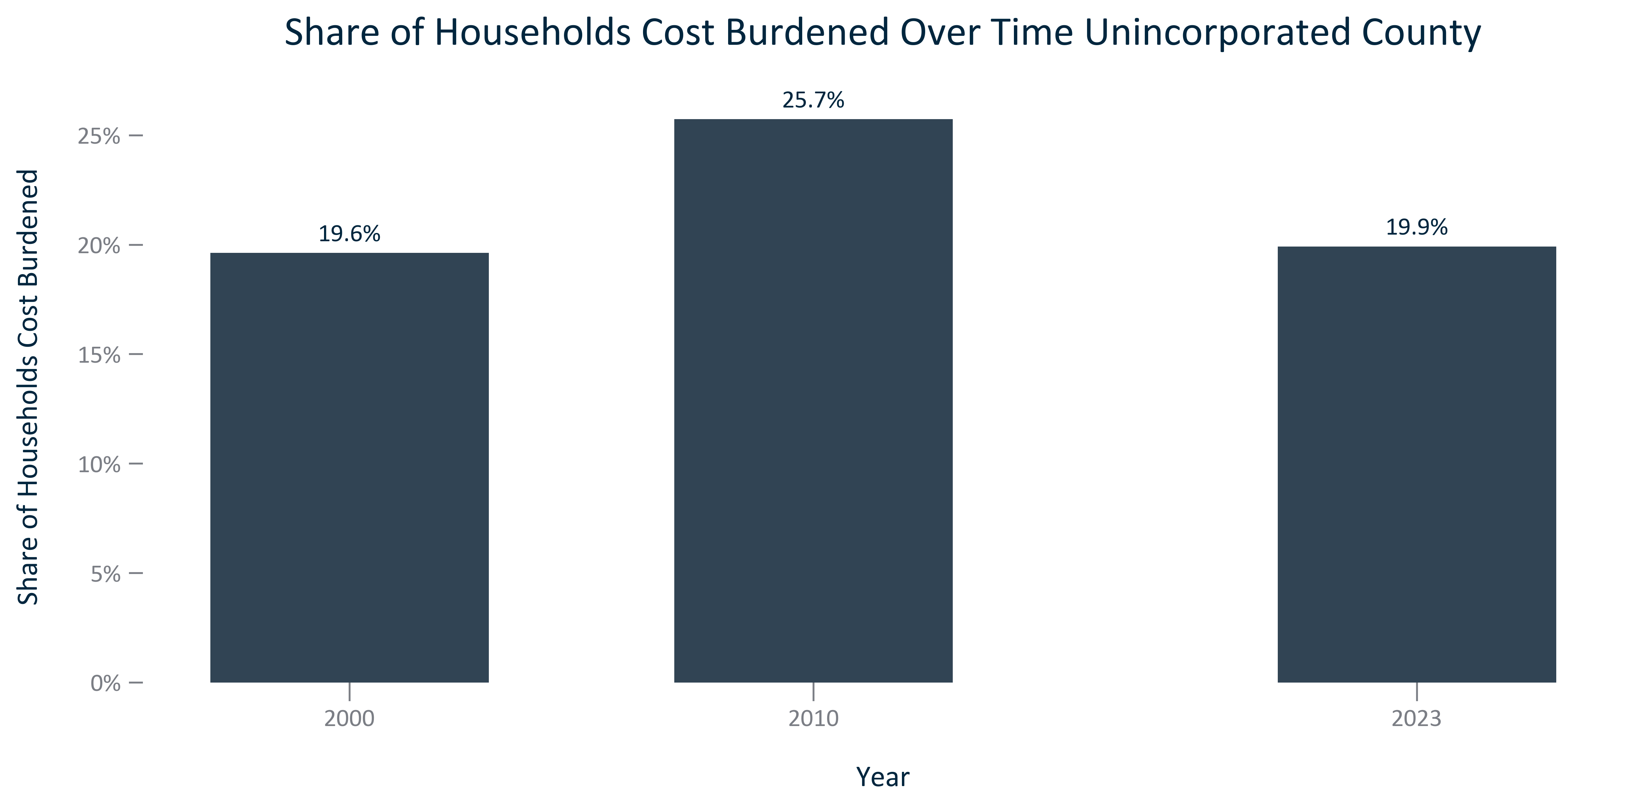

Citation: 2000 Decennial Census, 2006-2010 and 2019 - 2023 American Community Survey 5-Year Estimates

### TENURECOST_bar_primarygeo_costburdenedownerocchouseholds_overtime:

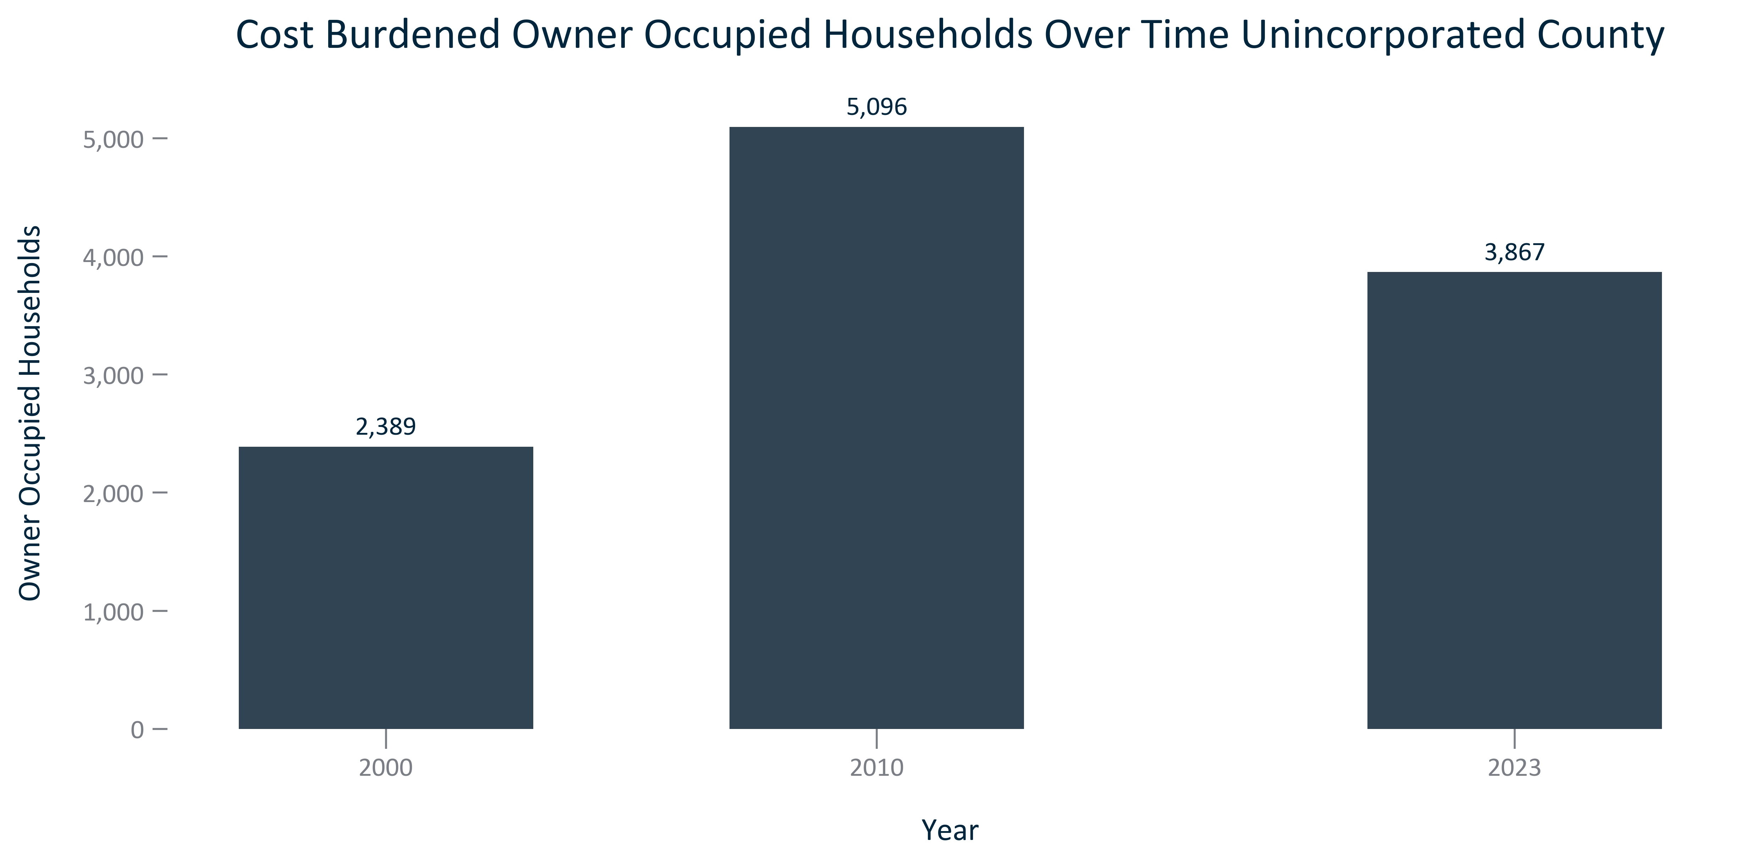

Citation: 2000 Decennial Census, 2006-2010 and 2019 - 2023 American Community Survey 5-Year Estimates

### TENURECOST_bar_primarygeo_shareownerocchouseholdscostburdened_overtime:

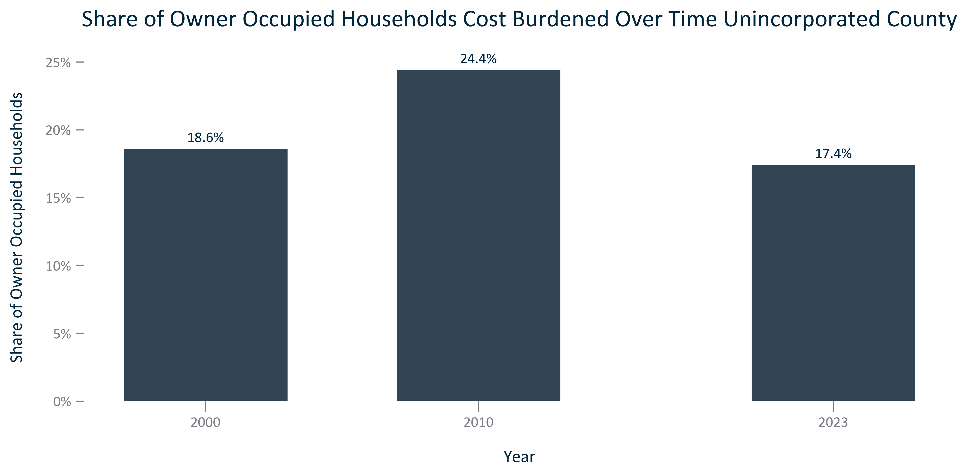

Citation: 2000 Decennial Census, 2006-2010 and 2019 - 2023 American Community Survey 5-Year Estimates

### TENURECOST_bar_primarygeo_costburdenedrenterocchouseholds_overtime:

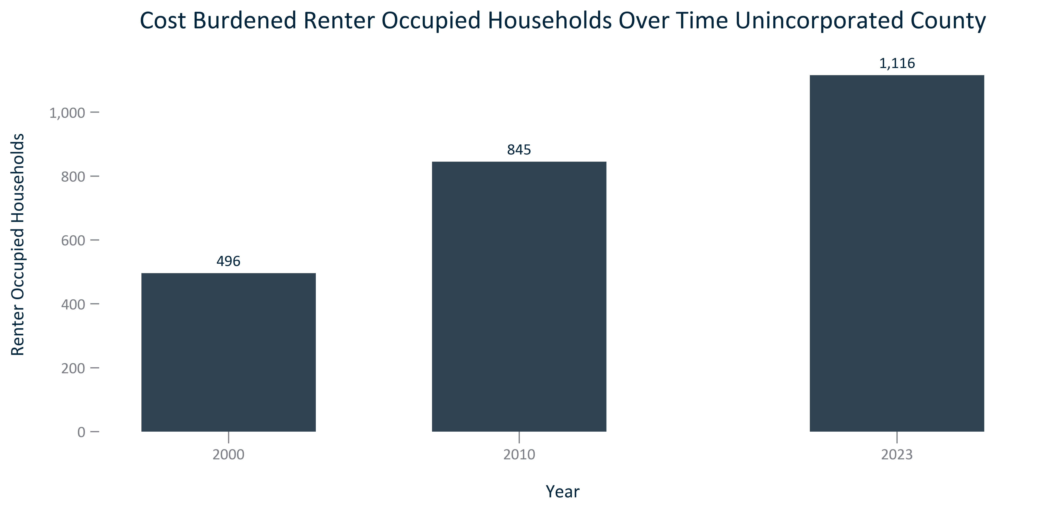

Citation: 2000 Decennial Census, 2006-2010 and 2019 - 2023 American Community Survey 5-Year Estimates

### TENURECOST_bar_primarygeo_sharerenterocchouseholdscostburdened_overtime:

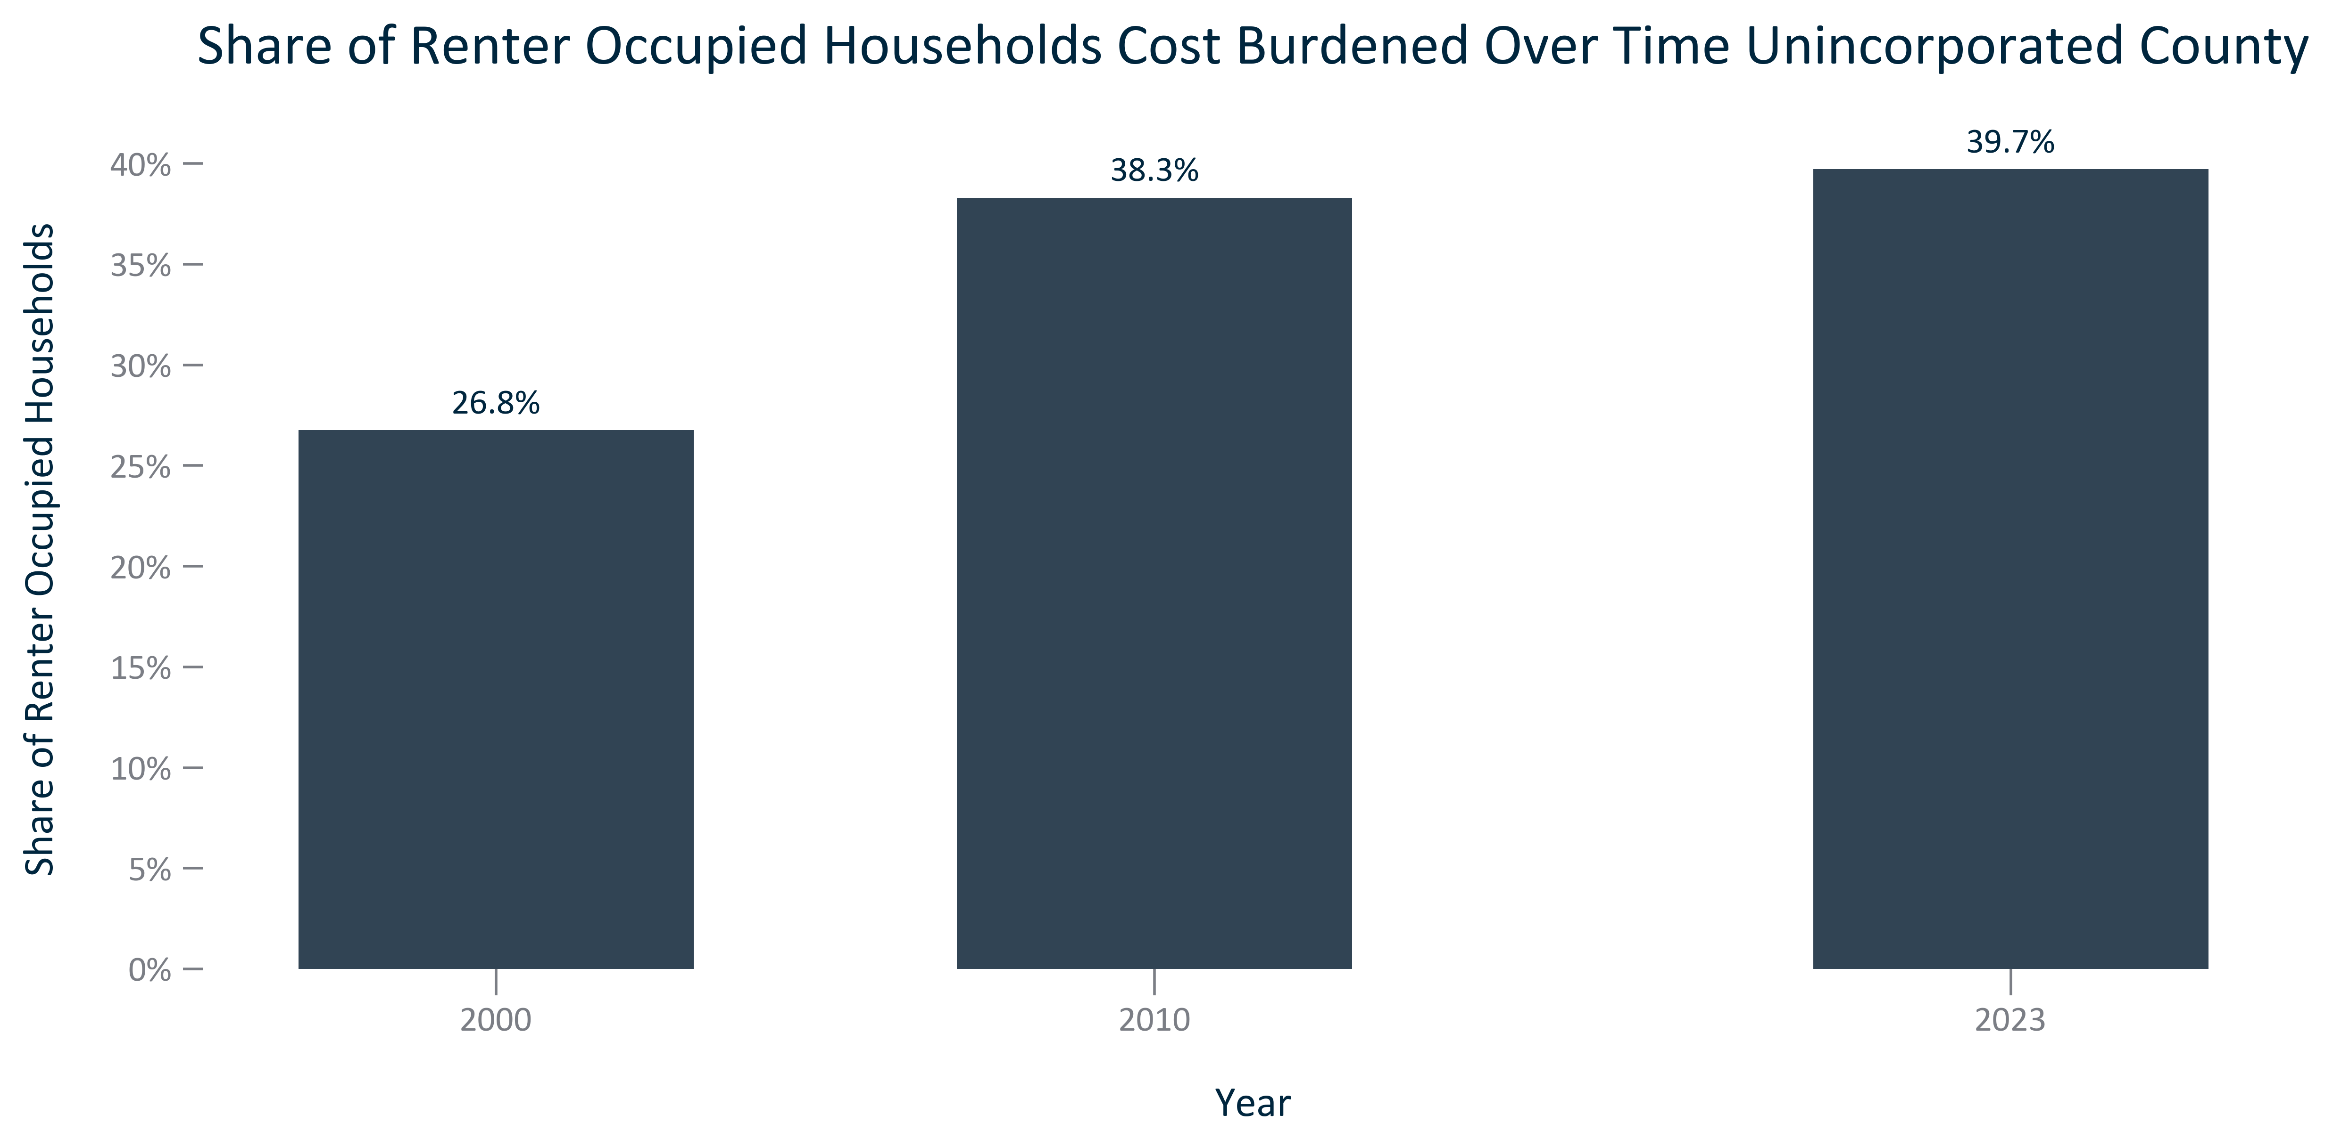

Citation: 2000 Decennial Census, 2006-2010 and 2019 - 2023 American Community Survey 5-Year Estimates

### TENURECOST_stackedbar_geocomparative_costburdenbytenure_2023:

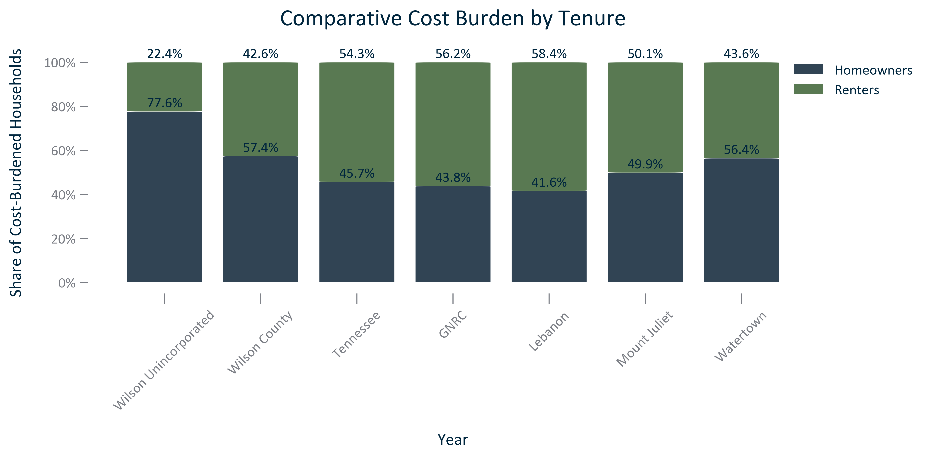

Citation: 2000 Decennial Census, 2006-2010 and 2019 - 2023 American Community Survey 5-Year Estimates

### TENURECOST_stackedbar_geocomparative_severecostburdenbytenure_2023:

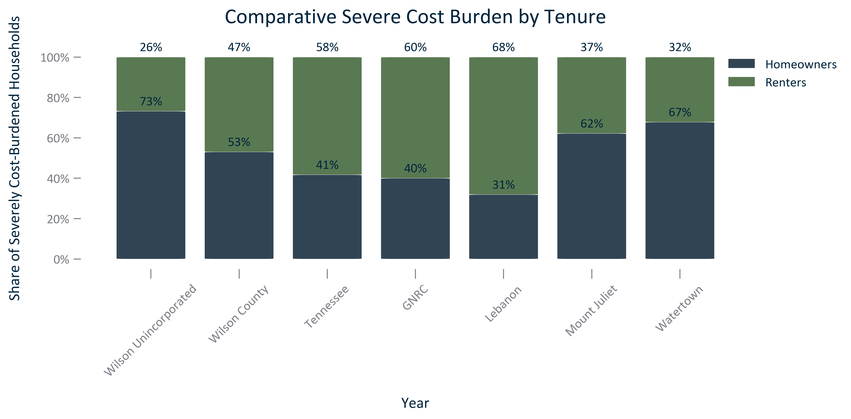

Citation: 2000 Decennial Census, 2006-2010 and 2019 - 2023 American Community Survey 5-Year Estimates

### TENURECOST_table_primarygeo_allcostburdennumberandpercent_overtime:

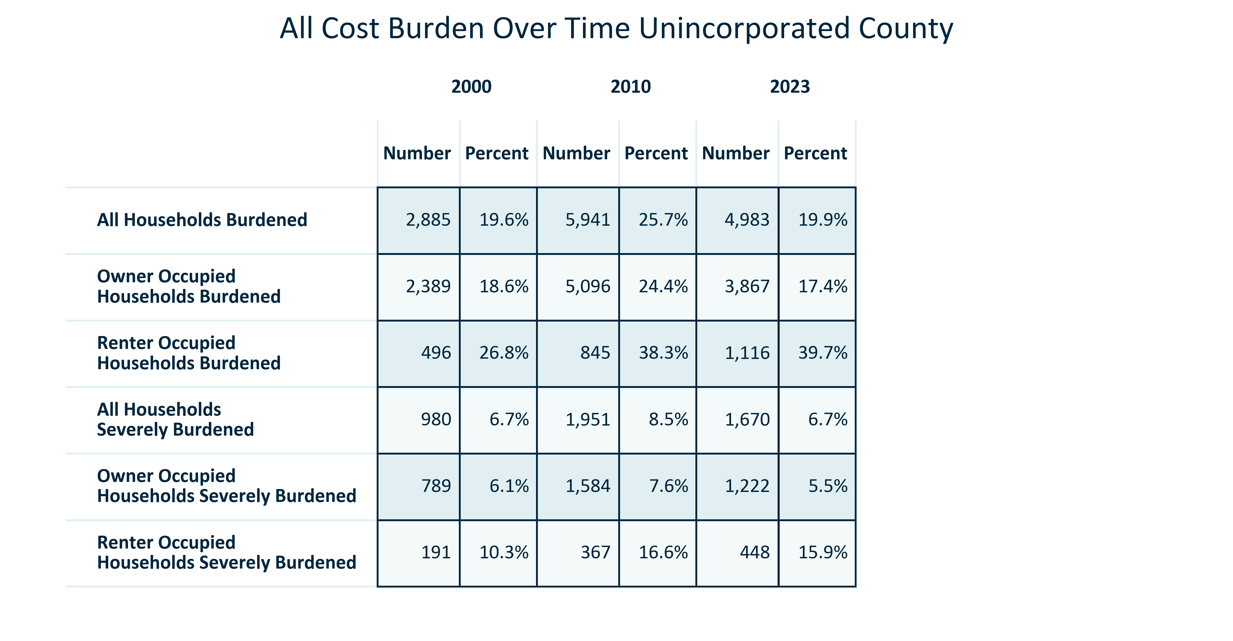

Citation: 2000 Decennial Census, 2006-2010 and 2019 - 2023 American Community Survey 5-Year Estimates

### TENURECOST_clusterbar_primarygeo_allcostburdenpercentchange_overtime:

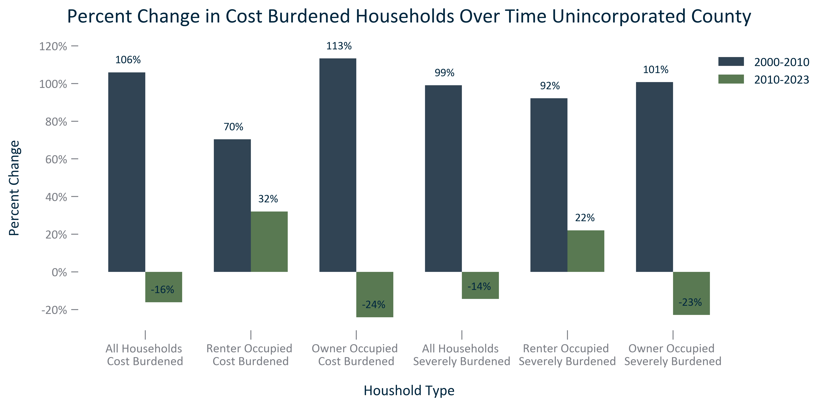

Citation: 2000 Decennial Census, 2006-2010 and 2019 - 2023 American Community Survey 5-Year Estimates

### TENURECOST_clusterbar_primarygeo_allcostburdenrealchange_overtime:

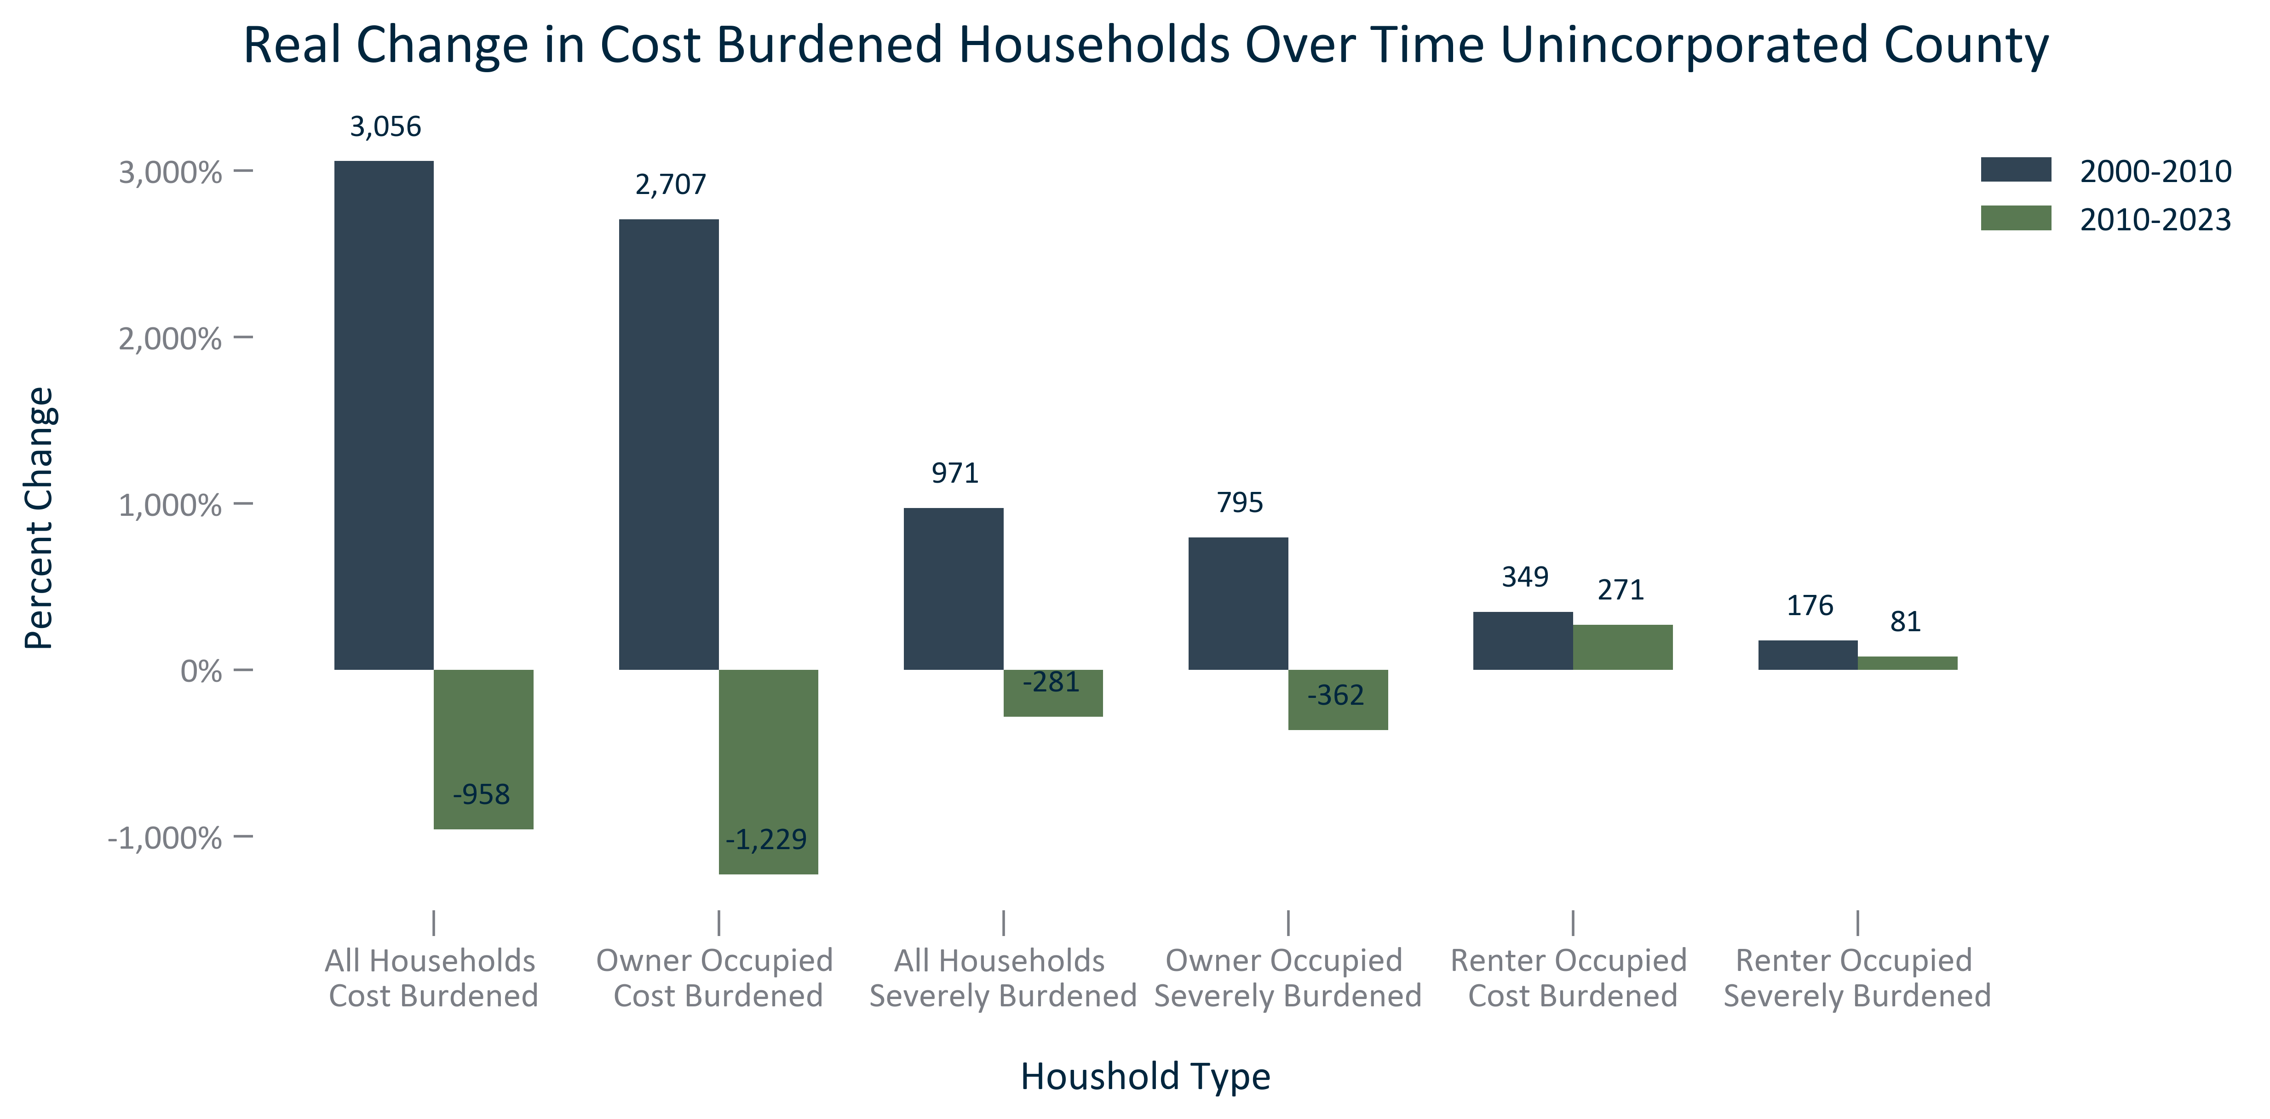

Citation: 2000 Decennial Census, 2006-2010 and 2019 - 2023 American Community Survey 5-Year Estimates

### TENURECOST_clusterbar_geocomparative_CNThtpercentofincome_current:

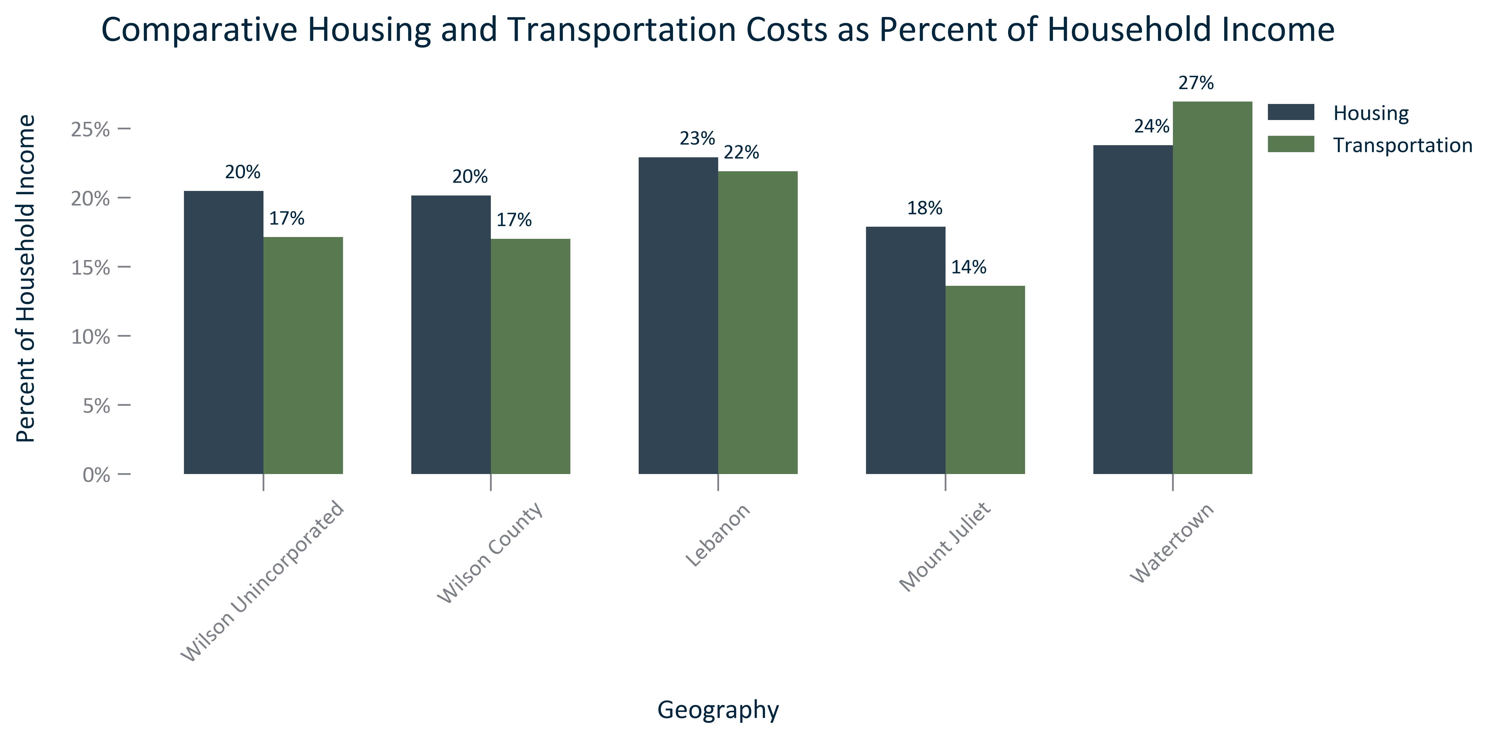

Citation: Center for Neighborhood Technology, 2020 Housing and Transportation Index

### TENURECOST_stackedbar_geocomparative_CNThousingplustransportationcosts_current:

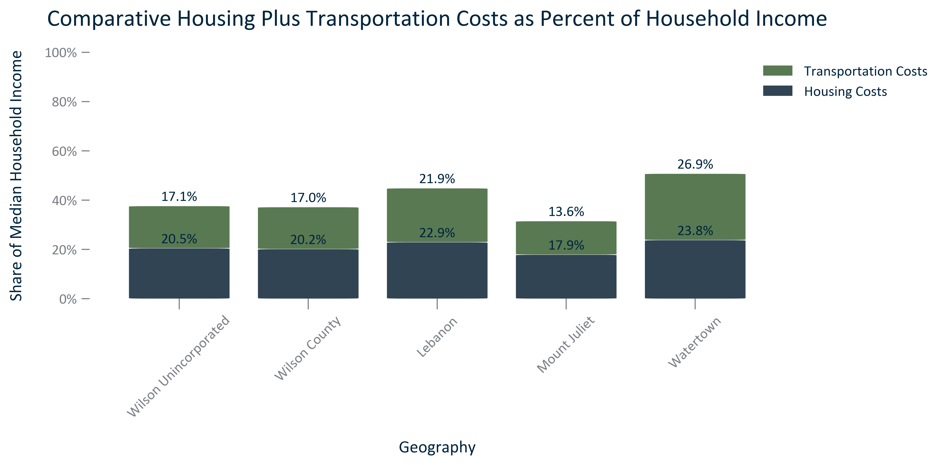

Citation: Center for Neighborhood Technology, 2020 Housing and Transportation Index

### TENURECOST_table_geocomparative_CNThousingandtransportation_current:

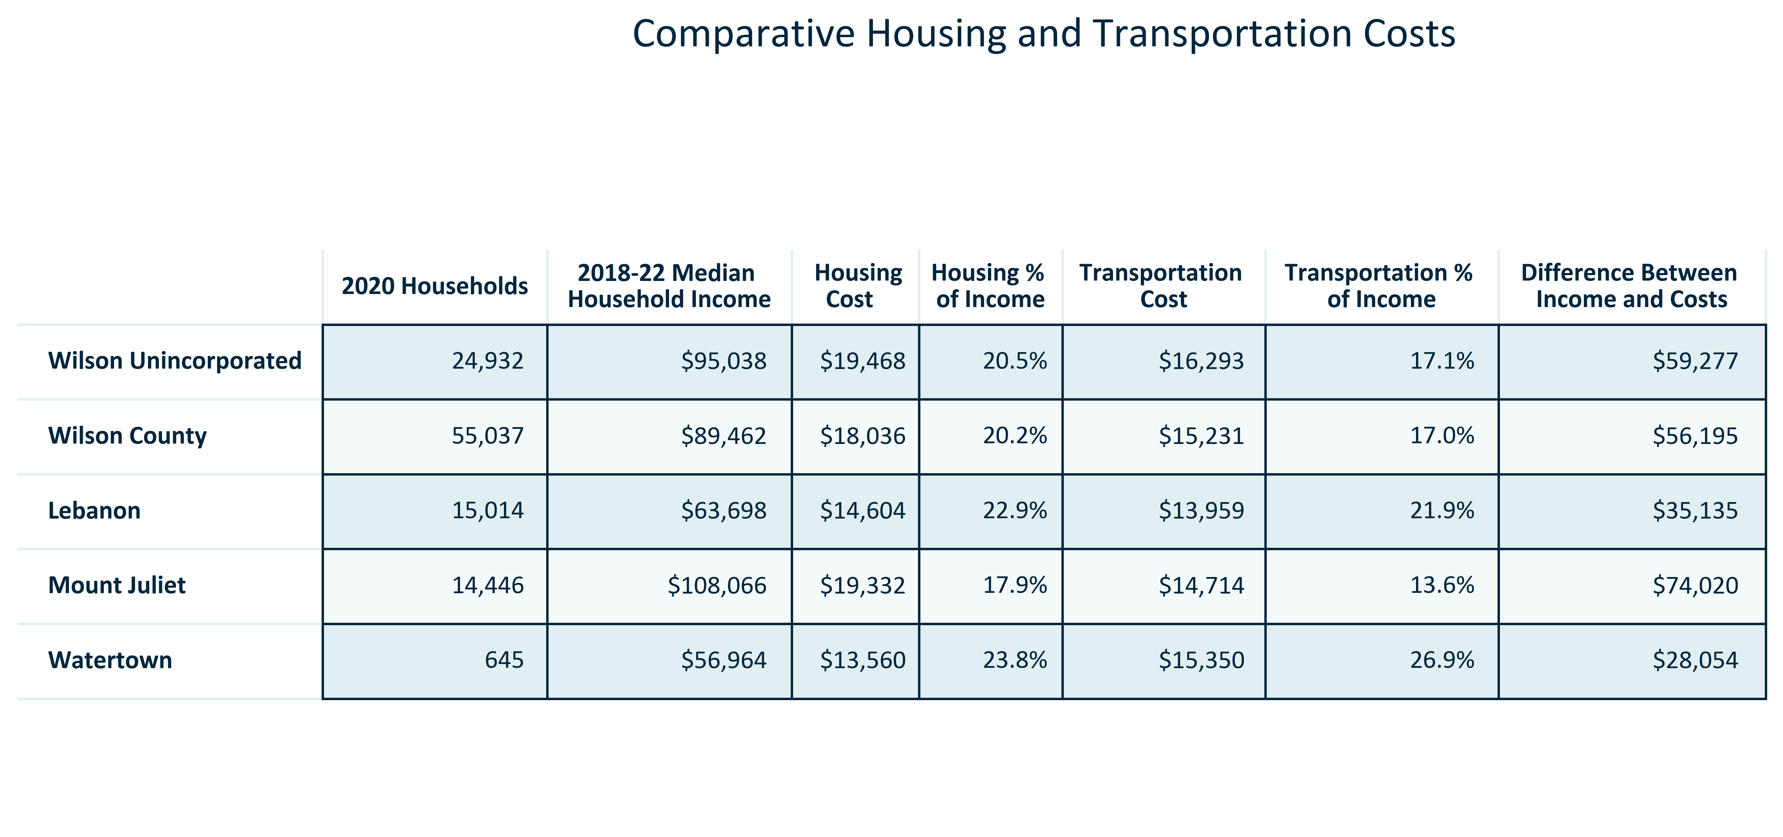

Citation: Center for Neighborhood Technology, 2020 Housing and Transportation Index, median household income is 2018-2022 ACS 5-Year to match

# Education

### EDUCATION_stackedbar_primarygeo_highestattainment_overtime:

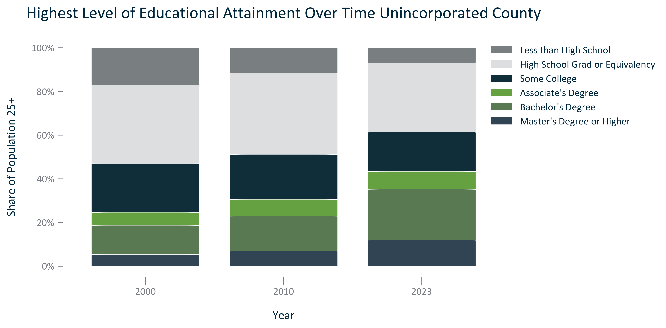

Citation: 2000 Decennial Census, 2006-2010 and 2019 - 2023 American Community Survey 5-Year Estimates

### EDUCATION_table_primarygeo_attainmentnumberandpercent_overtime:

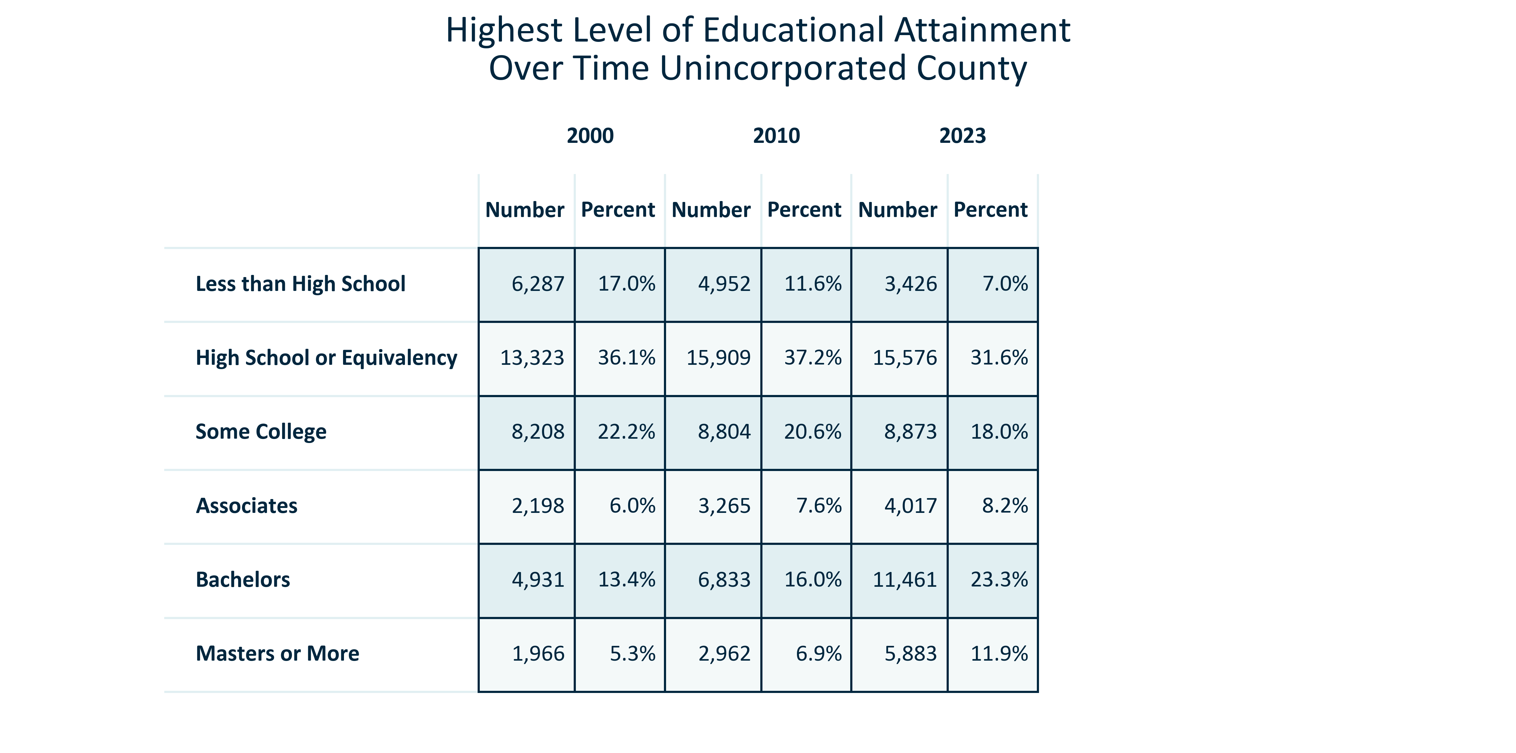

Citation: 2000 Decennial Census, 2006-2010 and 2019 - 2023 American Community Survey 5-Year Estimates

### EDUCATION_stackedbar_geocomparative_highestattainment_2023:

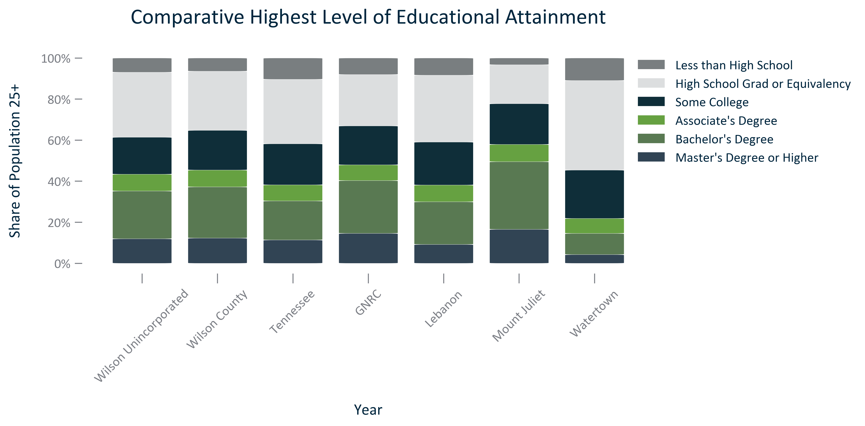

Citation: 2019 - 2023 American Community Survey 5-Year Estimates

### EDUCATION_table_geocomparative_attainment_2023:

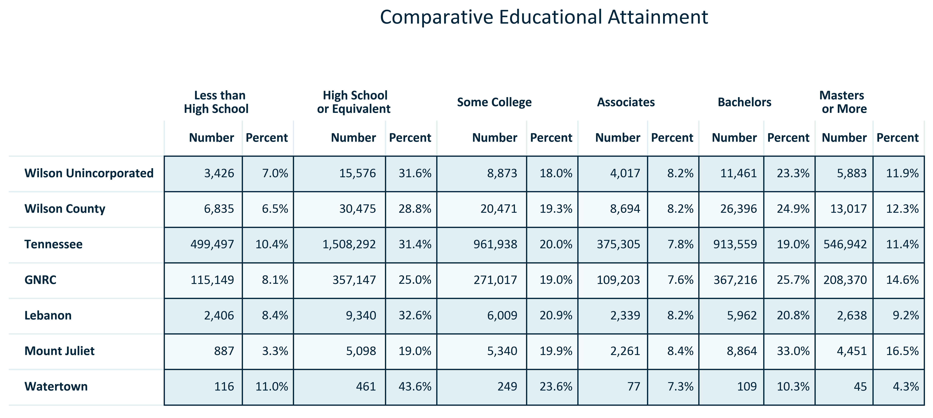

Citation: 2019 - 2023 American Community Survey 5-Year Estimates

### EDUCATION_bar_primarygeo_highschoolandabove_overtime:

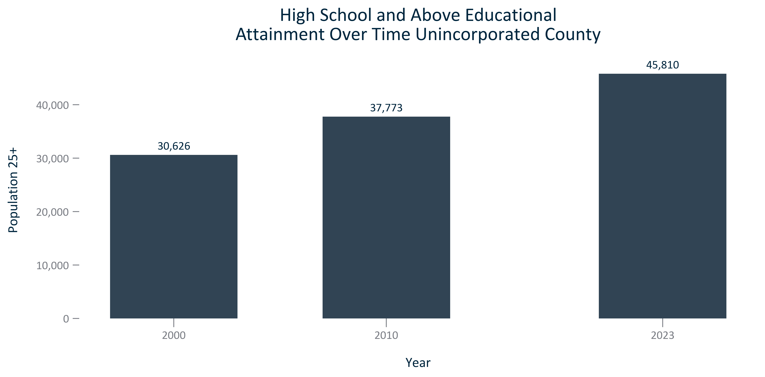

Citation: 2000 Decennial Census, 2006-2010 and 2019 - 2023 American Community Survey 5-Year Estimates

### EDUCATION_bar_primarygeo_sharehighschoolandabove_overtime:

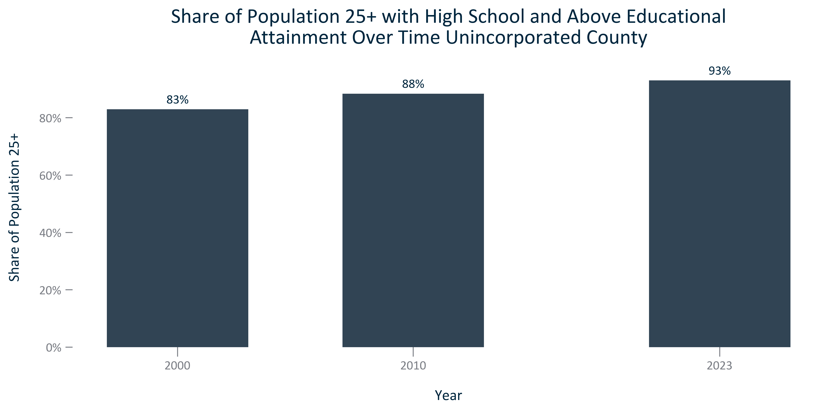

Citation: 2000 Decennial Census, 2006-2010 and 2019 - 2023 American Community Survey 5-Year Estimates

### EDUCATION_bar_geocomparative_highschoolorhigherattainment_2023:

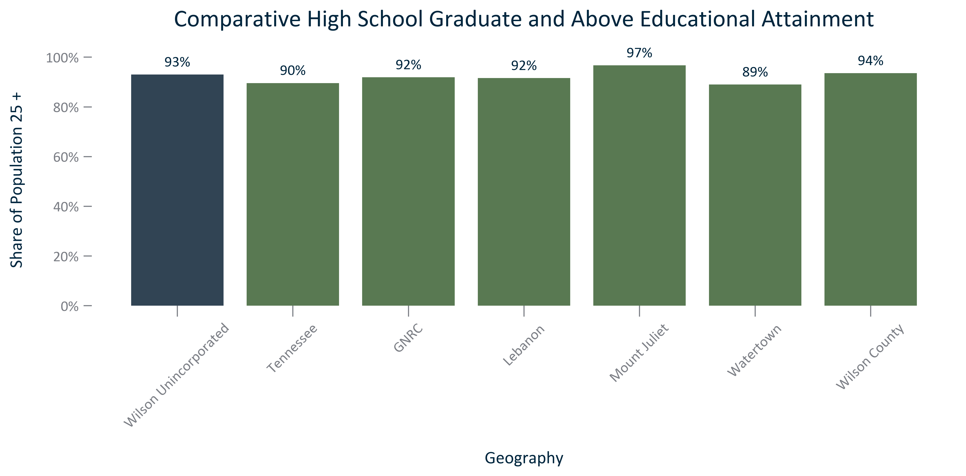

Citation: 2019 - 2023 American Community Survey 5-Year Estimates

### EDUCATION_bar_primarygeo_bachelorsandabove_overtime:

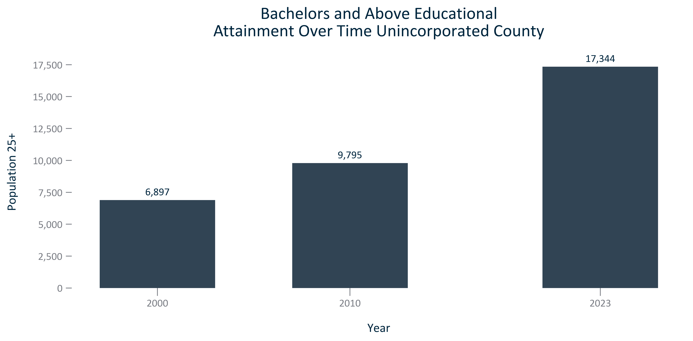

Citation: 2000 Decennial Census, 2006-2010 and 2019 - 2023 American Community Survey 5-Year Estimates

### EDUCATION_bar_primarygeo_sharebachelorsandabove_overtime:

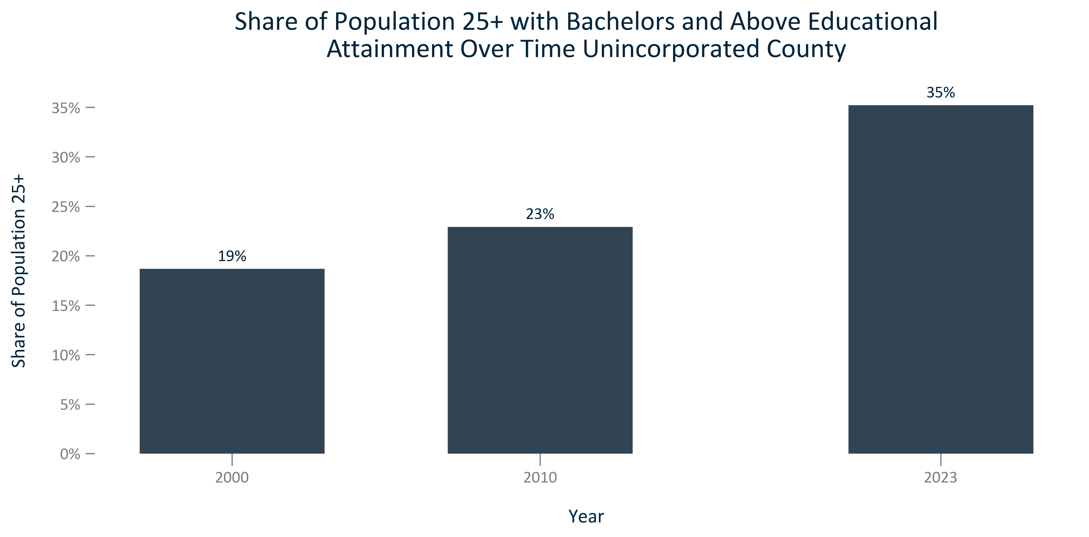

Citation: 2000 Decennial Census, 2006-2010 and 2019 - 2023 American Community Survey 5-Year Estimates

### EDUCATION_bar_geocomparative_bachelorsorhigherattainment_2023:

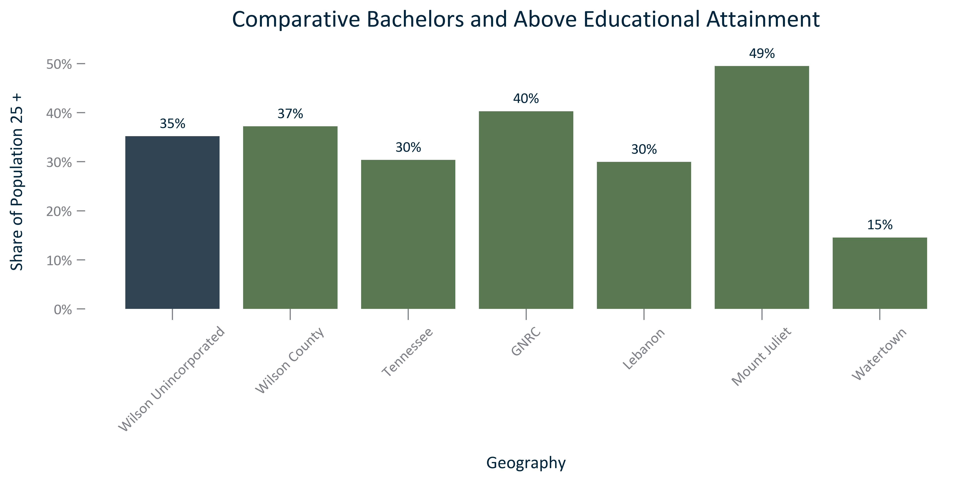

Citation: 2019 - 2023 American Community Survey 5-Year Estimates

# Employment and Economy

0 3.431358

Name: Percent of Resident Workforce, dtype: objectThis is the percent of workers living in the unincorporated county that work in the unincorporated county.

0 27.350297

Name: Percent of Resident Workforce, dtype: objectThis is the percent of workers living in the unincorporated county that work in the county.

0 91.421606

Name: Percent of Resident Workforce, dtype: float64This is the percent of workers living in the unincorporated county that work in the 13 county region.

### EMP_bar_primarygeo_numindustryemployment_2023:

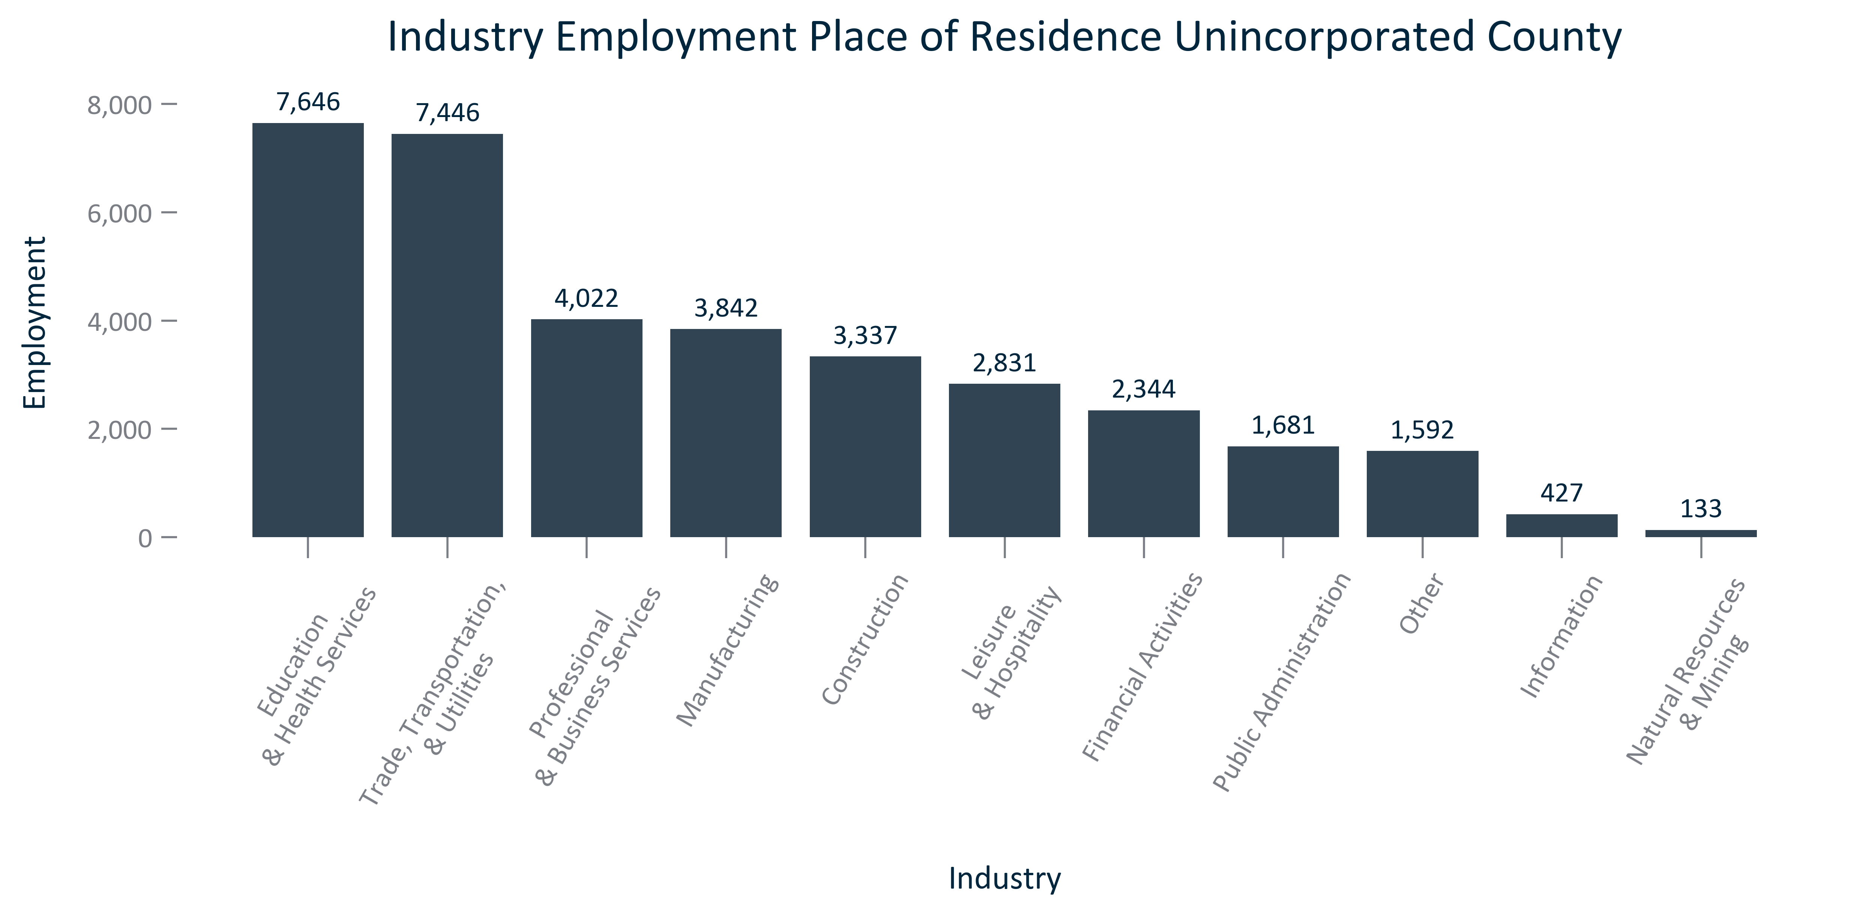

Citation: 2019 - 2023 American Community Survey 5-Year Estimates

### EMP_bar_primarygeo_shareindustryemployment_2023:

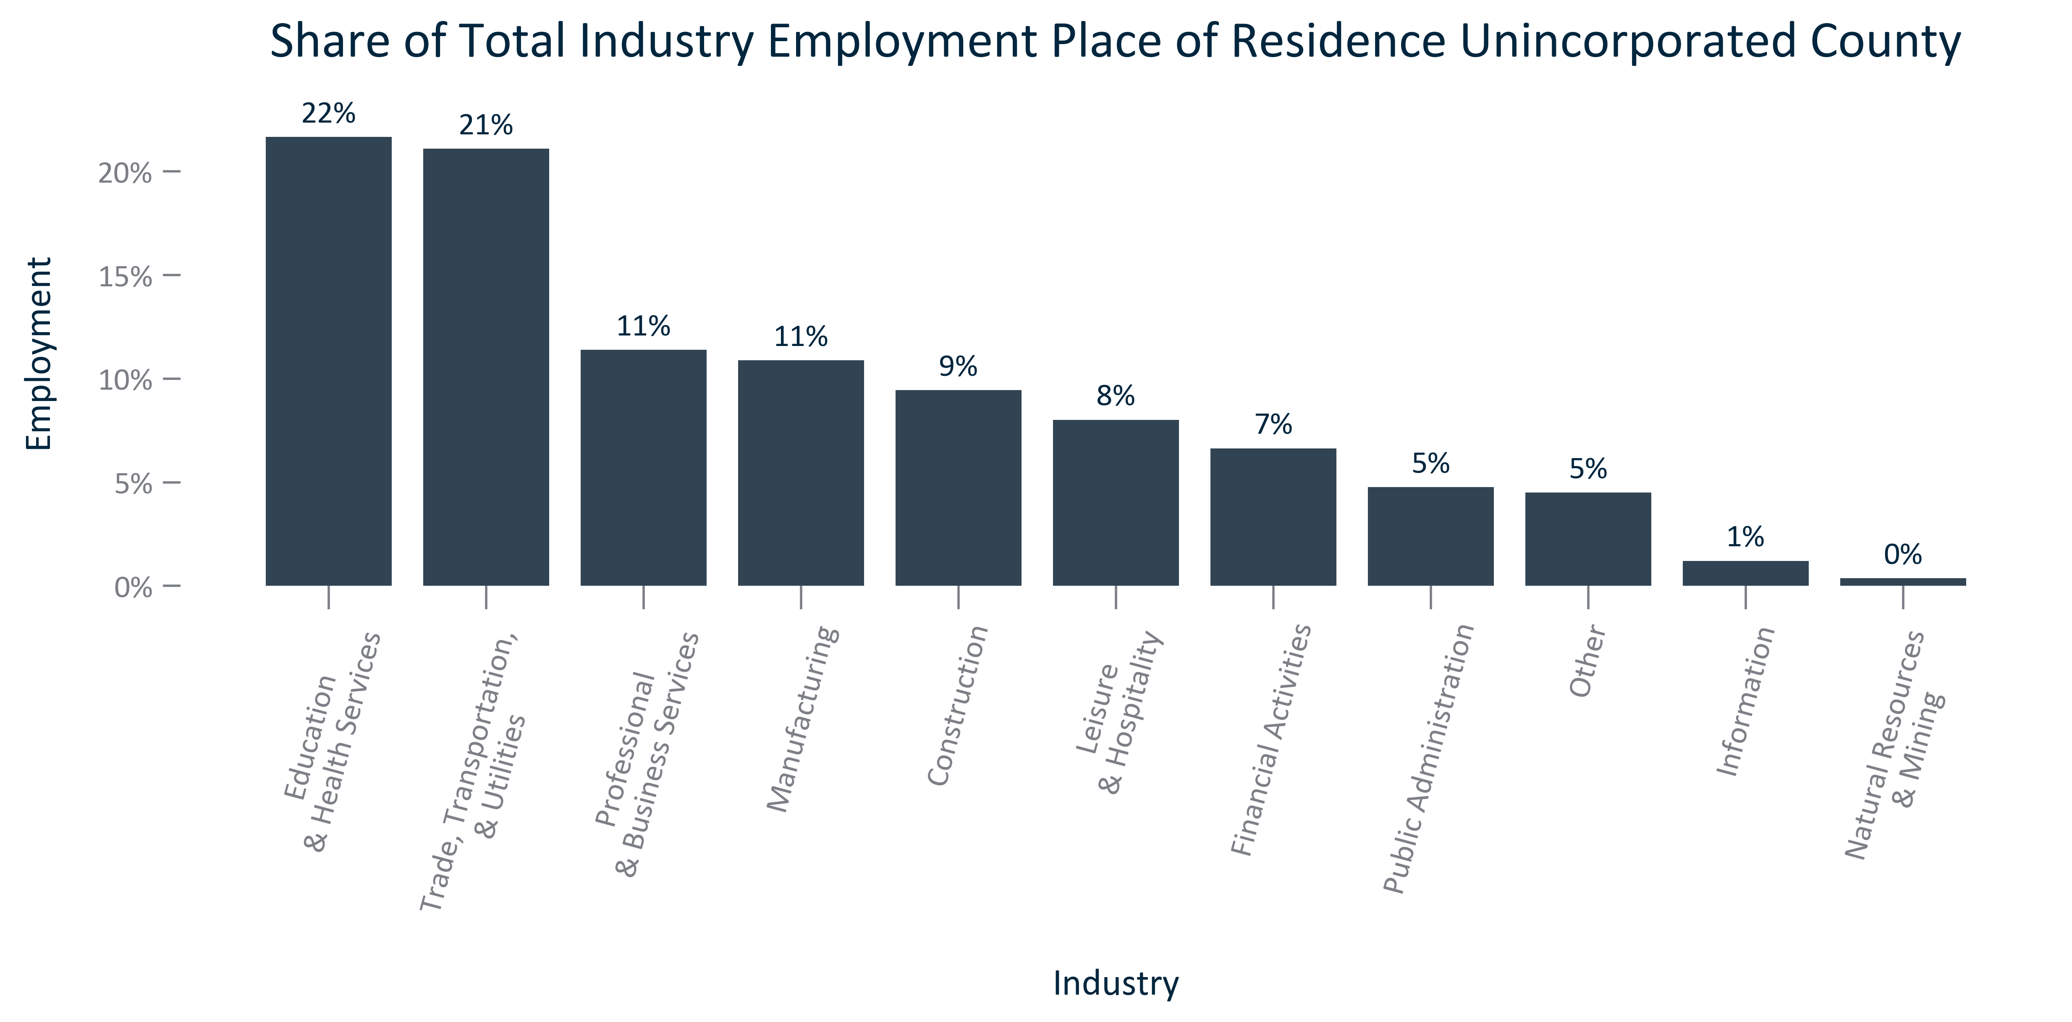

Citation: 2019 - 2023 American Community Survey 5-Year Estimates

### EMP_clusterbar_primarygeo_realchangeindustryemployment_overtime:

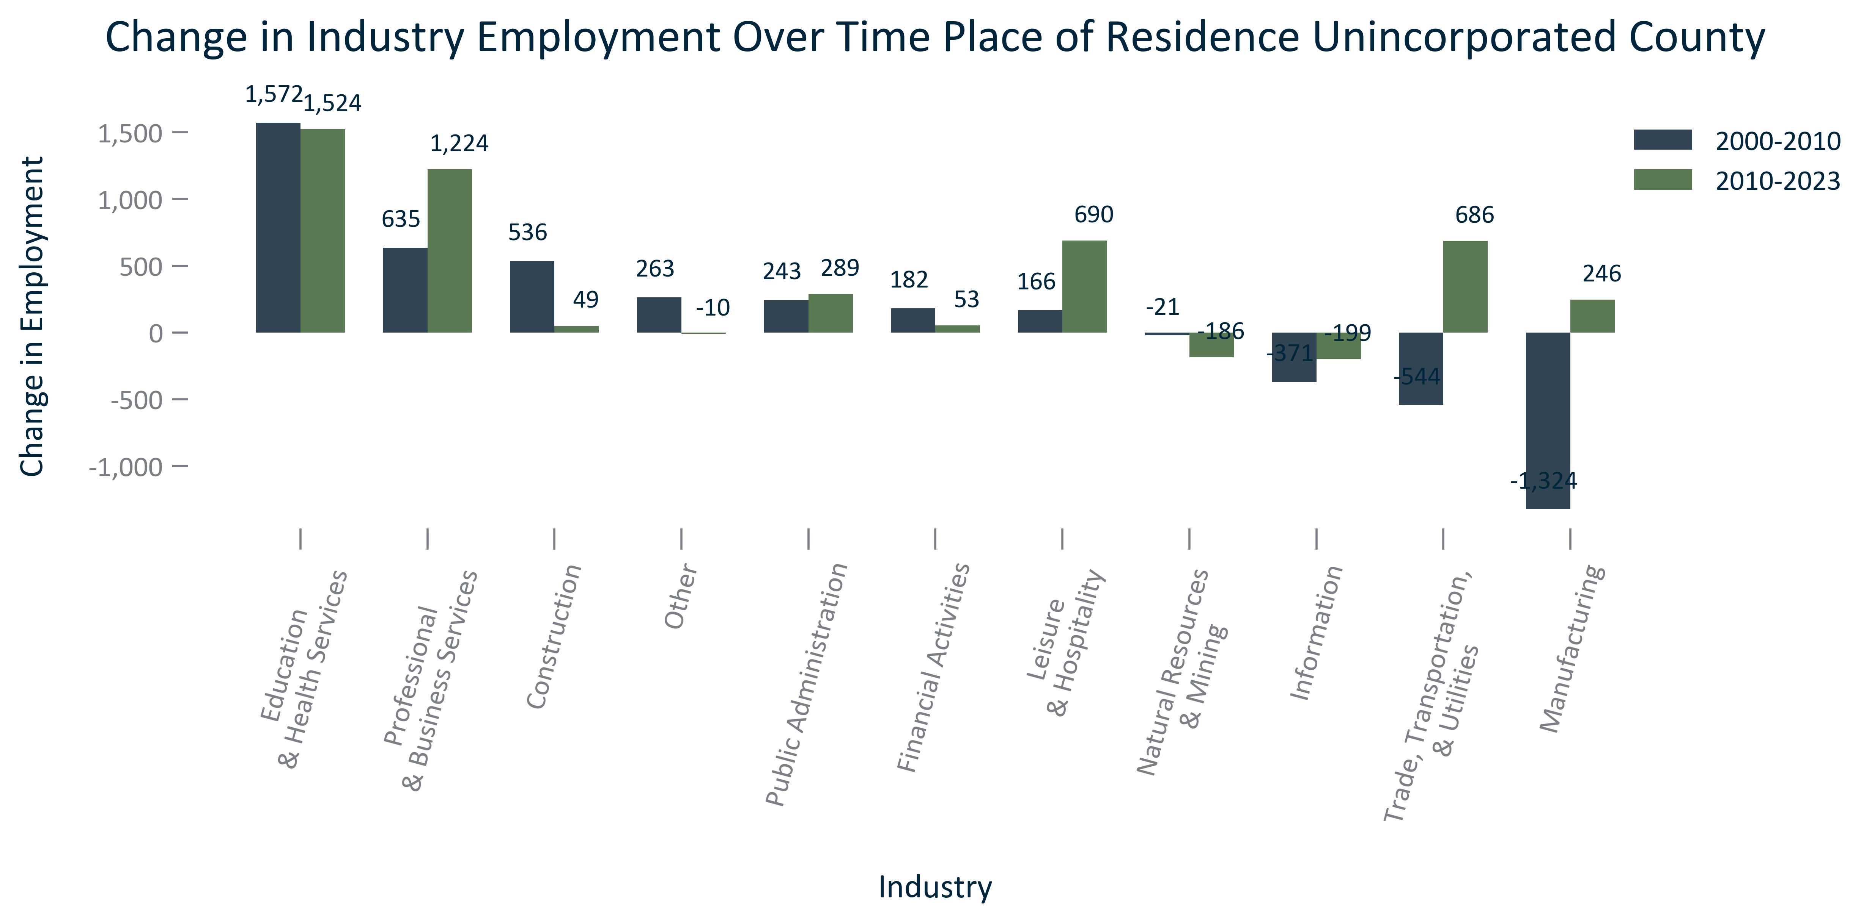

Citation: 2000 Decennial Census, 2006-2010 and 2019 - 2023 American Community Survey 5-Year Estimates

### EMP_clusterbar_primarygeo_percentchangeindustryemployment_overtime:

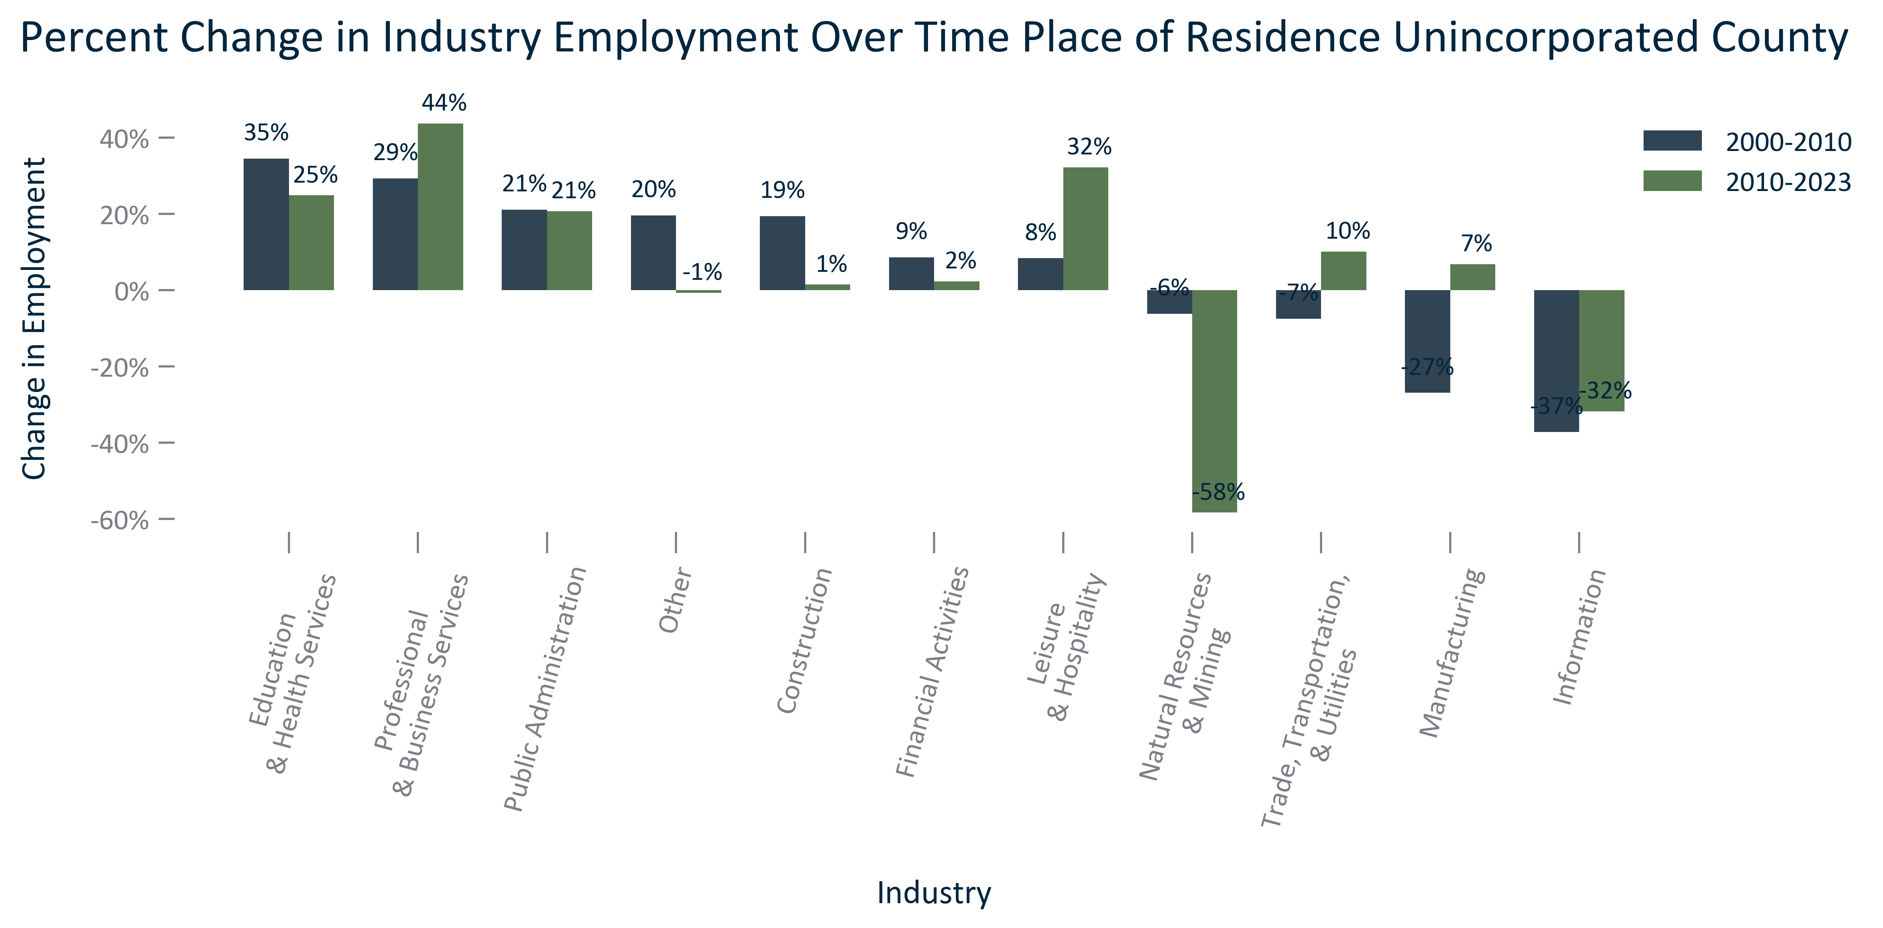

Citation: 2000 Decennial Census, 2006-2010 and 2019 - 2023 American Community Survey 5-Year Estimates

### EMP_table_primarygeo_industryemployment_overtime:

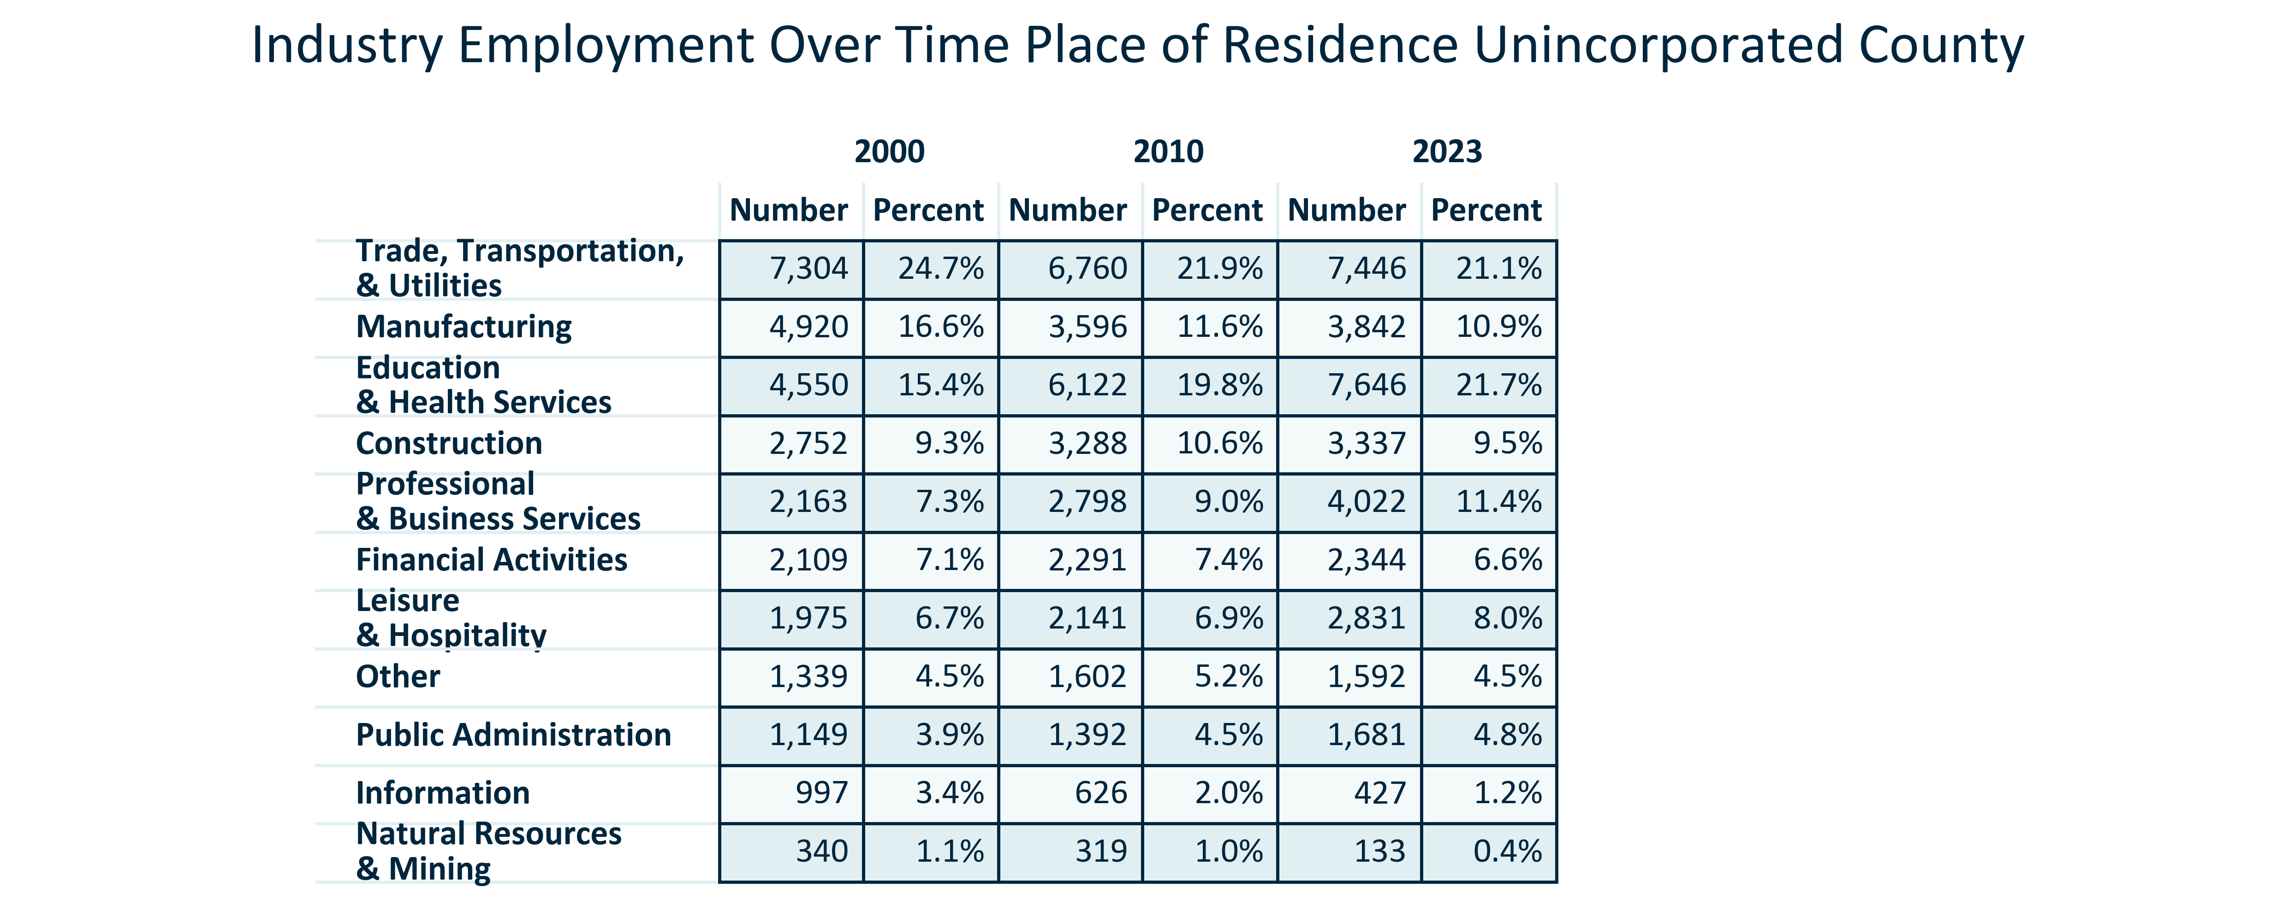

Citation: 2000 Decennial Census, 2006-2010 and 2019 - 2023 American Community Survey 5-Year Estimates

### EMP_pyramid_primarygeo_powporemploymentpyramid_2022:

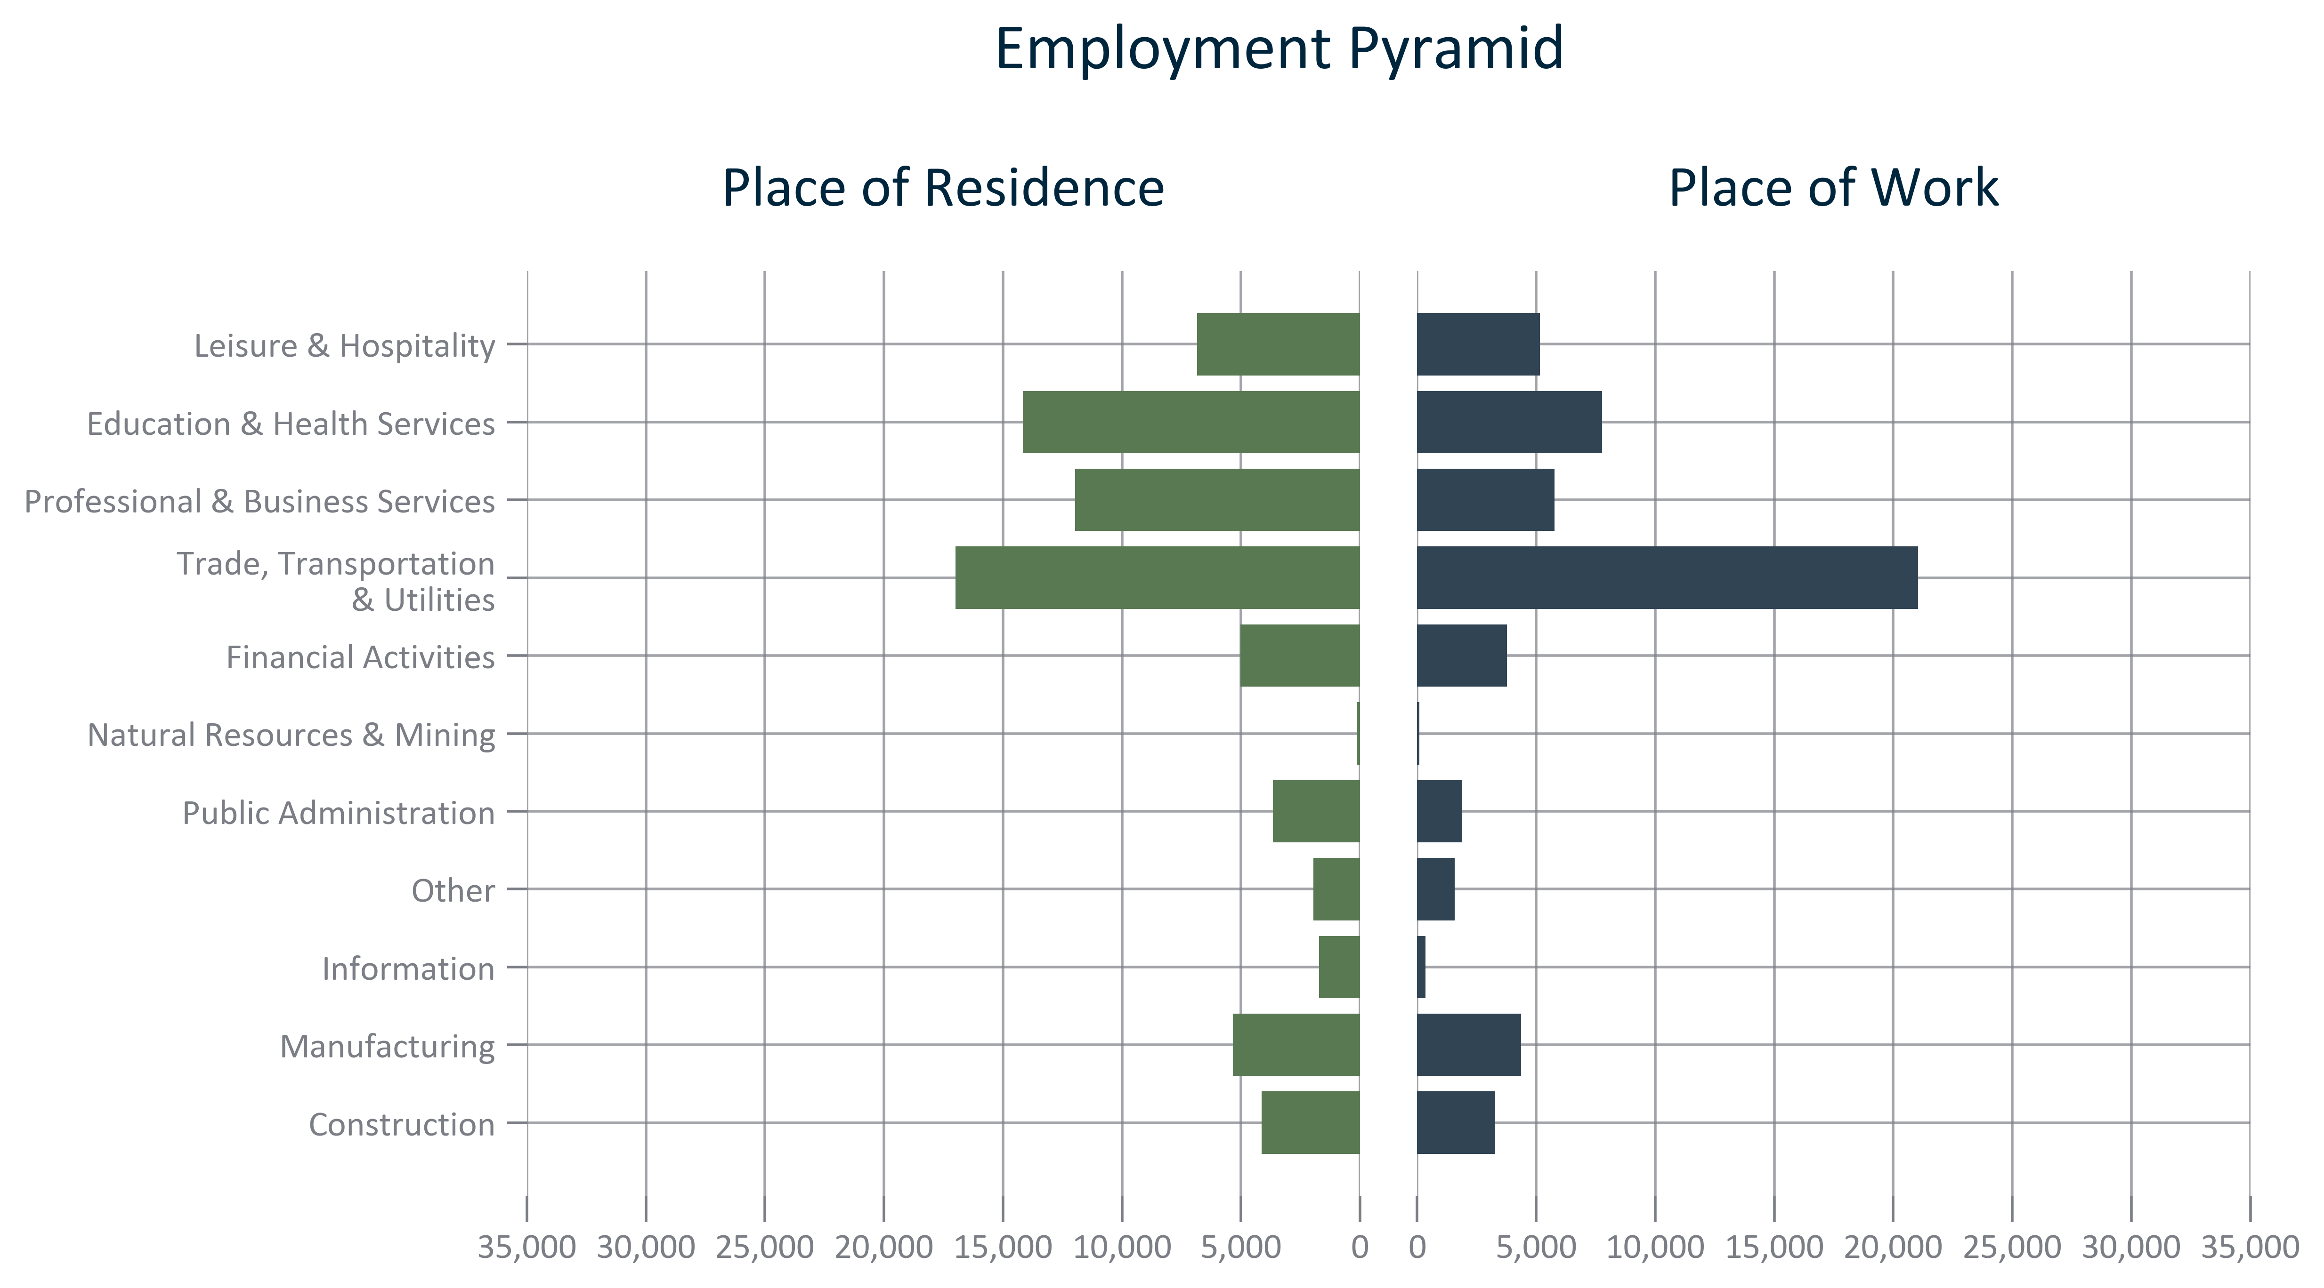

Citation: 2022 LEHD

### EMP_table_geocomparative_topemploymentcounties_2022:

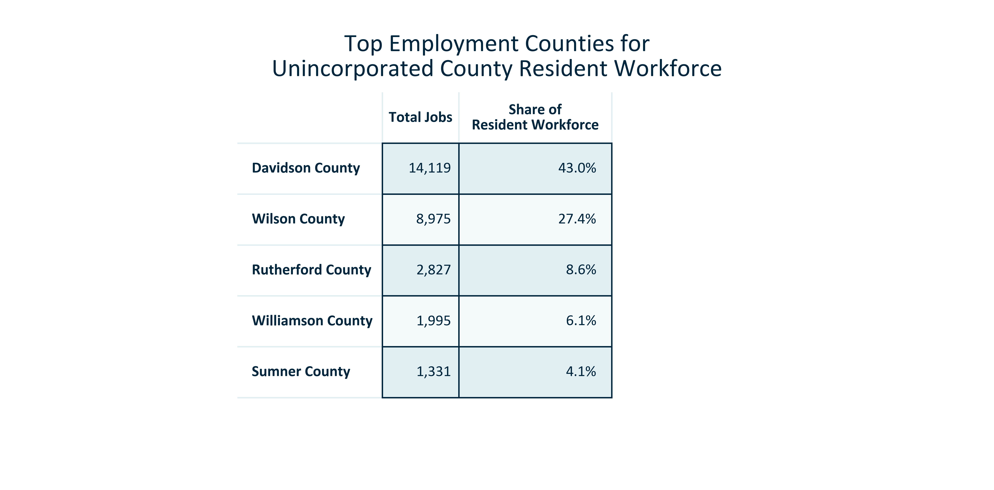

Citation: 2022 LEHD

### EMP_table_geocomparative_topemploymentcountiesage_2022:

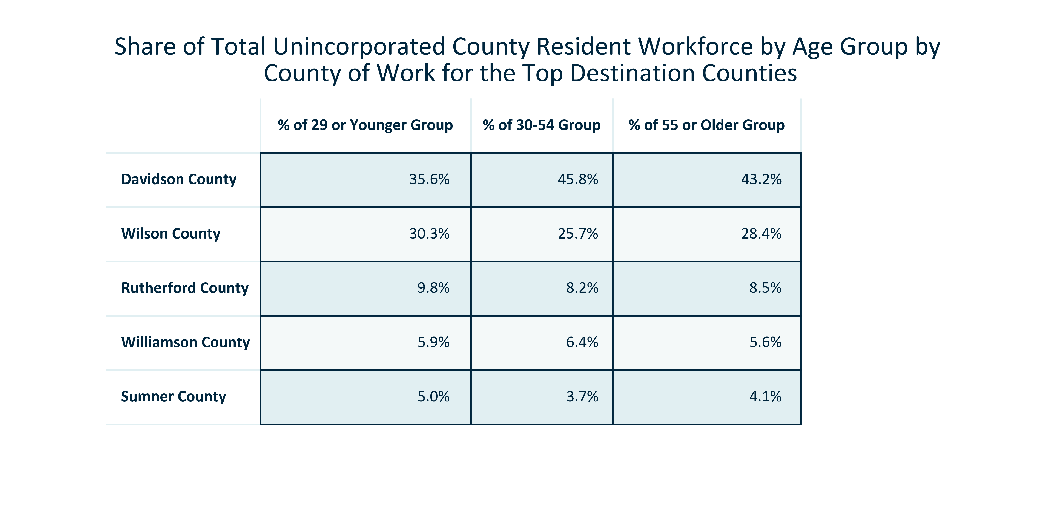

Citation: 2022 LEHD

### EMP_table_geocomparative_topemploymentcountiessupersector_2022:

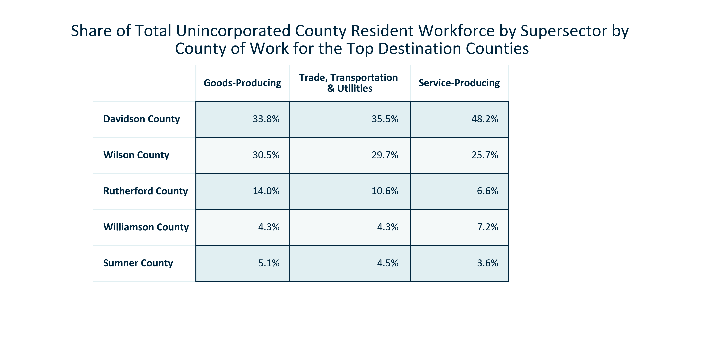

Citation: 2022 LEHD

### EMP_table_geocomparative_topemploymentplaces_2022:

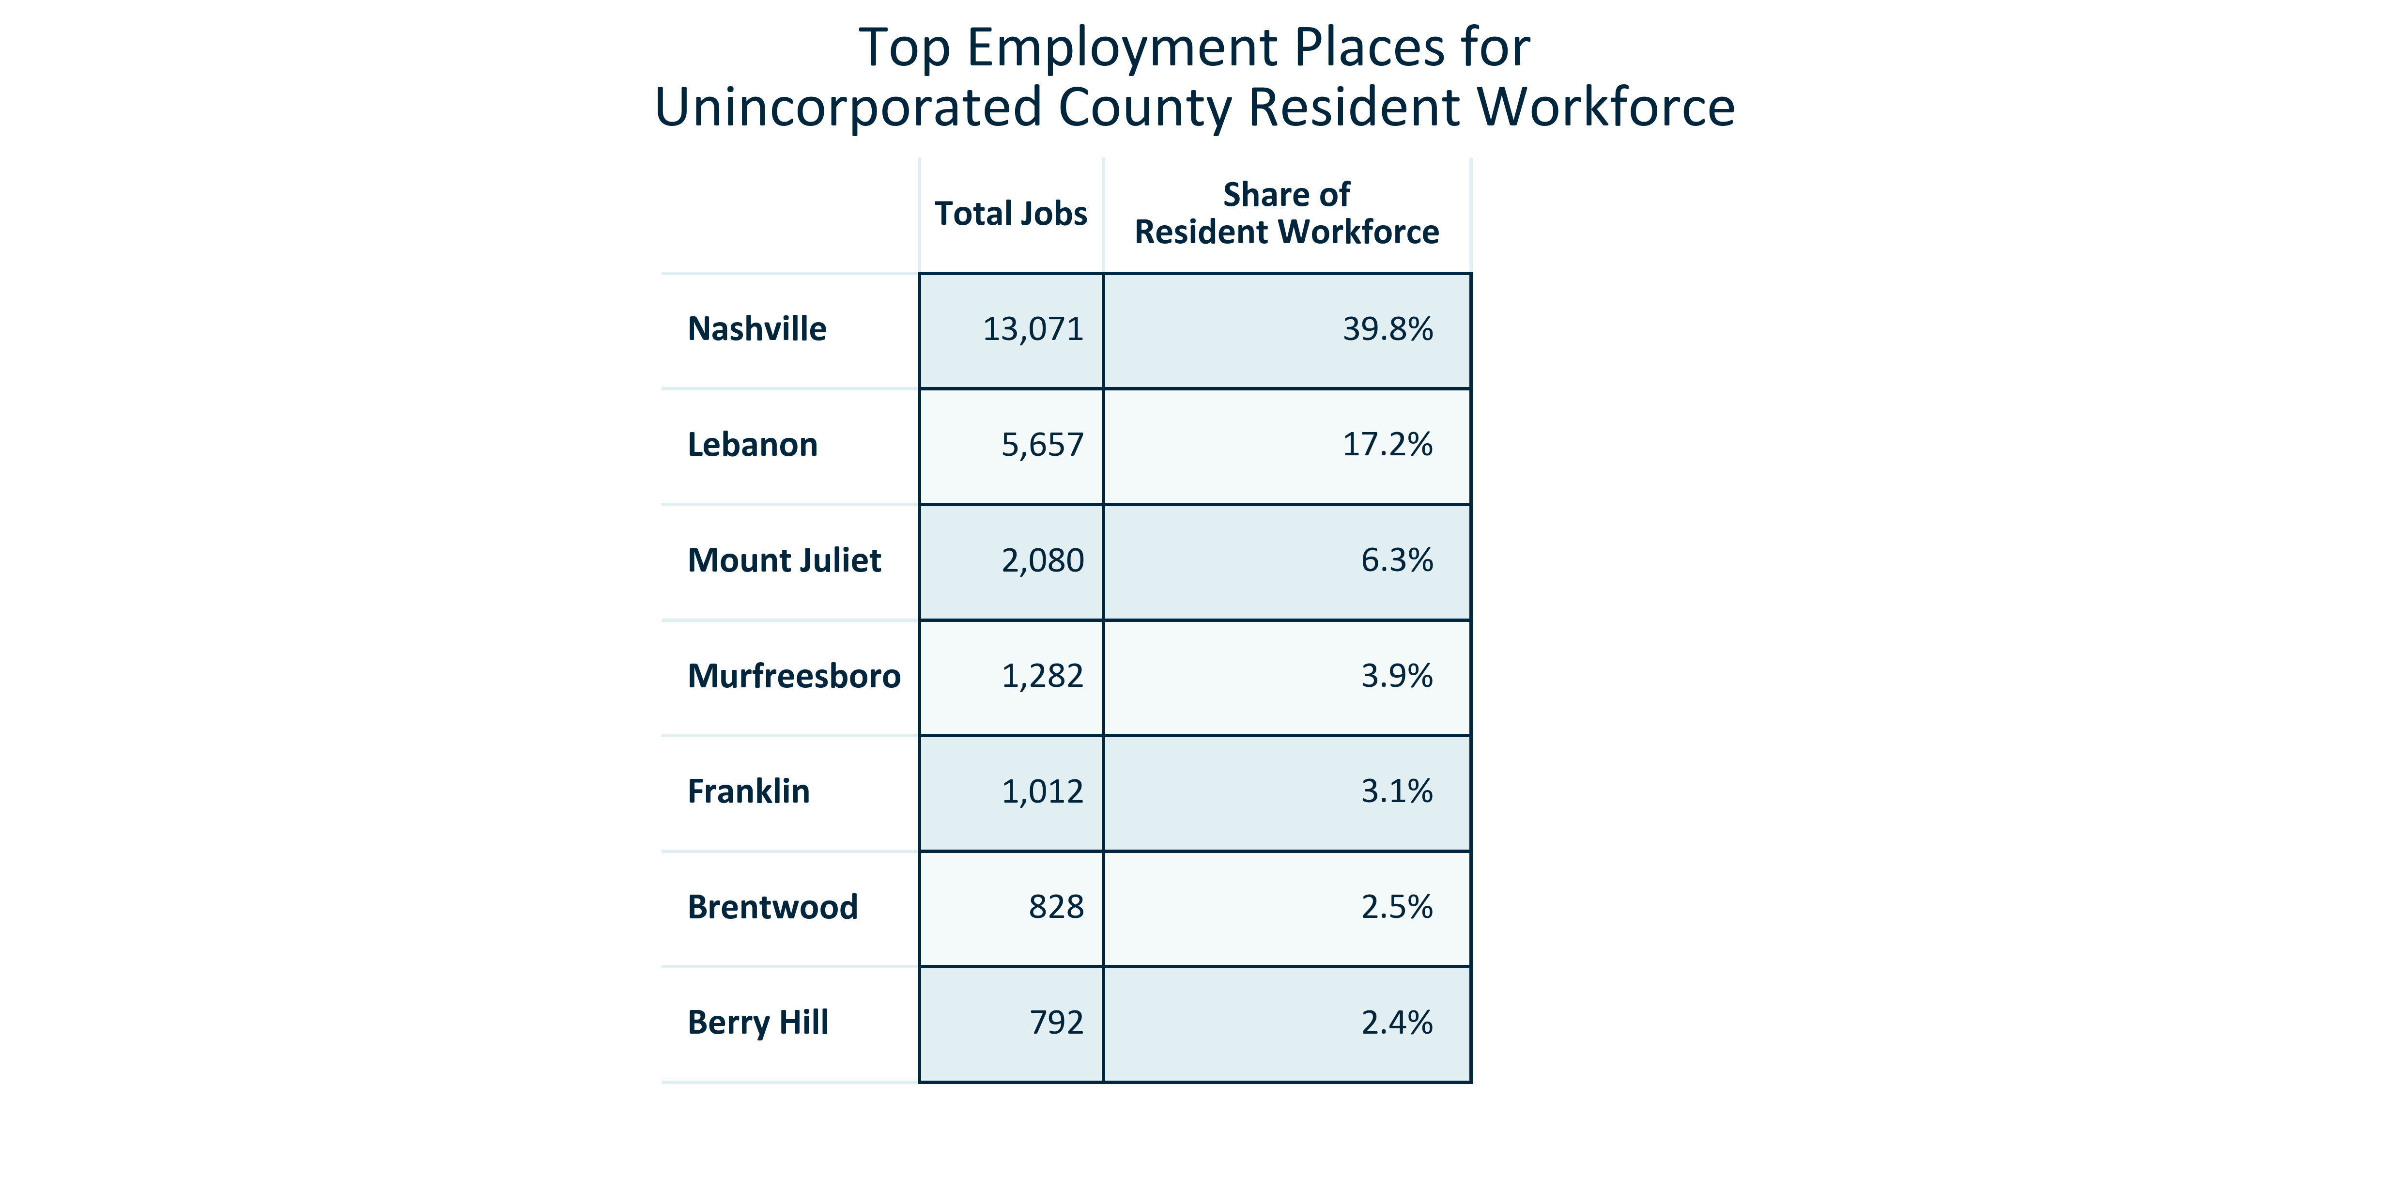

Citation: 2022 LEHD

### EMP_table_geocomparative_topemploymentplacesage_2022:

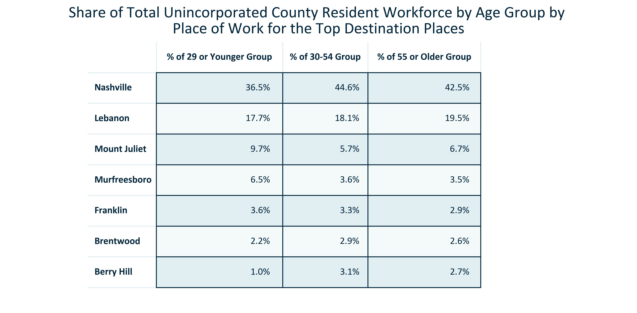

Citation: 2022 LEHD

### EMP_table_geocomparative_topemploymentplacessupersector_2022:

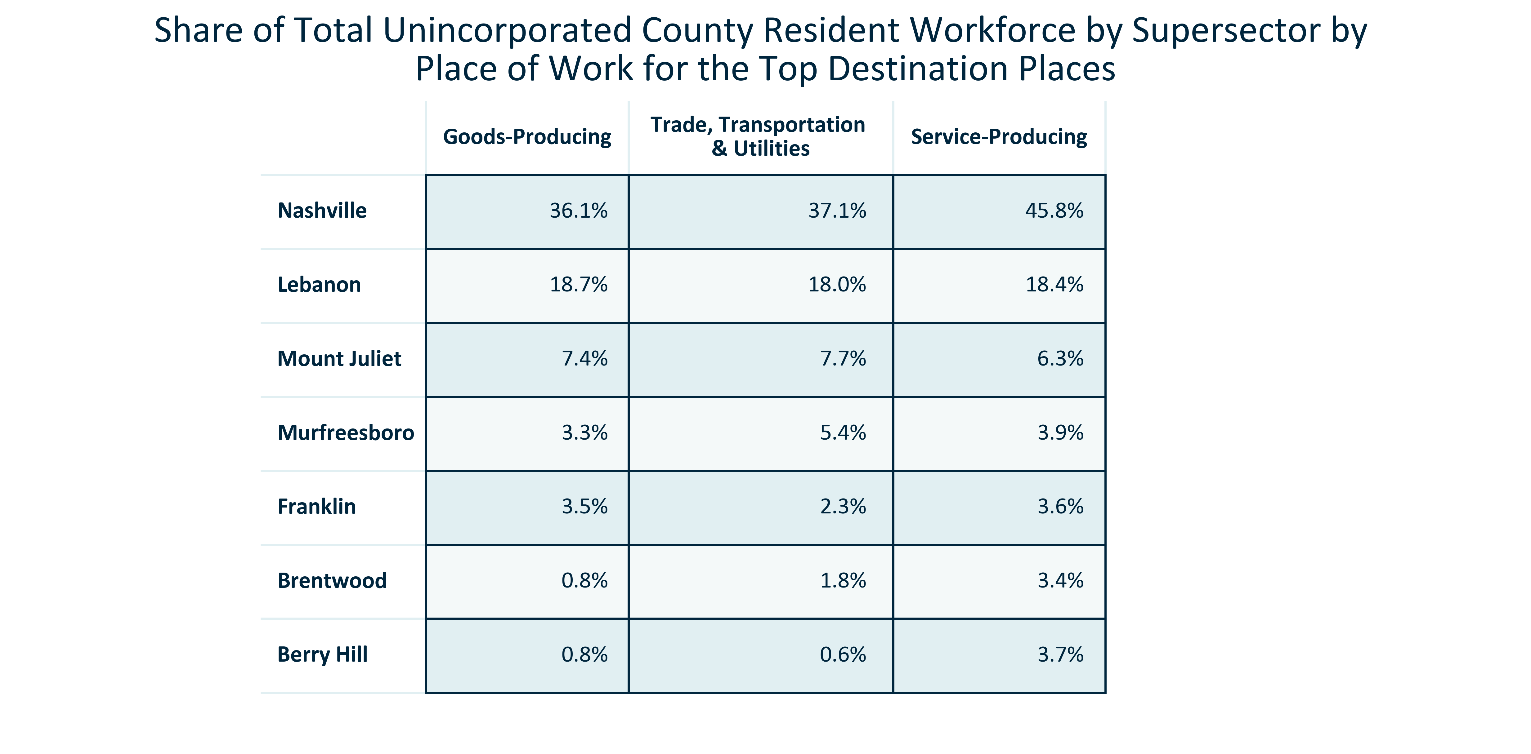

Citation: 2022 LEHD

### EMP_line_primarygeo_historicalemploymentplace_overtime:

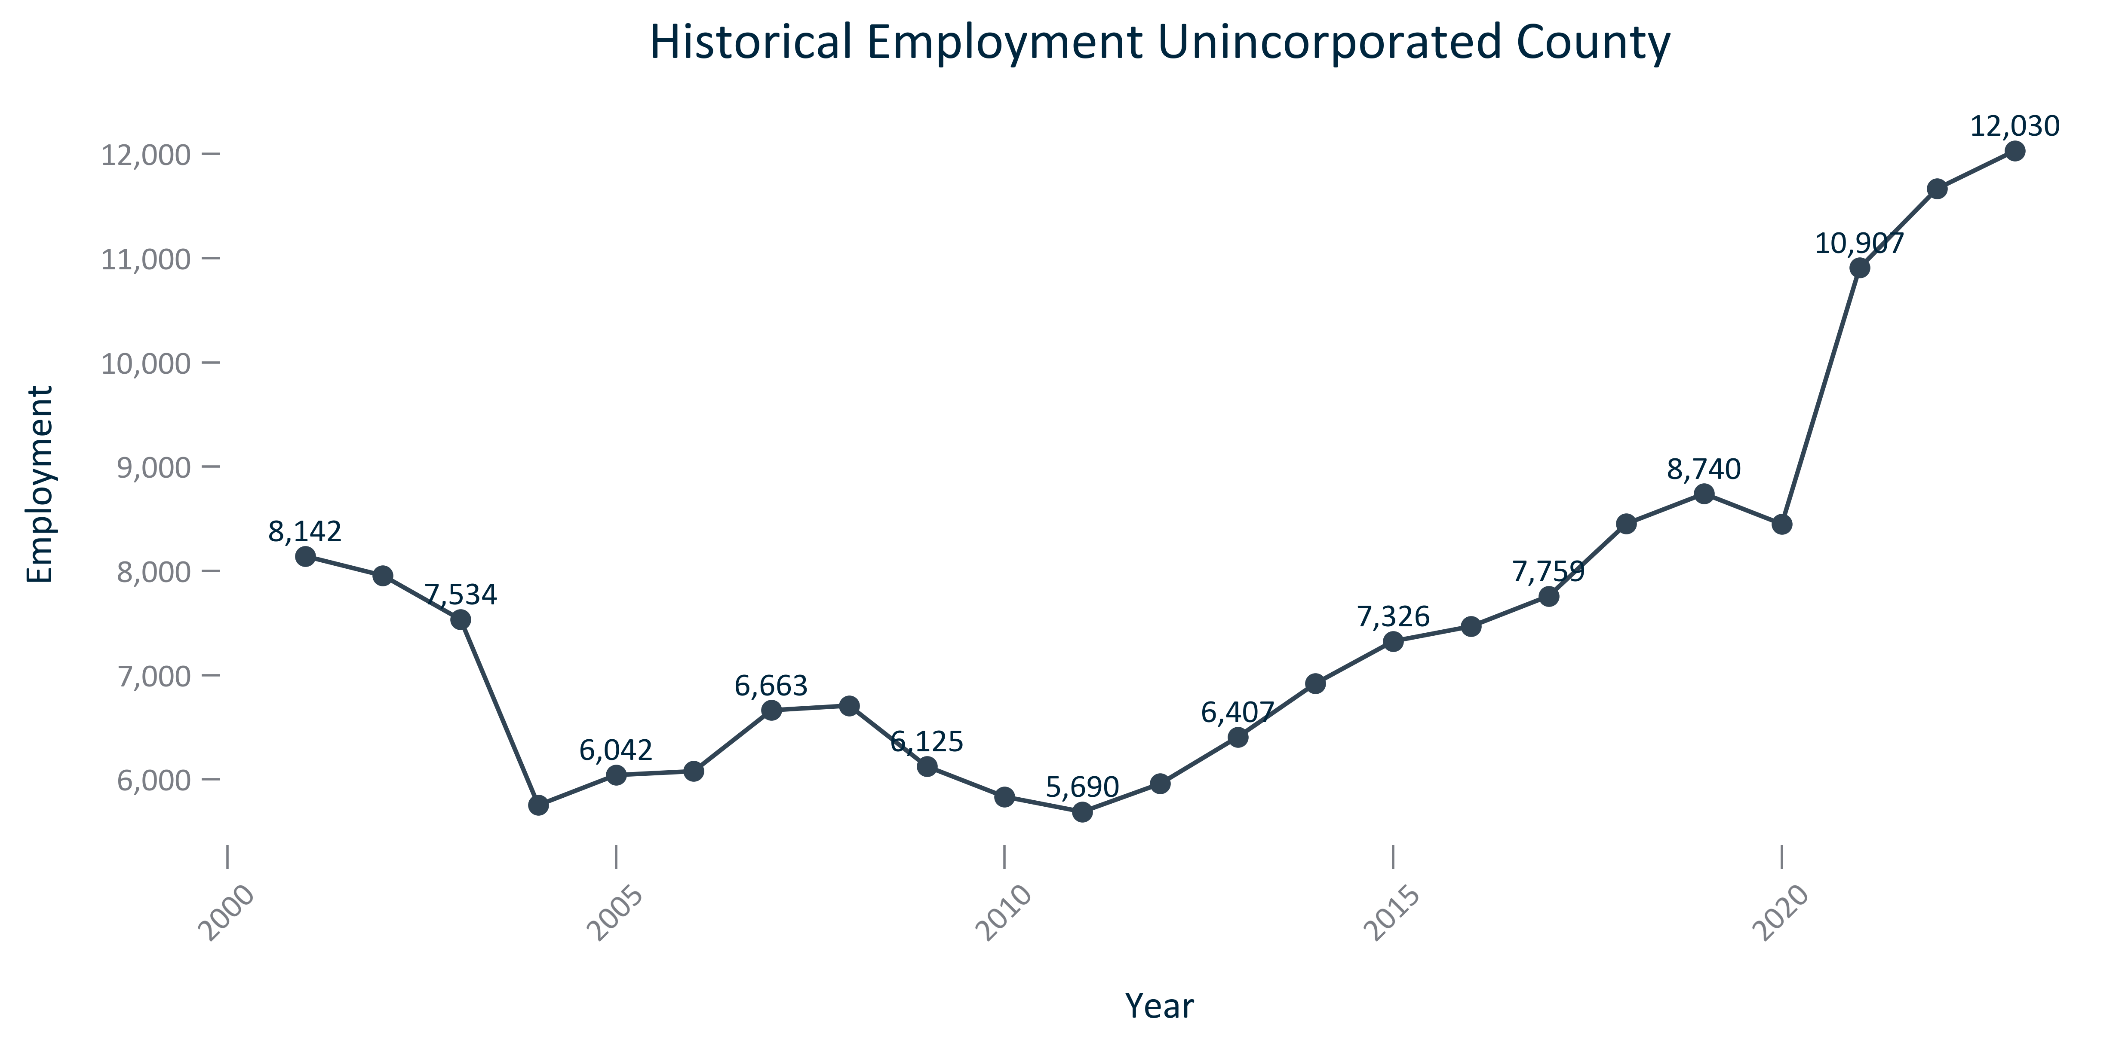

Citation: JobsEQ

### EMP_line_primarygeo_historicalemploymentbyindustryplace_overtime:

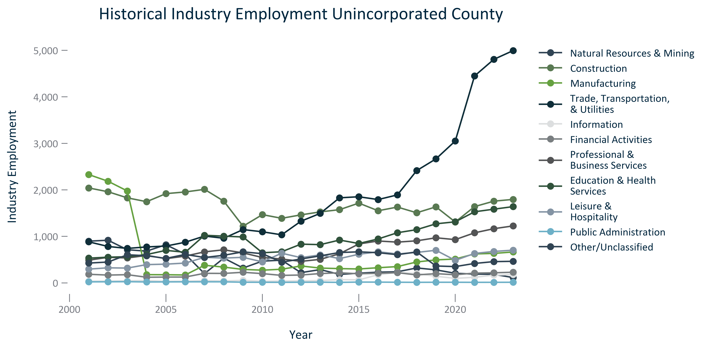

Citation: JobsEQ

### EMP_stackedbar_primarygeo_supersectoremploymentplace_overtime:

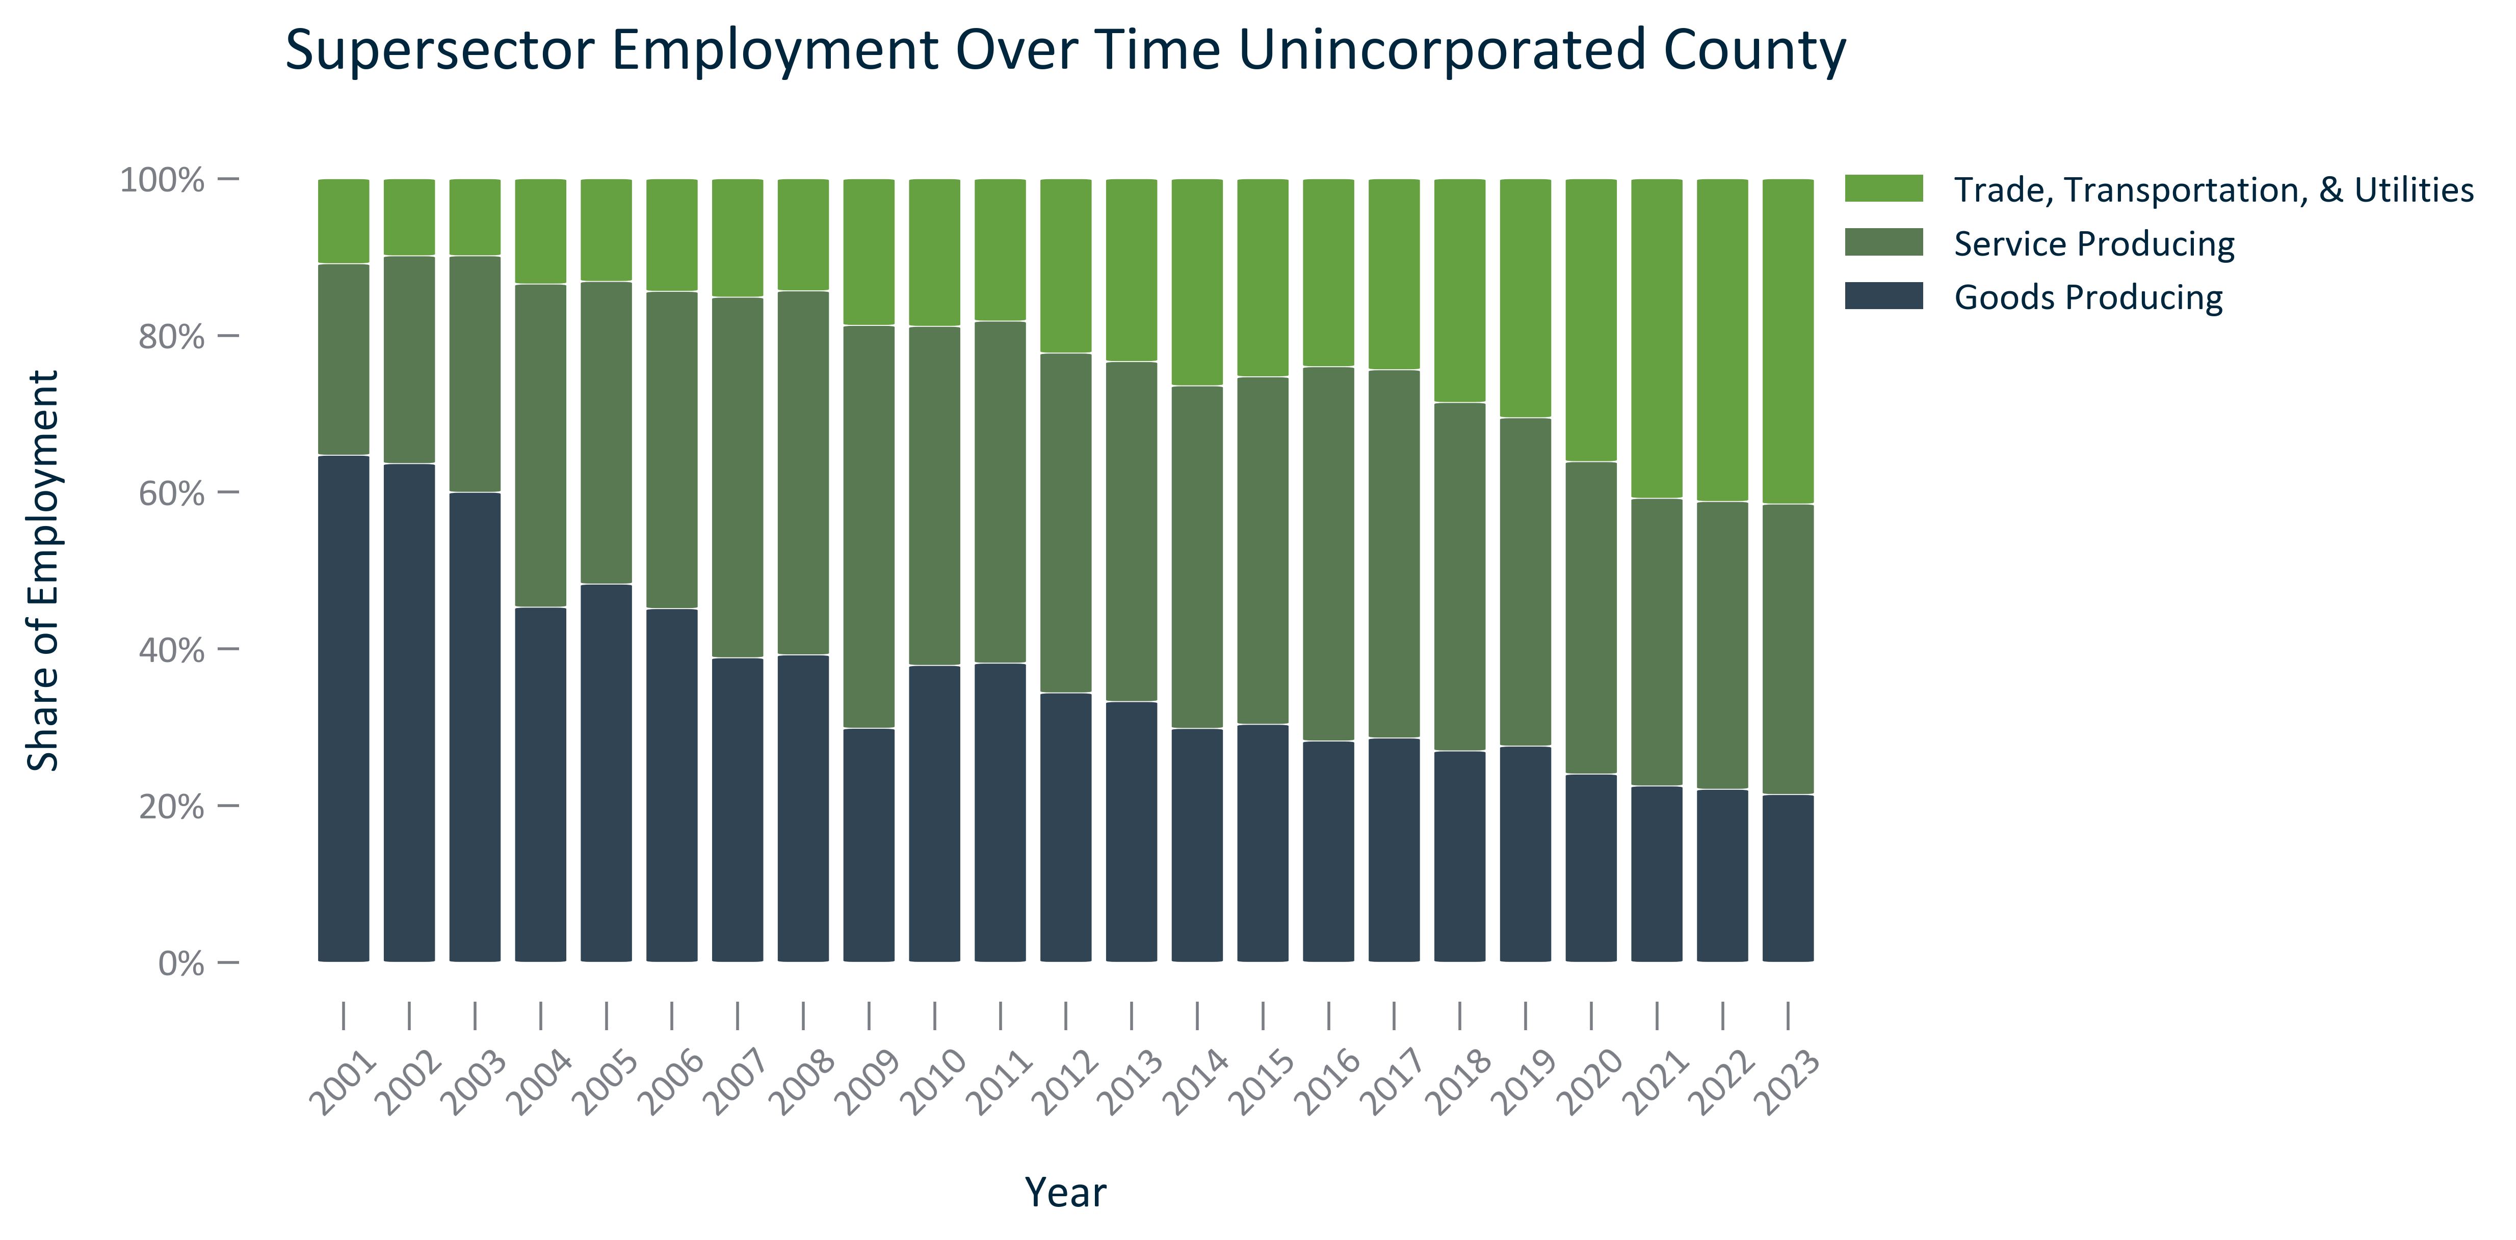

Citation: JobsEQ

### EMP_line_primarygeo_employmentquarterlycovid19_overtime:

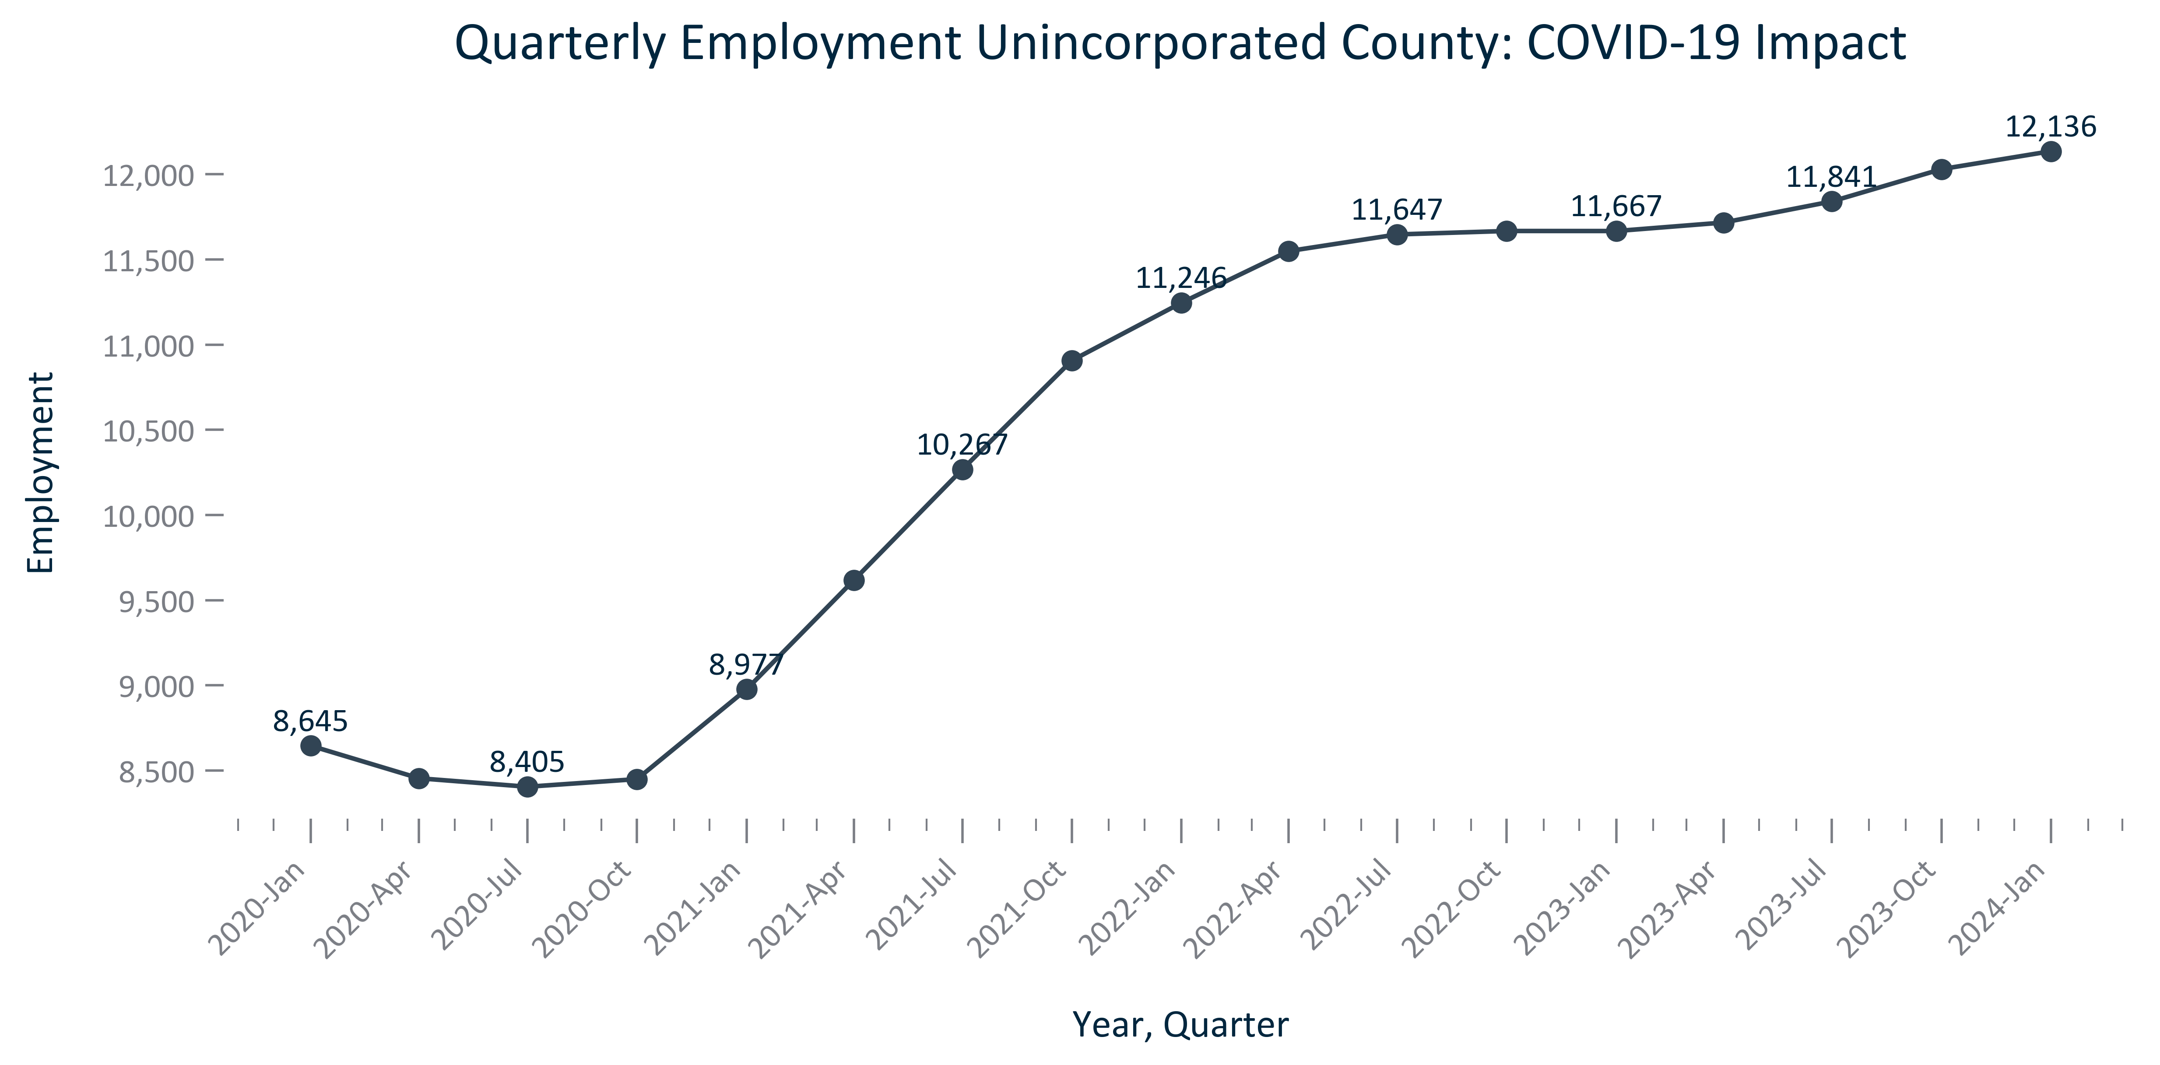

Citation: QCEW via JobsEQ

### EMP_line_county_employmentquarterlycovid19countyforplace_overtime:

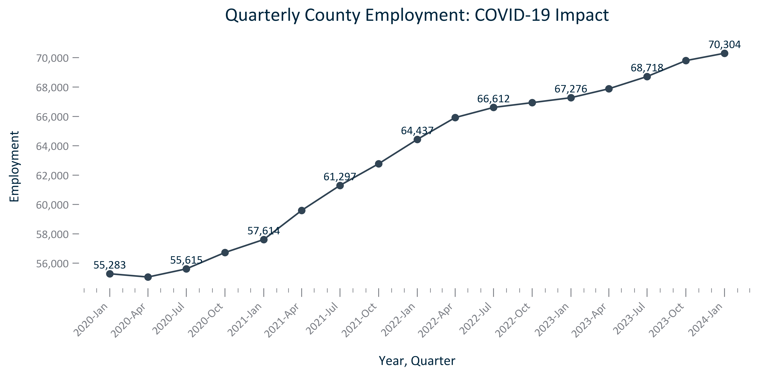

Citation: QCEW via JobsEQ

### EMP_line_geocomparative_unemploymentmonthly_overtime:

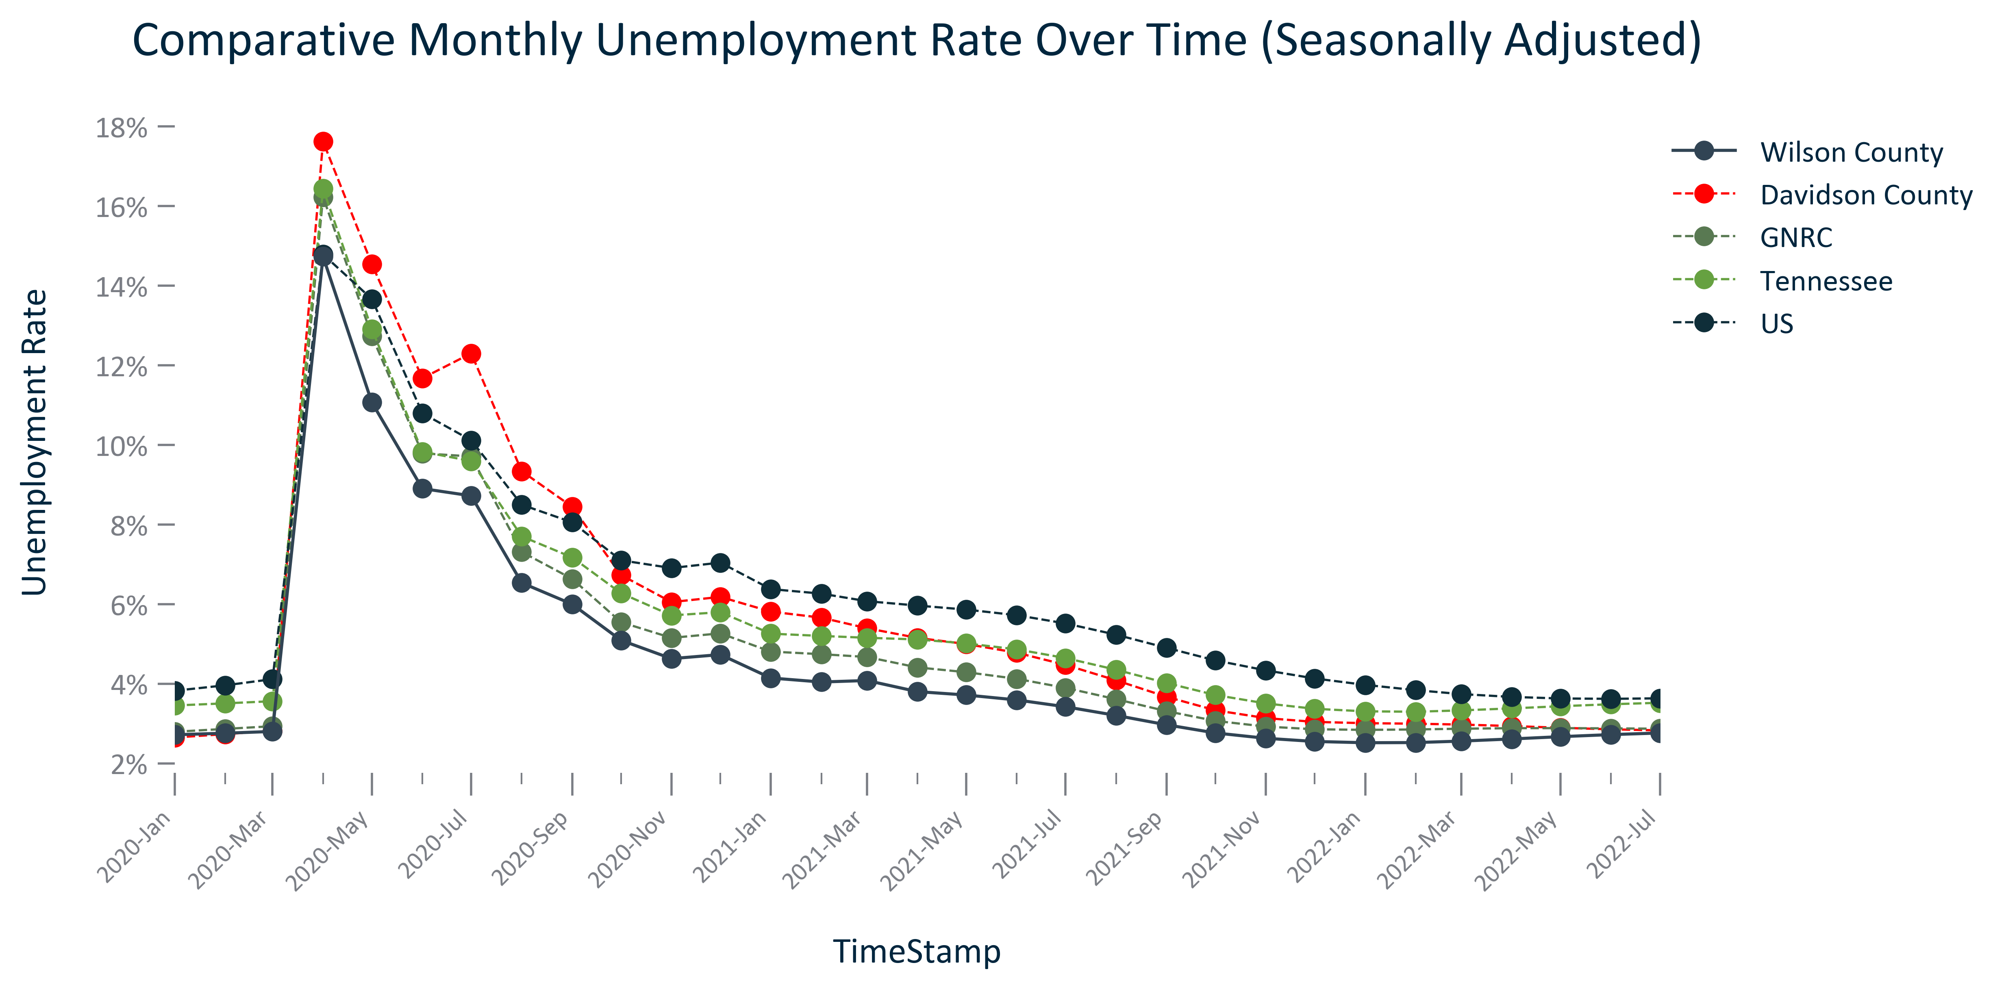

Citation: LAUS via JobsEQ

### EMP_table_primarygeo_industryemploymentplace_2023:

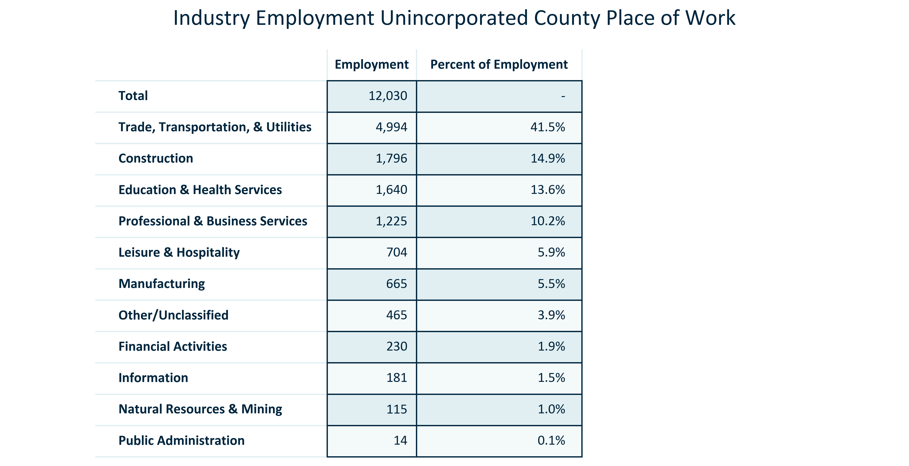

Citation: QCEW via JobsEQ

### EMP_bar_primarygeo_projectedemployment_overtime:

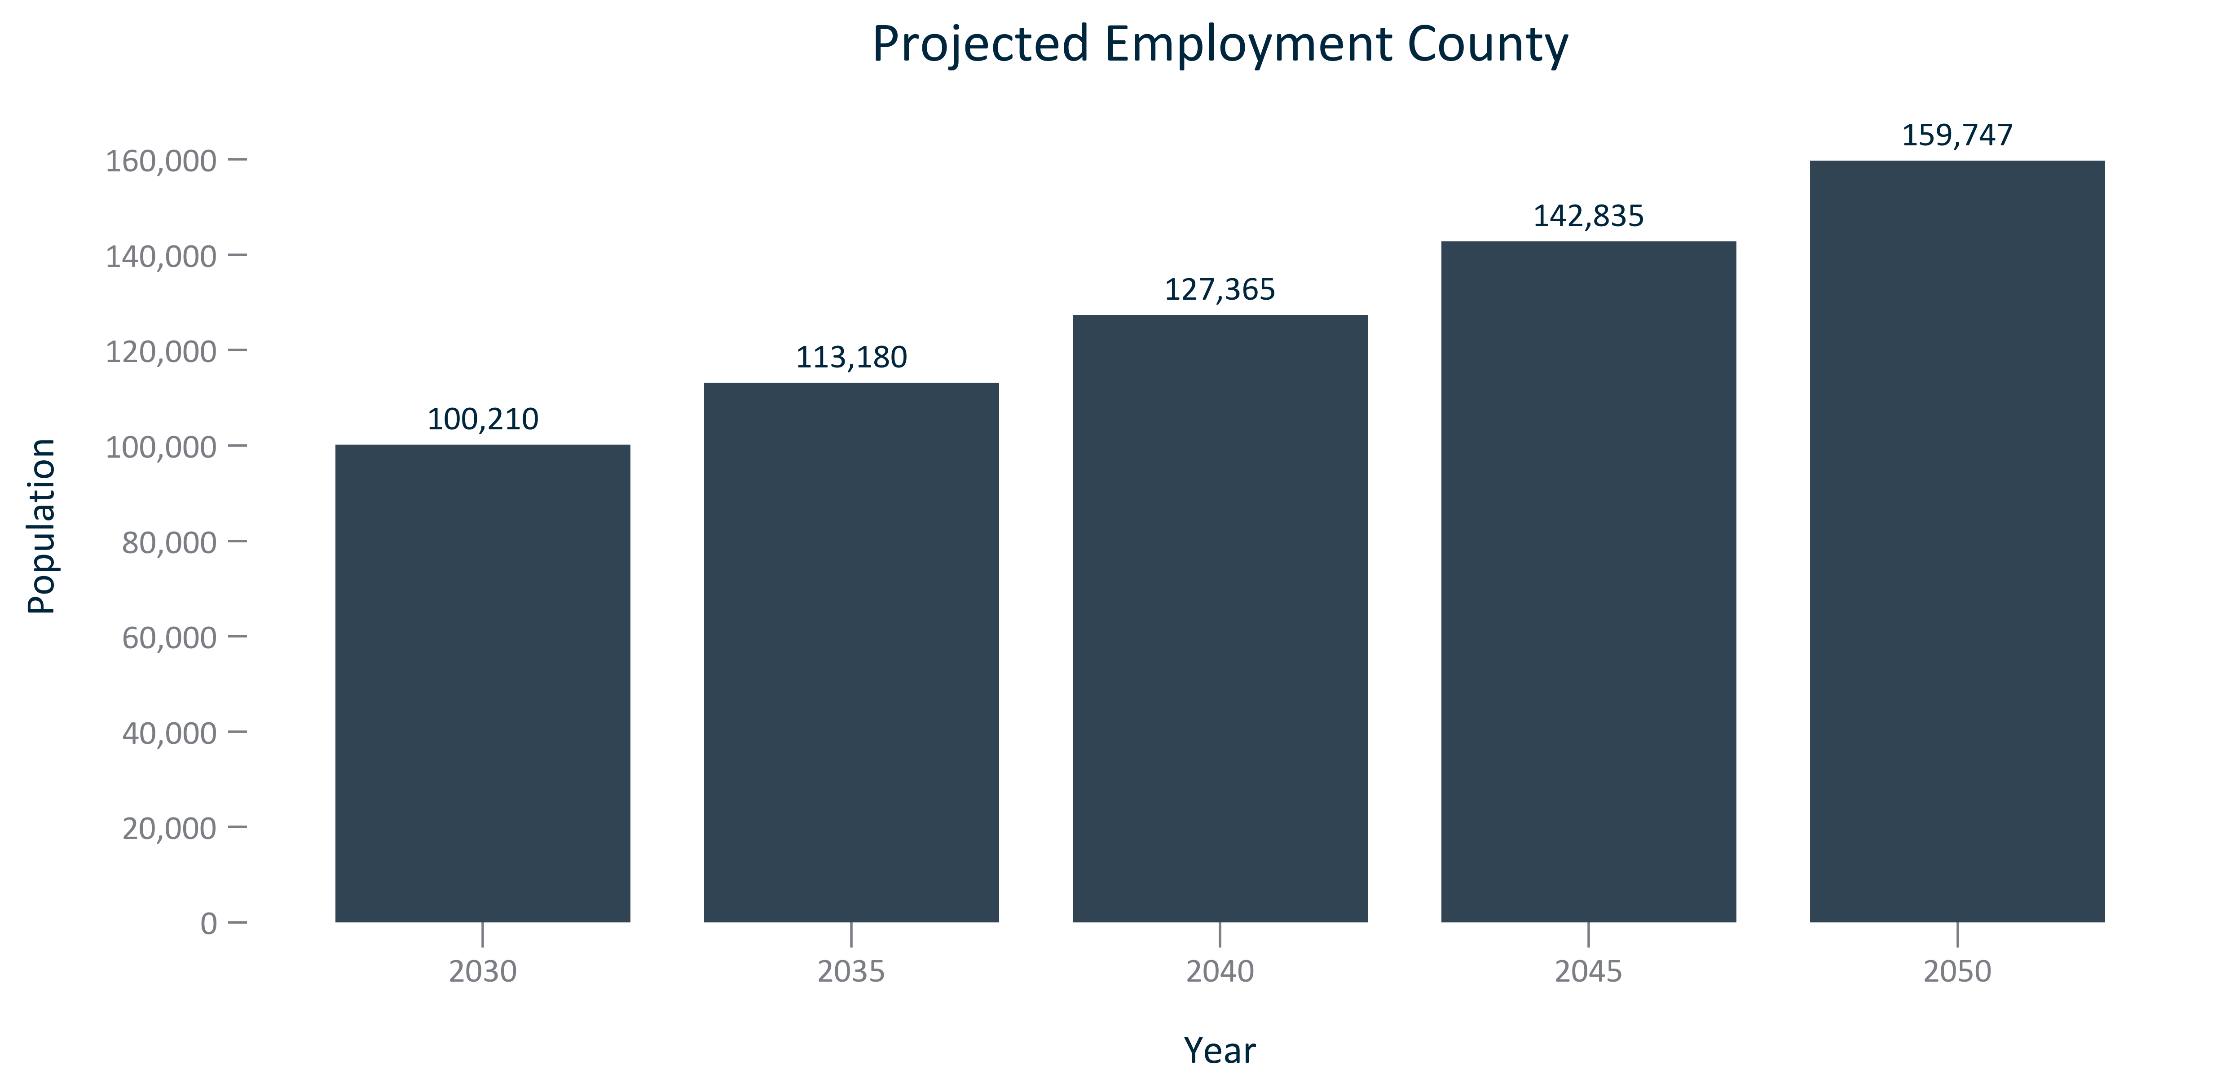

Citation: Woods and Poole Population Projections

### EMP_bar_primarygeo_percentchangeprojectedemployment_overtime:

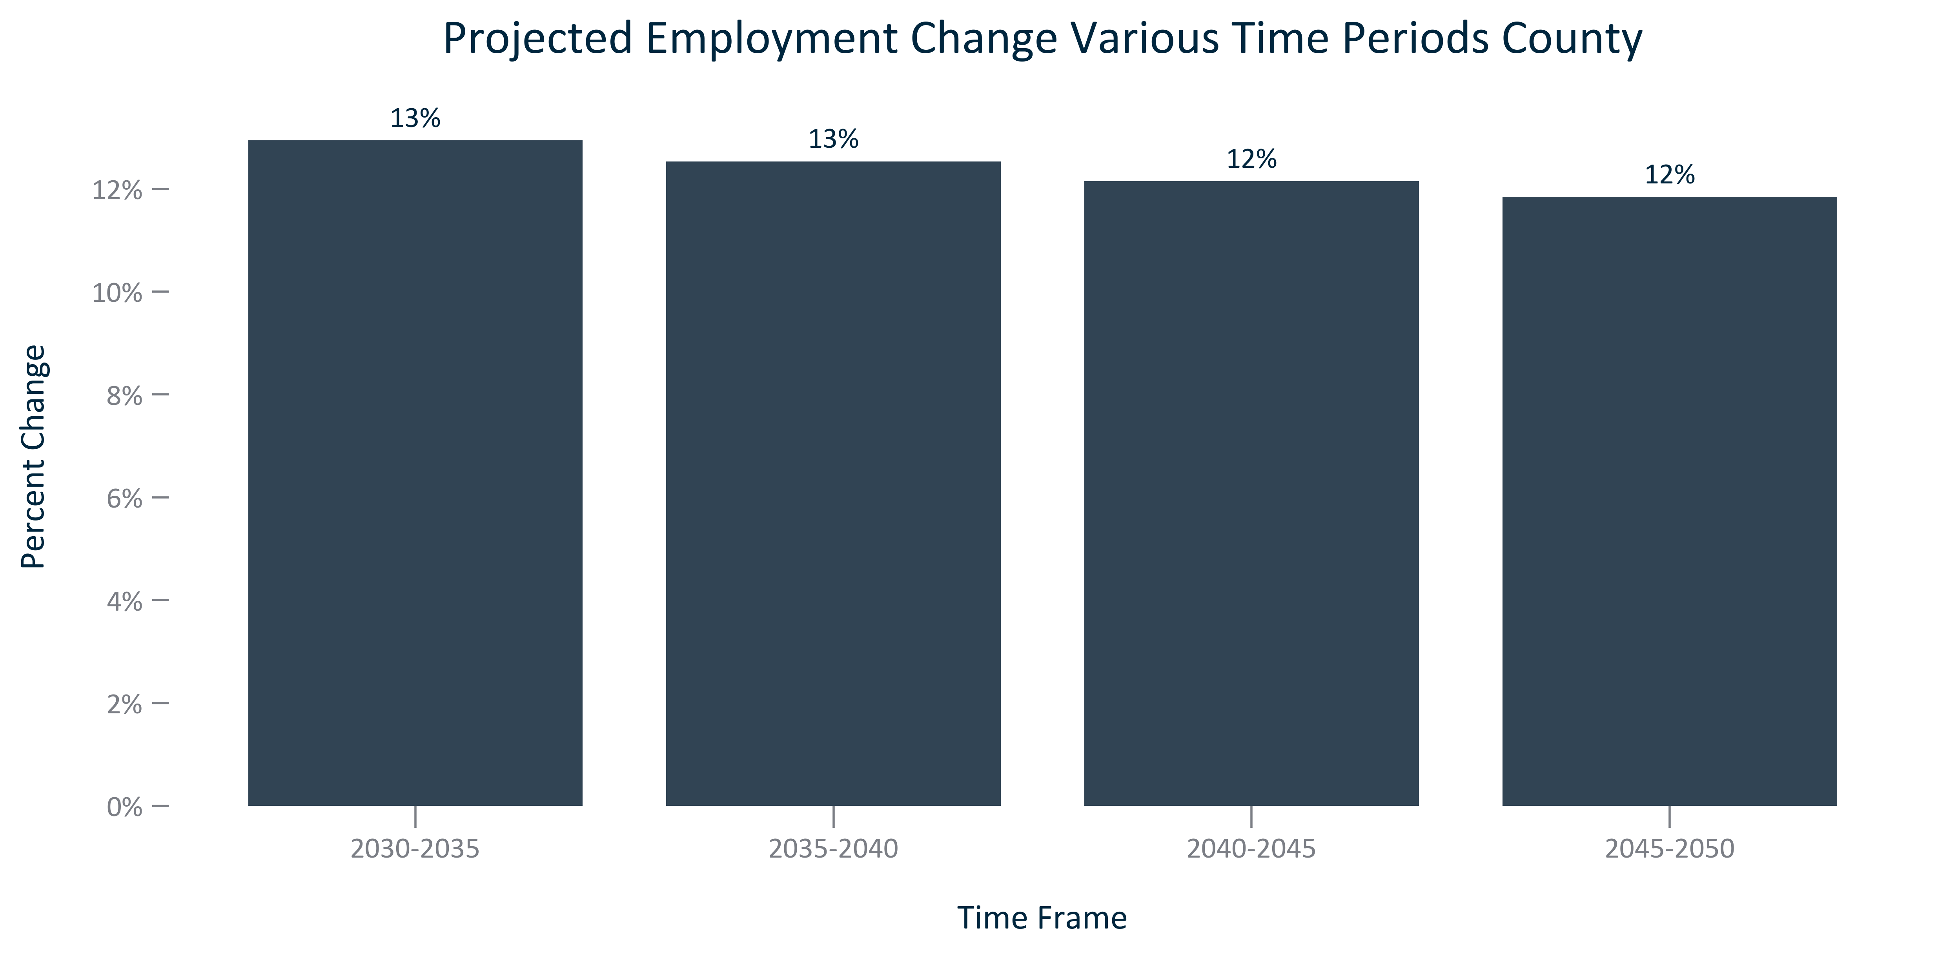

Citation: Woods and Poole Population Projections

### EMP_bar_geocomparative_projectedemploymentchange_overtime:

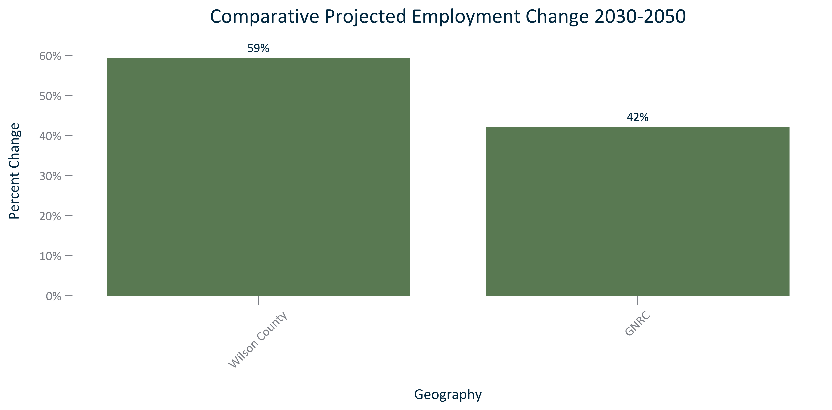

Citation: Woods and Poole Population Projections

### EMP_table_geocomparative_employmentprojectionandchange_overtime:

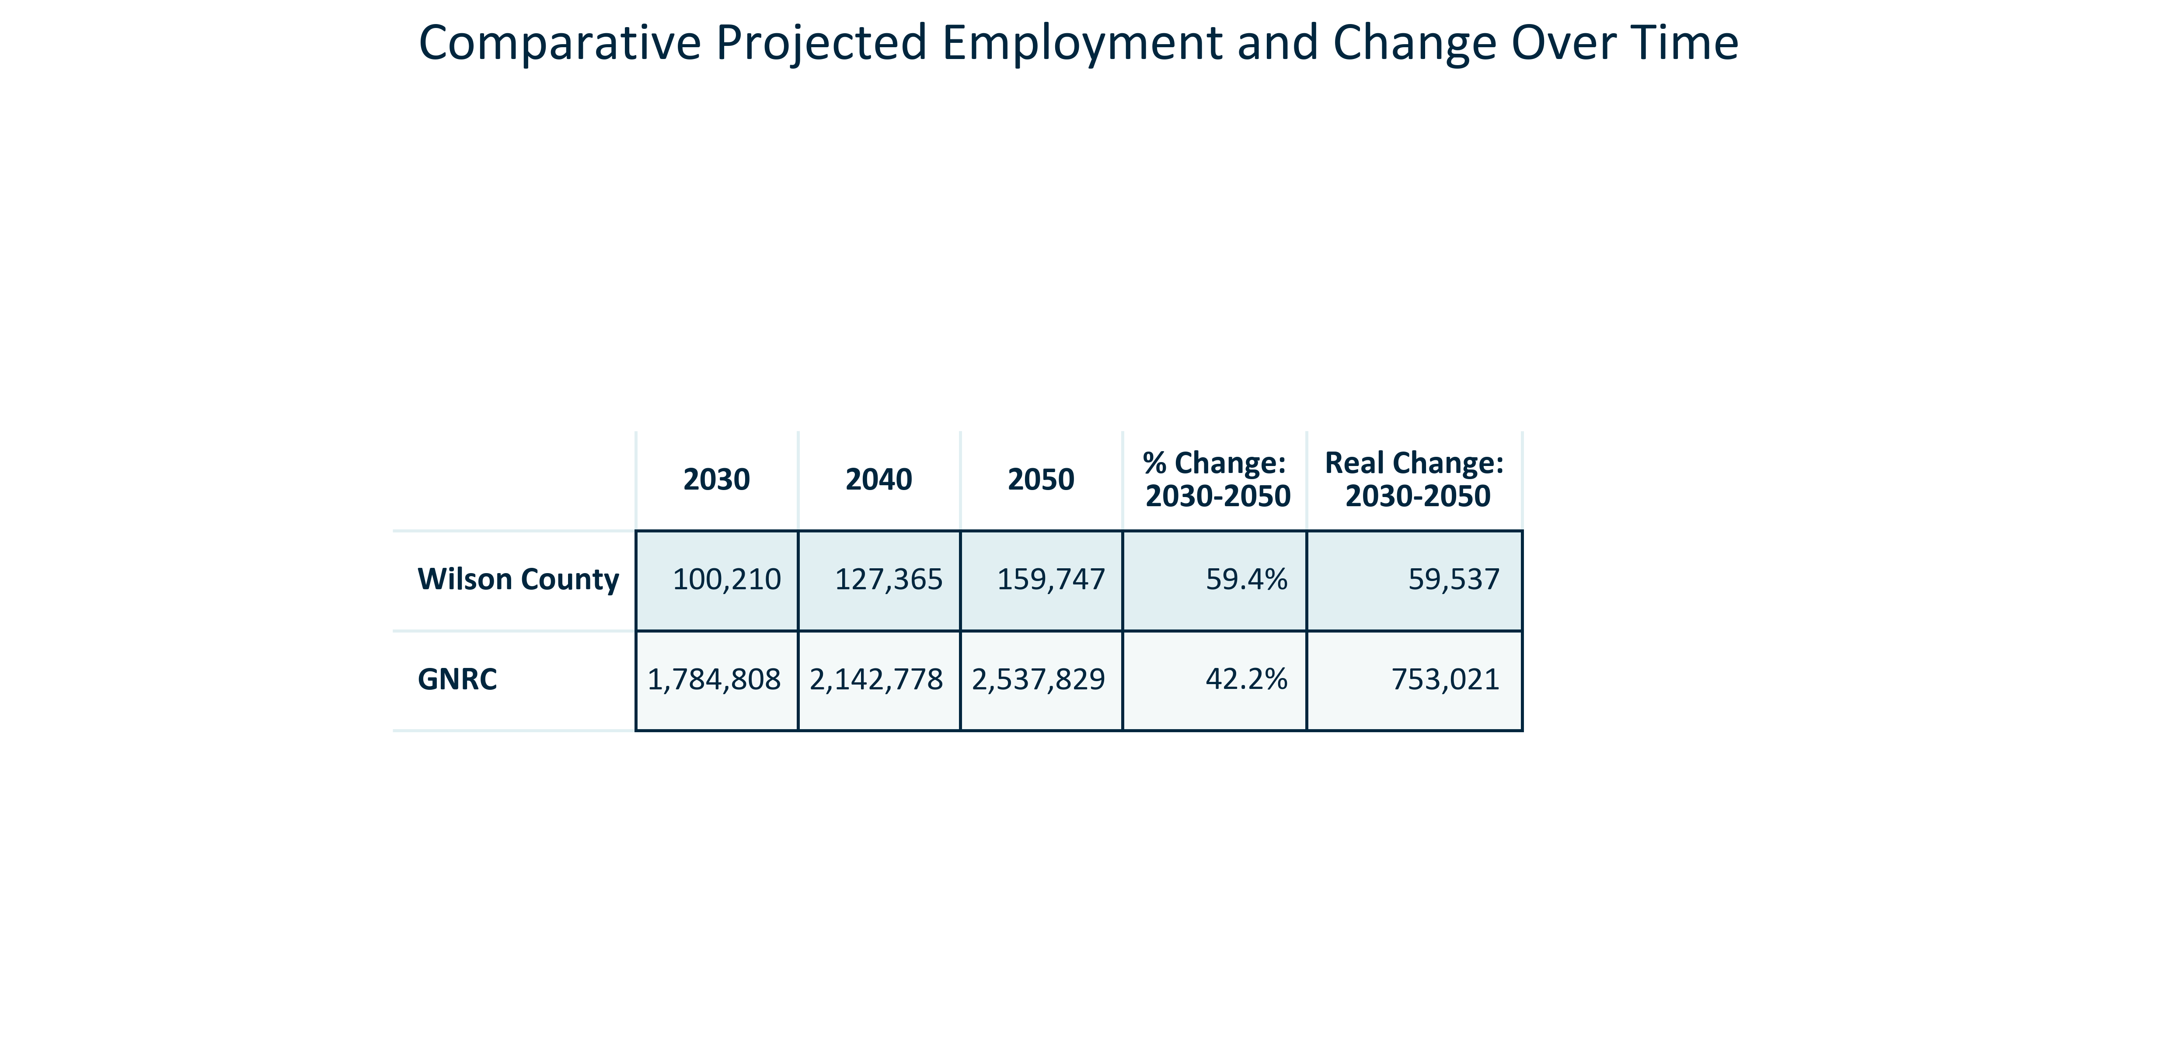

Citation: Woods and Poole Population Projections

### EMP_table_primarygeo_industryemploymentoutlook_2023Q4:

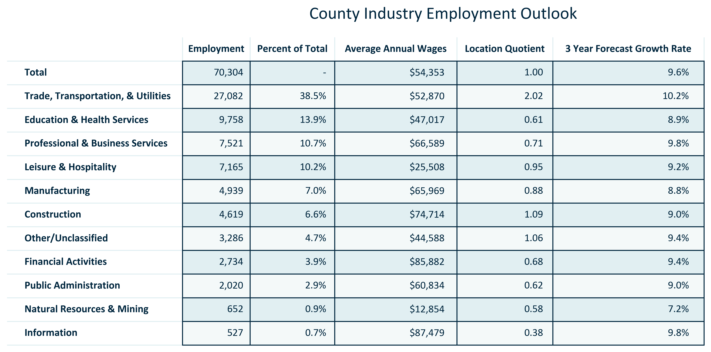

Citation: JobsEQ

### EMP_table_primarygeo_topcountyemployers_current:

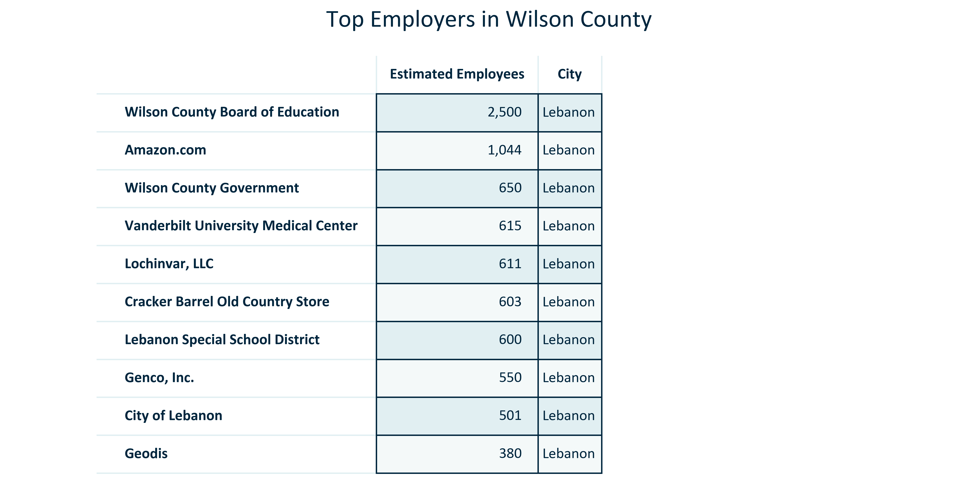

Citation: TNECD

### EMP_stackedbar_primarygeo_classofworker_overtime:

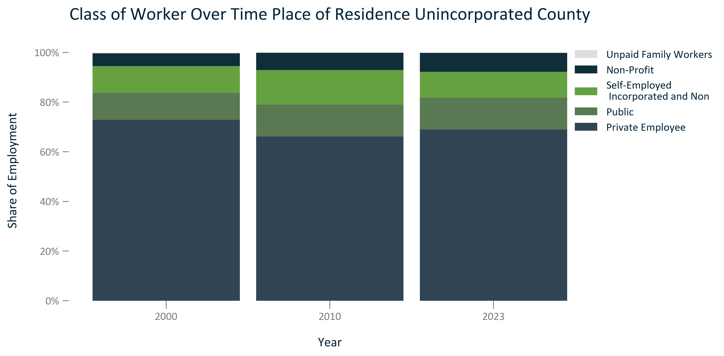

Citation: 2000 Decennial Census, 2006-2010 and 2019 - 2023 American Community Survey 5-Year Estimates

### EMP_bar_primarygeo_numoccupationalemployment_2023:

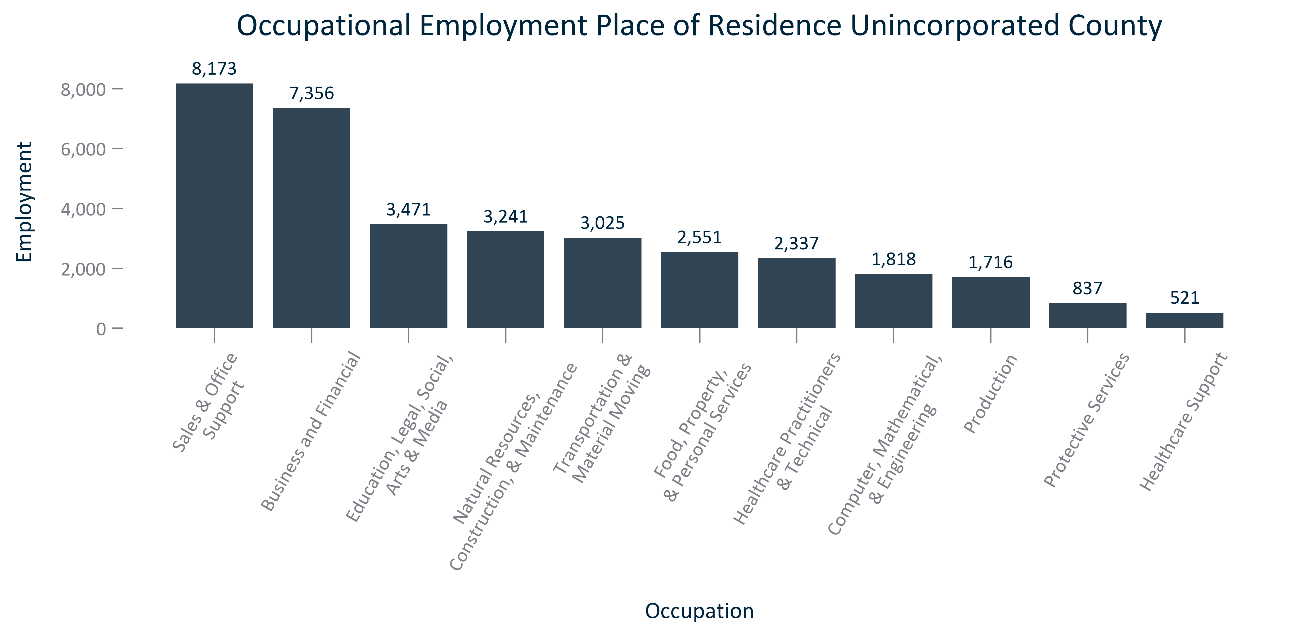

Citation: 2019 - 2023 American Community Survey 5-Year Estimates

### EMP_bar_primarygeo_shareoccupationalemployment_2023:

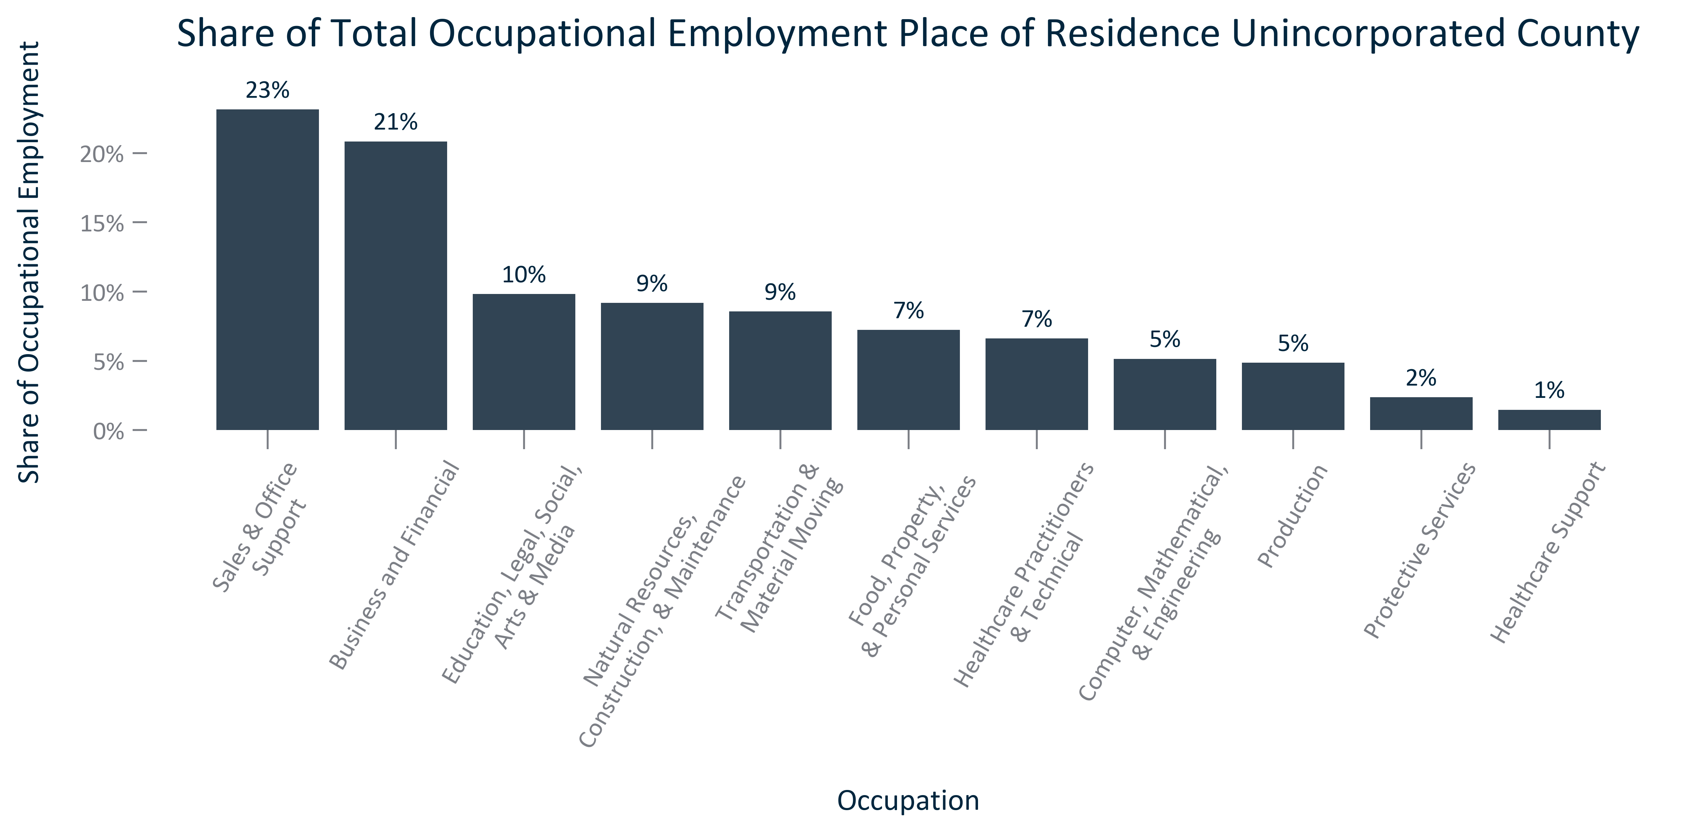

Citation: 2019 - 2023 American Community Survey 5-Year Estimates

### EMP_clusterbar_primarygeo_realchangeoccupationalemployment_overtime:

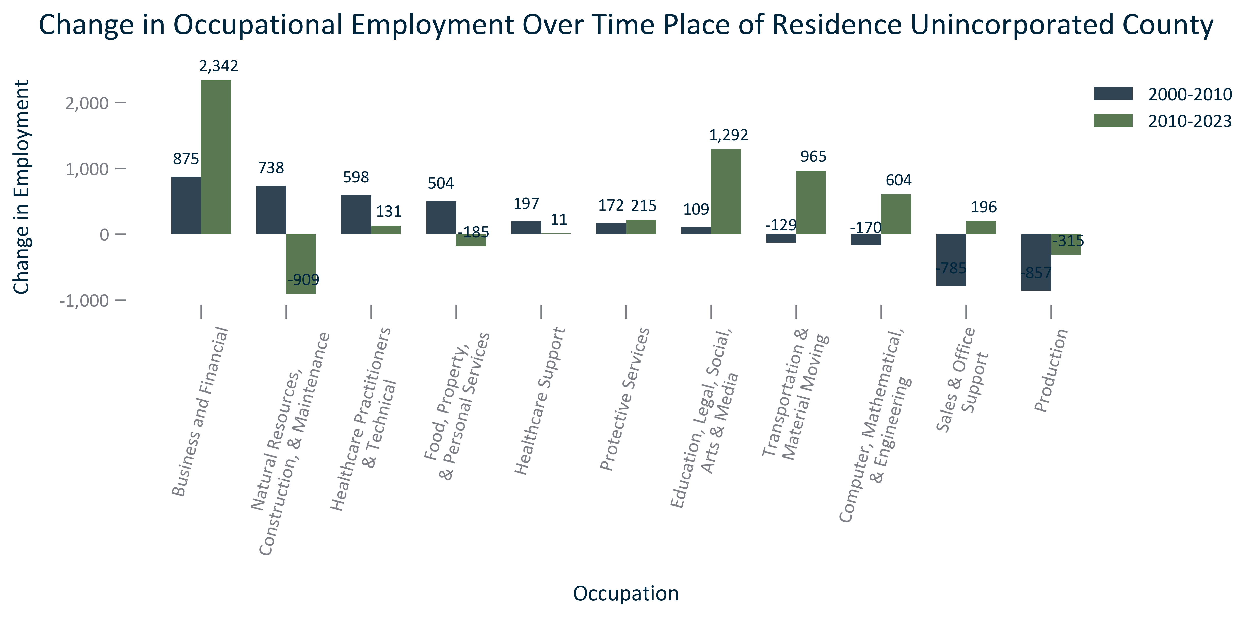

Citation: 2000 Decennial Census, 2006-2010 and 2019 - 2023 American Community Survey 5-Year Estimates

### EMP_clusterbar_primarygeo_percentchangeOccupationalemployment_overtime:

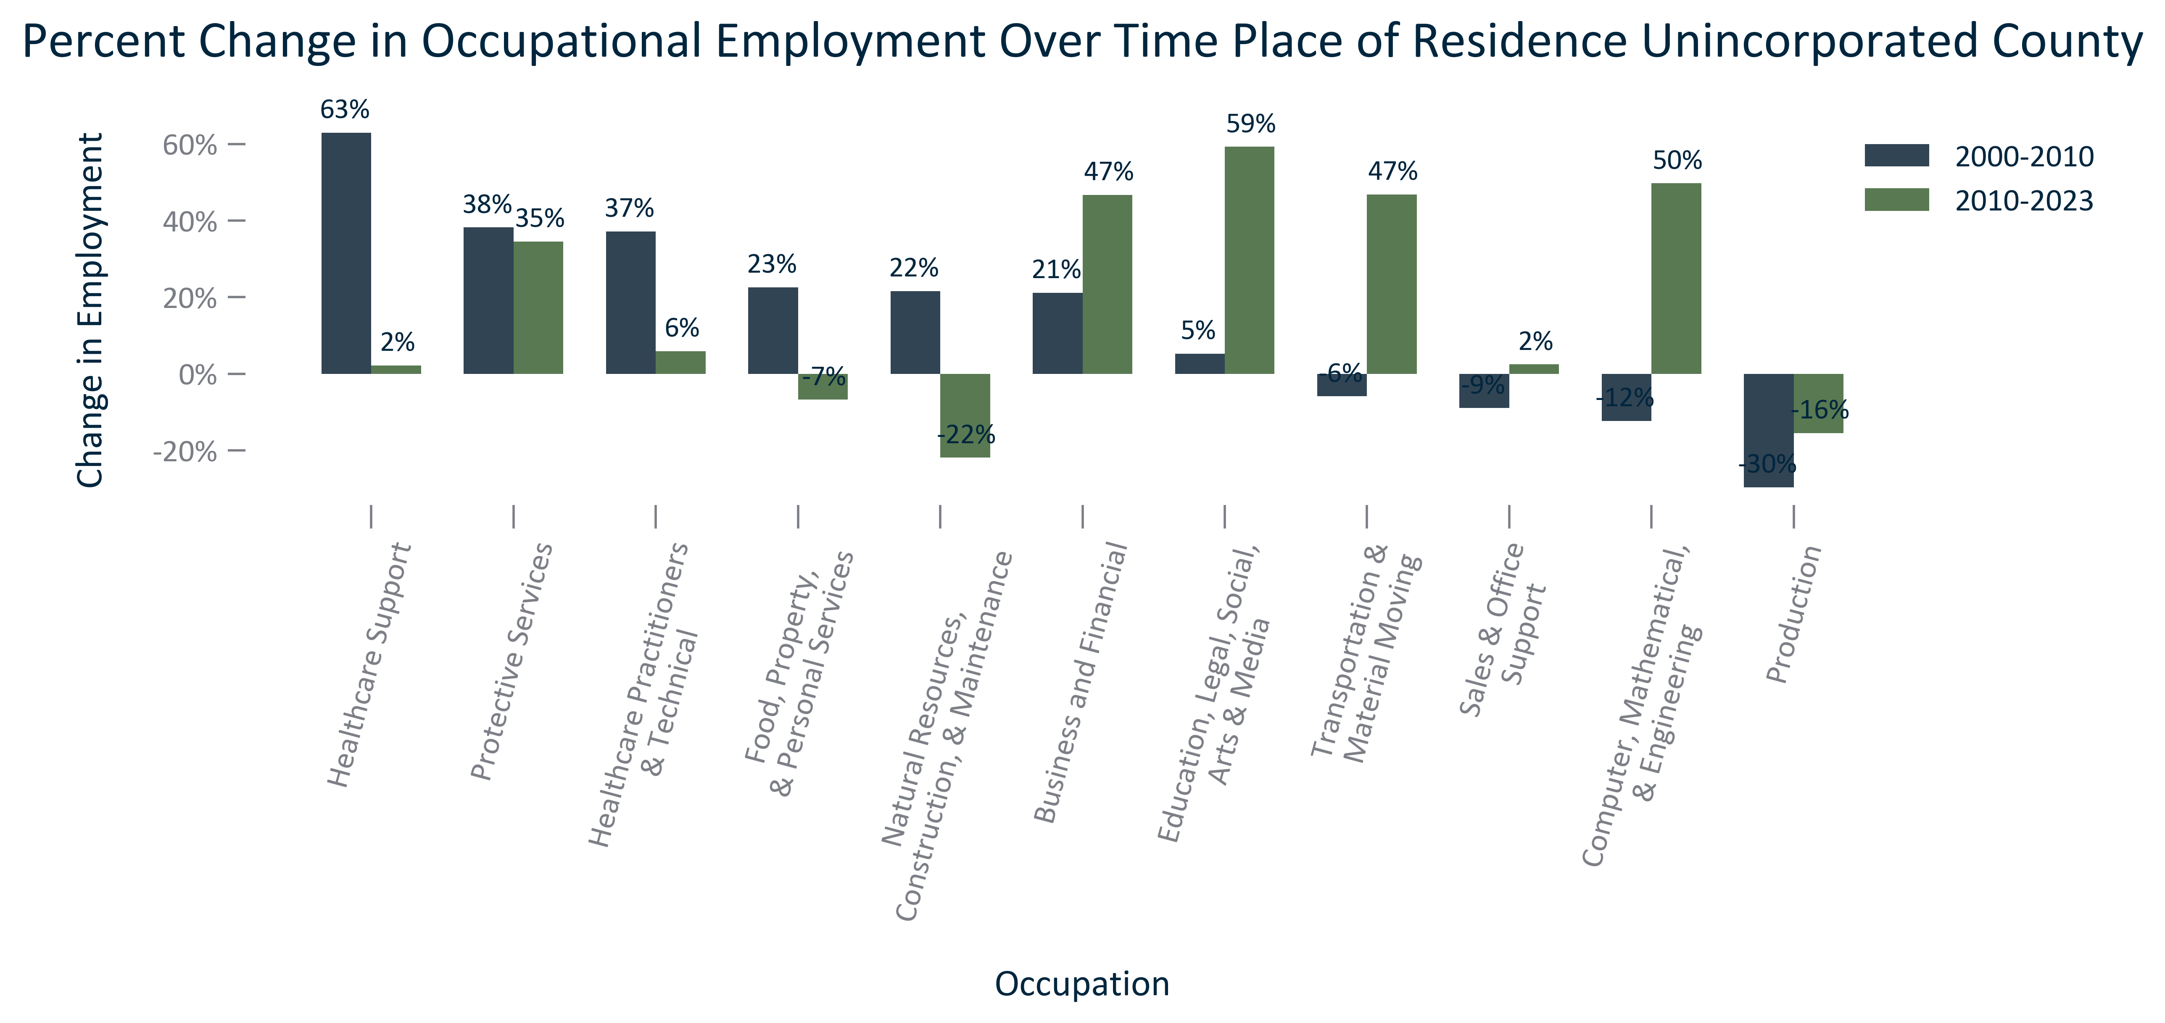

Citation: 2000 Decennial Census, 2006-2010 and 2019 - 2023 American Community Survey 5-Year Estimates

### EMP_table_primarygeo_occupationalemployment_overtime:

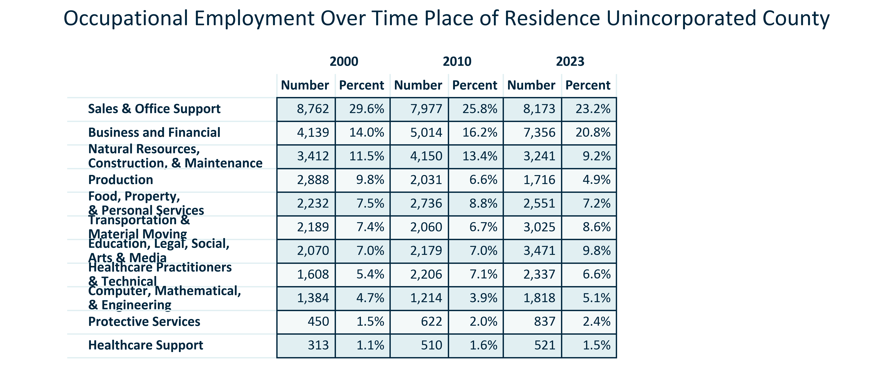

Citation: 2000 Decennial Census, 2006-2010 and 2019 - 2023 American Community Survey 5-Year Estimates

### EMP_line_primarygeo_historicalemploymentbyoccupation_overtime:

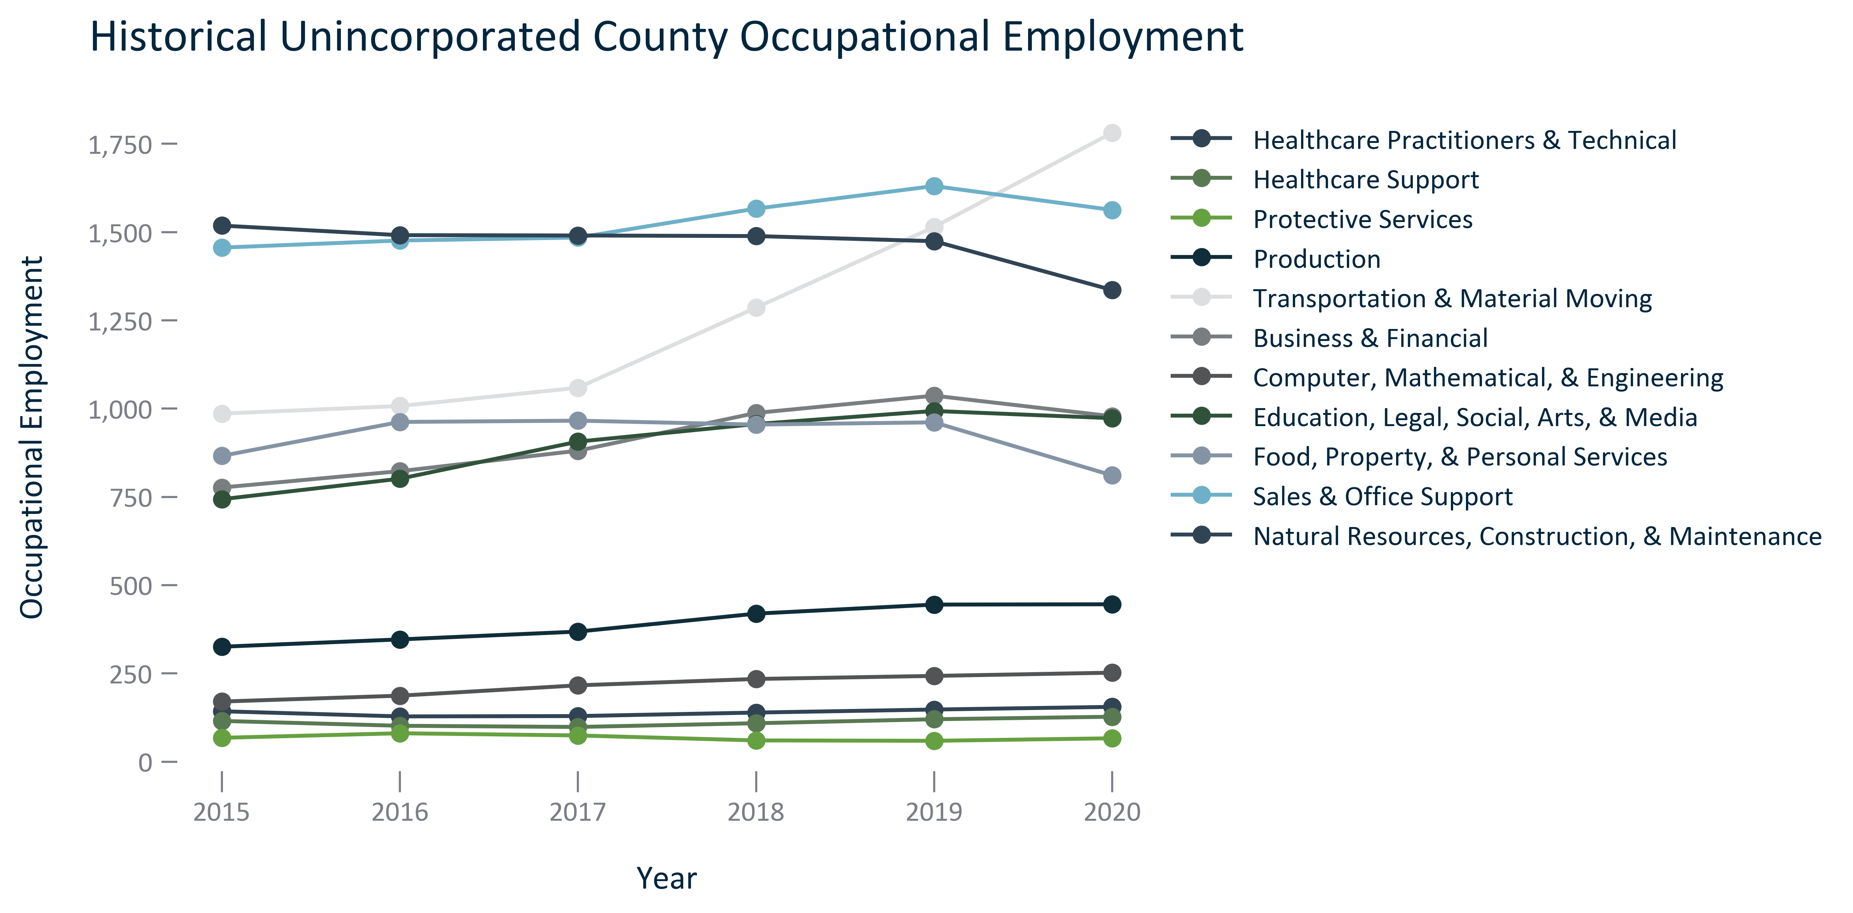

Citation: JobsEQ

### EMP_table_primarygeo_occupationalemploymentoutlook_2023Q4:

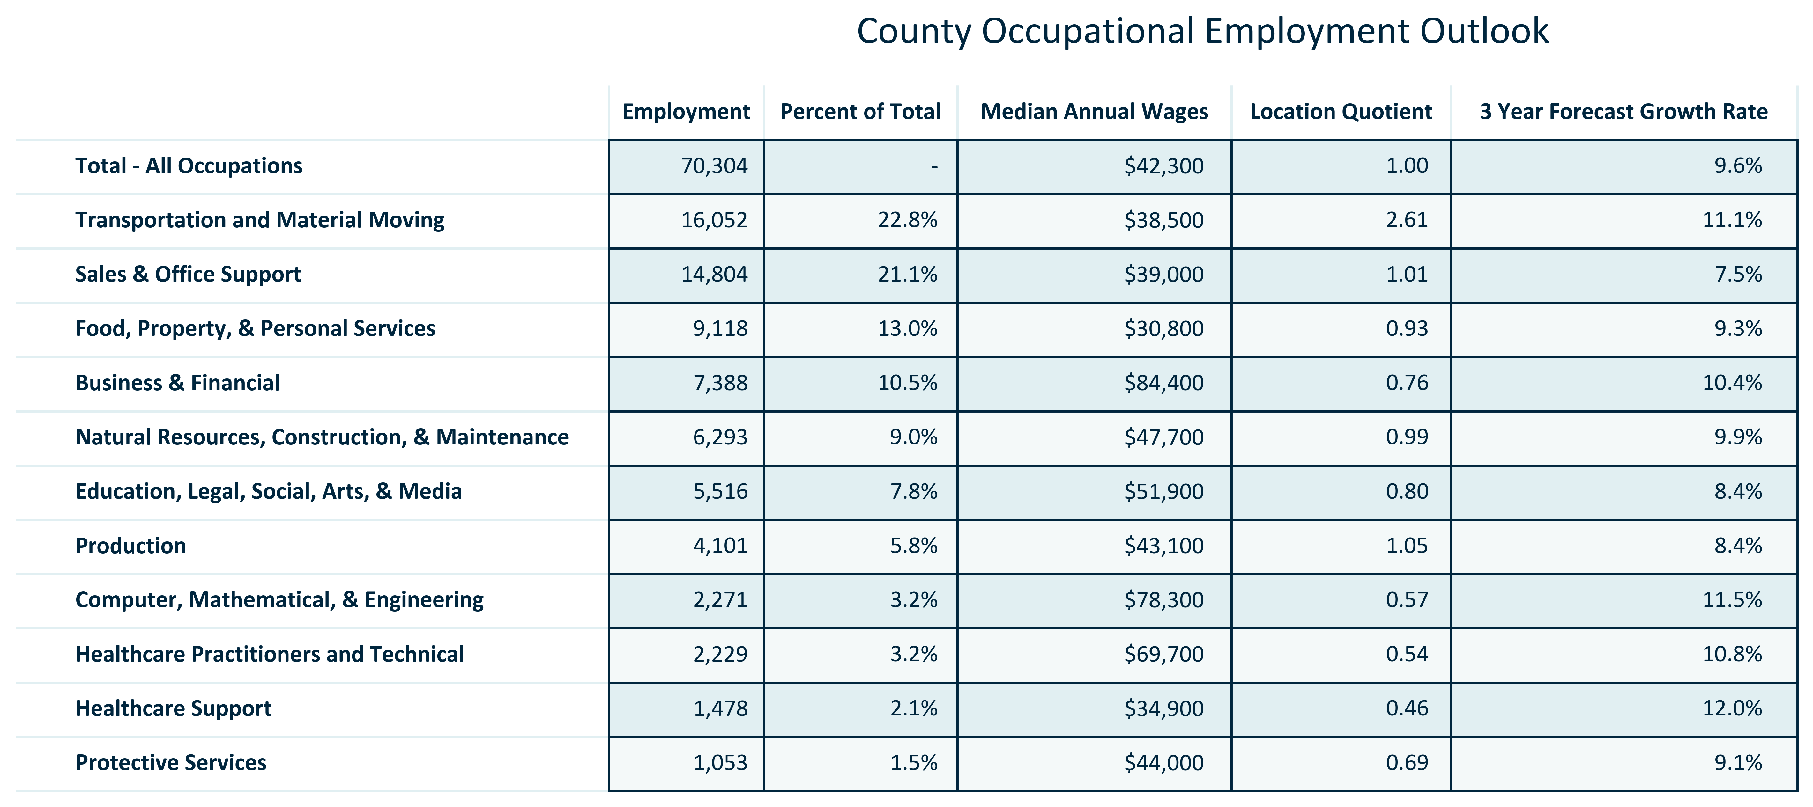

Citation: JobsEQ

### EMP_line_county_awardsgranted_overtime:

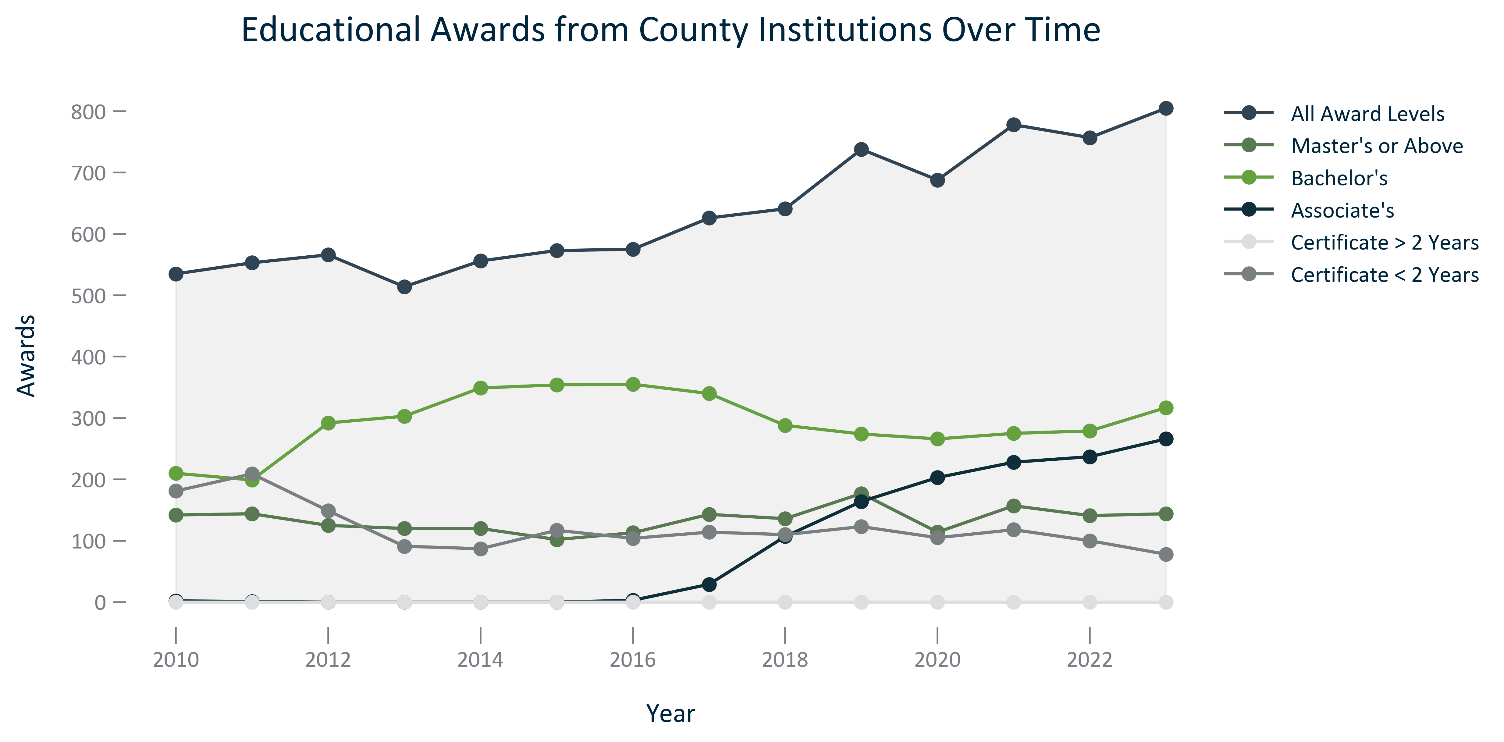

Citation: National Center for Education Statistics via JobsEQ

### EMP_line_geocomparative_topcountiesedawards_overtime:

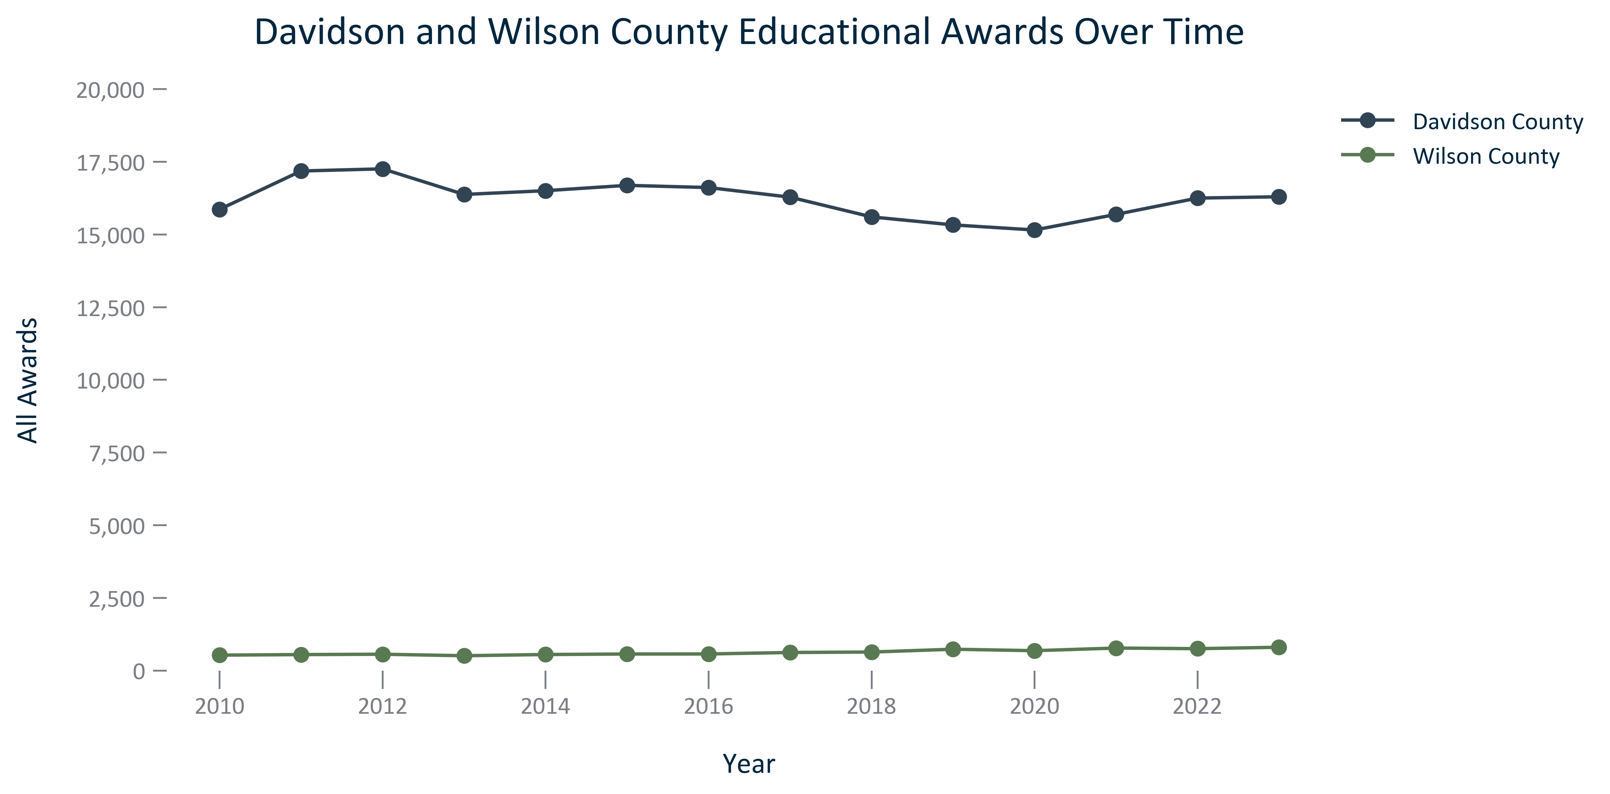

Citation: National Center for Education Statistics via JobsEQ

### EMP_line_geocomparative_allawardscounties_overtime:

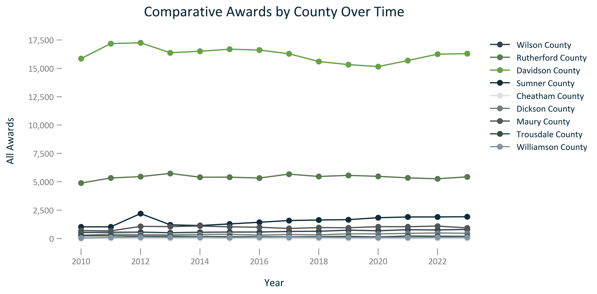

Citation: National Center for Education Statistics via JobsEQ

### EMP_bar_primarygeo_numlfstatus_2023:

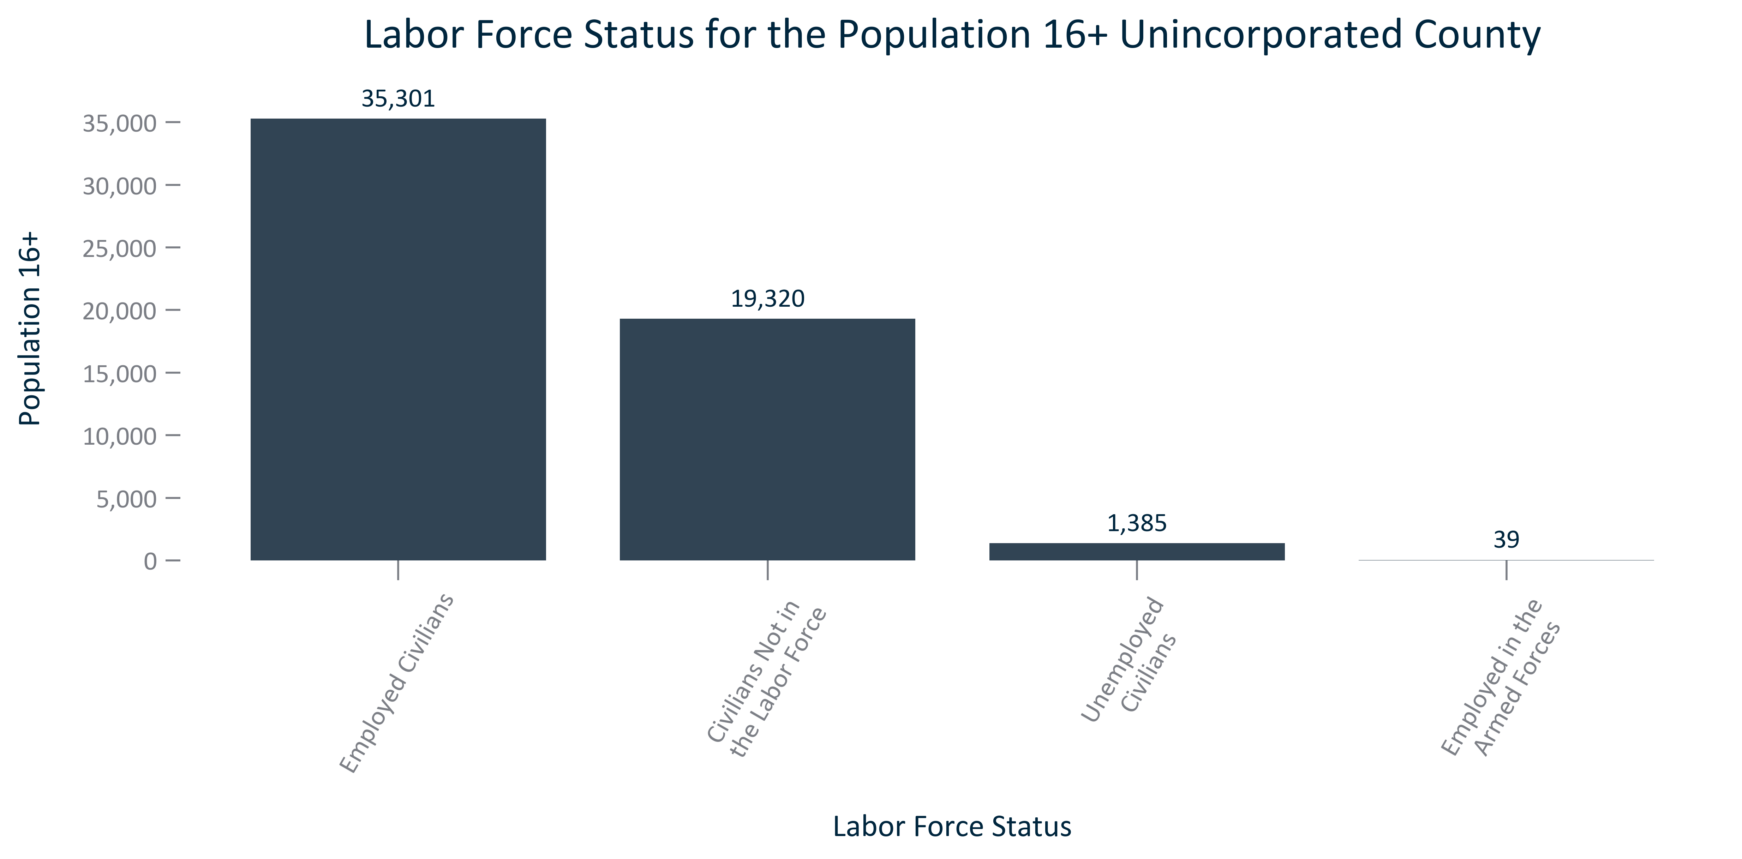

Citation: 2019 - 2023 American Community Survey 5-Year Estimates

### EMP_bar_primarygeo_percentlfstatus_2023:

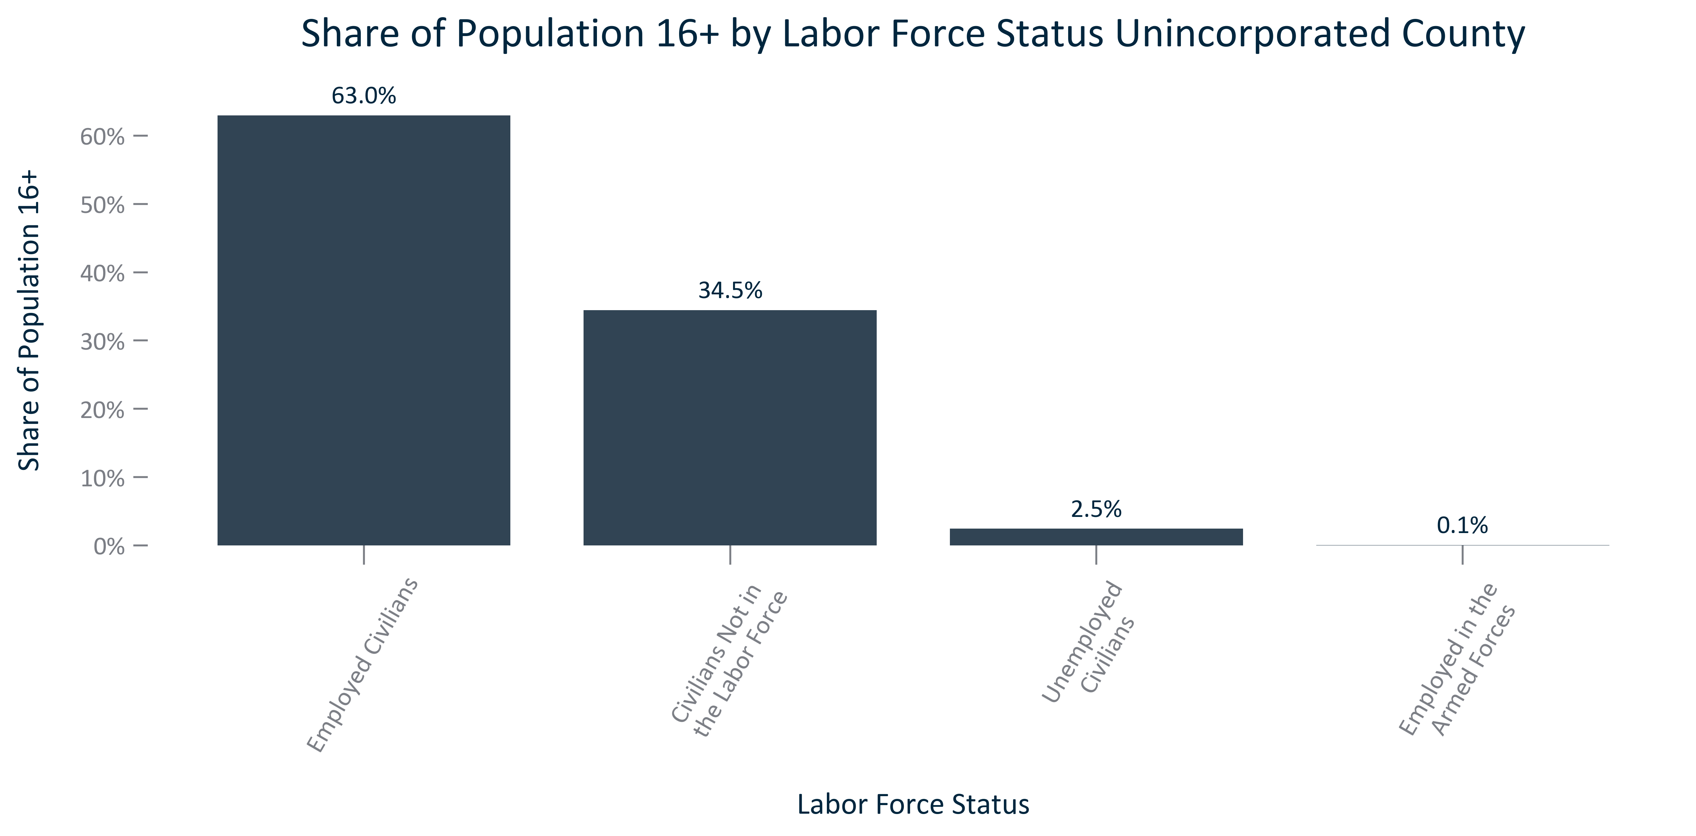

Citation: 2019 - 2023 American Community Survey 5-Year Estimates

### EMP_clusterbar_primarygeo_realchangelfstatus_overtime:

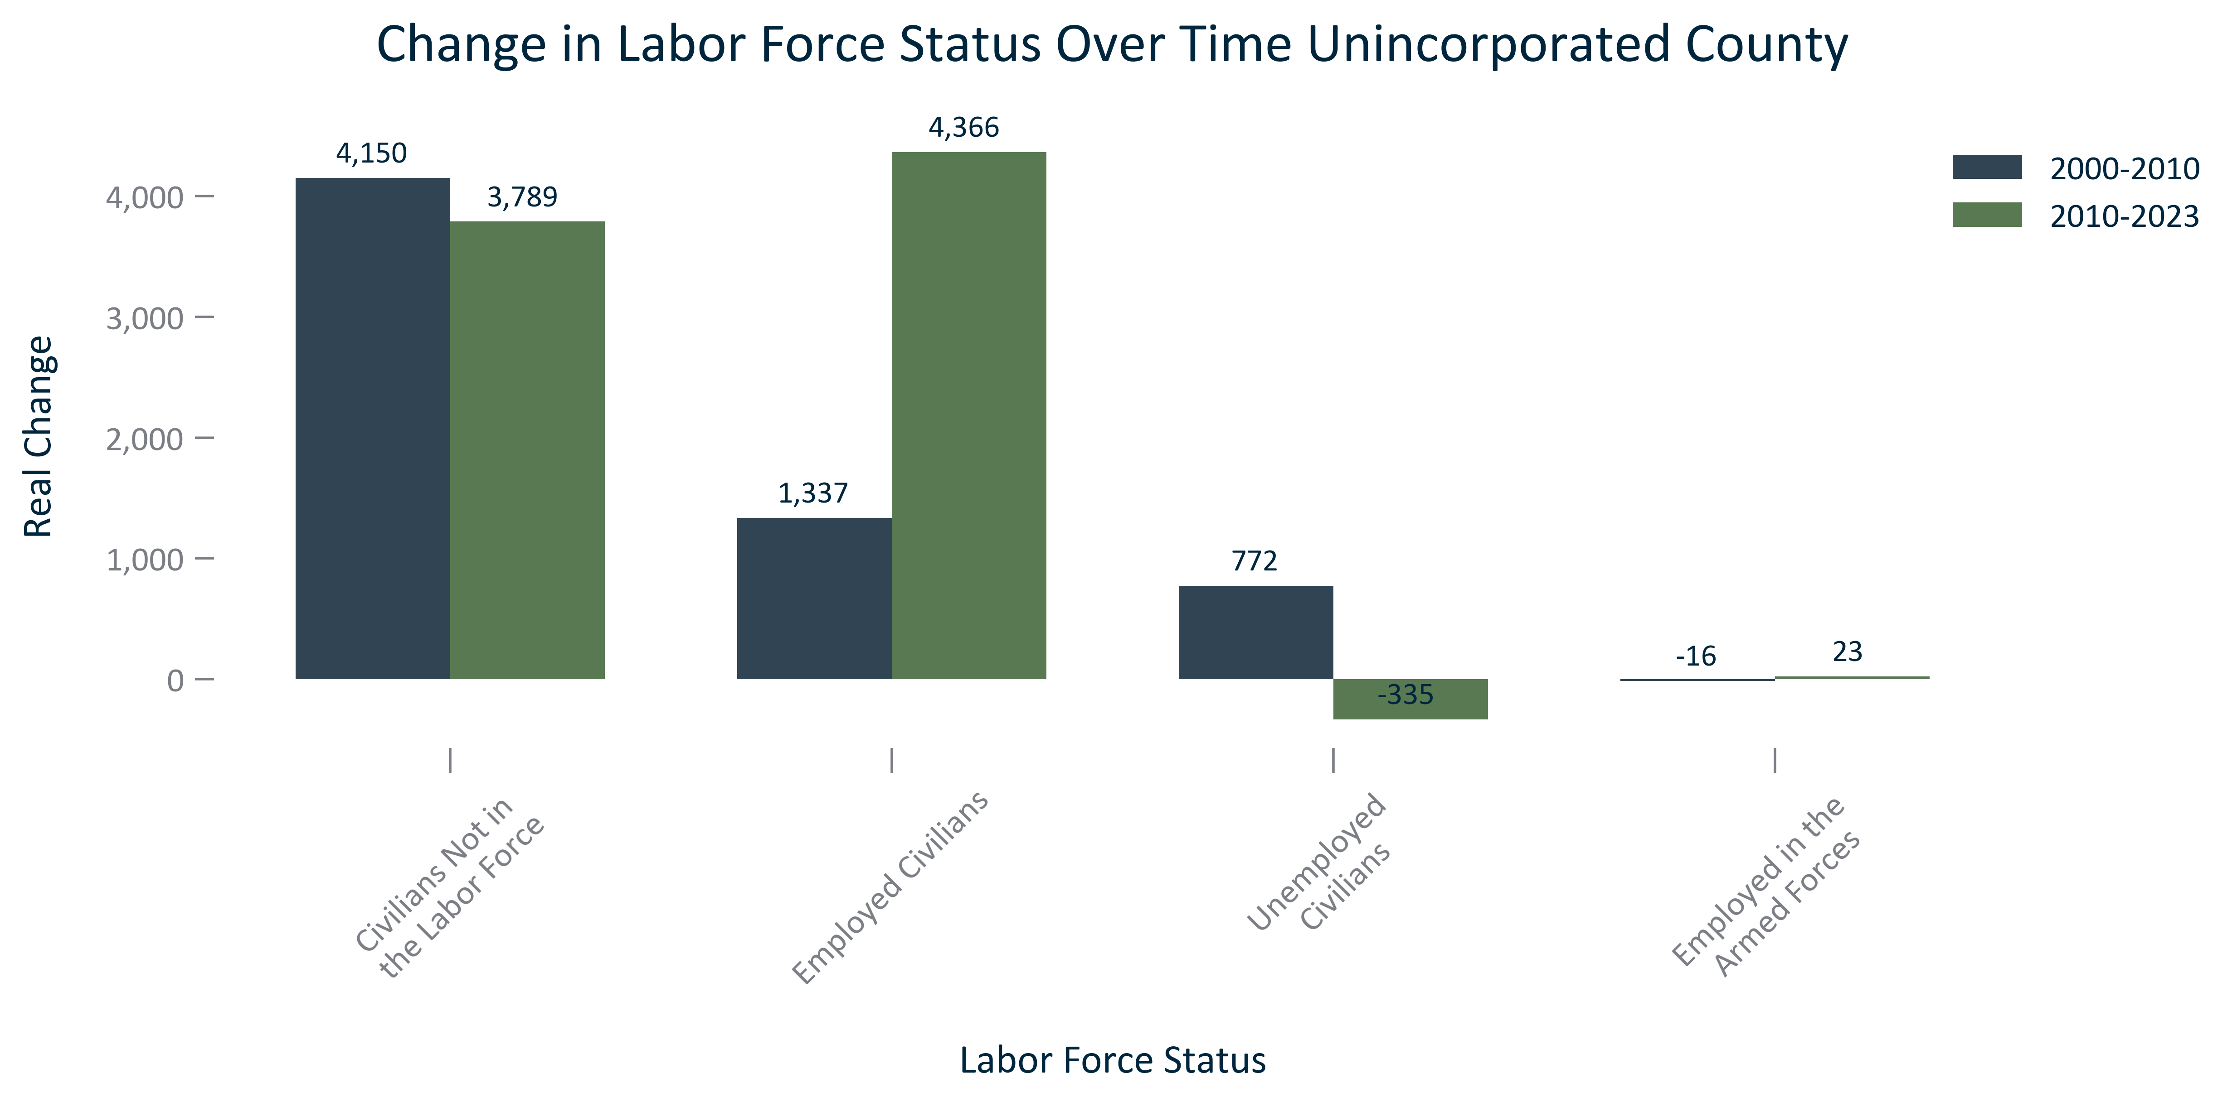

Citation: 2000 Decennial Census, 2006-2010 and 2019 - 2023 American Community Survey 5-Year Estimates

### EMP_clusterbar_primarygeo_percentchangelfstatus_overtime:

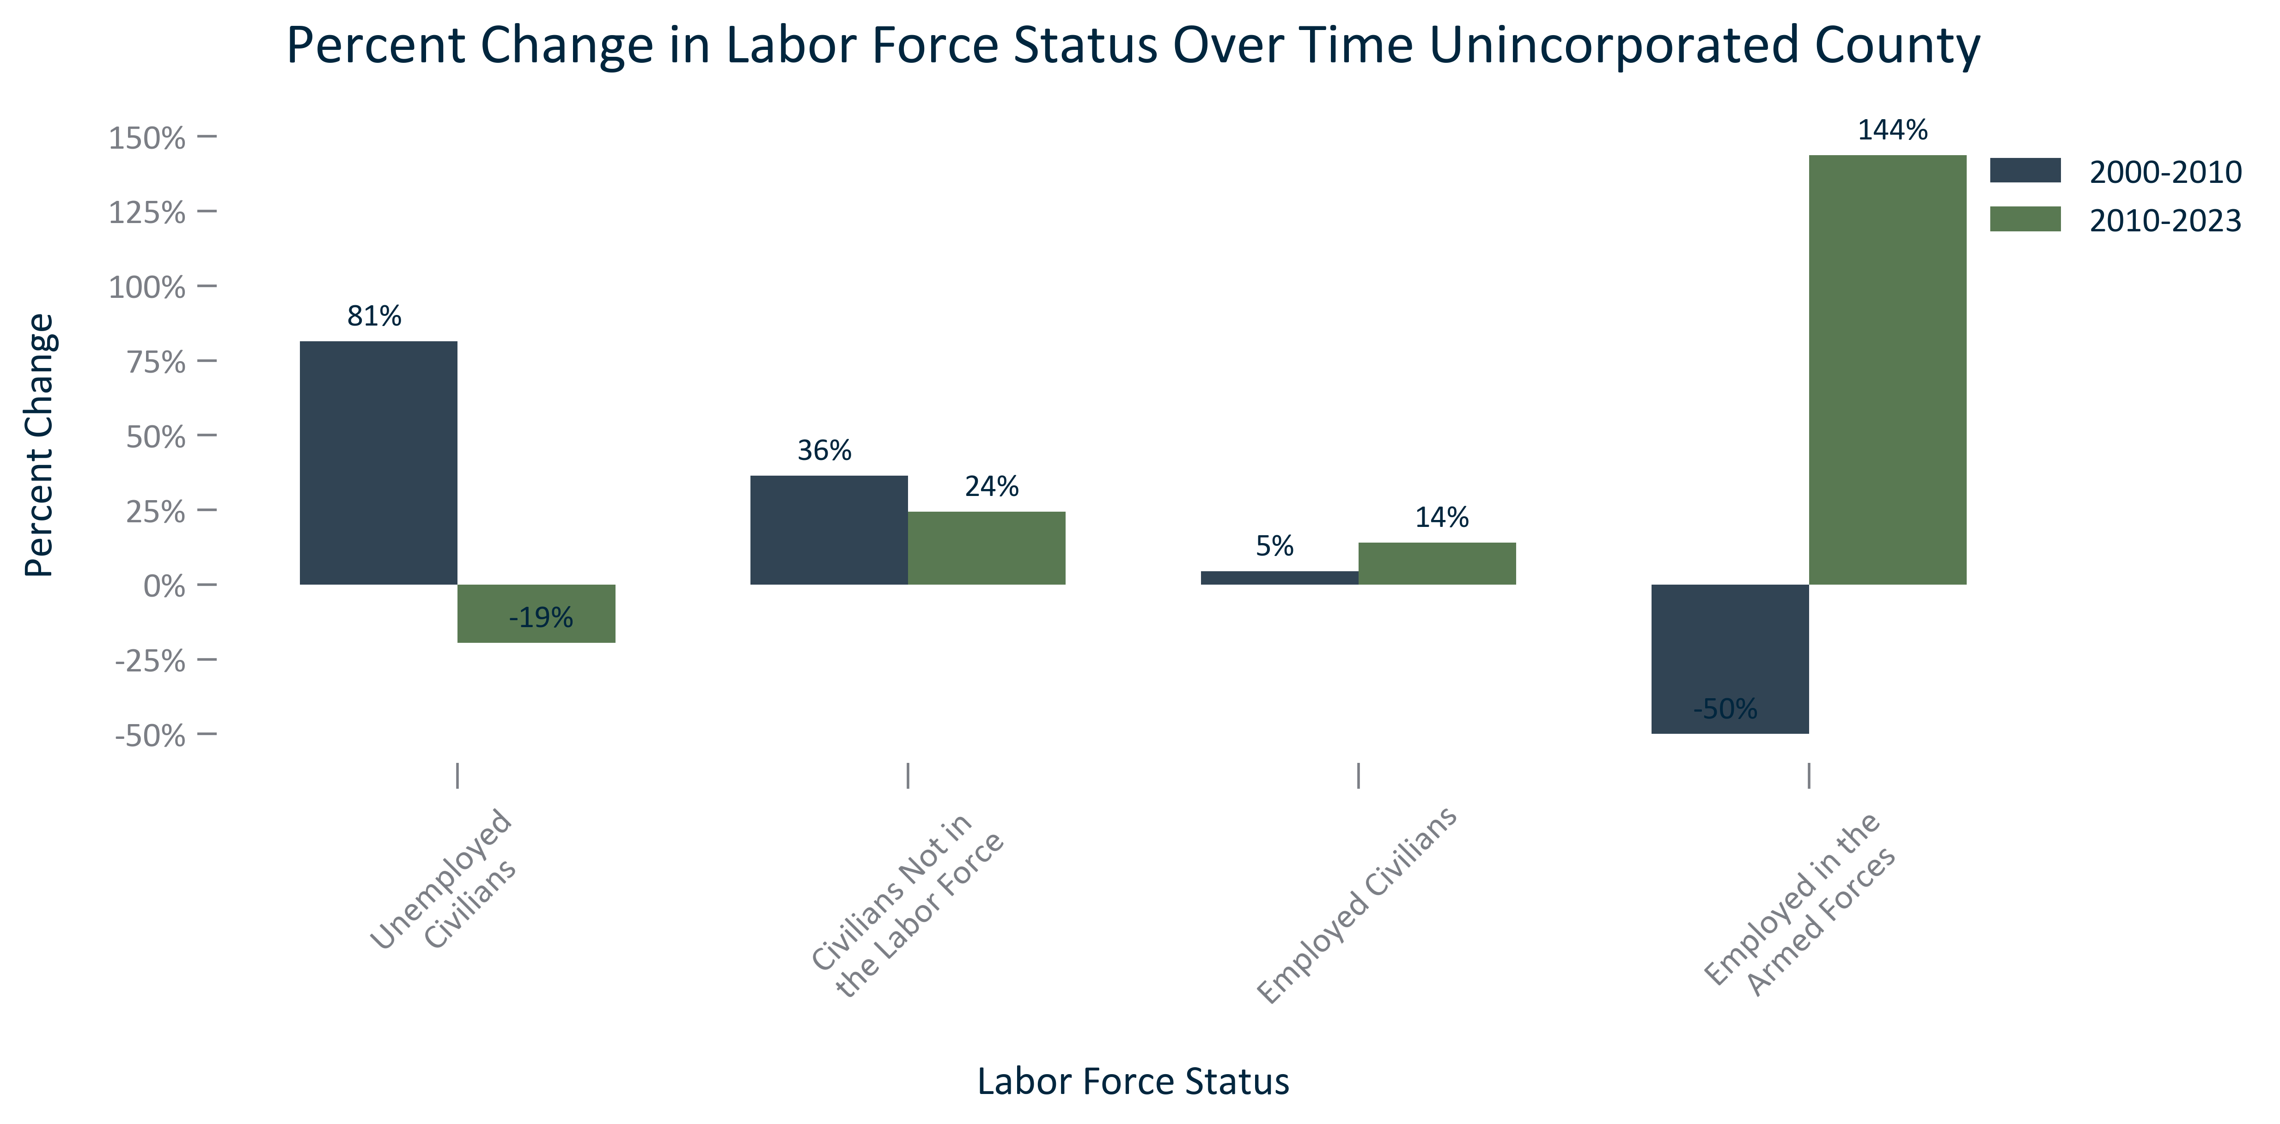

Citation: 2000 Decennial Census, 2006-2010 and 2019 - 2023 American Community Survey 5-Year Estimates

### EMP_stackedbar_primarygeo_lfparticipation_overtime:

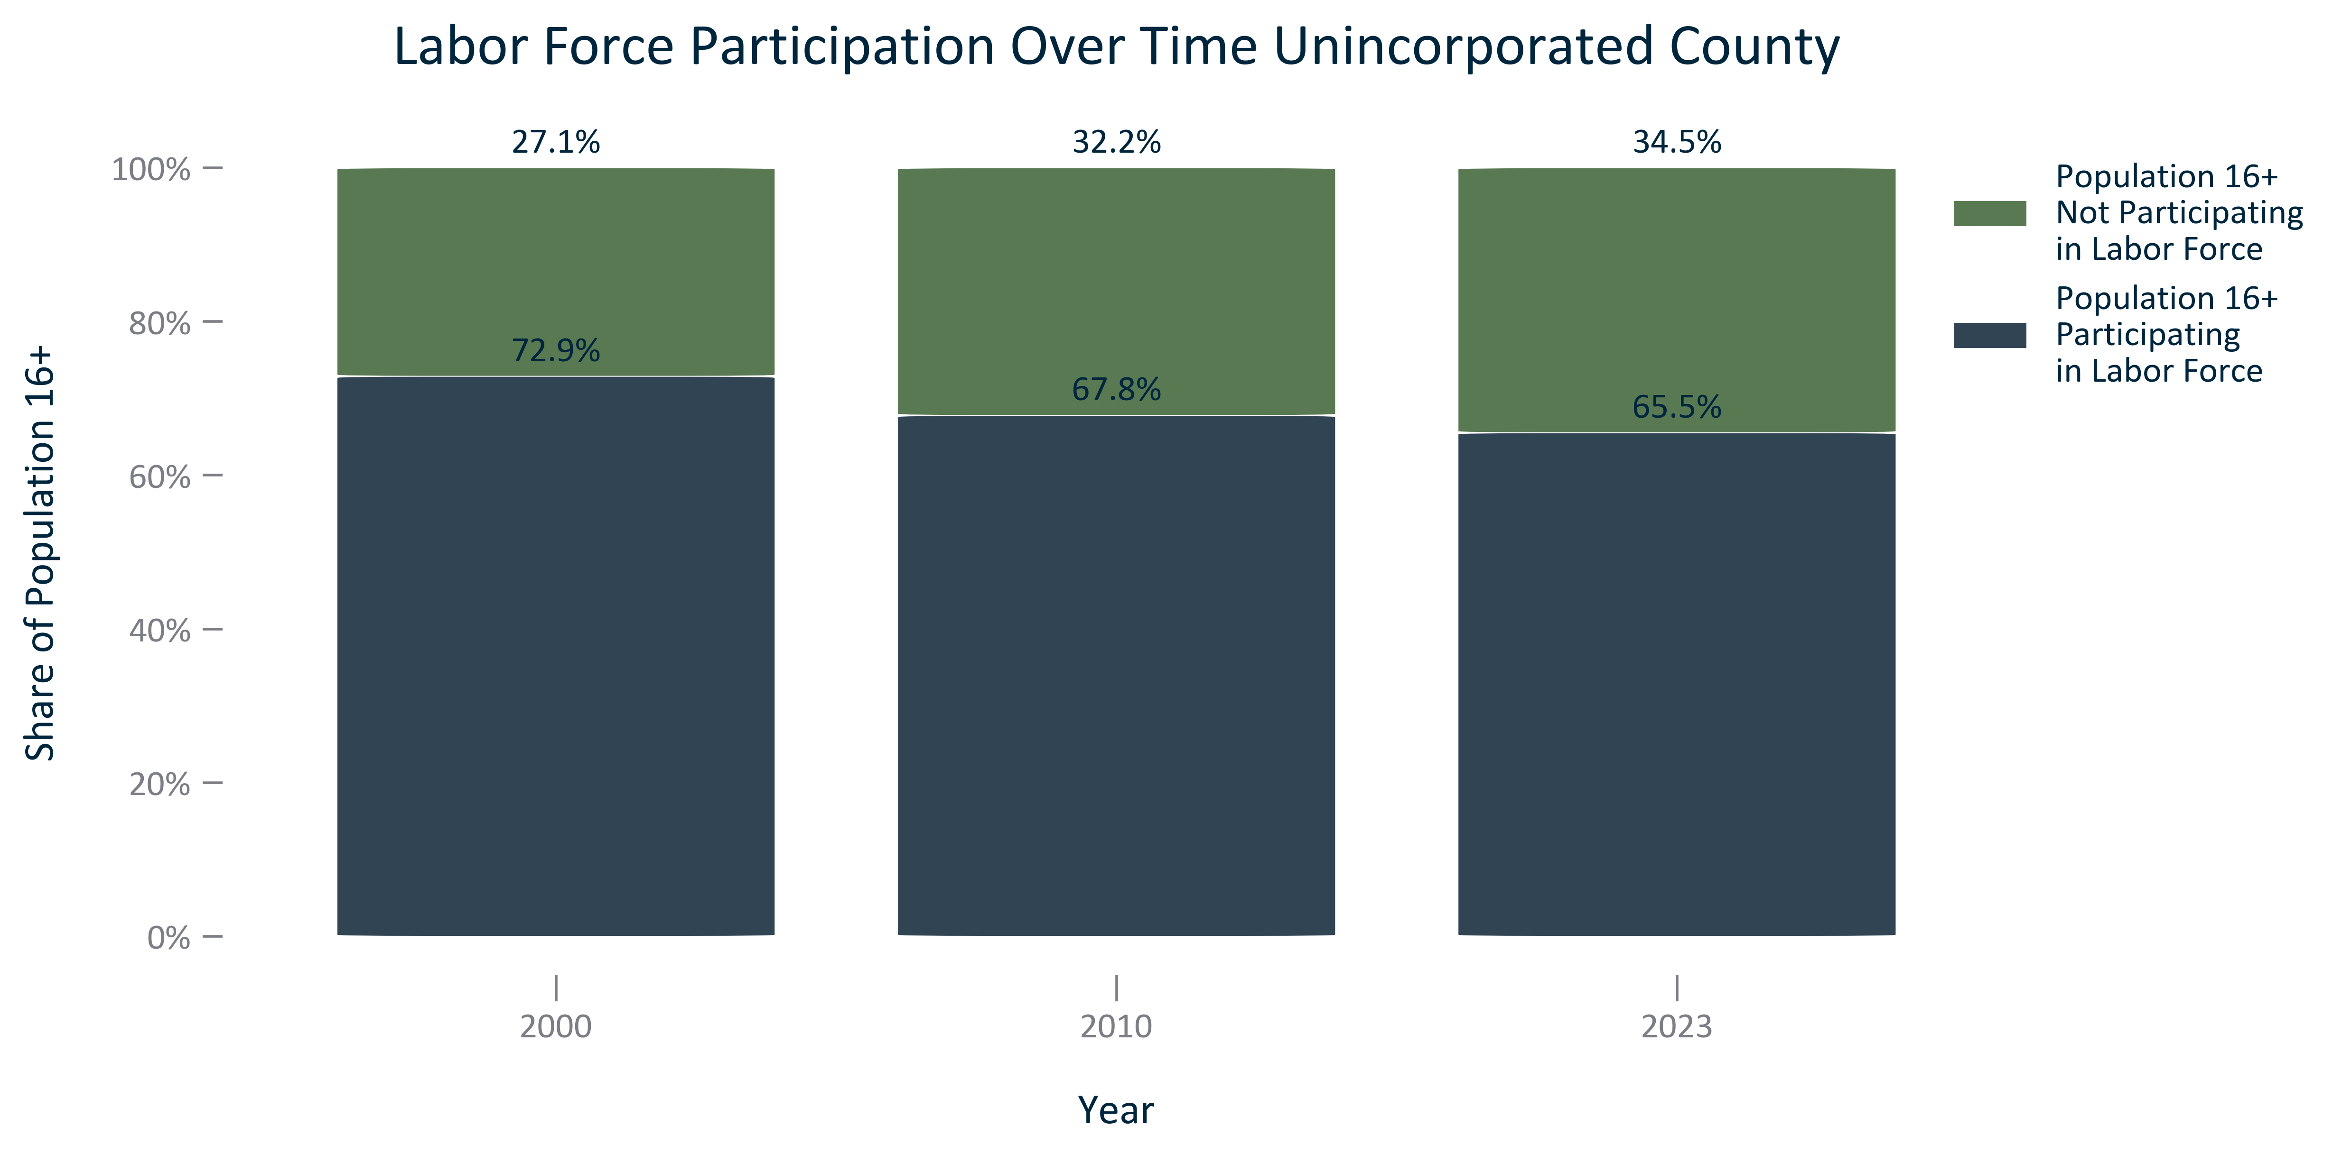

Citation: 2000 Decennial Census, 2006-2010 and 2019 - 2023 American Community Survey 5-Year Estimates

### EMP_stackedbar_primarygeo_civilianemploymentstatus_overtime:

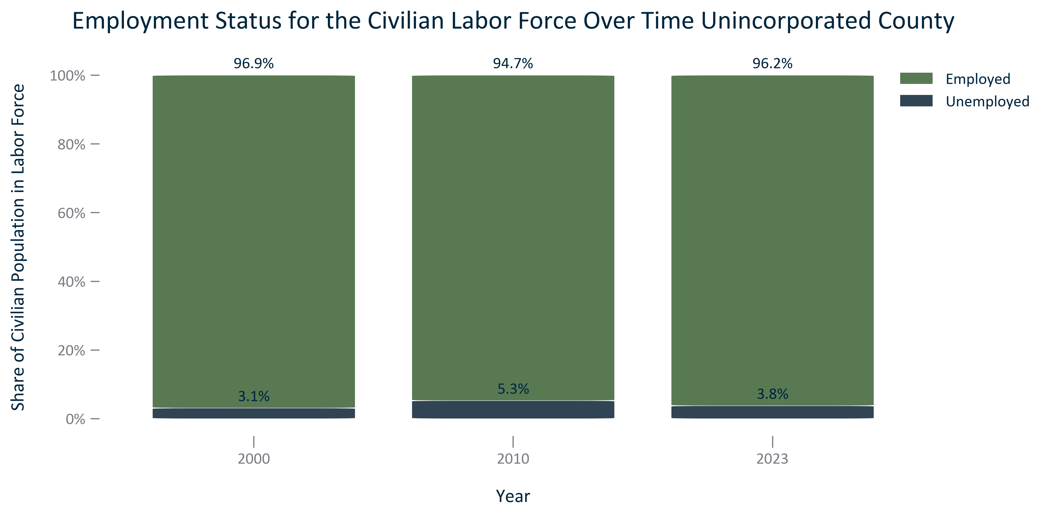

Citation: 2000 Decennial Census, 2006-2010 and 2019 - 2023 American Community Survey 5-Year Estimates

### EMP_line_geocomparative_unemploymentcounties_overtime:

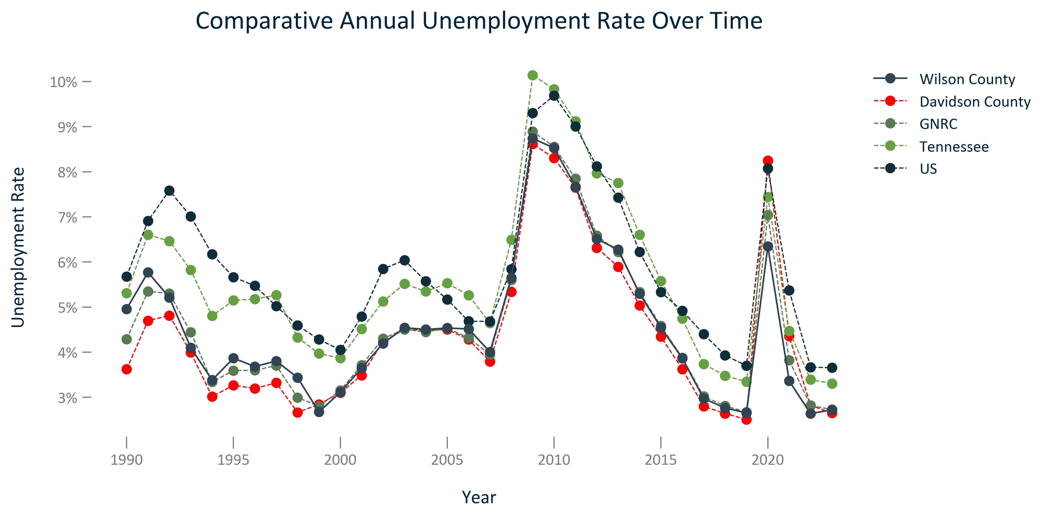

Citation: LAUS

### EMP_bar_geocomparative_civilianunemploymentrate_2023:

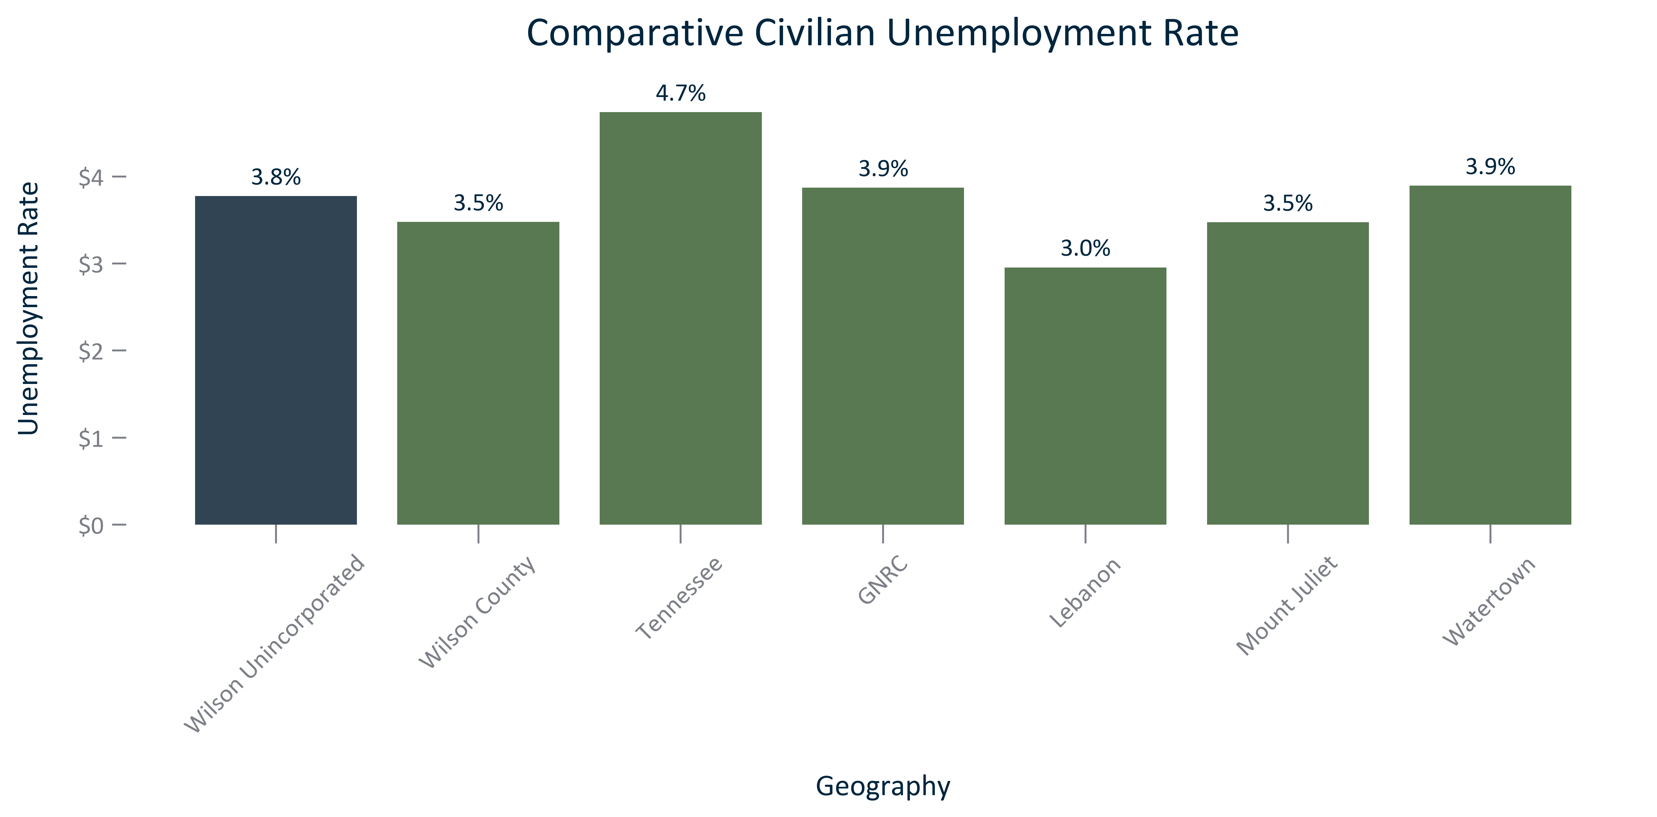

Citation: 2019 - 2023 American Community Survey 5-Year Estimates

### EMP_bar_primarygeo_medianannualearningsallworkers_overtime:

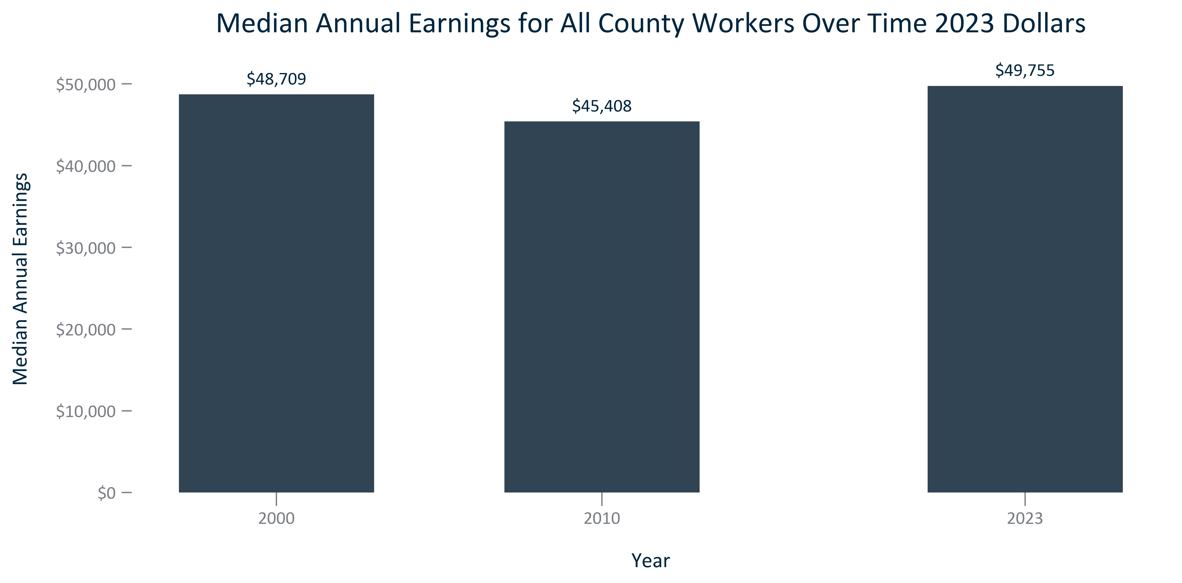

Citation: 2000 Decennial Census, 2006-2010 and 2019 - 2023 American Community Survey 5-Year Estimates in 2023 Dollars

### EMP_bar_primarygeo_medianannualearningsfulltimeworkers_overtime:

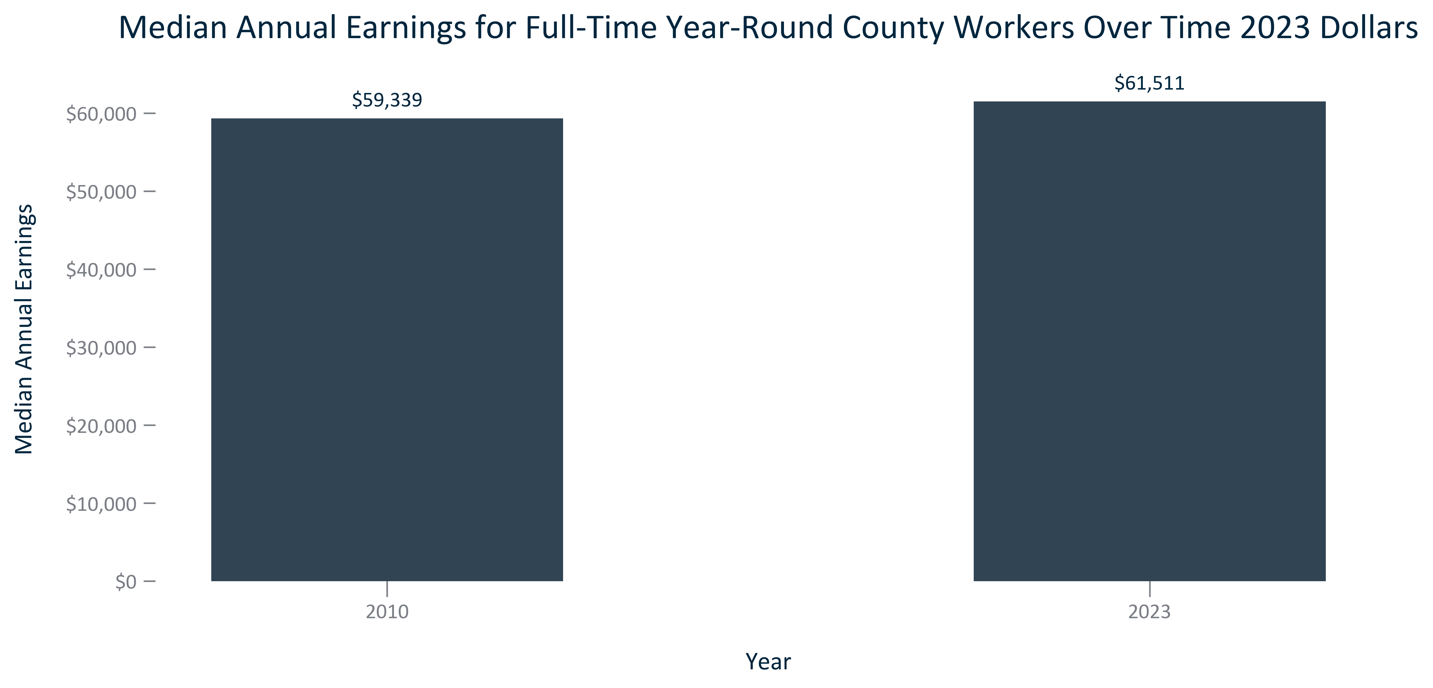

Citation: 2006-2010 and 2019 - 2023 American Community Survey 5-Year Estimates in 2023 Dollars

### EMP_bar_primarygeo_medianearningsallworkerscount_2023:

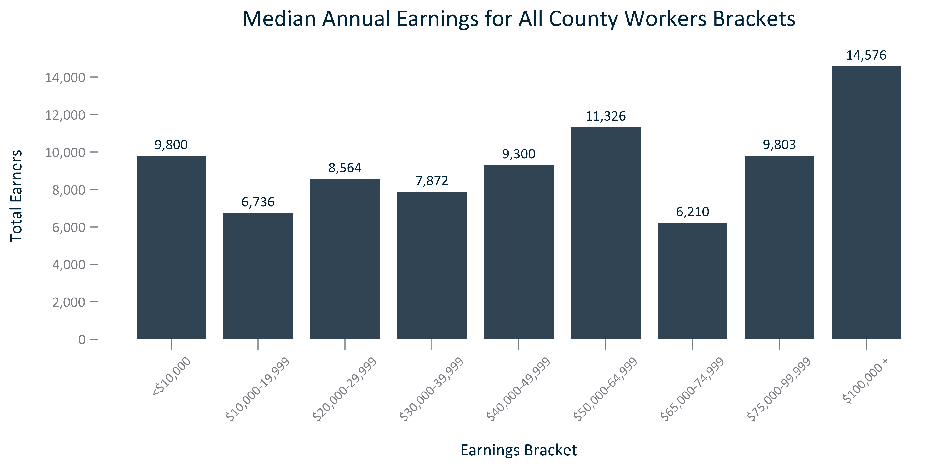

Citation: 2019 - 2023 American Community Survey 5-Year Estimates

### EMP_bar_primarygeo_medianearningsdistributionallworkers_2023:

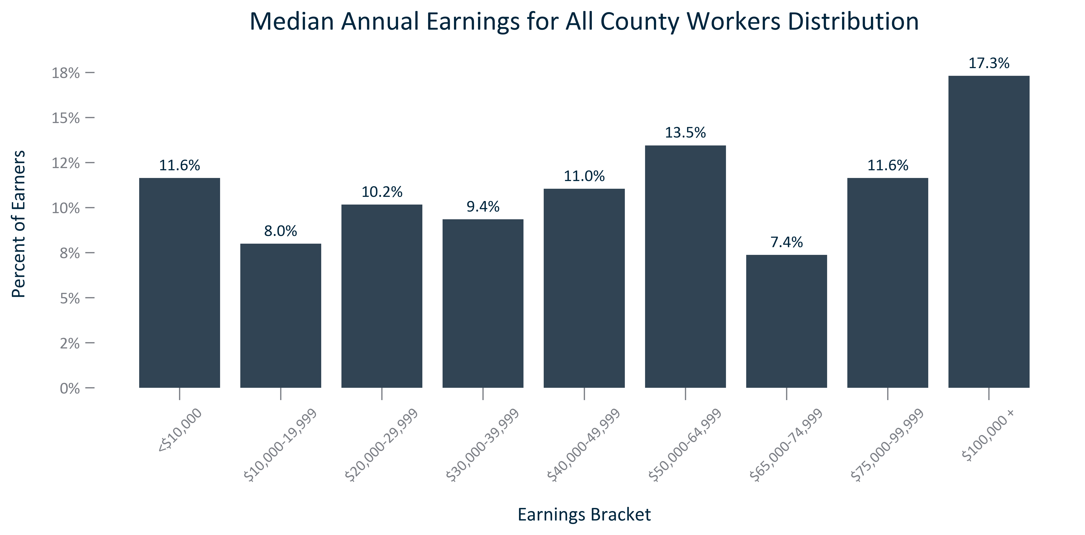

Citation: 2019 - 2023 American Community Survey 5-Year Estimates

### EMP_bar_primarygeo_medianearningsfulltimeworkerscount_2023:

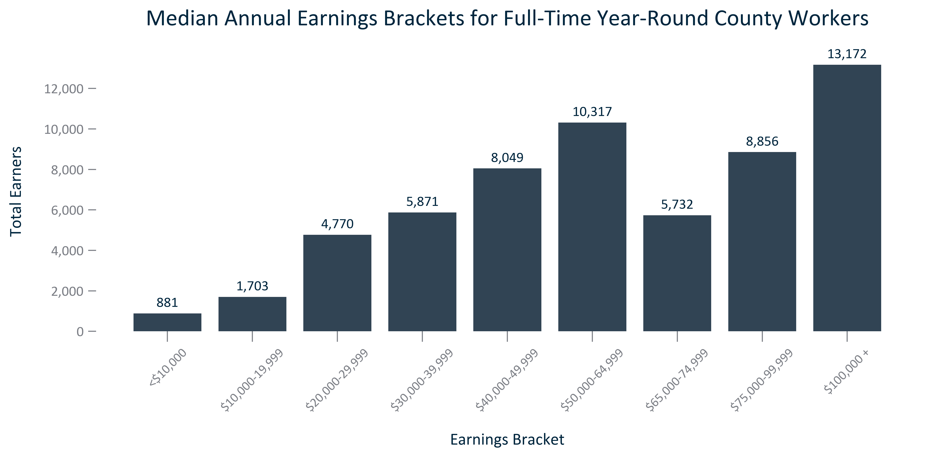

Citation: 2019 - 2023 American Community Survey 5-Year Estimates

### EMP_bar_primarygeo_medianearningsdistributionfulltimeworkers_2023:

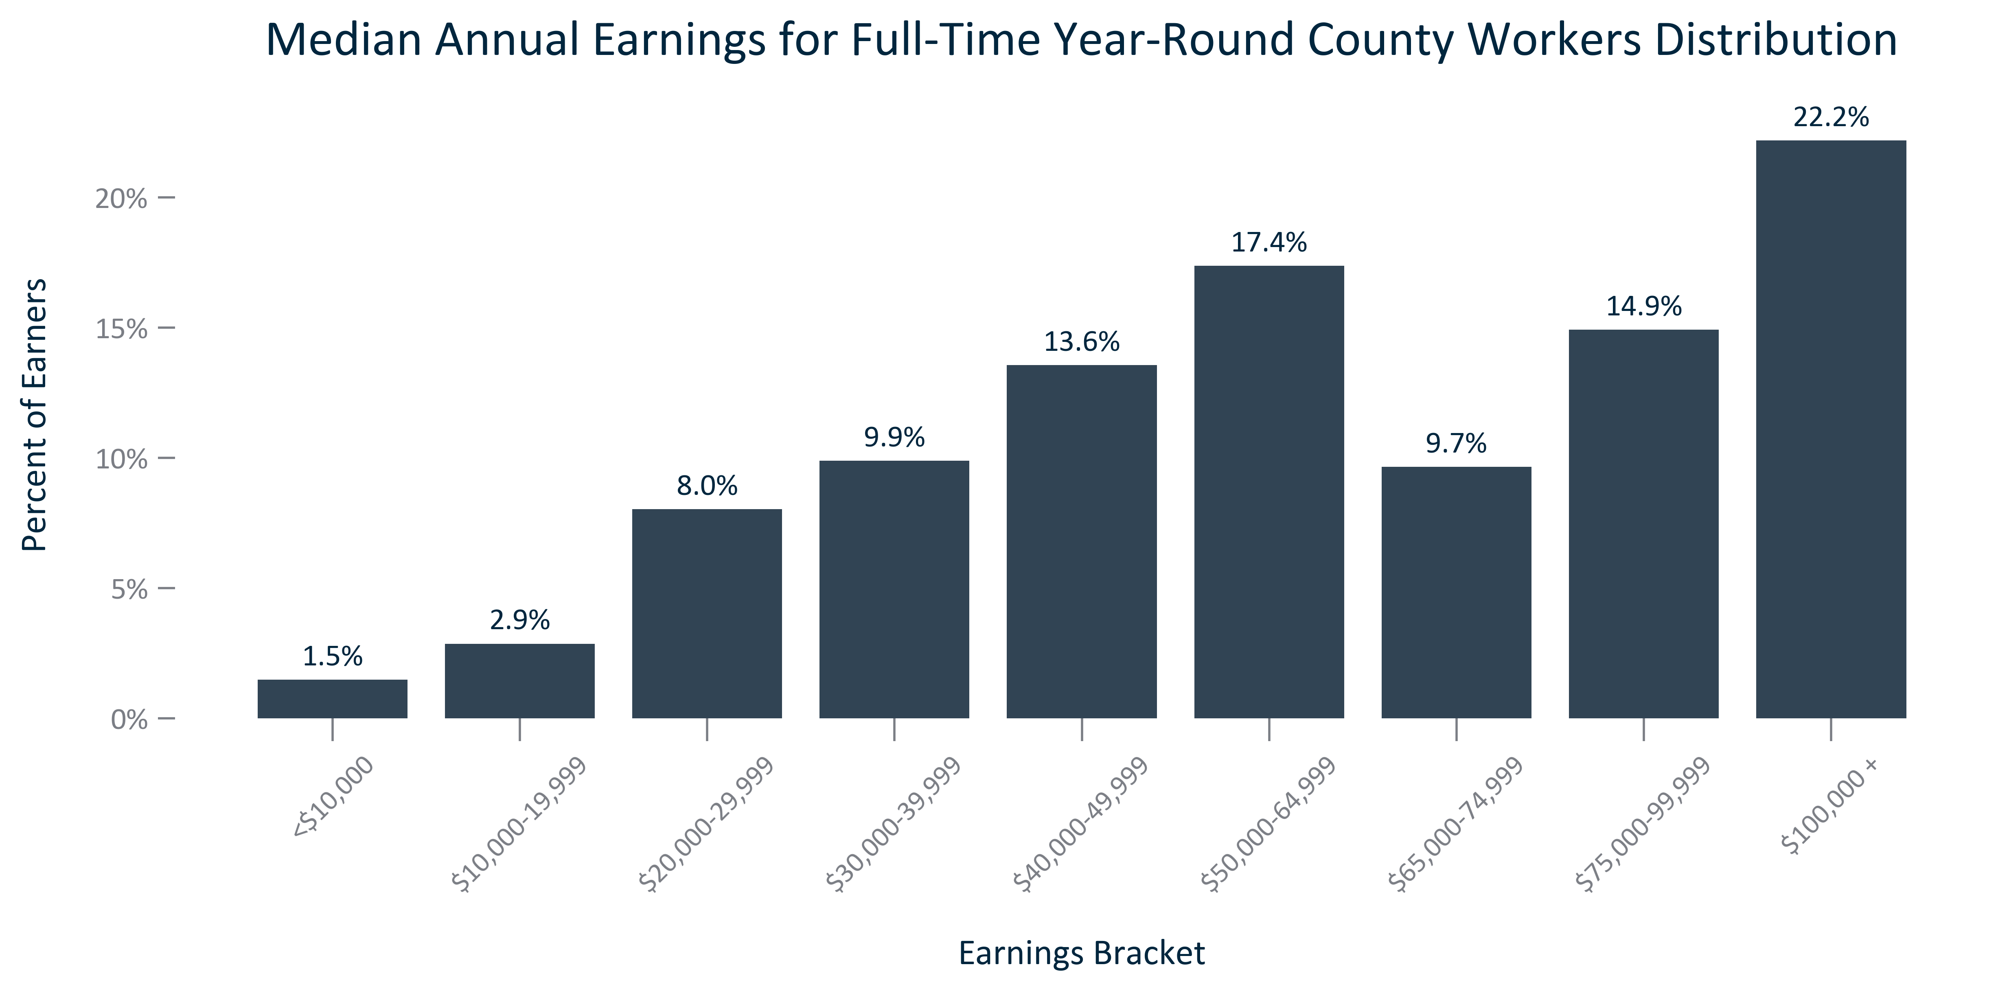

Citation: 2019 - 2023 American Community Survey 5-Year Estimates

### EMP_bar_geocomparative_medianannualearningsfulltimeworkers_2023:

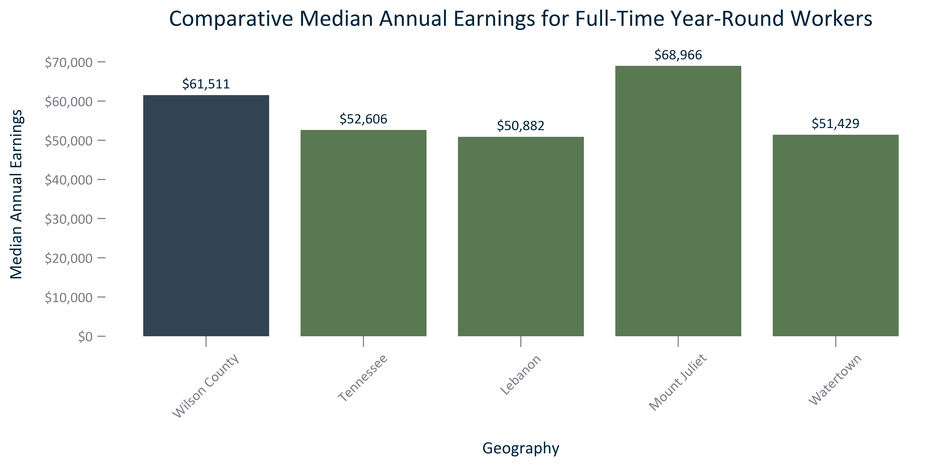

Citation: 2019 - 2023 American Community Survey 5-Year Estimates

### EMP_bar_primarygeo_medianannualearningsraceethallworkers_2023:

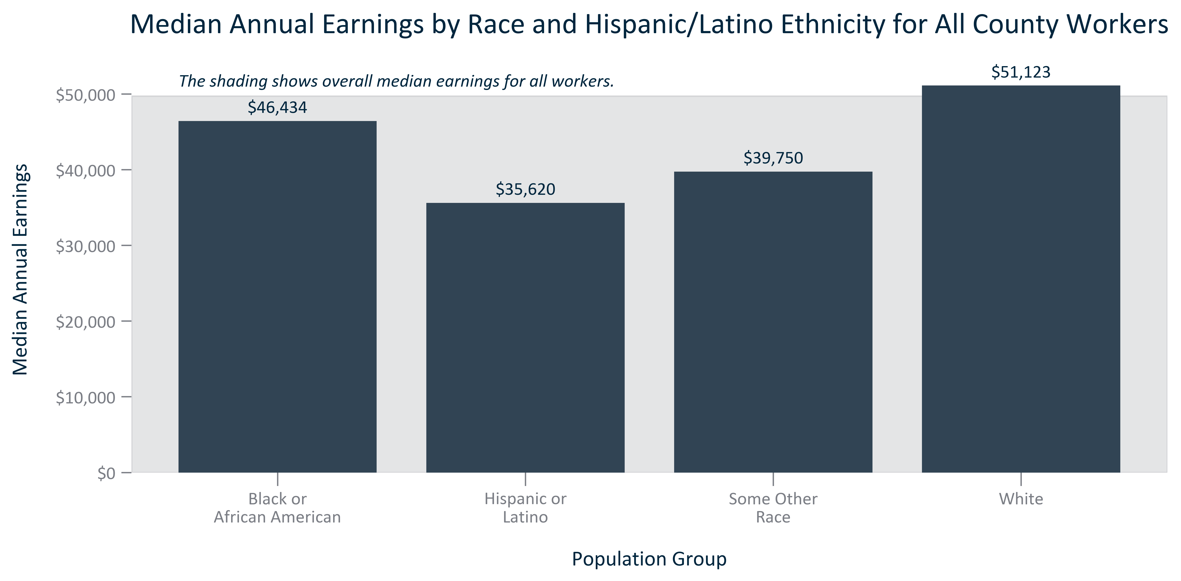

Citation: 2019 - 2023 American Community Survey 5-Year Estimates

### EMP_bar_primarygeo_percapitaincome_overtime:

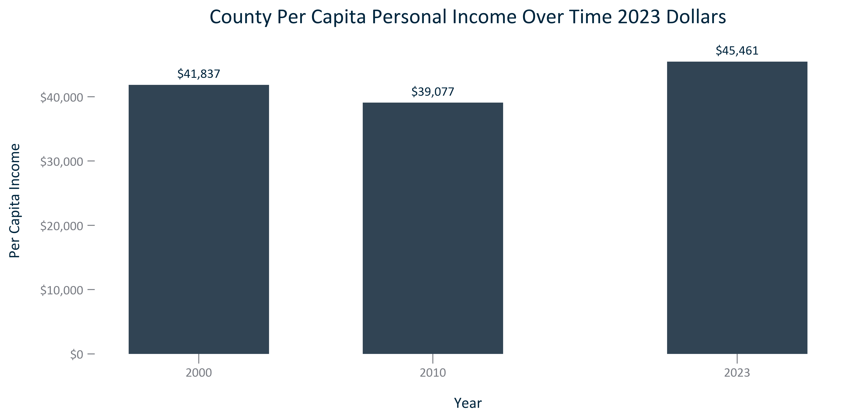

Citation: 2000 Decennial Census, 2019 - 2023 American Community Survey 5-Year Estimates in 2023 Dollars

### EMP_bar_geocomparative_percapitaincome_2023:

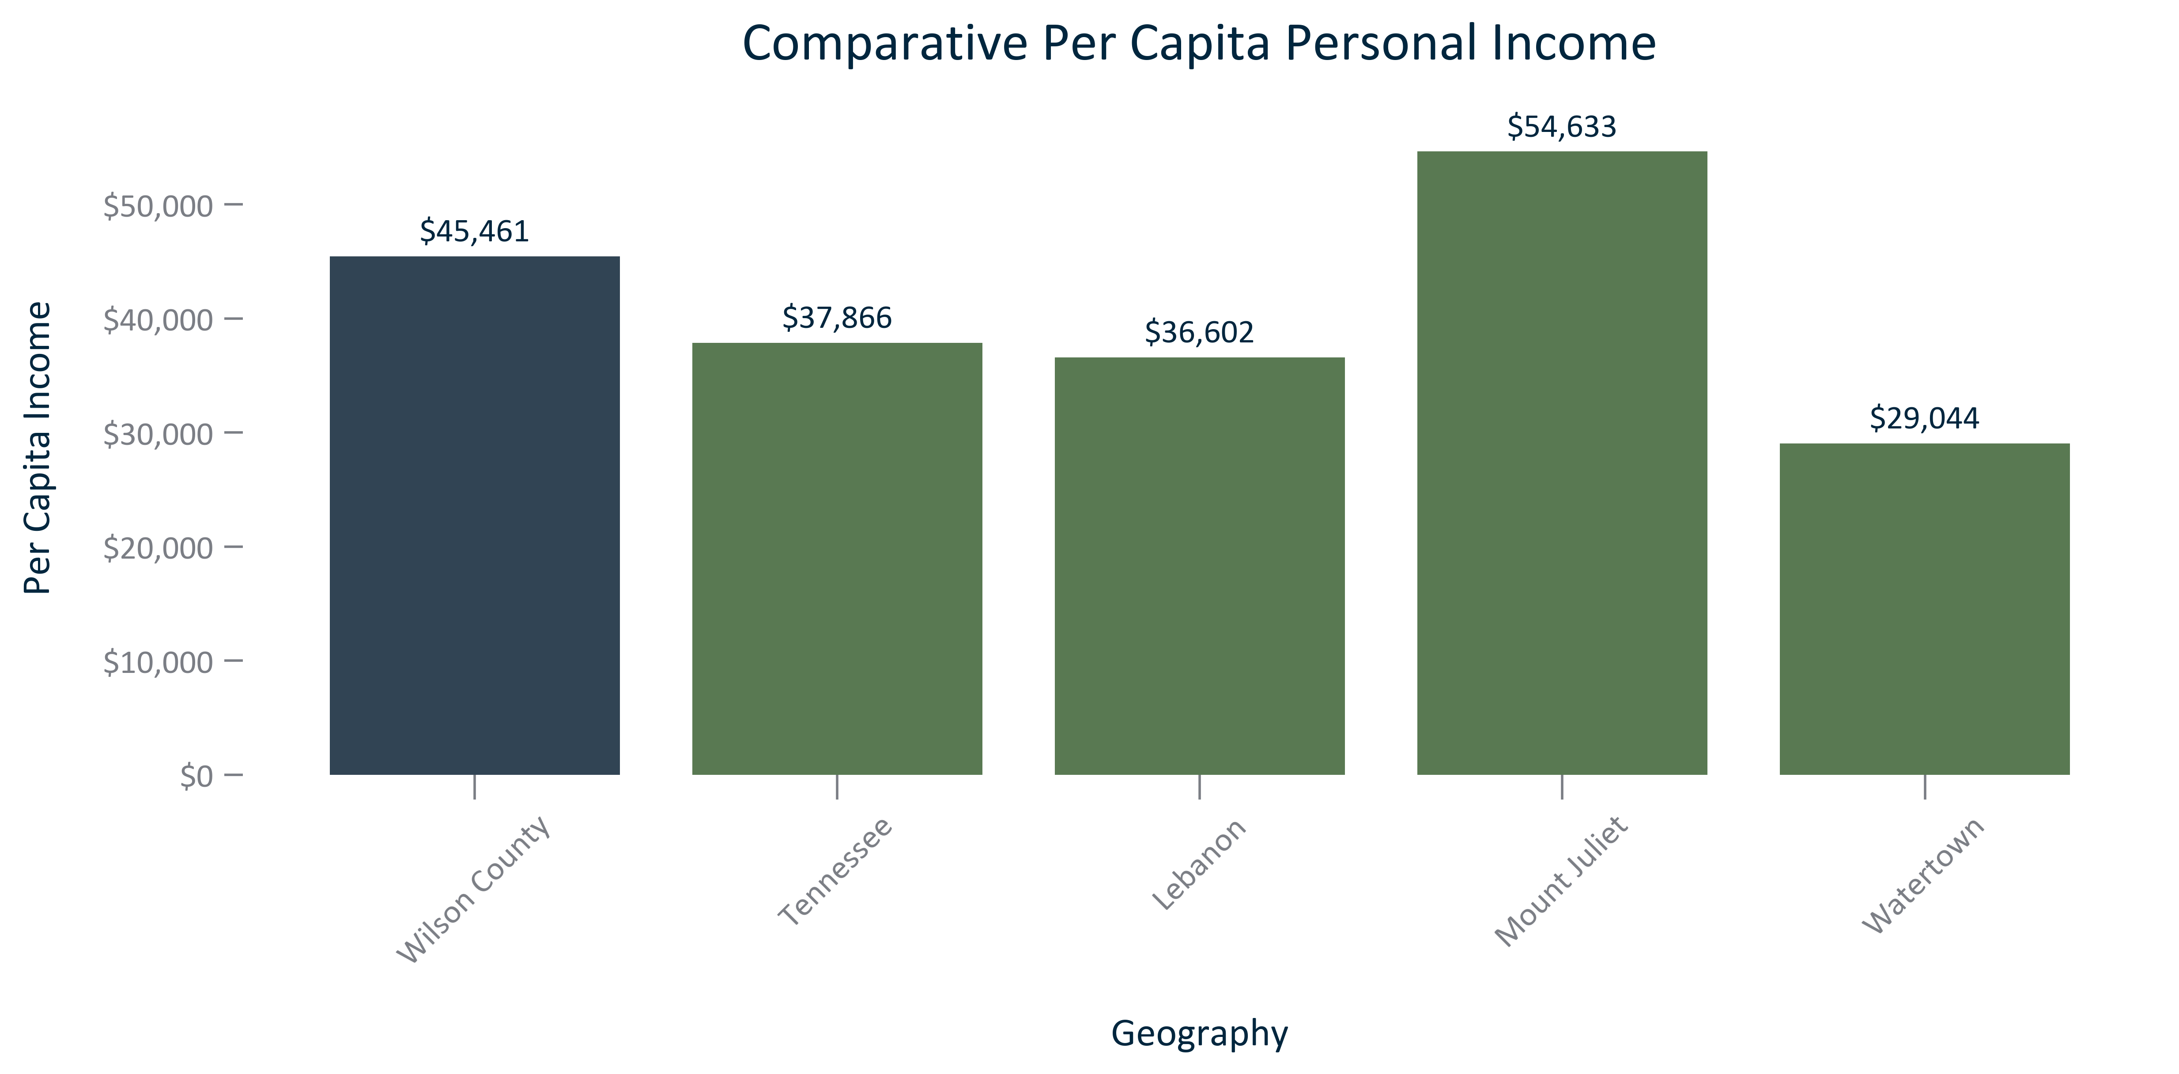

Citation: 2019 - 2023 American Community Survey 5-Year Estimates

### EMP_line_primarygeo_gdpcounty_overtime:

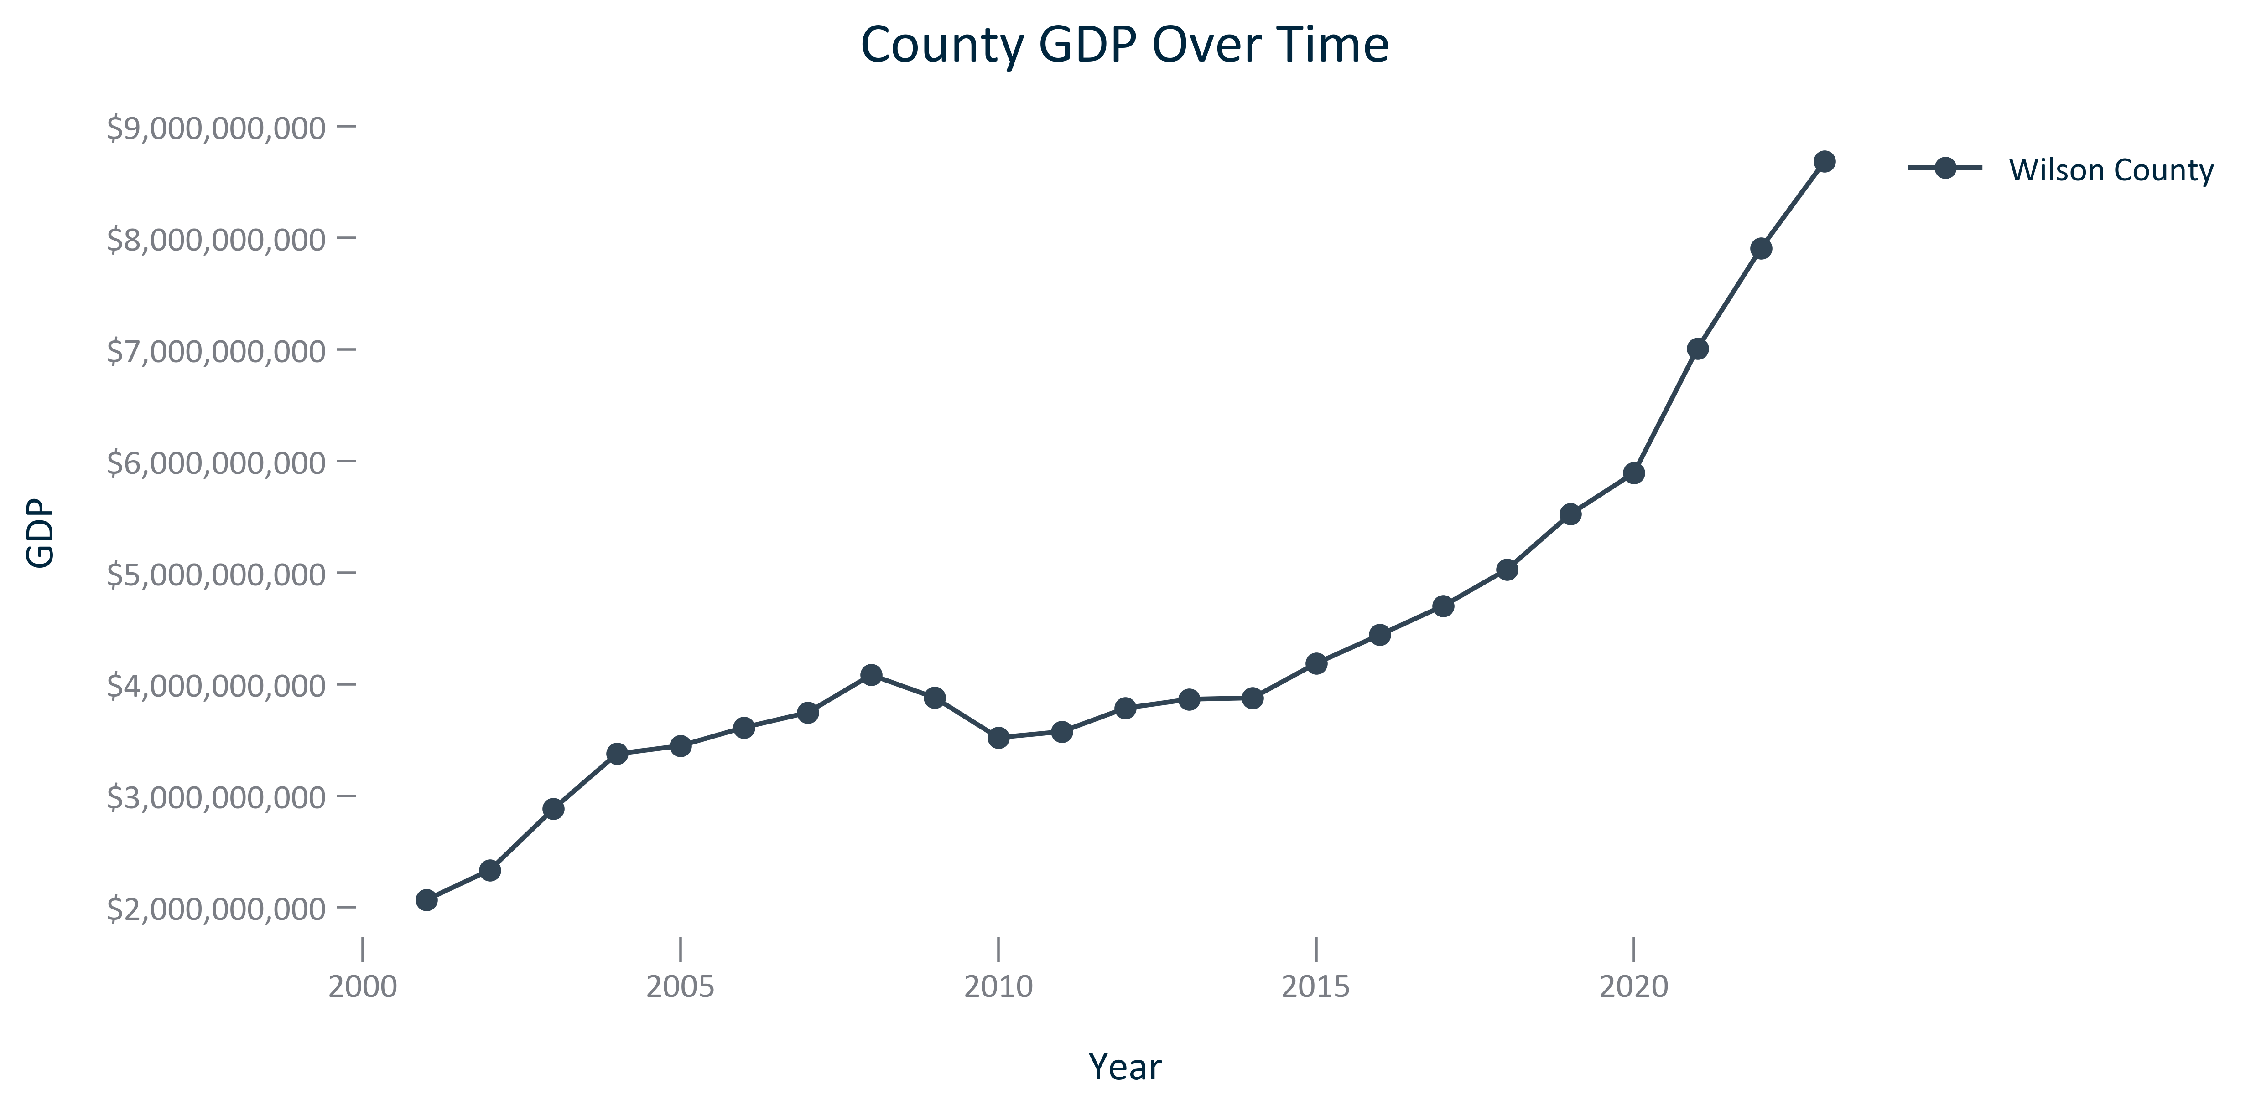

Citation: BEA via JobsEQ

### EMP_line_geocomparative_gdpcounties_overtime:

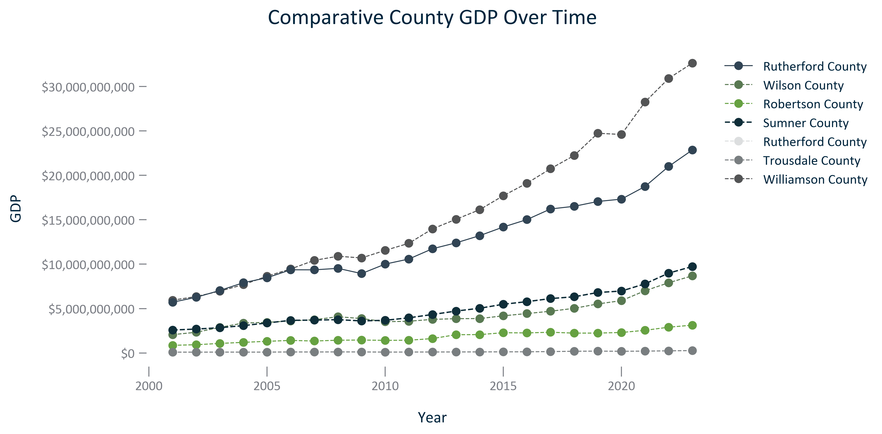

Citation: BEA via JobsEQ

### EMP_line_primarygeo_gdpcountydavidson_overtime:

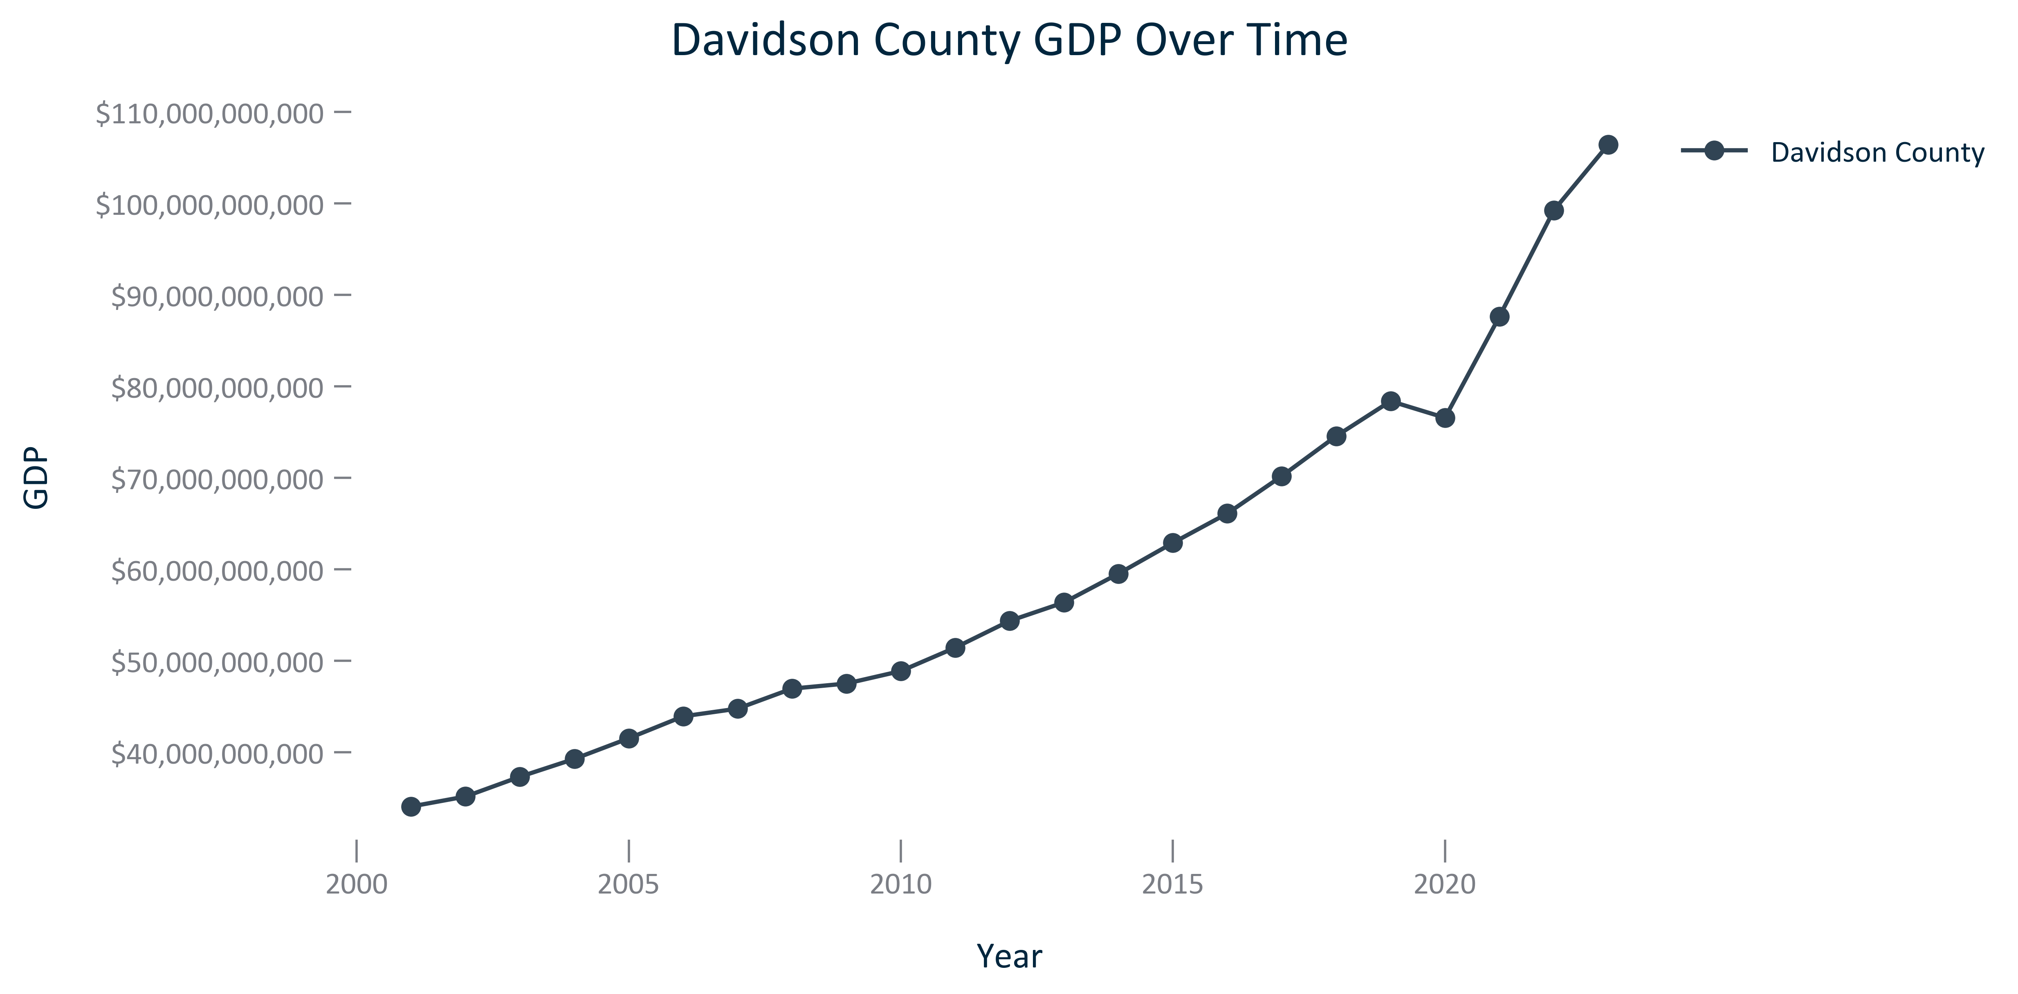

Citation: BEA via JobsEQ

# Transportation

### TRANSPO_table_geocomparative_totalcrashes_overtime:

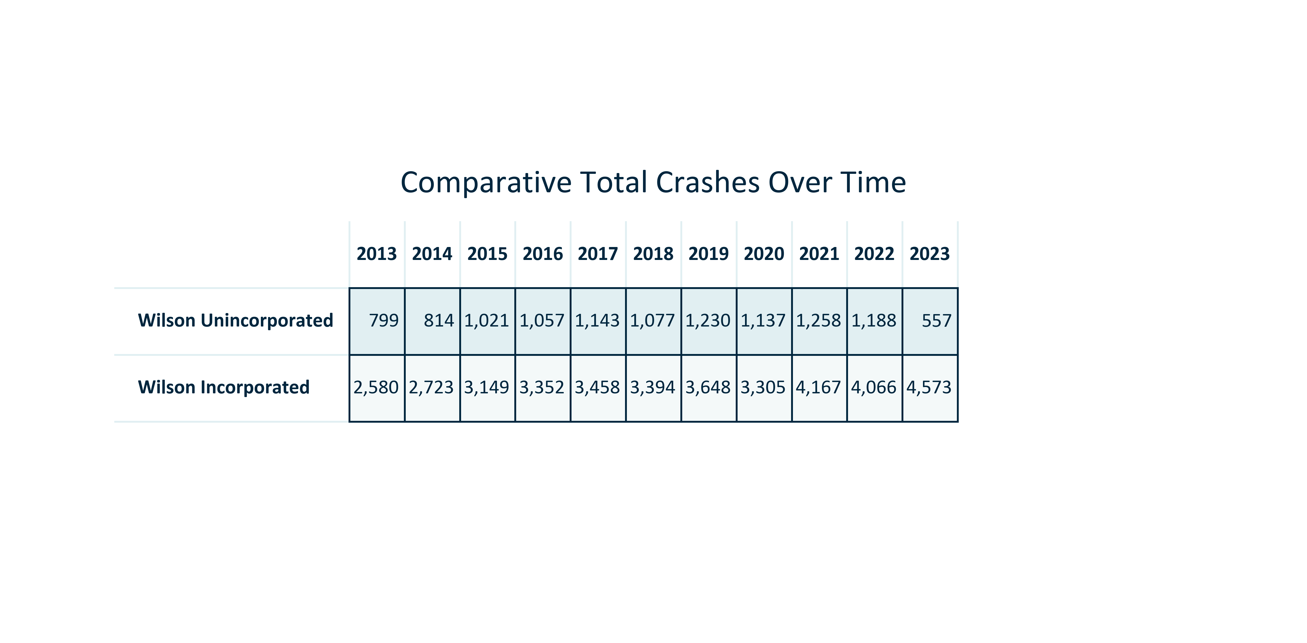

Citation: Crash Data

### TRANSPO_table_primarygeo_fatalcrashes_overtime:

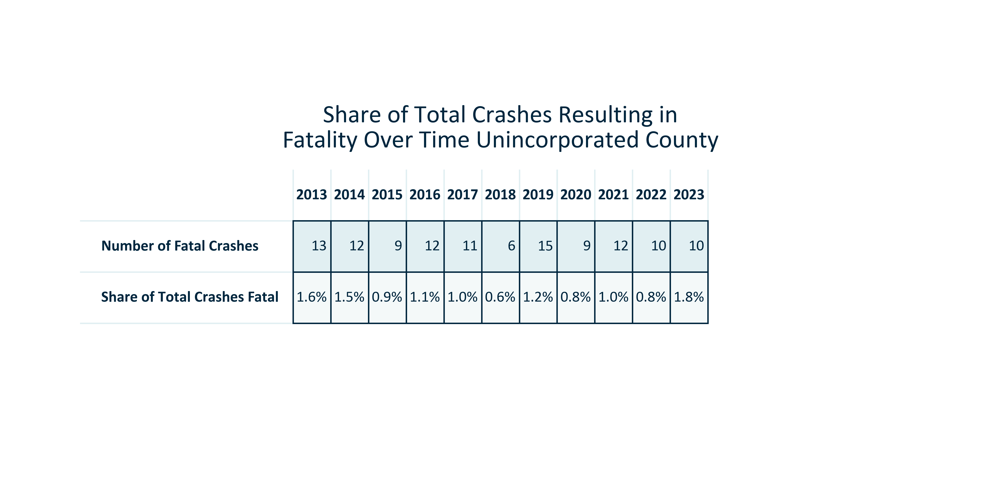

Citation: Crash Data

### TRANSPO_table_primarygeo_seriousinjurycrashes_overtime:

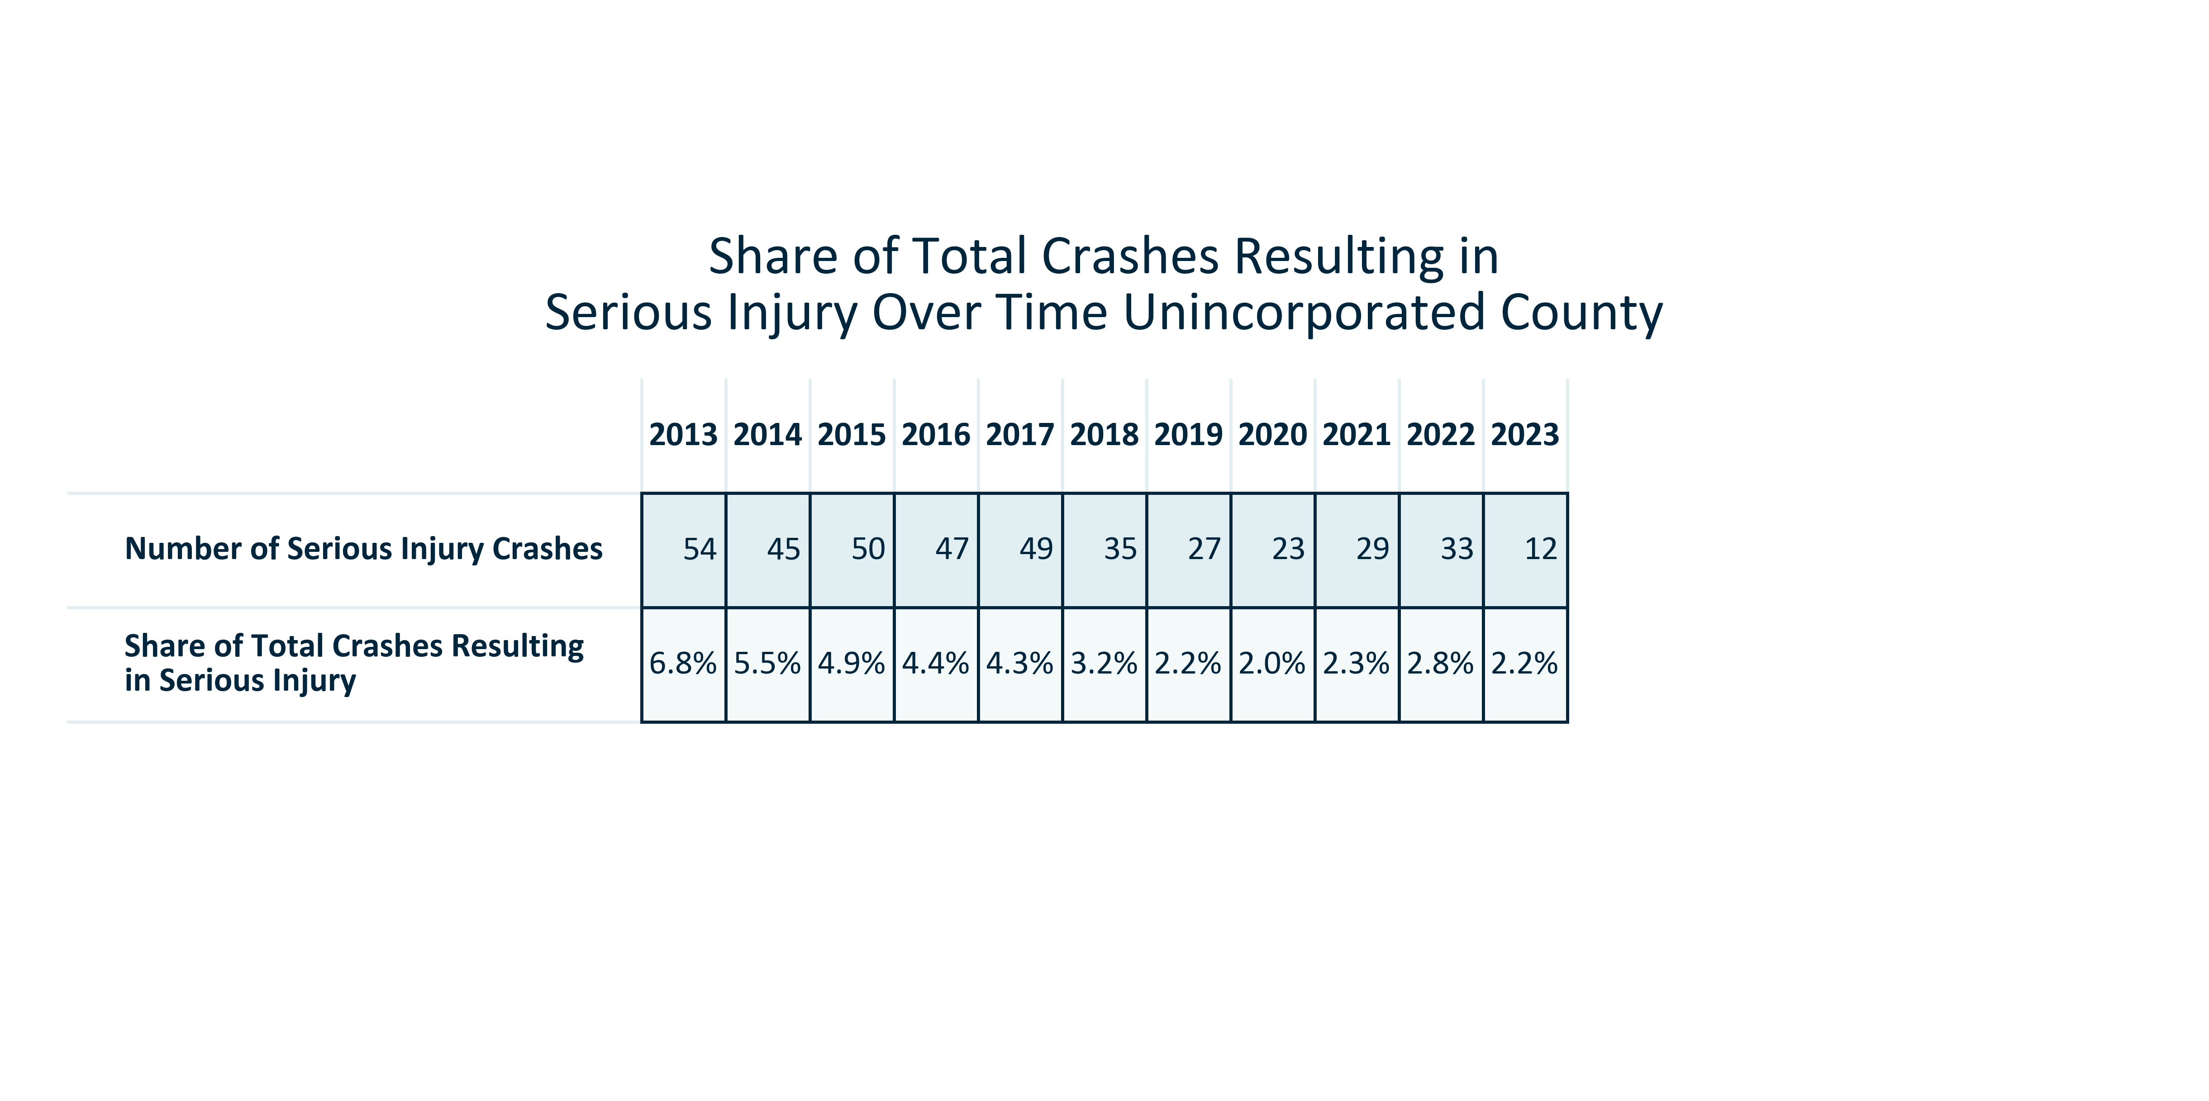

Citation: Crash Data

### TRANSPO_line_geocomparative_totalcrashes_overtime:

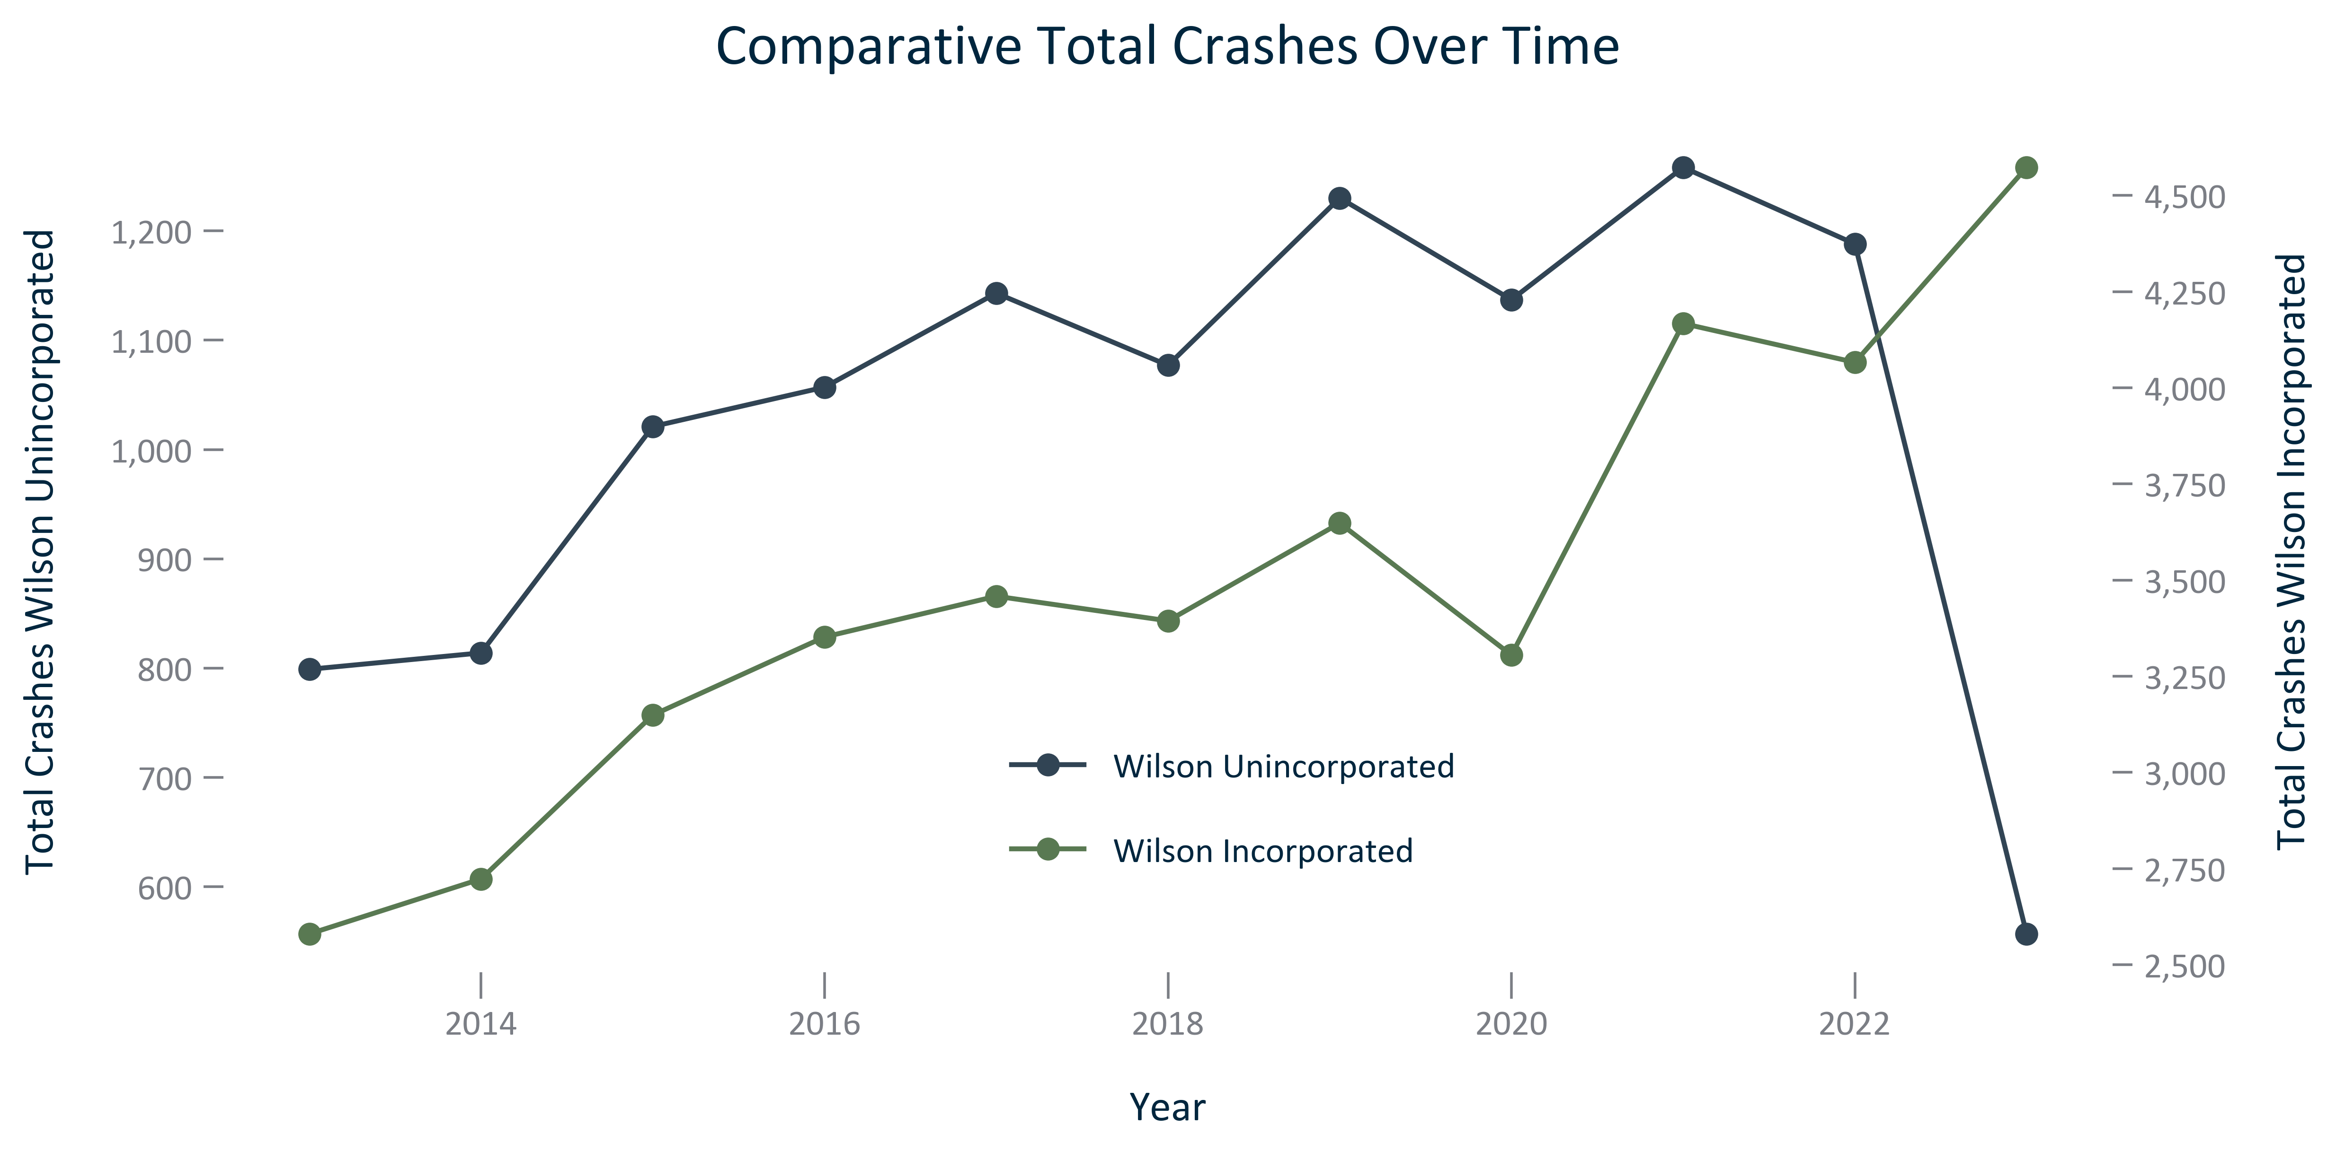

Citation: Crash Data

### TRANSPO_line_geocomparative_fatalcrashes_overtime:

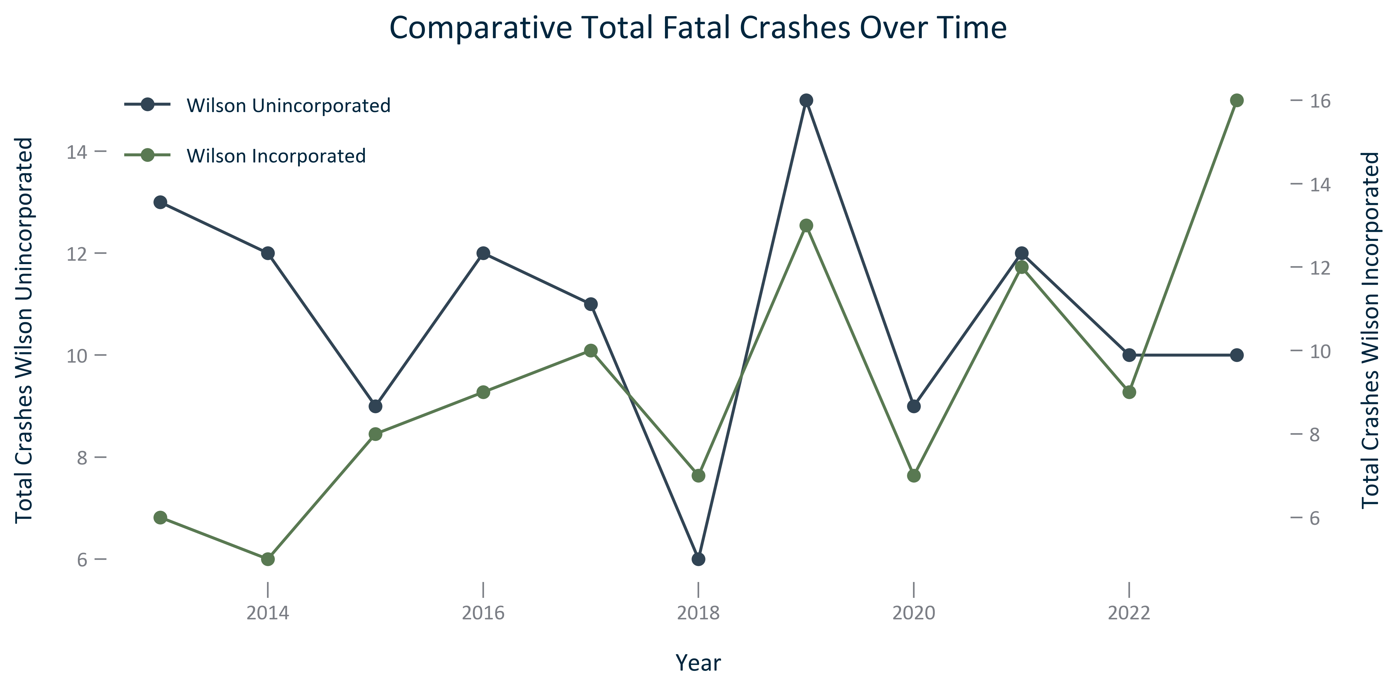

Citation: Crash Data

### TRANSPO_line_geocomparative_percentfatalcrashes_overtime:

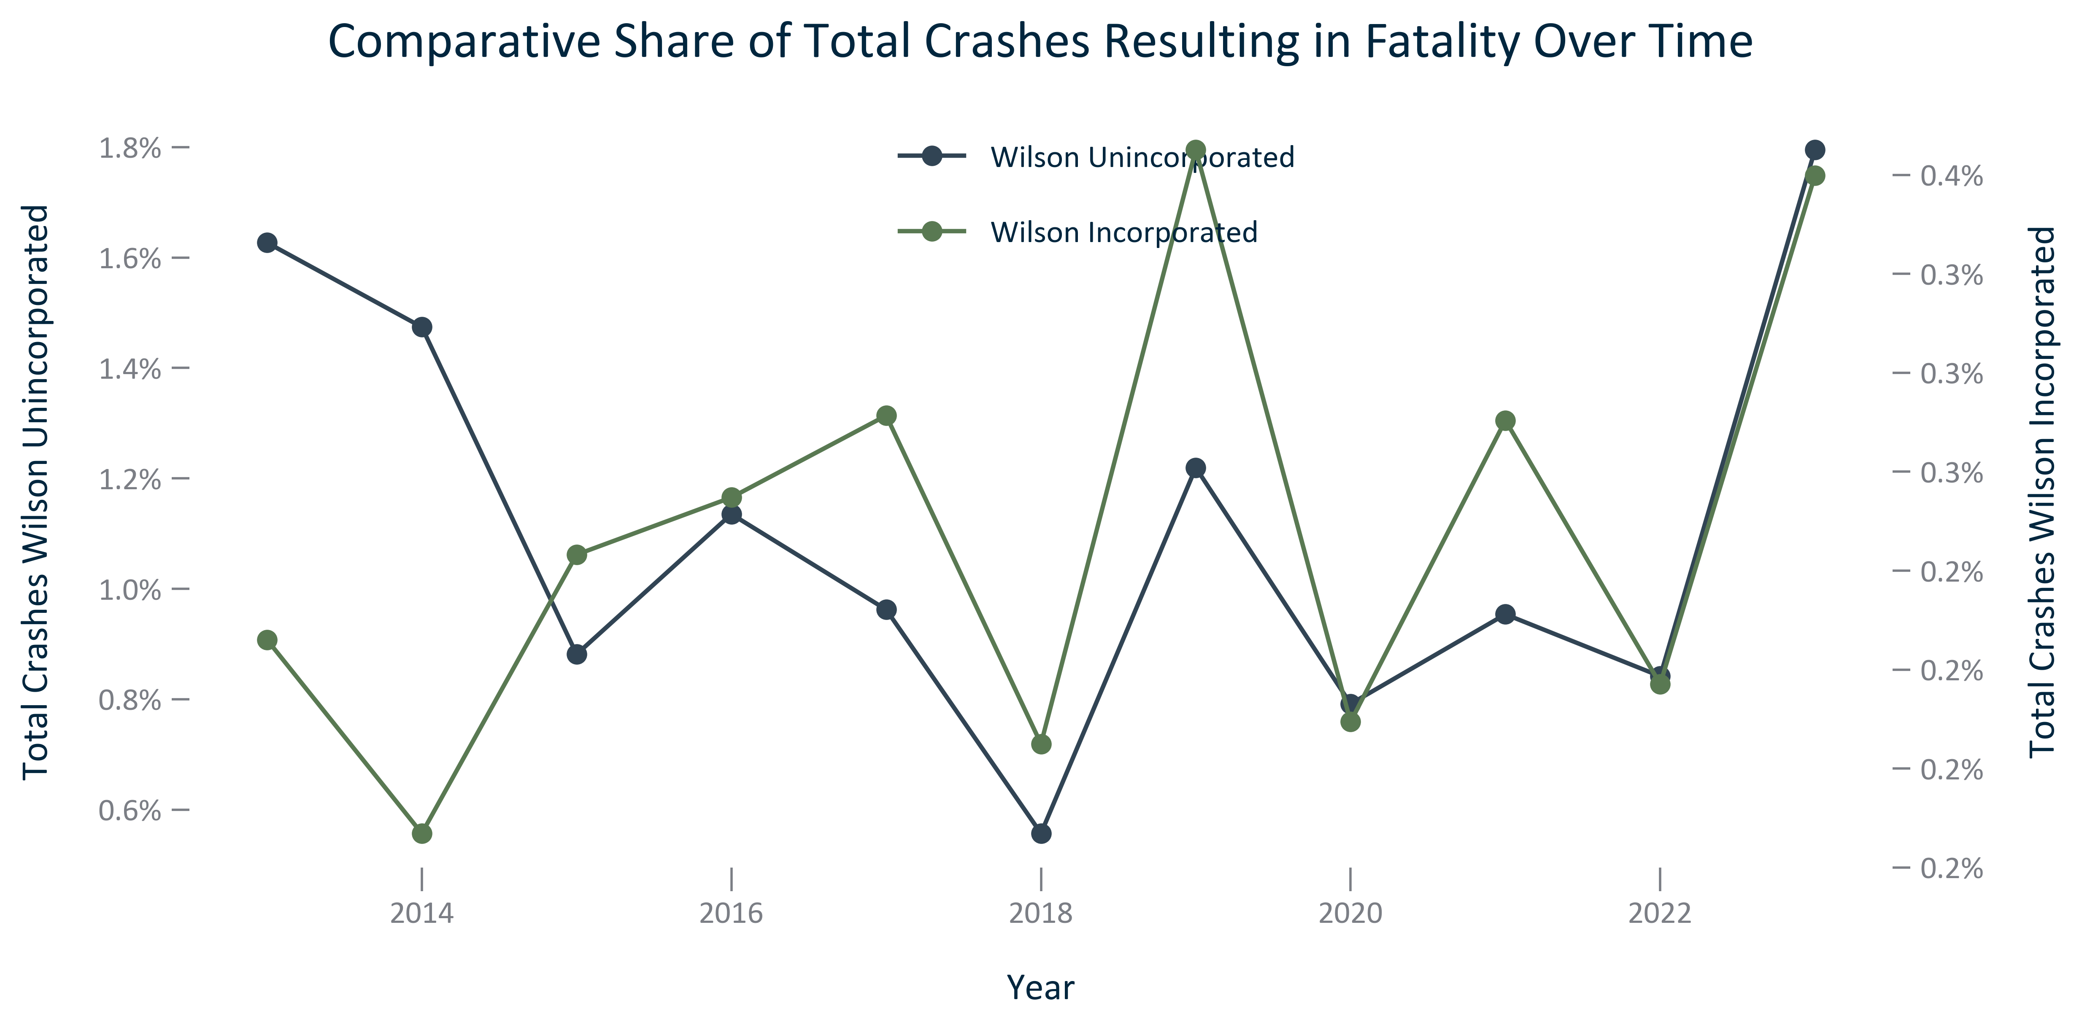

Citation: Crash Data

### TRANSPO_line_geocomparative_seriousinjurycrashes_overtime:

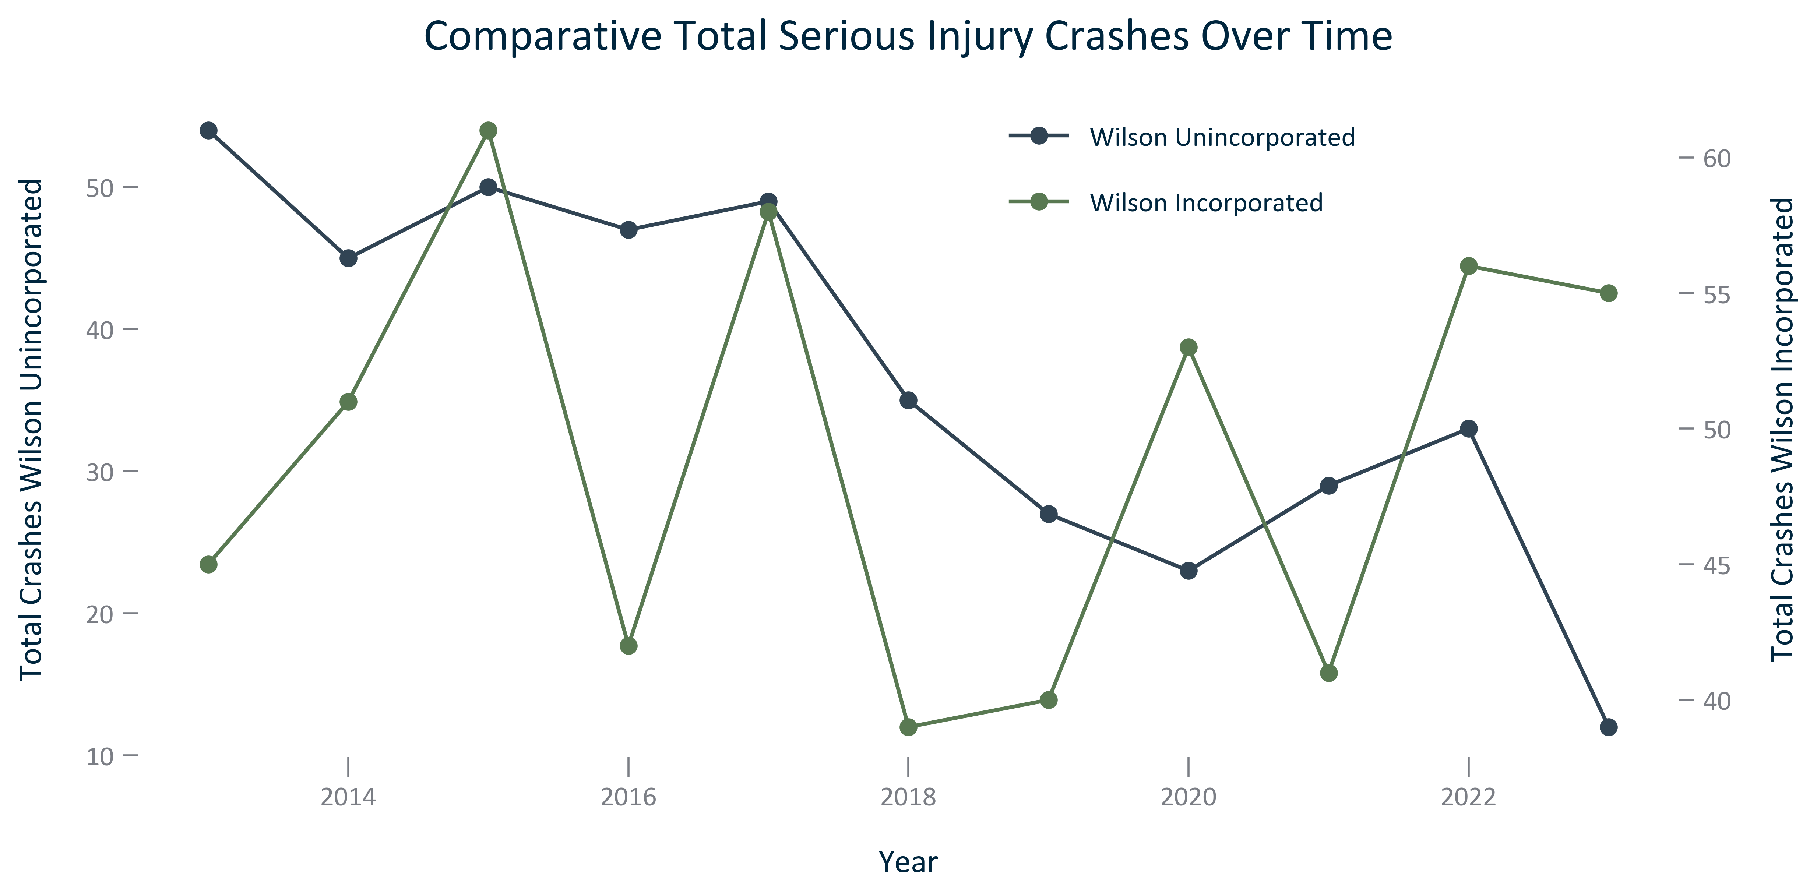

Citation: Crash Data

### TRANSPO_line_geocomparative_percentseriousinjurycrashes_overtime:

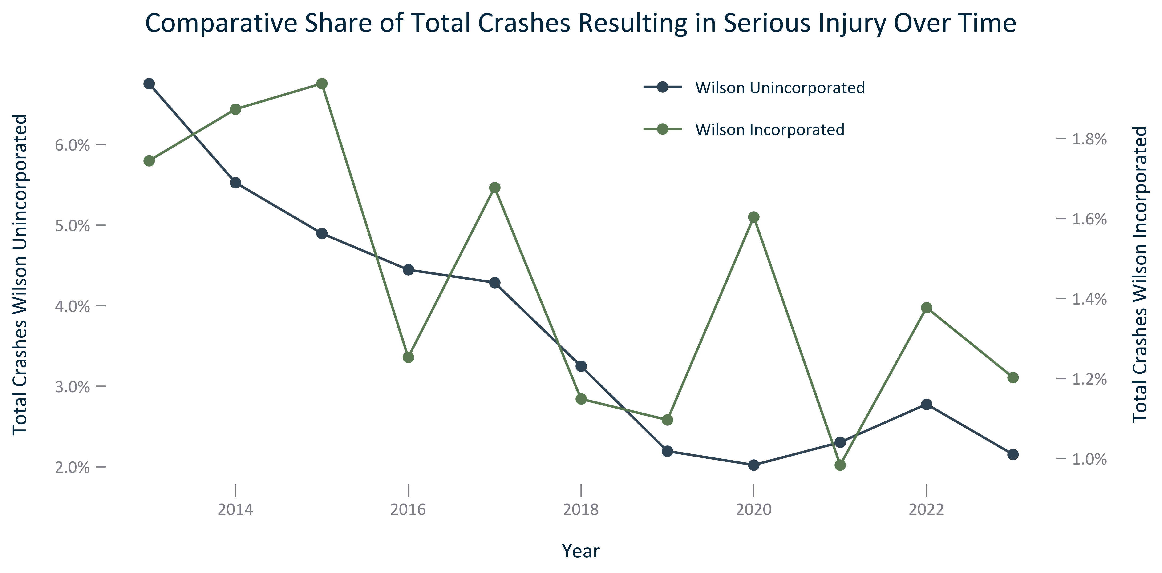

Citation: Crash Data

### TRANSPO_bar_primarygeo_meansoftransportationtowork_2023:

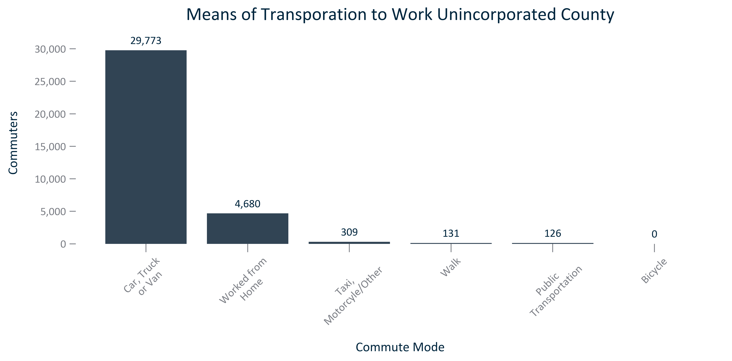

Citation: 2019 - 2023 American Community Survey 5-Year Estimates

### TRANSPO_bar_primarygeo_sharemeansoftransportationtowork_2023:

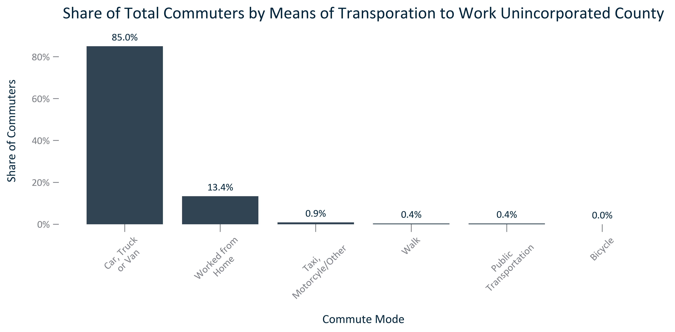

Citation: 2019 - 2023 American Community Survey 5-Year Estimates

### TRANSPO_stackedbar_primarygeo_sharecommutemodes_overtime:

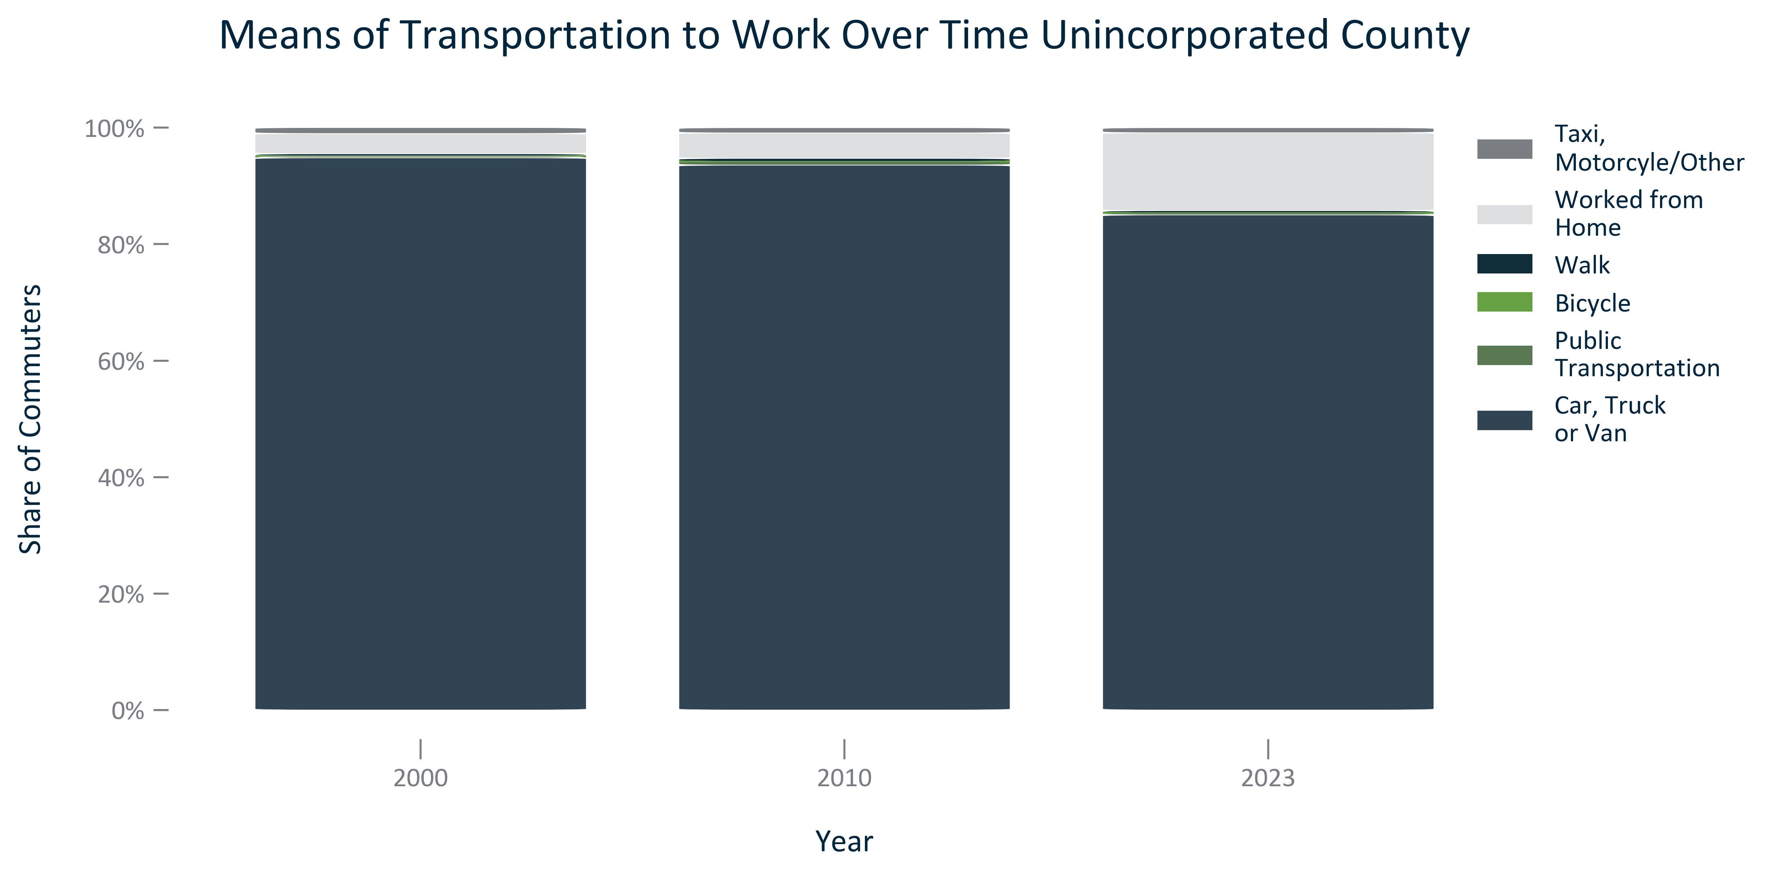

Citation: 2000 Decennial Census, 2006-2010 and 2019 - 2023 American Community Survey 5-Year Estimates

### TRANSPO_stackedbar_geocomparative_sharecommutemodes_2023:

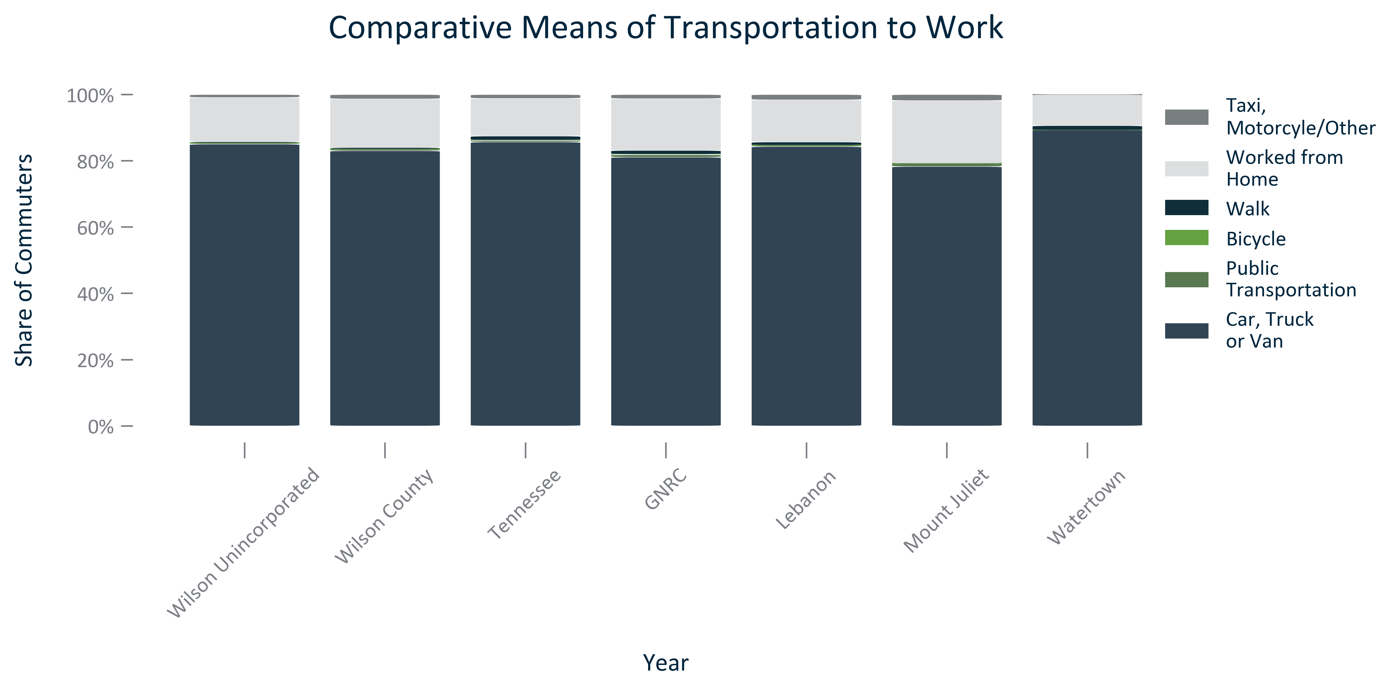

Citation: 2019 - 2023 American Community Survey 5-Year Estimates

### TRANSPO_line_geocomparative_commutetime_overtime:

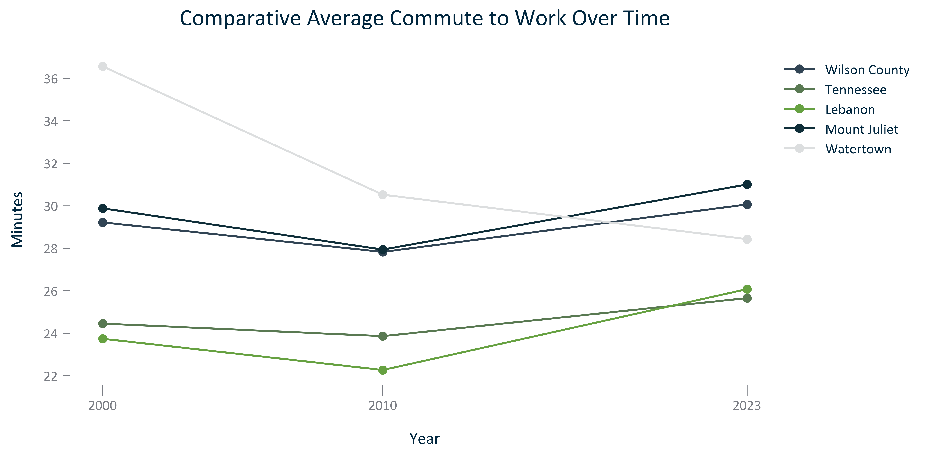

Citation: 2006-2010 and 2019 - 2023 American Community Survey 5-Year Estimates

### TRANSPO_bar_primarygeo_extremelylongcommutetime_overtime:

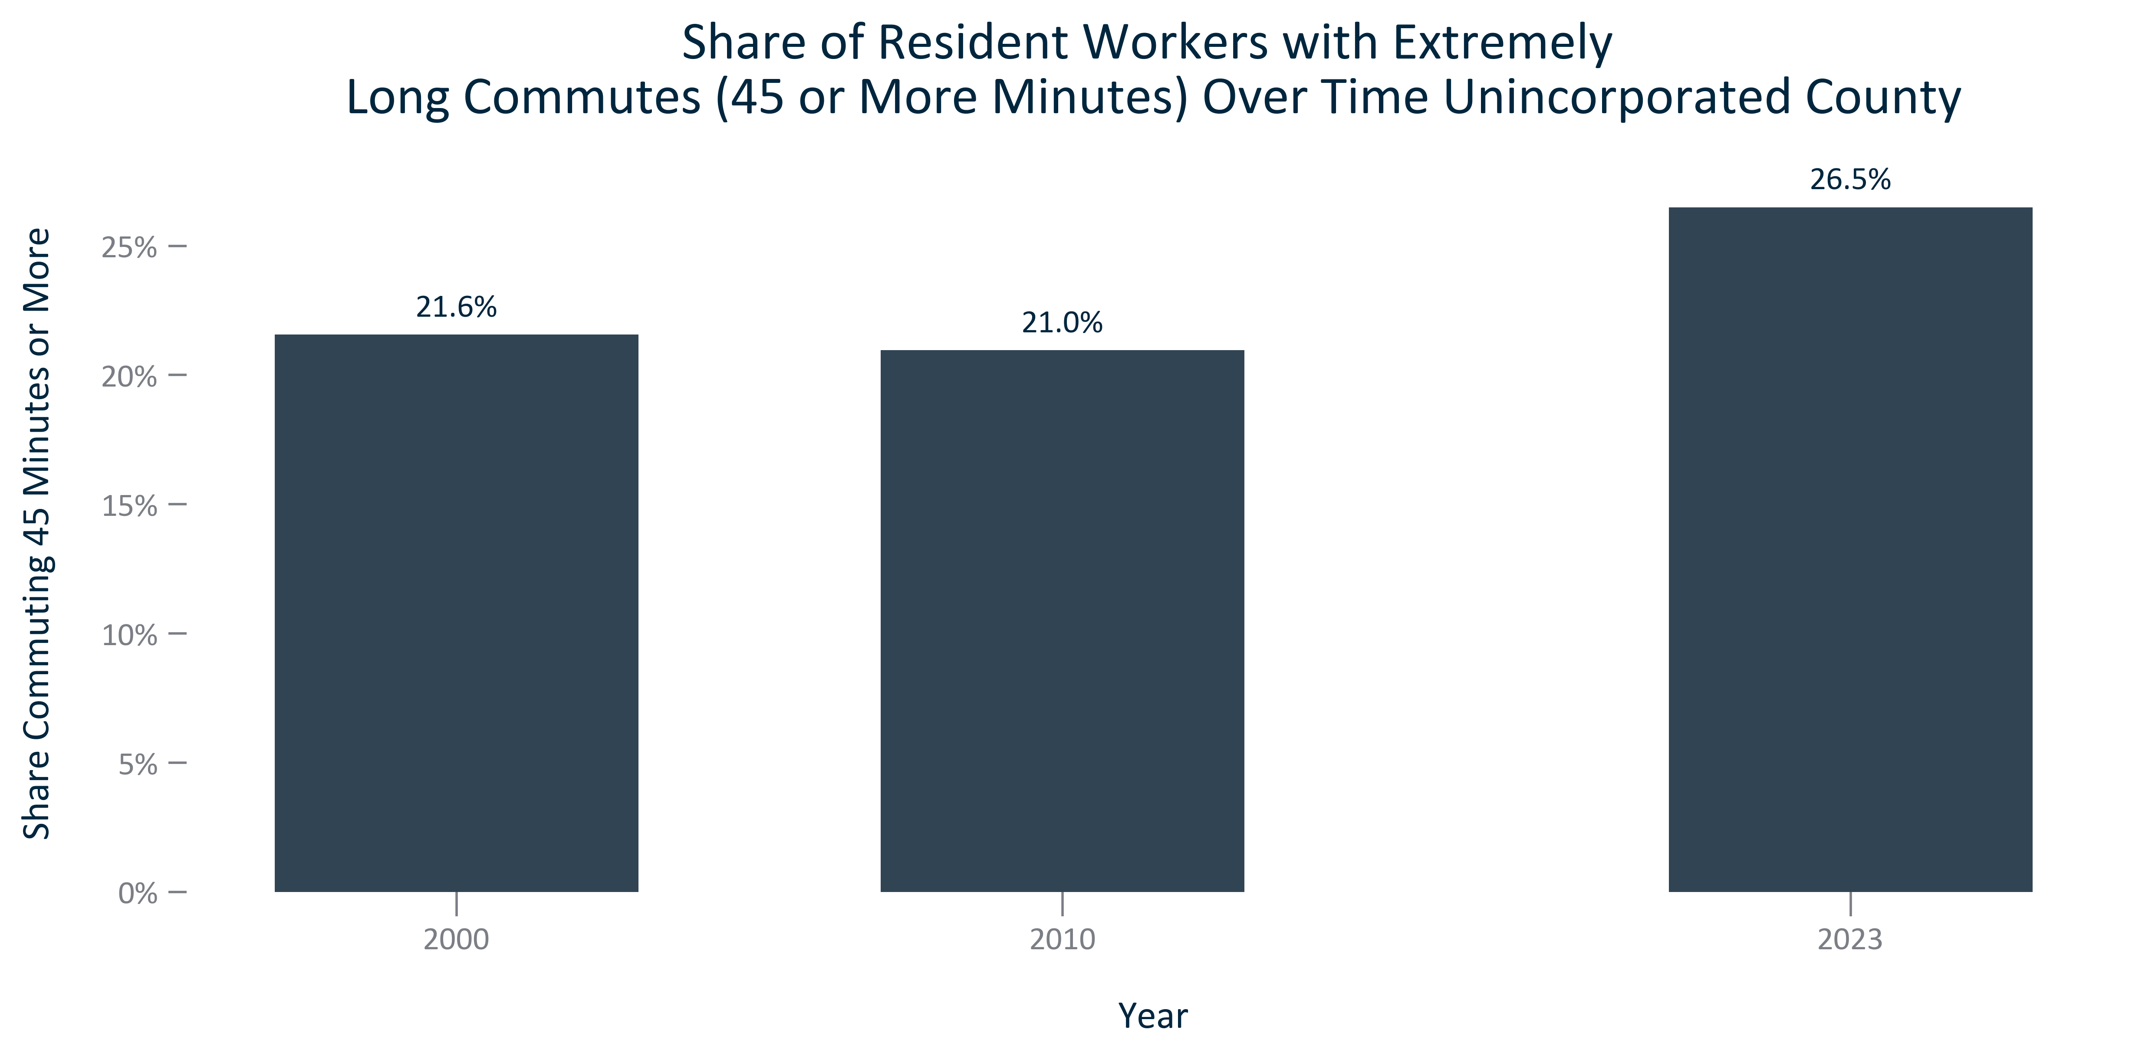

Citation: 2006-2010 and 2019 - 2023 American Community Survey 5-Year Estimates

### TRANSPO_line_geocomparative_extremelylongcommutetime_overtime:

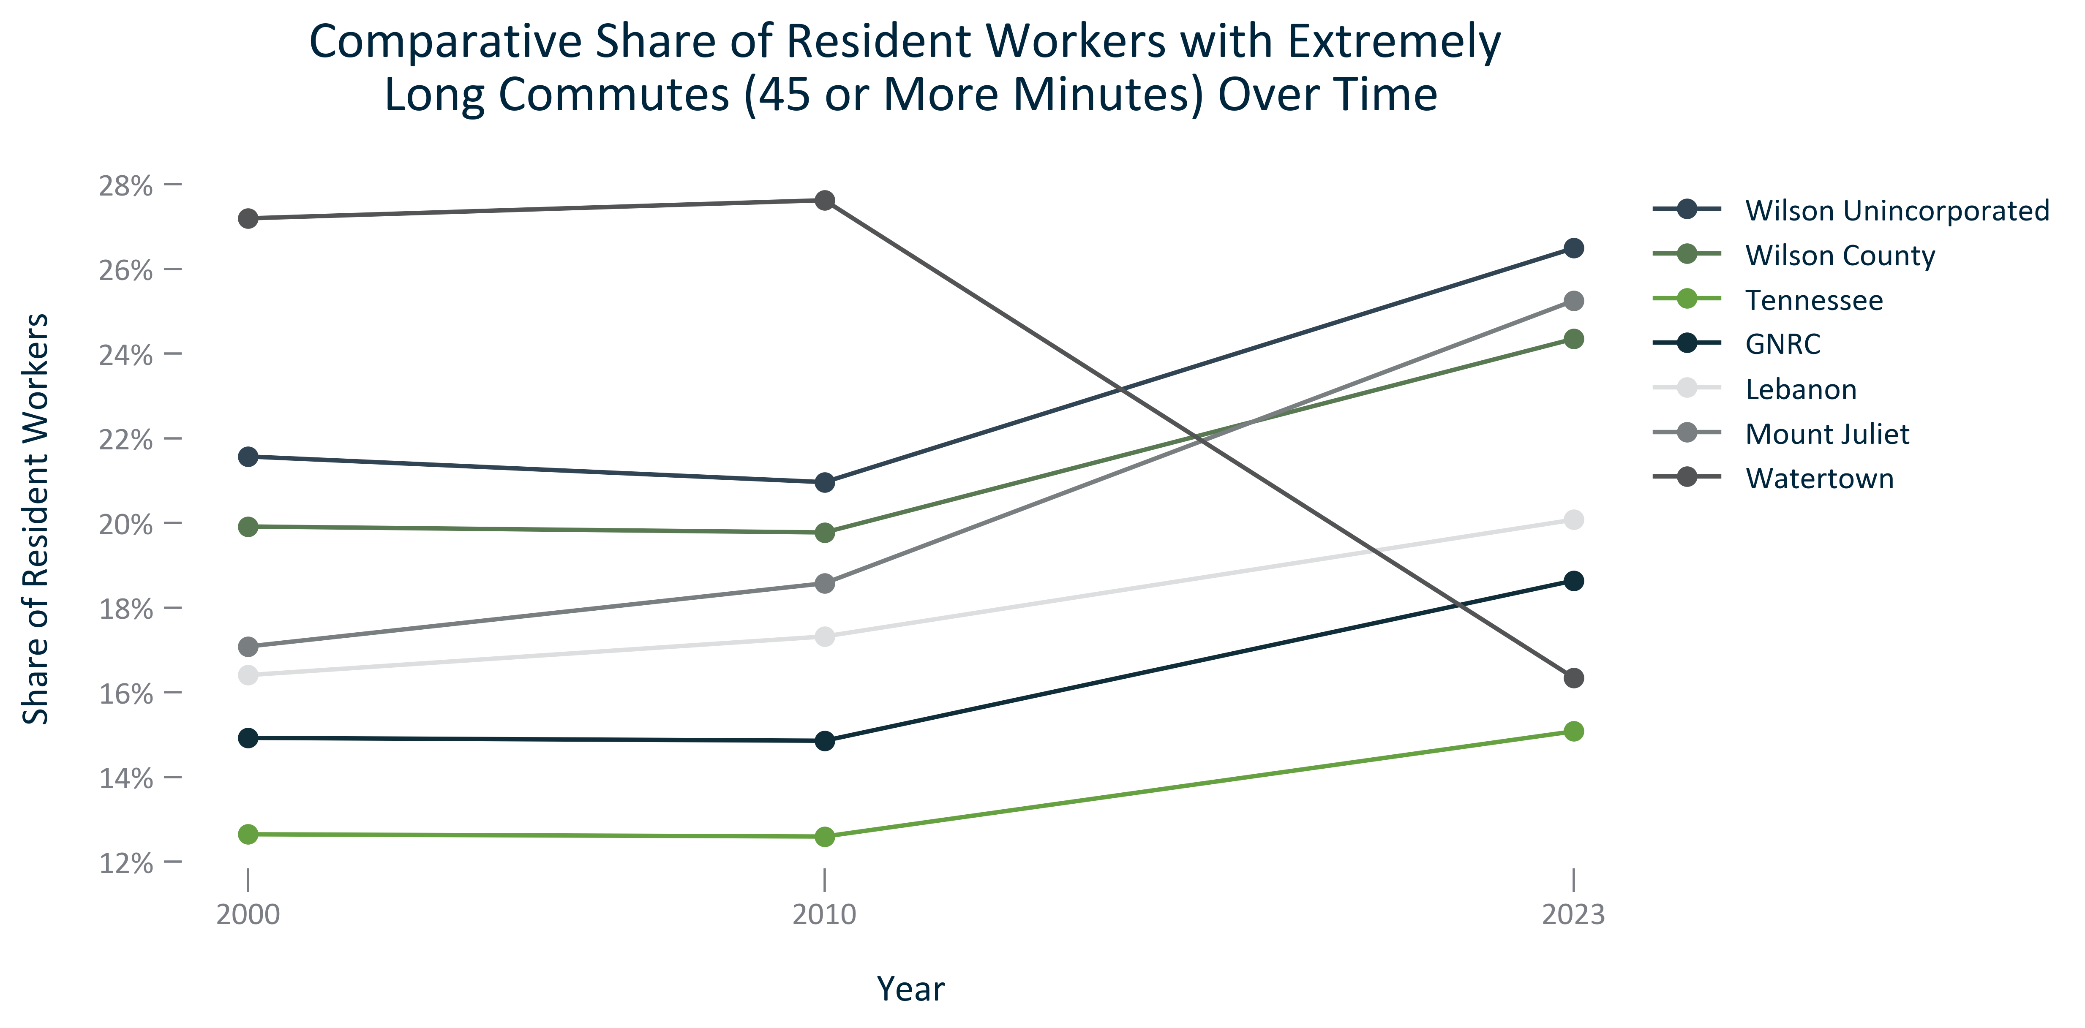

Citation: 2006-2010 and 2019 - 2023 American Community Survey 5-Year Estimates

### TRANSPO_bar_primarygeo_workfromhome_overtime:

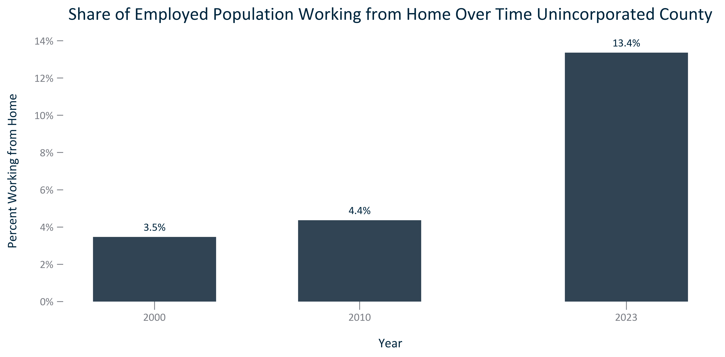

Citation: 2000 Decennial Census, 2006-2010 and 2019 - 2023 American Community Survey 5-Year Estimates

### TRANSPO_line_geocomparative_shareworkfromhome_overtime:

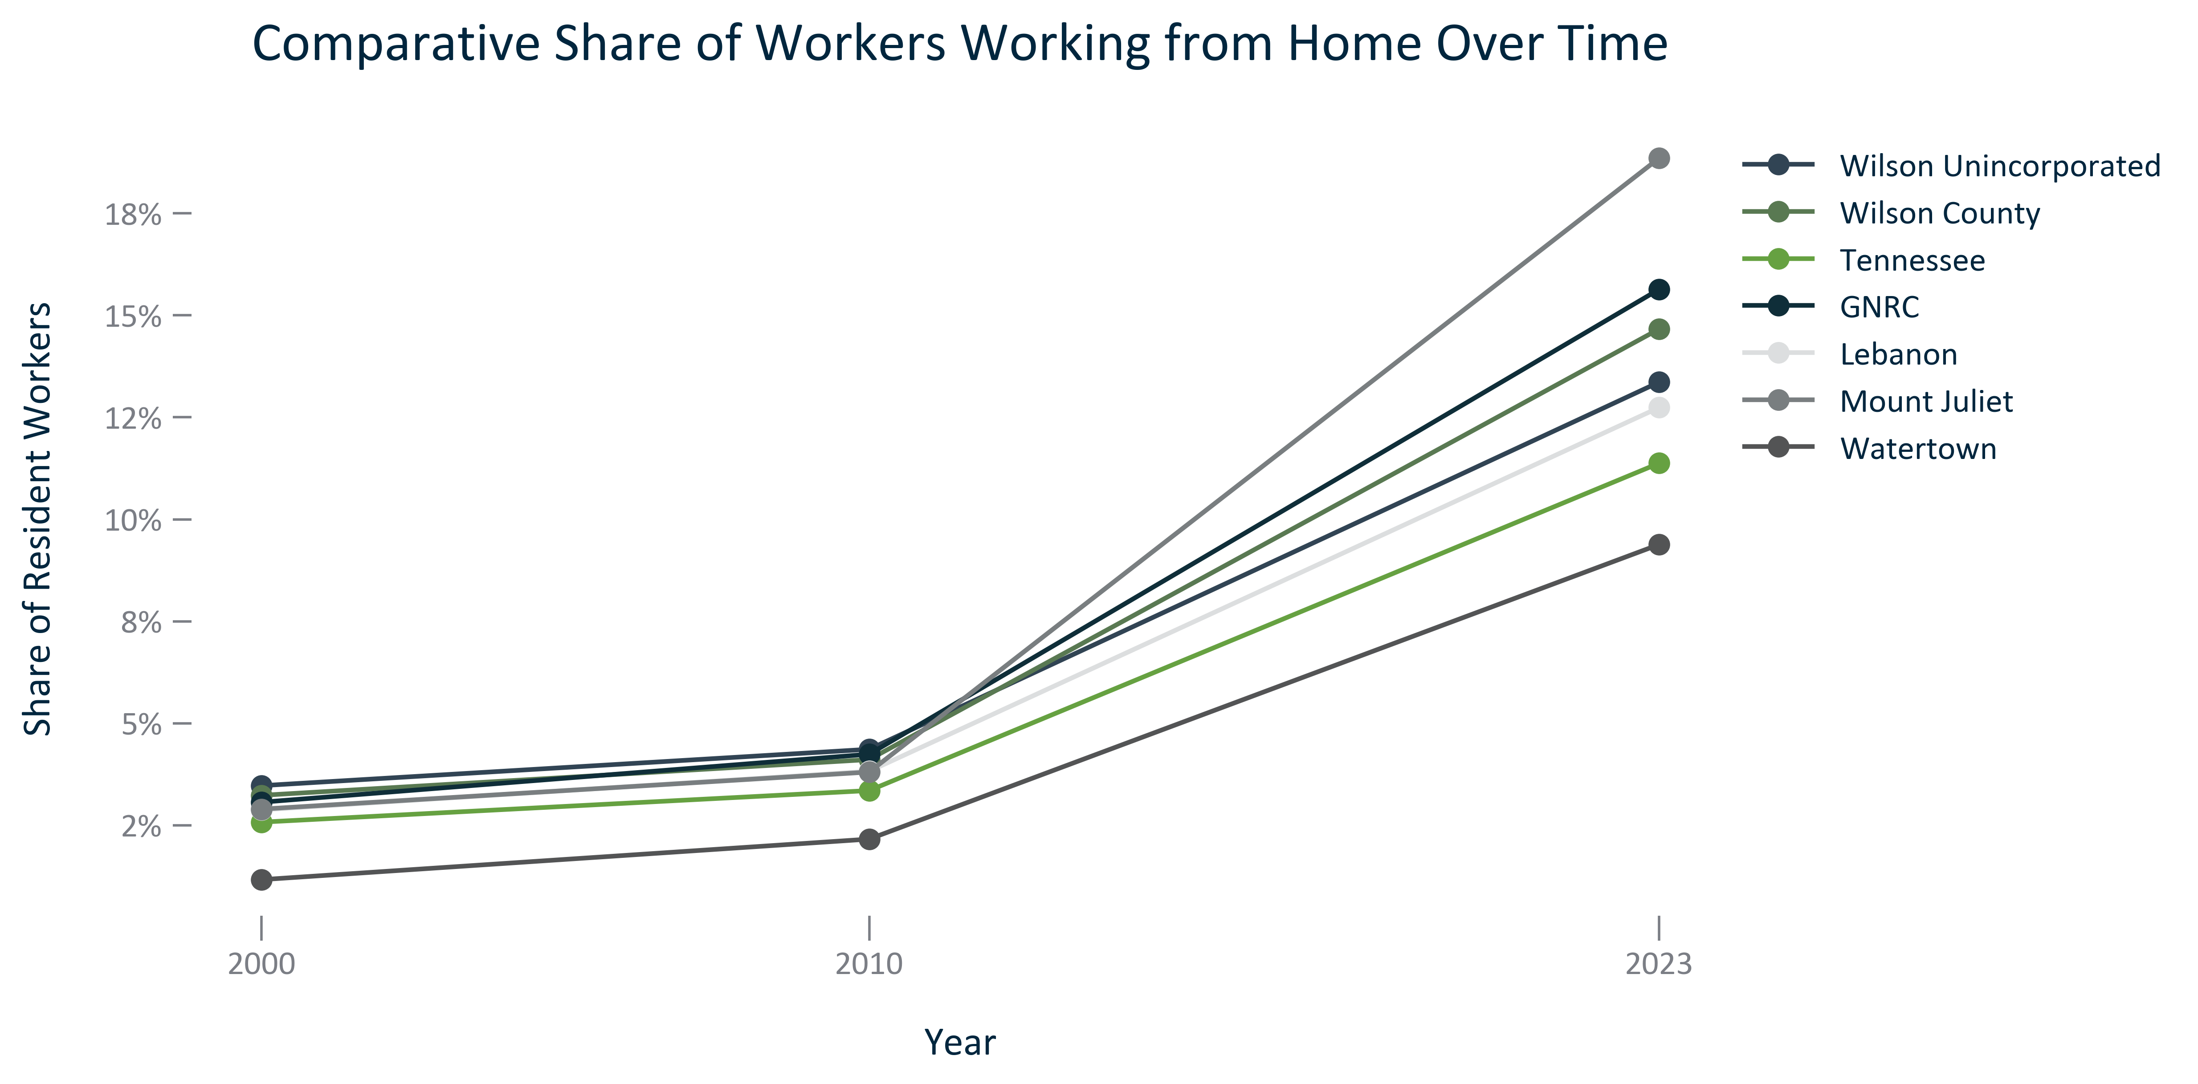

Citation: 2006-2010 and 2019 - 2023 American Community Survey 5-Year Estimates

### TRANSPO_bar_primarygeo_novehicleavailable_overtime:

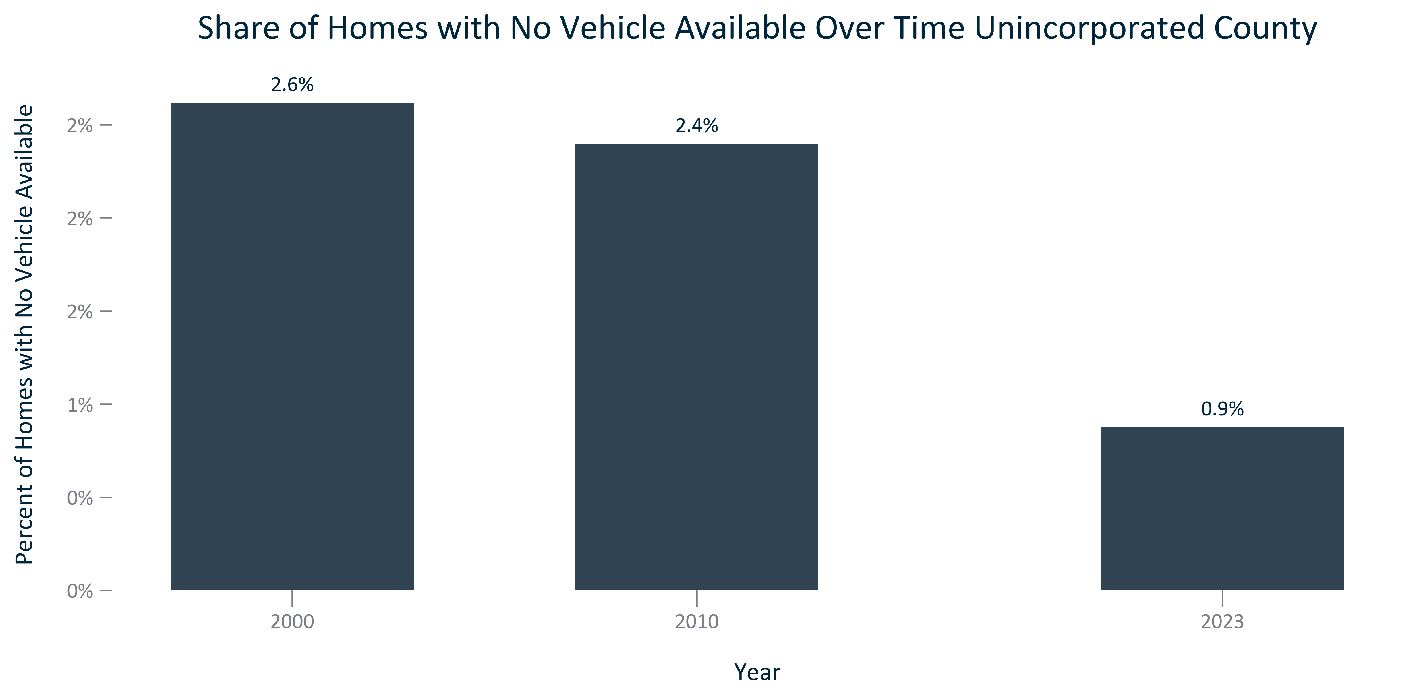

Citation: 2000 Decennial Census, 2006-2010 and 2019 - 2023 American Community Survey 5-Year Estimates

### TRANSPO_line_geocomparative_novehicleavailable_overtime:

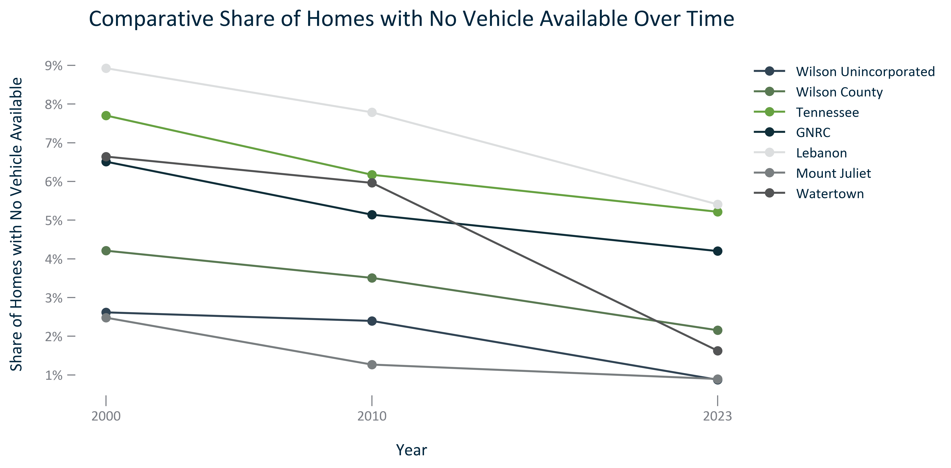

Citation: 2000 Decennial Census, 2006-2010 and 2019 - 2023 American Community Survey 5-Year Estimates

# Health

### HEALTH_bar_geocomparative_sharepopulationnohealthcoverage_2023:

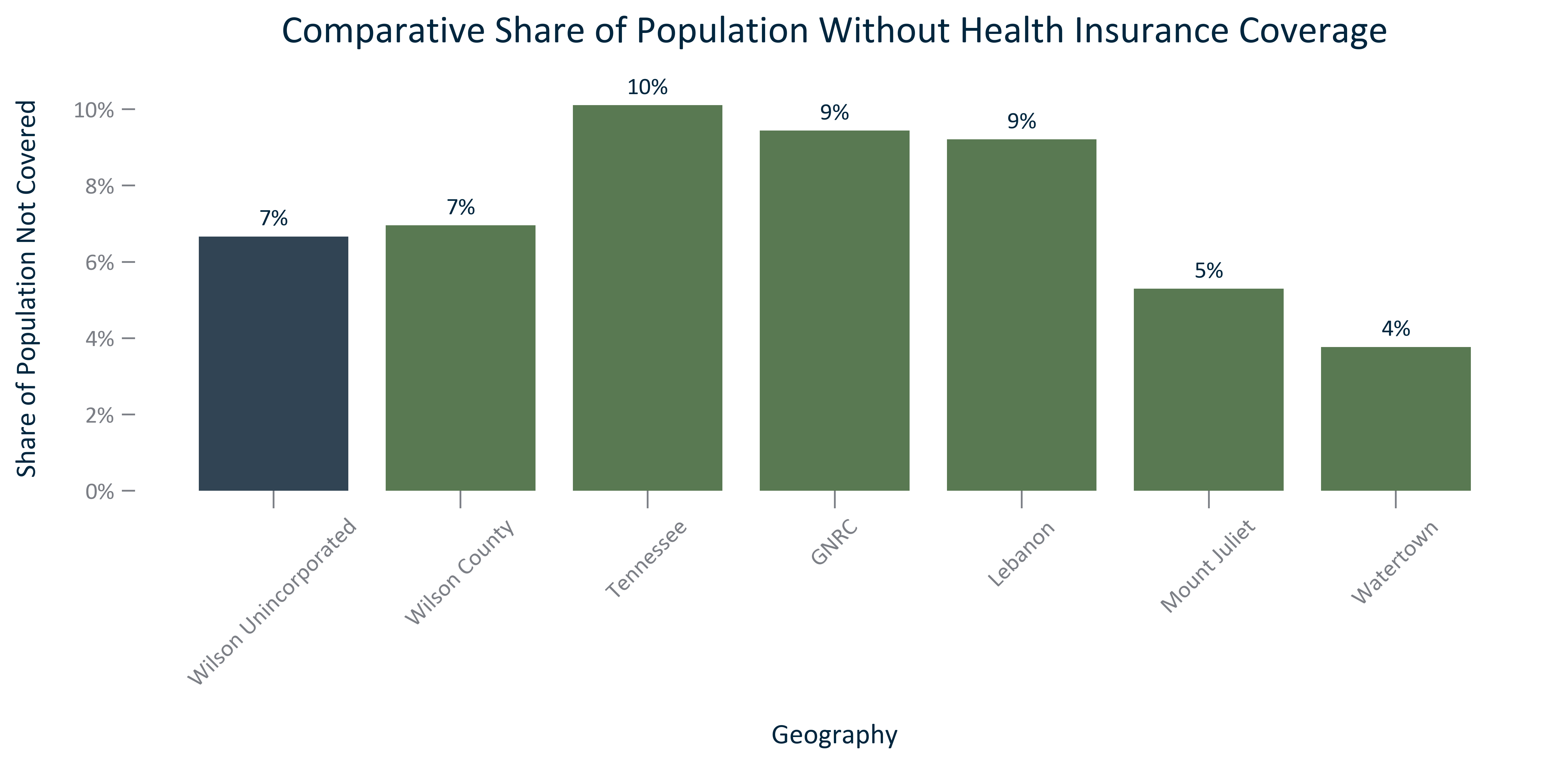

Citation: 2019 - 2023 American Community Survey 5-Year Estimates

### HEALTH_stackedbar_geocomparative_sharewithandwithouthealthcarecoverage_2023:

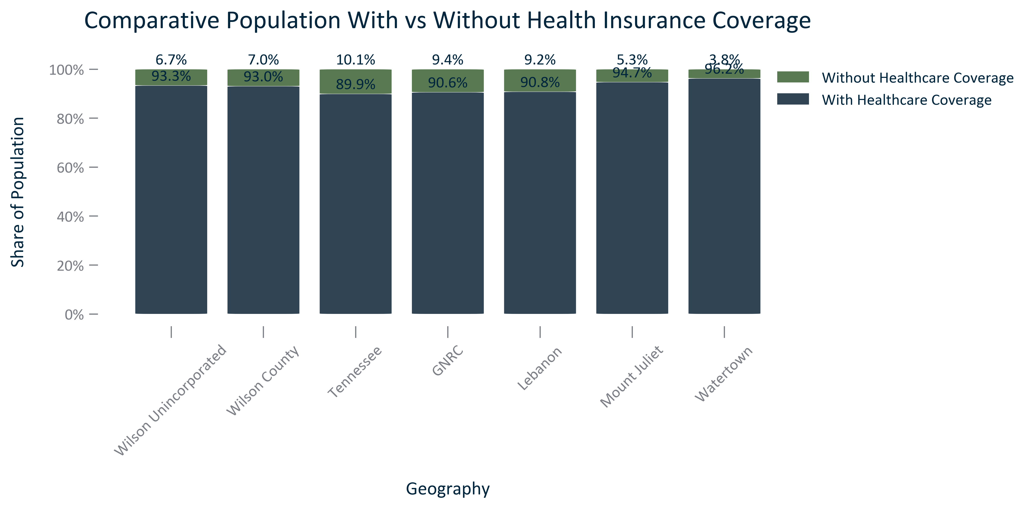

Citation: 2019 - 2023 American Community Survey 5-Year Estimates

### HEALTH_clusterbar_geocomparative_publicandprivatehealthinsurancecoverage_2023:

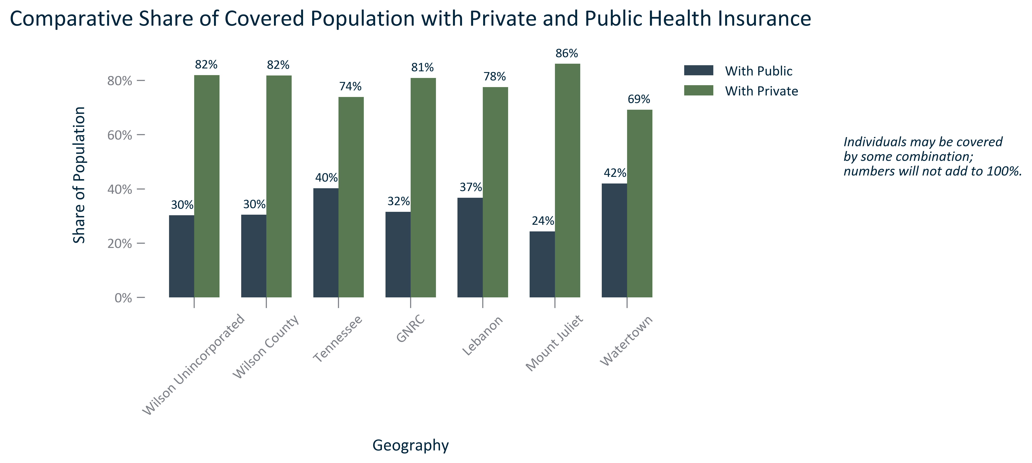

Citation: 2019 - 2023 American Community Survey 5-Year Estimates

### HEALTH_table_geocomparative_healthinsurancebytype_2023:

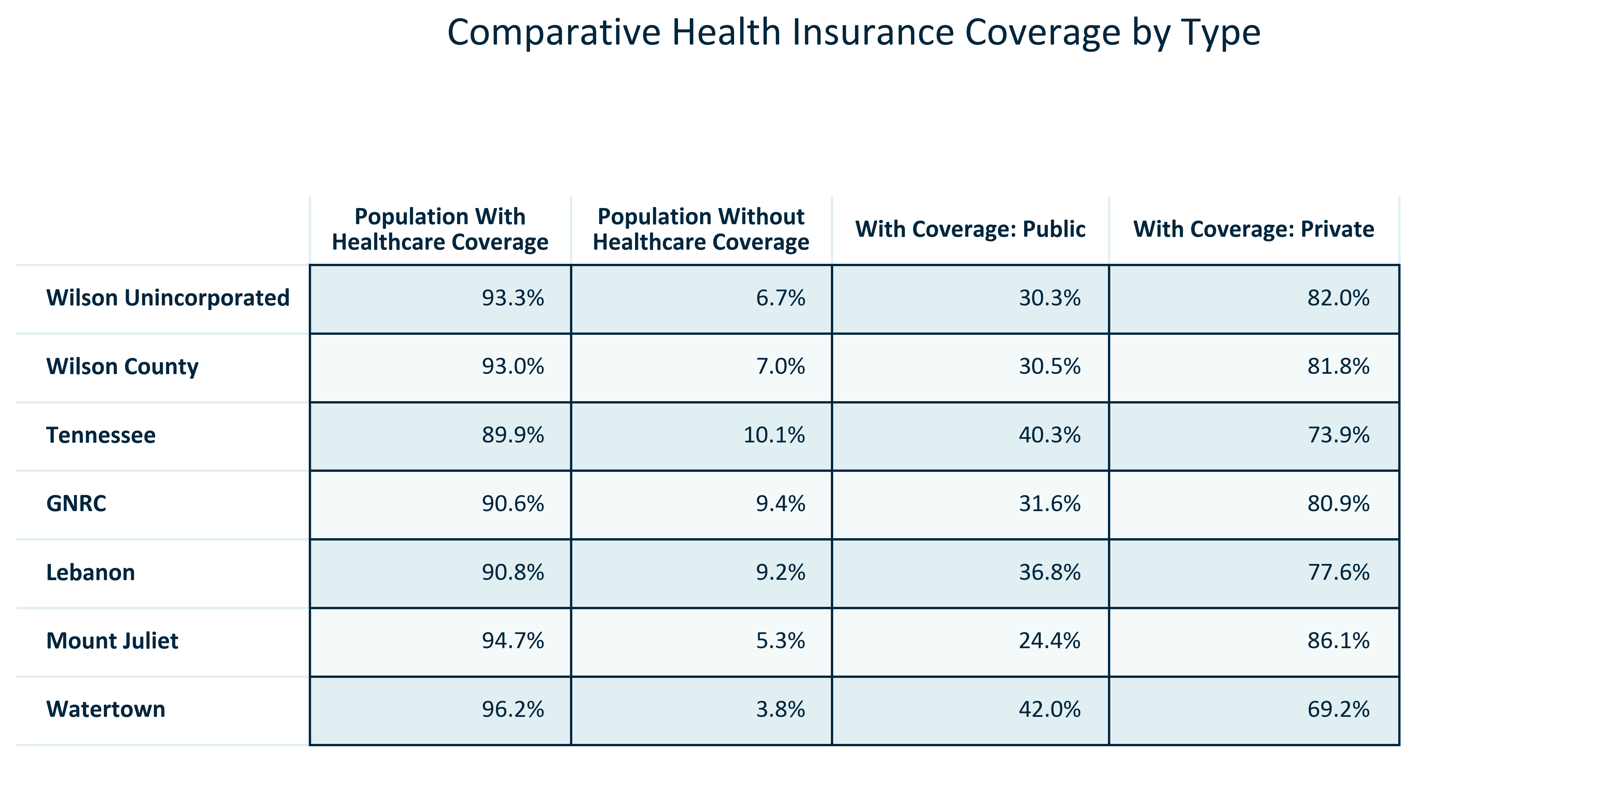

Citation: 2019 - 2023 American Community Survey 5-Year Estimates

### HEALTH_bar_geocomparative_countyhealthoutcomes_current:

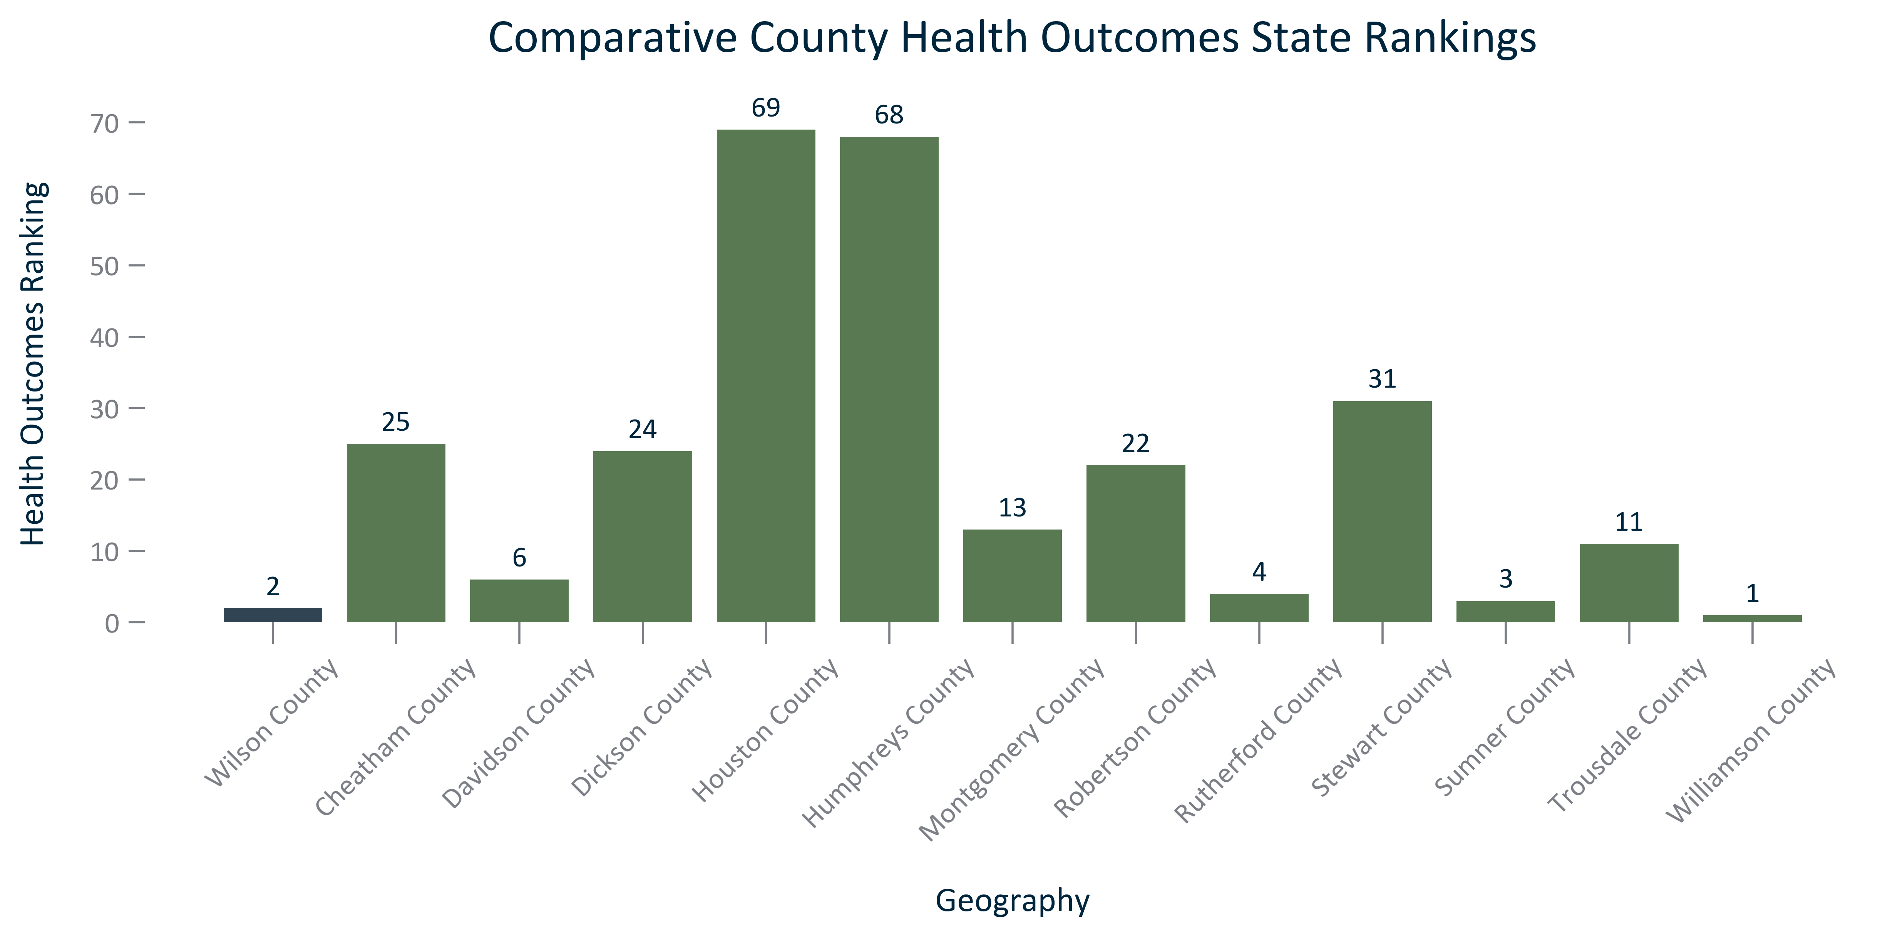

Citation: University of Wisconsin County Health Rankings

### HEALTH_bar_geocomparative_countyhealthfactors_current:

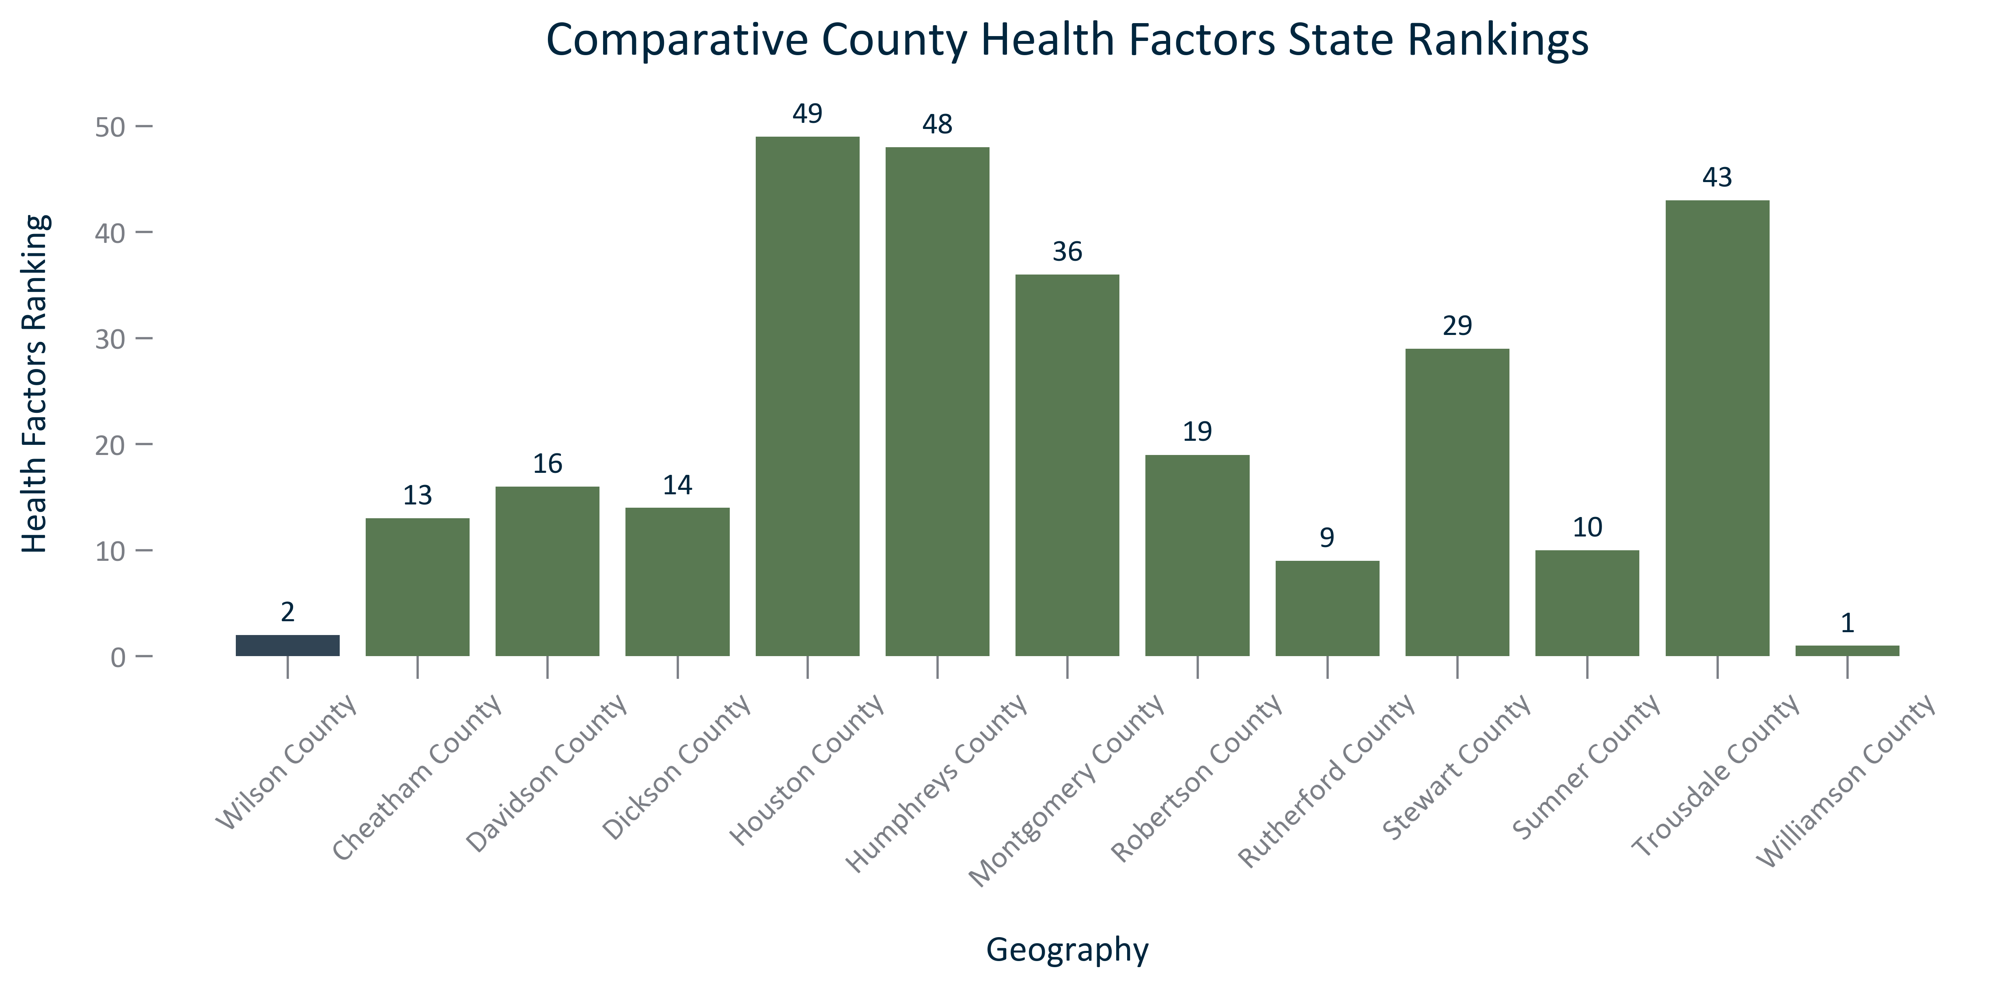

Citation: University of Wisconsin County Health Rankings

### HEALTH_bar_geocomparative_countyaveragelifeexpectancy_current:

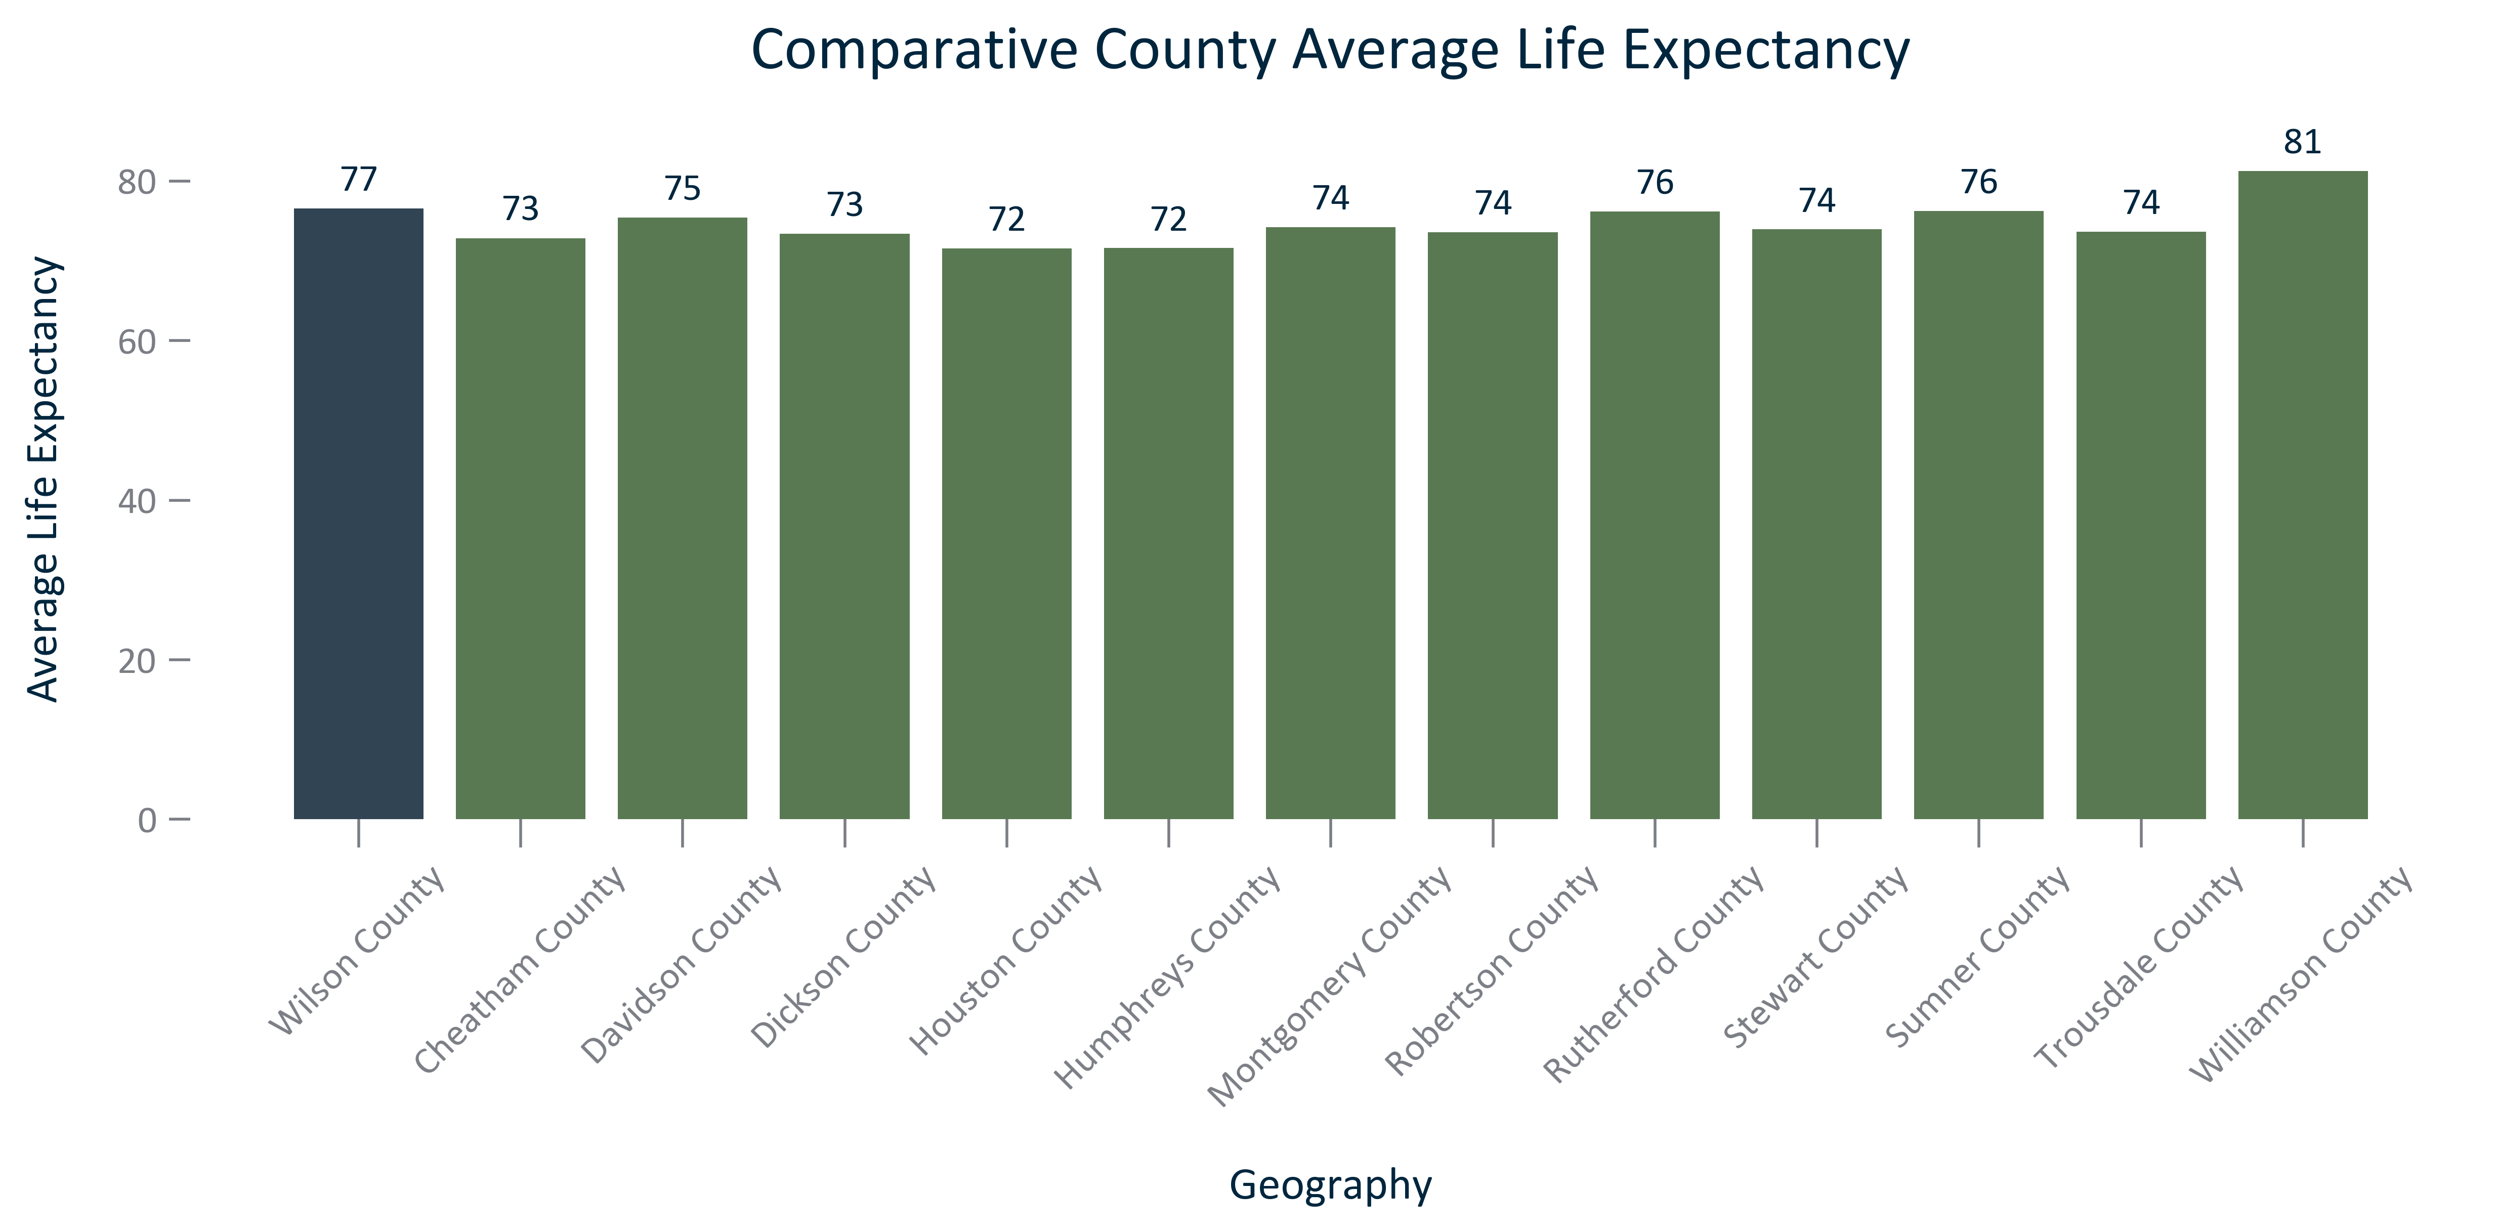

Citation: University of Wisconsin County Health Rankings

### HEALTH_bar_geocomparative_frequentphysicaldistress_current:

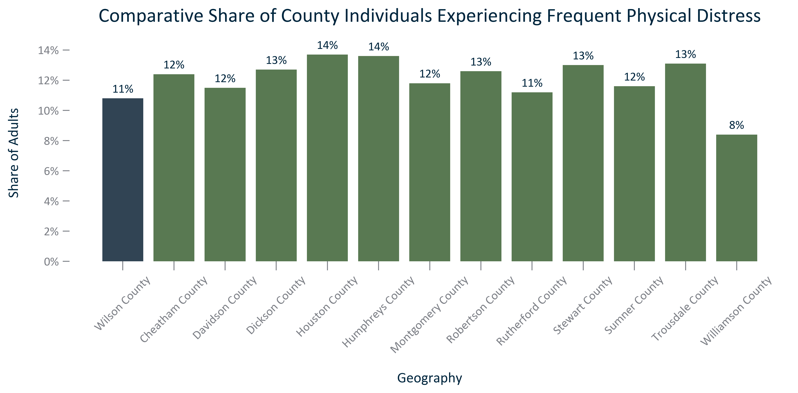

Citation: University of Wisconsin County Health Rankings

### HEALTH_bar_geocomparative_frequentmentaldistress_current:

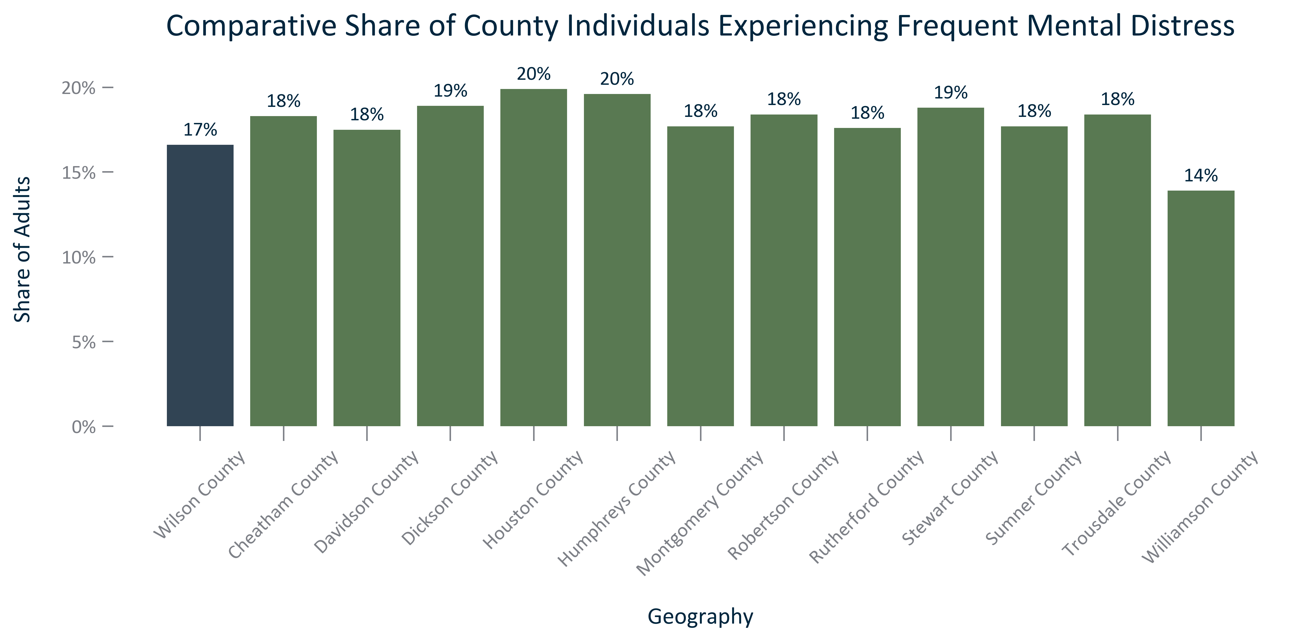

Citation: University of Wisconsin County Health Rankings

# Crime

### CRIME_bar_geocomparative_crimerate_current:

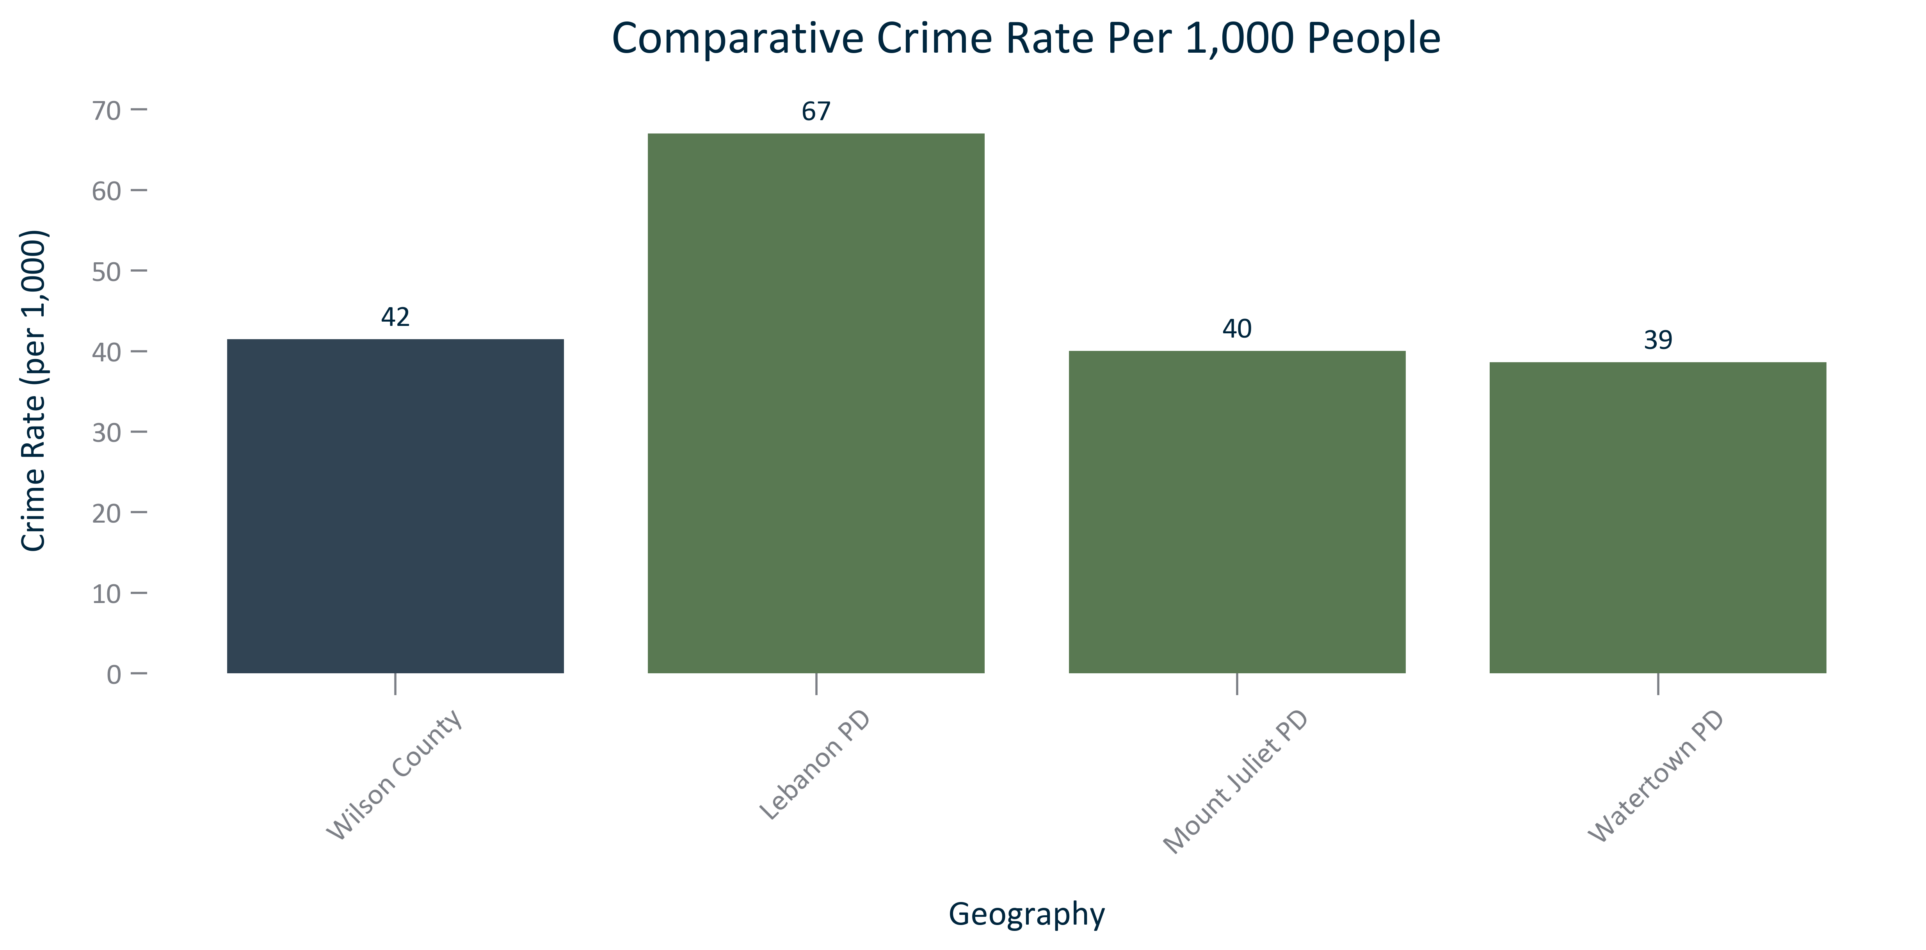

Citation: Tennessee Bureau of Investigation 2023 Incidents

### CRIME_bar_geocomparative_crimecount_current:

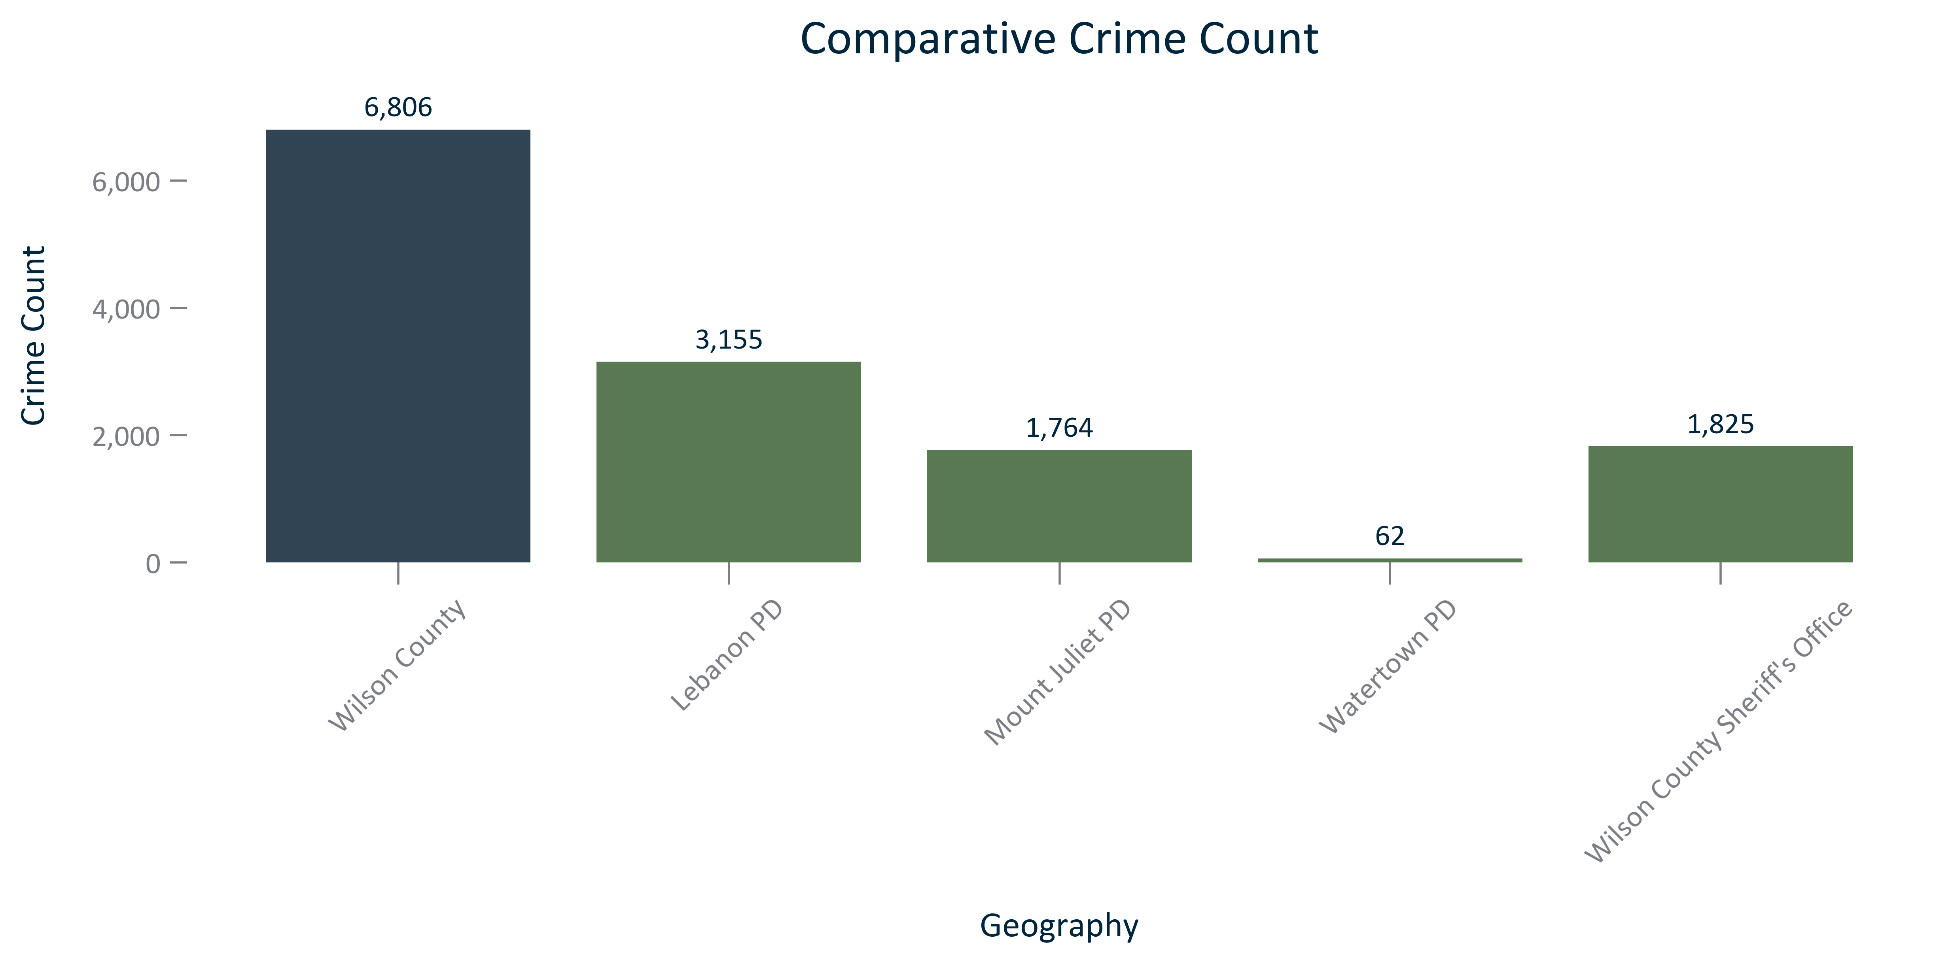

Citation: Tennessee Bureau of Investigation 2023 Incidents

### CRIME_bar_primarygeo_crimetype_current:

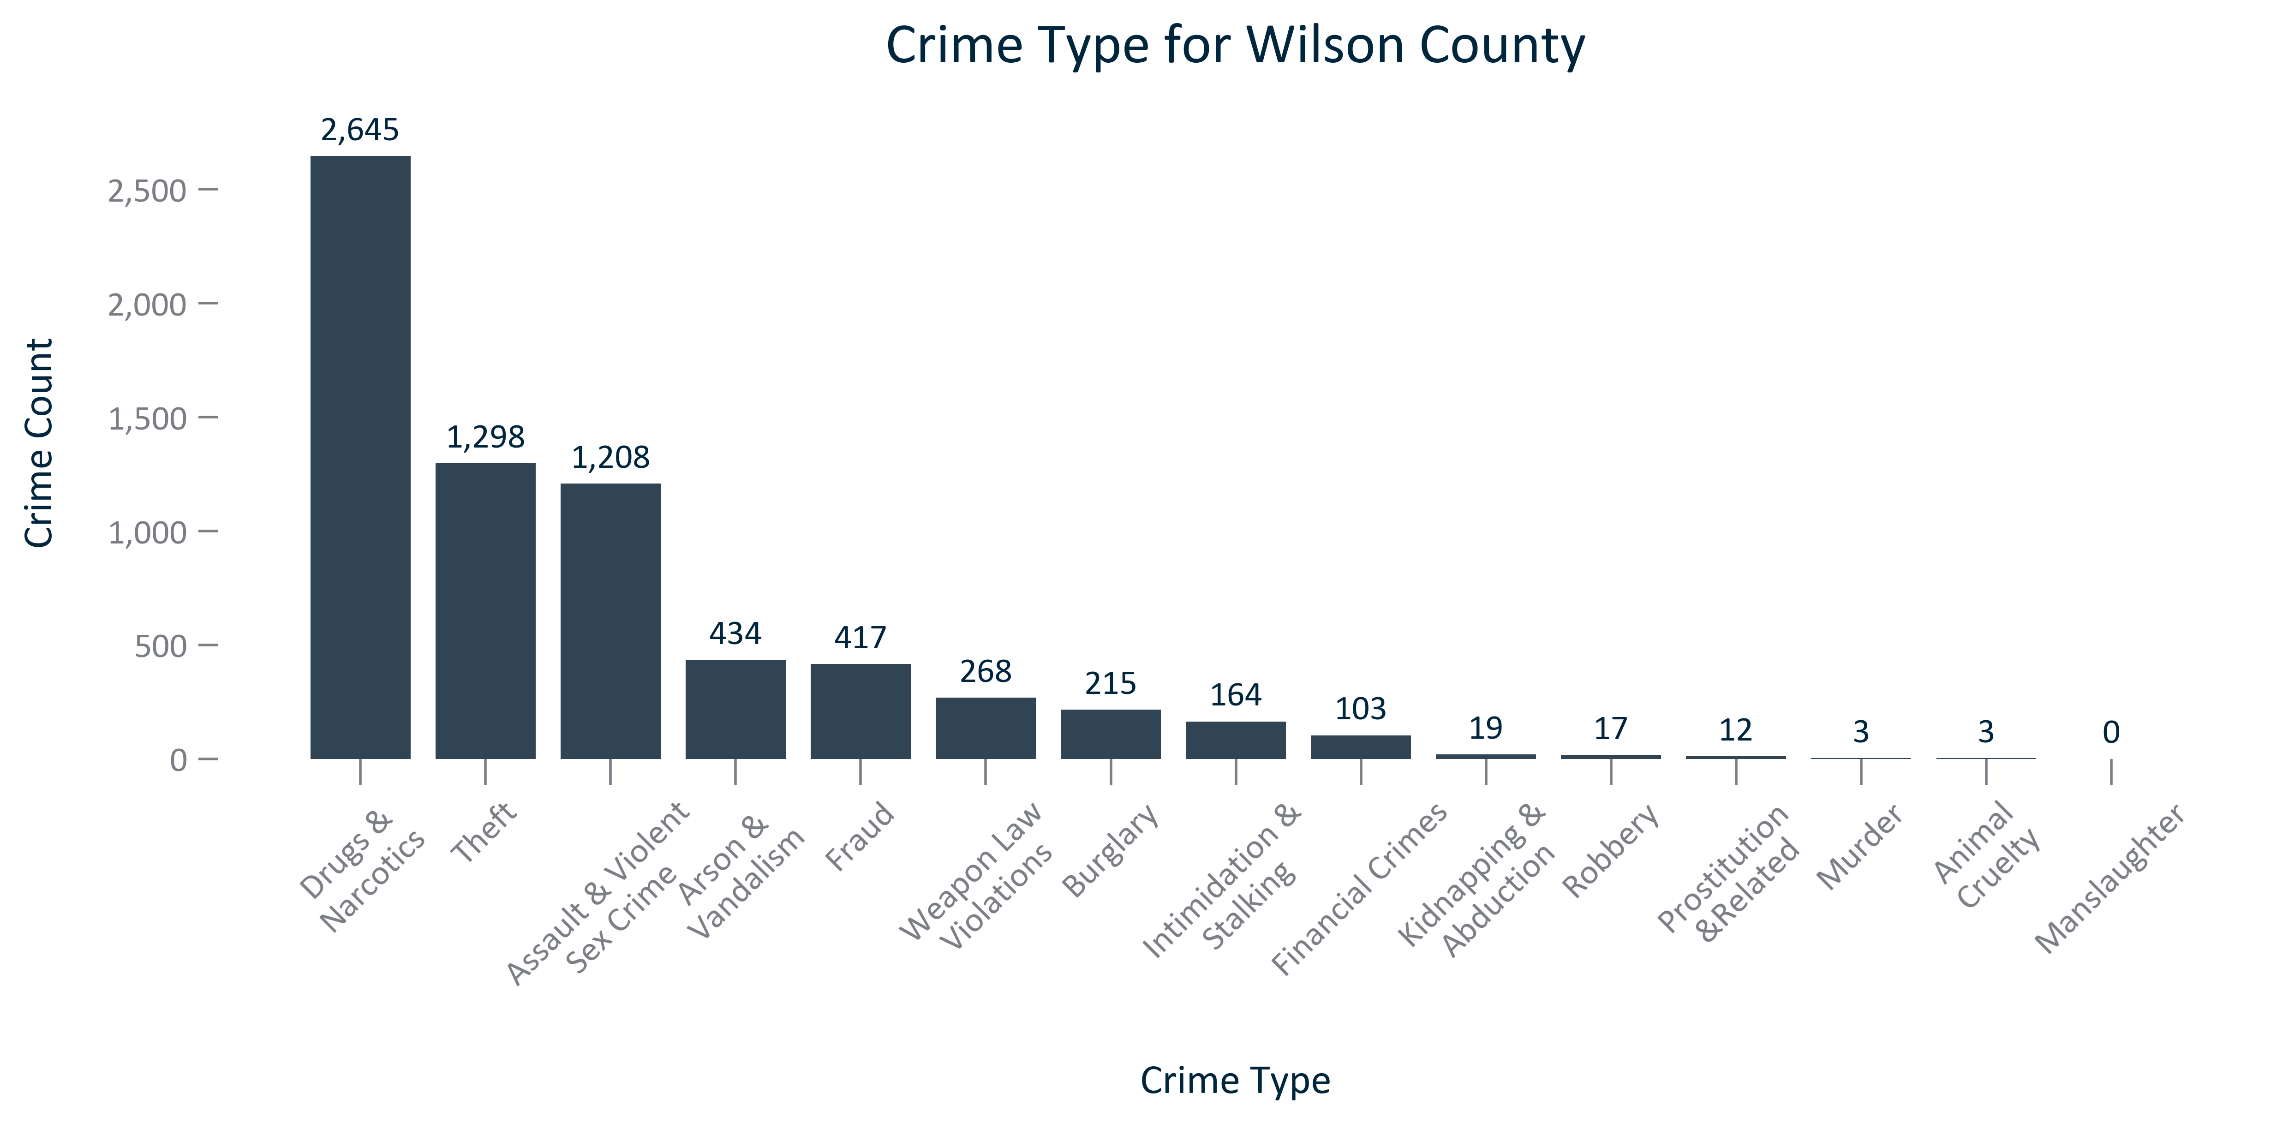

Citation: Tennessee Bureau of Investigation 2023 Incidents